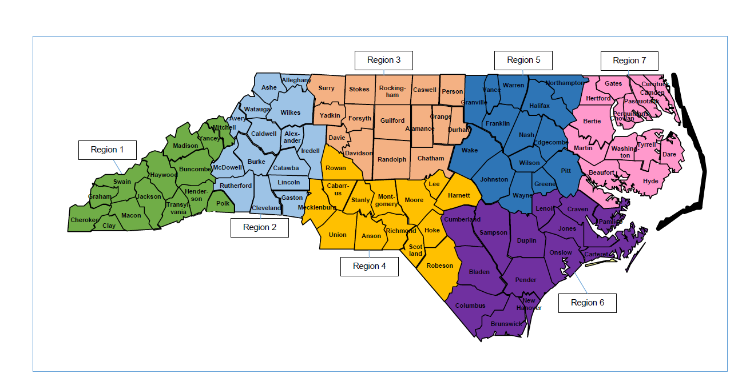
Adult Service CQI Specialist:
Adult Services Regional County Coverage
Region 1 | Anthony Hodges
Region 2 | Katie McCarron
Region 3 | LaVerne Blue
Region 4 | Kate Walton
Region 5 | April Black
Region 6 | Wendy Whitfield
Region 7 | Brandy Mann

Anthony Hodges - Region 1  Anthony.hodges@dhhs.nc.gov  919-614-7294 | Katie McCarron - Region 2 katie.mccarron@dhhs.nc.gov  919-239-0601 | LaVerne Blue - Region 3 Laverne.Blue@dhhs.nc.gov  919-594-7496 | Kate Walton - Region 4 Kate.Walton@dhhs.nc.gov  919-609-3435
Buncombe | Alexander | Alamance | Anson
Cherokee | Alleghany | Caswell | Cabarrus
Clay | Ashe | Chatham | Harnett
Graham | Avery | Davidson | Hoke
Haywood | Burke | Davie | Lee
Henderson | Caldwell | Durham | Mecklenburg
Jackson | Catawba | Forsyth | Moore
Macon | Cleveland | Guilford | Montgomery
Madison | Gaston | Orange | Richmond
Mitchell | Iredell | Person | Robeson
Polk | Lincoln | Randolph | Rowan
Swain | McDowell | Rockingham | Scotland
Transylvania | Rutherford | Stokes | Stanly
Yancey | Watauga | Surry | Union
 | Wilkes | Yadkin
April Black - Region 5 April.Black@dhhs.nc.gov  919-675-6971 | Wendy Whitfield - Region 6  Wendy.whitfield@dhhs.nc.gov  984-352-7950 | Brandy Mann - Region 7 Brandy.Mann@dhhs.nc.gov  919-594-0851
Edgecombe | Bladen | Beaufort
Franklin | Brunswick | Bertie
Greene | Carteret | Camden
Granville | Columbus | Chowan
Halifax | Craven | Currituck
Johnston | Cumberland | Dare
Nash | Duplin | Gates
Northampton | Jones | Hertford
Pitt | Lenoir | Hyde
Wayne | New Hanover | Martin
Warren | Onslow | Pasquotank
Wilson | Pamlico | Perquimans
Wake | Pender | Tyrrell
Vance | Sampson | Washington

