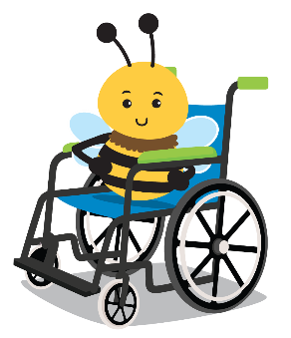
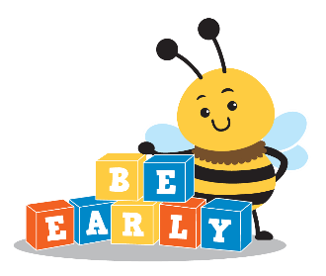
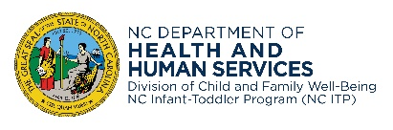
NC Infant-Toddler Program
Families and children will benefit from the assistive technology in the loan library if we all take time for proper care & cleaning.
the earlier you know, the better they’ll grow

Assistive Technology Loaning Program

Care and Cleaning Instructions
An important part of caring for the assistive technology device is cleaning after each use or on a regular basis. Proper care and cleaning of the device allows your family to benefit fully from it. It also helps to ensure your child’s safety.

If available, follow the manufacturer’s instructions for cleaning the device. Otherwise:
- Use a cleaning wipe or sanitizer on a paper towel or slightly damp sponge to clean the device. Do not spray cleaners directly onto the device.
- Avoid using too much liquid or harsh cleaners that may damage the device.
- Dry the device with a cloth after cleaning.

More Tips
- If device is not working properly or you notice any problems (e.g., loose pieces, missing straps) contact your Early Intervention Service Coordinator (EISC).
- If device is battery operated, turn it off when not in use.
- Keep all parts of the device, such as straps and battery covers, attached during the loan to avoid loss.

CDSA Contact Information:

EISC Name:

State of North Carolina | Department of Health and Human Services www.ncdhhs.gov
Division of Child and Family Well-Being | Early Intervention Section
N.C. DHHS is an equal opportunity employer and provider. 12/11, 3/22, 1/23, 5/23
www.ncdhhs.gov/itp-beearly

