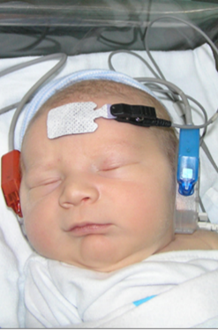

**Audiology Hearing Link Reporting Requirements**

<https://wcs.ncpublichealth.com>

Per NC Administrative Code (10A NCAC 43f.1200),

ANY screening information on children <6 months of age and,

ANY diagnostic or amplification information on children <12 months of age

**MUST BE reported within 5 days,** including no show appointments.

**What to Enter in Hearing Link**

* **Newborn screening follow-up results, with or without complete diagnostic information.**
* **A new diagnosis of permanent hearing loss OR a complete diagnostic evaluation obtained on a child with previously incomplete testing.**
* **Fitting of new amplification. (hearing aid, BAHA, CI, etc.)**
* **Future appointment date(s) that are scheduled when evaluation or amplification process is incomplete. (Record in the appointment tab)**
* **Child with KNOWN hearing loss who has recently relocated to NC.**

**NOTE: Children who have passed their NBHS, have no risk factors, and are followed for transient middle ear issues only, DO NOT need results entered in Hearing Link.**

**What is a “Complete EHDI Diagnostic Evaluation”?**

* **You can report that a child has permanent hearing loss OR normal hearing and no more diagnostic testing is needed.**
* **You have been able to determine type and degree of hearing loss with frequency and ear specific information.**
* **Temporary conductive hearing losses are considered an incomplete diagnosis until confirmation of normal hearing is obtained for each ear.**
* **Atresia is considered a complete diagnosis before bone conduction results are obtained.**
* **Auditory Neuropathy Spectrum Disorder is considered a complete diagnosis although further testing is necessary.**

**Permission for Referral Form**

* ***Should be signed by the family and sent to Raleigh within 5 days of diagnostic appointment.***
* ***If the family DECLINES services, complete the form and fax to Raleigh.***
* ***The form (English/Spanish) can be found in the “forms” section of the EHDI website.***

**NC EHDI Website**

**ncnewbornhearing.org**

**Questions?** Contact your Regional EHDI Consultant. Refer to the mapin the “contact us” section of the EHDI website.

**Need More Instructions?** Refer to the “Audiology Tracking Guidelines” section of the EHDI website.

**Password Issues?**Email: [hearing.link@dhhs.nc.gov](mailto:hearing.link@dhhs.nc.gov)