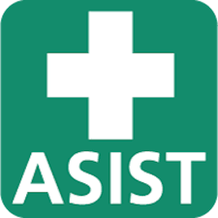
Space is limited and registration is required.
click on the options below to pre-register
(Register for one ASIST and one B.E. training. See below.)
Registration ends Friday, August 4th.

NCDHHS Division of Aging and Adult Services announces a 2-part training series aimed at addressing social isolation, loneliness, and elevated suicide risk (SILES) among older adults.
Part 1: B.E. Training (3 hours, virtual)
Part 2: Applied Suicide Intervention Skills Training (ASIST) (2 days, in-person)

The B.E. Training builds skills related to belonging and empathy and complements more intensive interventions (e.g., ASIST). It was developed as part of a federally supported clinical trial to measure the effectiveness of prevention within the aging services network.
ASIST is an interactive workshop in suicide first aid which teaches participants to recognize when someone may have thoughts of suicide and how to work with them to create a plan that will support their immediate safety. ASIST helps participants become more willing and able to intervene when someone is at risk of suicide.

pre-REgistration links | Step 1  Select ASIST DATE |  | Step 2  Select B.E. Training Date
Option # 1  Kernersville | ASIST  August 21-22  8:00-5:00 PM |  | B.E. Training  August 11, 9-11:30 AM  or August 14, 1-3:30 PM
Option # 2  Chapel Hill | ASIST  August 24-25  8:00-5:00 PM |  | B.E. Training  August 16, 9-11:30 AM  or August 15, 1-3:30 PM

We strive to host inclusive, accessible events that enable all individuals, including individuals with disabilities, to fully engage. Please contact us at the email above if you need to request an accommodation or for inquiries about accessibility. This training is made possible through the CARES Act funding from the Administration for Community Living.

We strive to host inclusive, accessible events that enable all individuals, including individuals with disabilities, to fully engage. Please contact us at the email above to request an accommodation.

