Call For Proposals
NCATP 2024 AT Expo

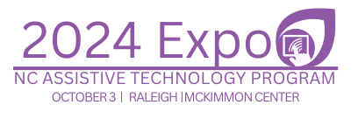

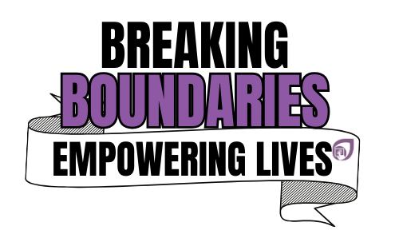

3080 Hammond Business Rd. Ste. 101
Raleigh, NC 27603-2804
Phone: 919-664-1244
Julie.dutchess@dhhs.nc.gov

Proposal Due Date: July 26, 2024

Call for Proposals – NCATP AT Expo 2024

Submission Deadline – July 26, 2024

SPEAKER INFORMATION:
The primary speaker is the only person to whom NCATP will send subsequent communication regarding the acceptance of the proposal and onsite logistics. Communications will be sent via email. Any change in email address should be reported promptly to julie.dutchess@dhhs.nc.gov to ensure that communication between NCATP and the primary speaker is uninterrupted.

Please complete electronically (fields expand to allow space to complete) and submit via email to julie.dutchess@dhhs.nc.gov

Primary Speaker
Name and Credentials
Affiliation or employer
Mailing Address
Preferred Phone
Mobile Phone
E-Mail
Additional Speakers
Name and Credentials
Affiliation or employer
Mailing Address
Preferred Phone
E-Mail

Session Title: (No more than ten words, should convey content or topic):

Focus Area: Check one area. If more than one applies, indicate 1st and 2nd choices.
☐ | Accessibility / Universal Design for Learning
☐ | AAC in Practice
☐ | Workplace / Transition
☐ | Smart Home and/or remote technologies in Practice
☐ | Aging

Session Synopsis : (No more than 125 words) Summarize the major points of your presentation

Presenter Bio: Please include a brief bio for the presenters, which will be published on the NCATP website with the conference materials. Include the most pertinent information as it relates to your presentation. (No more than 250 words)
Speaker:

Additional Speaker:

Additional Speaker:

Target Audience: Check all that apply:

☐ | AT Users | ☐ | Caregivers
☐ | Professionals  Employment  Education  Allied Health  Social Work | ☐ | AT Professionals

AV Equipment and Room Set-Up:

The standard AV setup is built into each room. The room includes LCD projector/screen, lectern with microphone, Windows laptop, an extra table, and wireless internet. This is a hybrid event. The microphone must be used during the entire session.

All presentations must be accessible. Following acceptance of the presentation, information will be provided to assist, if needed.
Please email your presentation to julie.dutchess@dhhs.nc.gov, and bring your presentation on a flash drive as a backup.

Conflict of Interest:
No promotion or sale of goods, services, or products is permitted during educational sessions. Any session where this occurs will be halted. NCATP recognizes that a speaker may have a financial interest in products or services discussed during an educational session. Such an interest is not prohibited, but it must be disclosed. Please check the appropriate statement. If a financial interest exists, it must be described below.

☐ | No speaker has a financial interest in products or services to be discussed in the proposed program.
☐ | The following speakers have a financial interest in products or services to be discussed in the proposed product:

