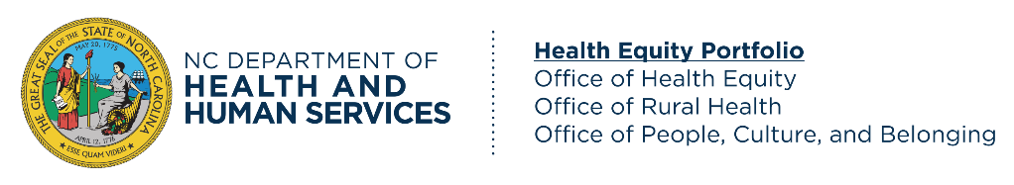 |  | Checklist for Meaningful Community Engagements
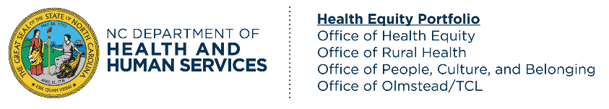 |  | 
Community and Partner Engagement Tool for Community- Based Organizations

Background
The North Carolina Department of Health and Human Services (NCDHHS) manages the delivery of health and human-related services for all North Carolinians, especially children, elderly, the disabled, low-income families, and other groups that have been marginalized economically and socially. Our mission is to work collaboratively with partners to improve the health, safety, and well-being of all North Carolinians.
Among other factors, improving health outcomes requires partnership, commitment, and collaboration.
Purpose: This resource is a checklist that supports community-based organizations in meaningfully engaging meaningfully engaging and in prioritizing community needs in planning and organizing events and engagements.
Timing: Individuals and community-based organizations should use this document before, during, and after an event or engagement, and co-create a communication plan with the communities that may be involved. Consider returning to this checklist regularly to reflect on the status of your ongoing engagements.
Objectives:
- To provide direction and guidance when communicating with communities.
- To generate more effective solutions for community concerns and priorities.
- To empower and integrate the voices and experiences of individuals from different backgrounds.
- To build trust with the community.

Pre-Event Engagement Checklist
Understand Community Diversity
☐ | Identify community resources: Identify current resources in the community. Additionally, identify existing groups that NCDHHS has previously worked with among the target community. You can view the NCDHHS Services and Partner Roster here. Assess the list of organizations you are convening for gaps in representation and inclusion.
☐ | Emphasize community voices: Establish open communication with your core audience and/or bring different voices, perspectives, and cultures into existing groups to bring viewpoints from people directly impacted by the topics of the event/engagement. For more information, see NCDHHS Community and Partner Guide, Appendix D: Prioritizing Community Voices Resources (page 27).
☐ | Choose diverse participants of the community: Consider the makeup of the community and ensure that the groups involved represent the community inclusively, i.e., including individuals from all demographic groups that are part of that community, as well as those with disabilities, those who are deaf and hard of hearing, and/or blind, among others. Consider turning to non-traditional leaders or individuals who may not hold official titles but are respected and relied upon in the community.
☐ | Anticipate conflict: Using your knowledge about the community, assess where conflicts may arise given the history of the community. Some common causes of conflict in community engagement include:  - A lack of trust  - Historically unresolved conflicts  - Perceived differences in values  - A dislike of change  - Lack of information/misinformation
Develop a Community Engagement Plan
☐ | Develop a Community Engagement Plan with community involvement to foster collaboration, lift up voices with lived experiences, and optimize success. The plan should include:  - Community engagement goals and objectives  - Accountability measures, including how potential risks to the community will be mitigated  - Timeline for engagement  - Community needs/concerns
☐ | Outline the benefits of engaging with the community.
☐ | Ensure that the community understands how and when engagement will occur throughout the partnership.
☐ | Provide opportunities for feedback on the Community Engagement Plan, such as hosting community consultations/town halls before finalizing the plan.
☐ | Create multiple ways for the communities to empower themselves by providing feedback.

Resources:
- Communication Styles How-To Guide
- Effective Cross-Cultural Communication Skills Checklist
- Combating Implicit Bias and Stereotypes How-To Guide
- How to Better Understand Different Social Identities How-To Guide
- Public Participation Guide
- Health Equity Resources Website
- For additional support, contact the Office of Health Equity HealthEquityOffice@dhhs.nc.gov

Event Planning and Execution Checklist
Develop Inclusive Communication
☐ | Select communication tools that meet the needs and preferences of your audience. Use multiple modes of communication such as text, graphics, audio, and video. Be sure that your communication tools are accessible to all audiences by following best practices for individuals who identify as deaf, hard of hearing, visually impaired, or may be in need of accommodation. .
☐ | Use concise, plain language, and be mindful to use terms that reflect the community appropriately. For example: If communicating with Spanish-speaking communities, communication should be sent in Spanish. Meetings should also be presented and interpreted in Spanish as needed.
☐ | Seek feedback on your communication tools from community members to assess accessibility and inclusiveness.
☐ | Reach out to the HEP Office of Health Equity if you need consultation to make your communications culturally and linguistically appropriate.
☐ | Share communication through platforms that reach the largest audience, strategizing with communities (where applicable) to support communication initiatives/needs.
Managing and Resolving Conflict in the Engagement Process
☐ | Develop a conflict strategy: Develop a strategy for addressing conflict when it arises in the moment. Consider how you might mitigate or de-escalate potential problems with active listening, empathy, and a collaborative atmosphere. Some conflict strategies are:  - Listen first: Listen to understand, not respond  - Develop a common understanding of the root causes of the problem  - Develop shared goals and objectives  - Communicate your willingness to collaborate on solutions
☐ | Communicate clearly and respectfully: Use active listening skills such as paraphrasing, open-ended questions, and constructive language, such as “I understand,” “I agree,” and “I suggest.” Active listening fosters cultural awareness, sensitivity, competence, and humility. For more information on cultural competency, sensitivity, awareness, and humility, see NCDHHS’ Cultural Competency Checklist for Community Partners.
☐ | Follow-up: After implementing a solution, be sure to evaluate the solution’s effectiveness and provide feedback updates to the community on your responsiveness to their recommendations and rationale for decision-making.
☐ | Reflect: Learn from the experience by reflecting on the cause of the conflict, the resolution process, and what you can do differently or better in the future.
☐ | Managing difficult conversations: Consider the need for a facilitator to provide support for difficult conversations or strained community relationships.

Event Planning and Execution Checklist (continued)
Build Momentum for Community Engagement
☐ | Collaborate with other relevant community partners and local governing bodies to increase support and feasibility for engagement.
☐ | Share your Community Engagement Plan with relevant community partners.
☐ | Consider piloting elements of the plan with community members to gauge early successes.
Post-Event Checklist
For More Information, Visit:
- NCDHHS Office of Health Equity
- Community and Partner Engagement | NCDHHS

Common Risks / Pitfalls to Consider:
- Meet people where they are: Provide information and communication through mechanisms and timelines that work best for the community.

- more time than people plan for and expect.
- Establishing a culturally competent framework requires long-term commitment, thought, intentionality, flexibility, and openness.

Gather Feedback to Evaluate the Event and Community Engagement Plan
☐ | Ask communities to provide feedback on the day of the event. Consider using a simple survey asking questions like:  - What went well during the event/engagement?  - Do you have any remaining questions or concerns?  - On a scale of 1-10, how satisfied are you with the event/engagement?
☐ | Identify ways to gain greater public participation and engagement for future events as well as areas for improvement for future projects.
☐ | Ensure clear and measurable outcomes are being properly reported and effectively communicated to communities
☐ | Solicit feedback on and assess the effectiveness of engagement strategies.
☐ | Develop a system for regular touchpoints and updates with community partners. Touchpoints should occur proactively and at regular intervals in the engagement process to nurture the relationship, build sustained trust, and build upon outcomes and decisions resulting from the partnership.
Maintain Ongoing Engagement
☐ | Develop a cadence for sustaining community feedback after the life of the project, providing milestone updates and opportunities for continued engagement.
☐ | Open multiple channels of communication such as large and small group meetings, public comment periods, newsletter dissemination, coffee chats, and online or paper feedback.
☐ | Inform community members of future projects and opportunities for collaboration.

