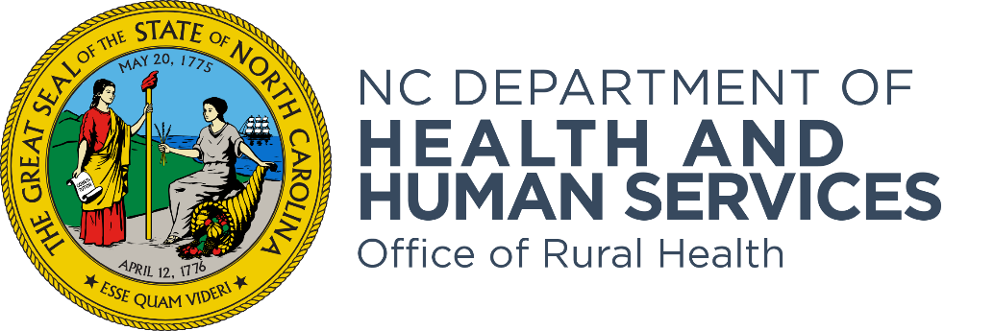

Community Health Grant SFY2024 Technical Assistance Webinar
Frequently Asked Questions Document

The purpose of the Office of Rural Health’s Community Health Primary Care Access Program is to provide primary medical care services to underserved residents in North Carolina by awarding Community Health Grants (CHG) to health entities throughout the state.

- What do you consider underinsured? Medicaid? Private insurance with high deductible? People are underinsured if they are below 200% of the federal poverty guideline, fall within the Medicaid Part D coverage gap, or have health insurance but the policy has a high deductible, high out-of-pocket maximums, or only covers a limited number of treatment services. A person who has insurance but chooses not to use it (for whatever reason) is not considered underinsured.

- How does this grant interfere with FTCA? Free clinics who are Federal Tort Claims Act recipients that choose a “per encounter” reimbursement methodology (the Community Health Grant Track A option) may void their FTCA liability protection. Please reach out to the NC Association of Free & Charitable Clinics for additional information.

- Will evaluation measures be required to be drawn from the entire organization's patient population, or will we be able to report on the population that is being served by the specific program funded by the grant? Please report on the patient population(s) being served by the grant funds. For instance, if you are funding a maternal health project, only report on the maternal health patient population at your organization. If you are serving two populations, maternal health patients and dental patients, then report on both. Make sure the data for your population is collectible (i.e., can be separated out from the overall organization’s patient population) and that you consistently report on the same patient population throughout the grant cycle.

- Can more than one person in the organization request a unique link? No, only one person in the agency should request a unique application link. Duplicate requests from the same organization will be deleted.

- Does the community health needs assessment come from public health? All North Carolina local health departments and tax-exempt hospitals are required to conduct Community Health Needs Assessments (CHNA). Please refer to the most current CHNA report for your community.

- Can an organization completing year three of a current Community Health Grant submit a new application in this new grant cycle? Yes. If your agency is in Year 3 of a three-year grant (which will be ending on 6/30/2023) you may apply for a new Year 1 grant in this SFY24 CHG RFA.

- If I have a grant ending 6/30/2022, can I reapply with this opportunity for a new grant? Yes, as long as your funding project is not eligible for continuation grant funding.

- Are the outcome measures only for patients that participate in the program funded through Community Health Grants or our entire patient population? Please report on performance measures for the patient population included in your project proposal – i.e. report on the patient population(s) being served by the grant funds.

- If you are an Integrated Primary Care Medical Home, can you submit an RFA for Medical Care and one for Behavioral Health separately? Each agency may only submit one (1) application for Year 1 SFY24 CHG funding. You may not submit two separate applications. However, you may submit one application for a combined project that is serving both General Care and Behavioral Health patients.

- How do you address baseline numbers from EHRs from programs that are new or haven’t been funded for a few years? For a new project proposal, you may start your performance measure baselines at zero.

- I just want to make sure organizations are not allowed to submit an application for more than one project, is that correct? For the competitive application process, we will accept one application per organization. For clarification, this is per organization, not by service site, or “doing business as”, or instances where separate EINs are all connected to the same eligible organization.

