North Carolina Department of Health and Human Services
CPS Assessment in Child Welfare Track Training

Participant’s Workbook
Day One

October 2024


600 Airport Rd
Lakewood, NJ, 08701-5995
www.pubknow.com

info@pubknow.com
(800) 776-4229

This curriculum was developed by the North Carolina Department of Health and Human Services, Division of Social Services, and revised by Public Knowledge® in 2024.

Copyright © 2024 Public Knowledge®. All rights reserved. No part of this publication may be reproduced, distributed, or transmitted in any form without the written permission of the publisher.
Table of Contents
Instructions 4
Course Themes 4
Training Overview 5
Learning Objectives 7
Day One Agenda 10
Welcome & Introductions 11
Purpose and Legal Basis for Child Protection Services in North Carolina 13
North Carolina Practice Model 13
Activity: Core Values 13
Activity: Learning Review: NC Child Welfare Practice Standards 15
Purpose and Overview of CPS Assessments 17
Goals of Child Welfare Services 17
Handout: Intake Process Map 19
Handout: Policy Guidance for Making Informed Decisions 21
Multiple Response System (MRS) 22
Activity: CPS Assessment Tracks 23
Overview of Assessment Processes and Policies 24
Activity: Learning Review: CPS Assessment Process 24
Activity: Learning Review: CPS Assessment Policy 25
Roles and Responsibilities of CPS Assessment Social Worker 26
Legal Aspects of CPS Assessment 29
Activity: Legal Aspects 29
Handout: North Carolina Right to Enter a Residence 33
Activity: Learning Review: Applying Legal Standards 34
Essential Function: Communicating 35
Communicating Overview 35
Self-Assessment Tool: Communicating Function 36
Skills Practice: Introducing Your Role 40
Crucial Conversations 41
Activity: Power Dynamics in Child Welfare Interventions 44
Diversity, Equity, Inclusion and Belonging 45
Institutional Racism in Child Welfare Systems in the United States 45
Video: The Racist Roots of the Child Welfare System 45
Video: Exploring Implicit Bias in Child Protection 48
Debrief 49
Cultural Humility, Inclusion, and Considerations for Child Welfare Assessments and Decision-Making 50
Video: What Exactly is Cultural Humility? 50
Activity: Child Welfare Practice Strategies to Center Families 52
Identifying and Addressing Bias 54
Activity: Learning Zones 55
Trauma-Informed Care 57
Core Value: Trauma-Informed Care 57
End-of-Day Values Reflection 61
Communicating: Build Your Own Field Guide 61
Questions and Reflections: 62
Bibliography of References 63
Appendix: Handouts 1
Intake Process Map 2
Policy Guidance for Making Informed Decisions 3
Federal Child Welfare Laws Overview 4
Self-Assessment Tool: Communicating Function 21
North Carolina Right to Enter a Residence 25

Instructions
This course was designed to guide child welfare professionals through the knowledge, skills, and behaviors needed to engage with families in need of child protection services. The workbook is structured to help you engage in the lesson through reflection and analysis throughout each week of training. Have this workbook readily available as you go through each session to create a long-lasting resource you can reference in the future.
If you are using this workbook electronically: Workbook pages have text boxes for you to add notes and reflections. Due to formatting, if you are typing in these boxes, blank lines will be “pushed” forward onto the next page. To correct this when you are done typing in the text box, you may use delete to remove extra lines.

Course Themes
The central themes of the CPS Assessment Track Training are divided across several course topics.
- Purpose and Legal Basis for Child Protection Services in North Carolina
- Essential Function: Communicating
- Diversity, Equity, Inclusion, and Belonging
- Trauma-Informed Care
- Family-Centered Practice
- Essential Function: Engaging
- Safety Focused
- Essential Function: Assessing
- Interviewing Learning Lab
- The Role of Observation in Assessing for Safety
- Structured Decision-Making: Safety Assessment
- Assessment Learning Lab
- Safety Planning
- Safety Planning Learning Lab
- Trauma-Informed Practice
- Considerations for Cases Involving Special Circumstances
- Social Worker Safety
- Engaging the Family in Child Protection Services
- Risk Assessment
- Crucial Conversations
- Quality Contacts
- Assessing Family Strengths and Needs
- Secondary Traumatic Stress and Vicarious Traumatization
- Ongoing Assessment
- Family Engagement and Ongoing Assessment Learning Lab
- Documentation
- Well-Being as an Outcome
- Reasonable Efforts and Removals
- Reasonable Efforts and Removals Learning Lab
- Decision-Making
- Decision-Making and Case Closure Learning Lab

Training Overview
Training begins at 9:00 a.m. and ends at 4:00 p.m. If a holiday falls on the Monday of training, the training will begin on Tuesday at 9:00 a.m. This schedule is subject to change if a holiday falls during the training week or other circumstances occur. The time for ending training on Fridays may vary and trainees need to be prepared to stay the entire day.
Attendance is mandatory. If there is an emergency, the trainee must contact the classroom trainer and their supervisor as soon as they realize they will not be able to attend training or if they will be late to training. If a trainee must miss training time in the classroom, it is the trainee’s responsibility to develop a plan to make up missed material.
Pre-Work Online e-Learning Modules
There is required pre-work for the CPS Assessment Track Training in the form of online e-Learning modules. Completion of the e-Learnings is required prior to attendance at the classroom-based training. The following are the online e-Learning modules:
- North Carolina Worker Practice Standards
- Safety Organized Practice
- Understanding and Assessing Safety and Risk
- Understanding and Screening for Trauma
Transfer of Learning
The CPS Assessment Track Training Transfer of Learning (ToL) tool is a comprehensive and collaborative activity for workers and supervisors to work together in identifying worker goals, knowledge gain, and priorities for further development throughout the training process. In four distinct steps, the worker and supervisor will highlight their goals and action plan related to participating in training, reflect on lessons and outstanding questions, and create an action plan to support worker growth. The tool should be started prior to beginning the CPS Assessment Track Training and re-visited on an ongoing basis to assess growth and re-prioritize actions for development.
- Part A: Training Preparation: Prior to completing any eLearning and in-person Track Training sessions, the worker and supervisor should meet to complete Part A: Training Preparation. In this step, the worker and supervisor will discuss their goals for participation in training and develop a plan to meet those goals through pre-work, other opportunities for learning, and support for addressing anticipated barriers.
- Part B: Worker Reflections During Training: The worker will document their thoughts, top takeaways, and outstanding questions regarding each section. This level of reflection serves two purposes. First, the practice of distilling down a full section of training into three takeaways and three remaining questions requires the worker to actively engage with the material, subsequently forming cognitive cues related to the information for future use in case practice. Second, prioritizing takeaways and questions by section allows workers to continually review information to determine if questions are answered in future sessions and supports the development of an action plan by requiring workers to highlight the questions they find most important.
- Part C: Planning for Post-Training Debrief with Supervisor: The worker considers the takeaways and questions they identified in each section and creates a framework to transfer those takeaways and questions into an action plan.
- Part D: Post-Training Debrief with Supervisor: Provides an opportunity for the supervisor and worker to determine a specific plan of action to answer outstanding questions and to further support worker training.
While this ToL is specific to the Track Training in North Carolina, workers and supervisors can review the takeaways and questions highlighted by the worker in each section of training on an ongoing basis, revising action steps when prior actions are completed, and celebrating worker growth and success along the way.
Training Evaluations
At the conclusion of each training, learners will complete a training evaluation tool to measure satisfaction with training content and methods. The training evaluation tool is required to complete the training course. Training evaluations will be evaluated and assessed to determine the need for revisions to the training curriculum.
All matters as stated above are subject to change due to unforeseen circumstances and with approval.

Learning Objectives
Day One
Purpose and Legal Basis for Child Protection Services in North Carolina
- Learners will be able to describe the key decision points in an assessment.
- Learners will be able to describe when an Investigative Assessment or Family Assessment is appropriate based on case circumstances.
- Learners will be able to distinguish between Family and Investigative Assessments.
- Learners will be able to describe and follow the steps of Family and Investigative Assessments.
- Learners will understand what circumstances require a MRS response.
- Learners will be able to navigate the NC DSS policy manuals.
- Learners will be able to describe the CPS Assessment process.
- Learners will be able to explain interview protocols based on case circumstances.
- Learners will be able to outline responsibilities specific to CPS Assessment workers.
- Learners will be able to describe their role in assessing safety and risk and making case decisions.
- Learners will be able to explain circumstances under which a child welfare professional can enter a residence when conducting an assessment.
- Learners will be able to demonstrate appropriate information sharing during an open CPS Assessment.
- Learners will be able to distinguish allowable actions from those that infringe on parental rights during a CPS Assessment.
- Learners will be able to describe diligent efforts at all stages of a CPS Assessment.
- Learners will be able to define Reasonable Efforts.
- Learners will be able to explain the rationale and application of reasonable efforts.
Essential Function: Communicating
- Learners will be able to identify points of conflict and various strategies to help children and families resolve conflict.
Diversity, Equity, Inclusion, and Belonging
- Learners will be able to explain the history of institutional racism in child welfare and its impact on disproportionality in child welfare.
- Learners will be able to discuss the impact of institutional racism in child welfare on safety, well-being, and permanency outcomes for children and families.
- Learners will be able to describe how marginalized children and families have been historically overrepresented in child welfare.
- Learners will be able to identify institutional racism in assessment and decision-making processes.
- Learners will be able to define underrepresentation and overrepresentation in the child welfare system.
- Learners will be able to recognize underrepresentation and overrepresentation in the child welfare system.
- Learners will be able to identify underlying causes of disproportionality and disparity for children and families in marginalized populations.
- Learners will be able to recognize how disproportionality leads to inequitable service provision and disparate outcomes for children and families.
- Learners will be able to examine how firsthand experiences and biases affect decisions made for children and families receiving Child Protective Services.
- Learners will be able to explain the importance of cultural humility and inclusion when conducting assessments.
- Learners will be able to demonstrate an understanding of cultural humility as a lifelong process of self-awareness and learning from other cultures.
- Learners will be able to discuss cultural barriers families may face when involved with Child Protective Services.
- Learners will be able to share examples of advocating for fair and culturally appropriate In-Home Services for children and families.
- Learners will be able to explain the concept of bias and how it impacts assessments and decision making.
- Learners will be able to utilize techniques for self-reflection and self-evaluation to recognize and manage their own potential biases.
- Learners will be able to discuss social and health disparities among children and youth in diverse populations.
- Learners will be able to assess whether children fall under the Indian Child Welfare Act (ICWA) and how to comply with prevention and active efforts standards set forth in the Act.
- Child welfare professionals will collaborate with Tribal agencies as required during CPS Assessments.
- Learners will be able to describe the importance of linking children and families to culturally competent community services, and advocacy groups.
- Learners will be able to provide legal and practical Notice to Tribes when children are believed to have American Indian/Alaskan Native heritage.
- Learners will be able to define Active Efforts.
- Learners will be able to describe the importance of identifying their own biases.
- Learners will be able to explain how they will maintain cultural humility in their work.

Day One Agenda
CPS Assessment Track Training
Welcome and Introductions
Purpose and Legal Basis for Child Protection Services in North Carolina
North Carolina Practice Model
Purpose and Overview of CPS Assessments
Multiple Response System
Overview of Assessment Process and Policies
Roles and Responsibilities of CPS Assessment Social Worker
Legal Aspects of CPS Assessment
Essential Function: Communicating
Communicating Overview
Crucial Conversations
Diversity, Equity, Inclusion, and Belonging
Institutional Racism in Child Welfare Systems in the United States
Cultural Humility, Inclusion, and Considerations for Child Welfare Assessments and Decision-Making
Identifying and Addressing Bias
Trauma-Informed Care
Core-Value: Trauma
End-of-Day Values Reflection

Welcome & Introductions
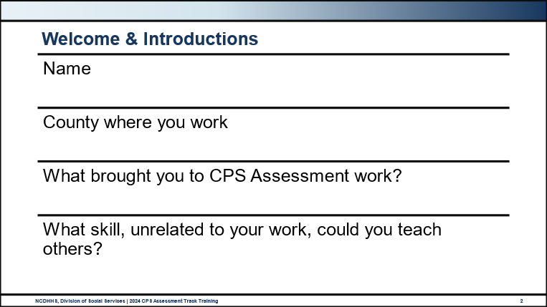
Use this outlined space to record notes from the introduction activity.

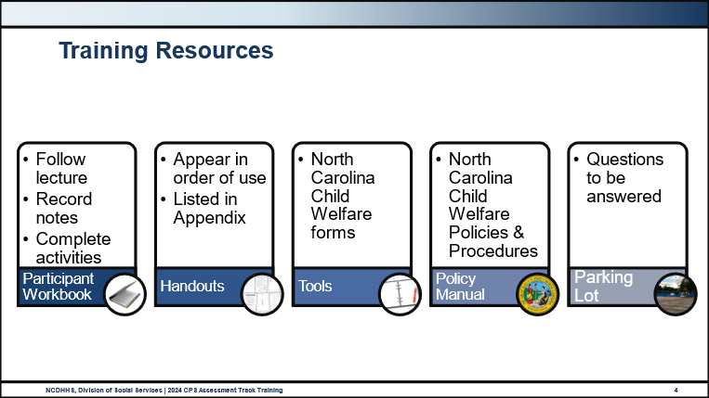
Use this space to record notes.

Purpose and Legal Basis for Child Protection Services in North Carolina

North Carolina Practice Model

Activity: Core Values
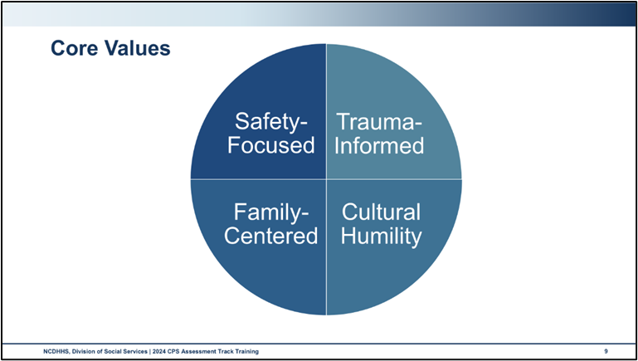
Use this space to record notes.

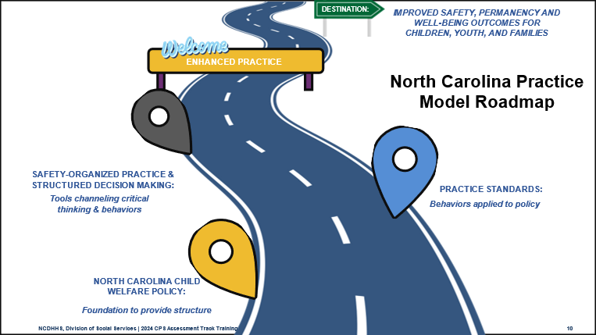
Use this space to record notes.

Activity: Learning Review: NC Child Welfare Practice Standards
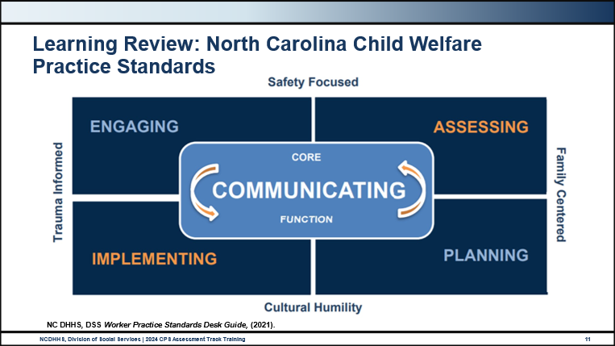
Use this space to record notes.

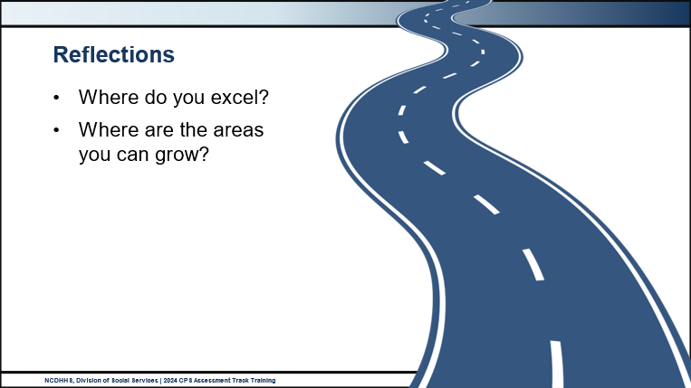
What areas do you excel in?
Where are the areas you can grow?

Purpose and Overview of CPS Assessments

Goals of Child Welfare Services
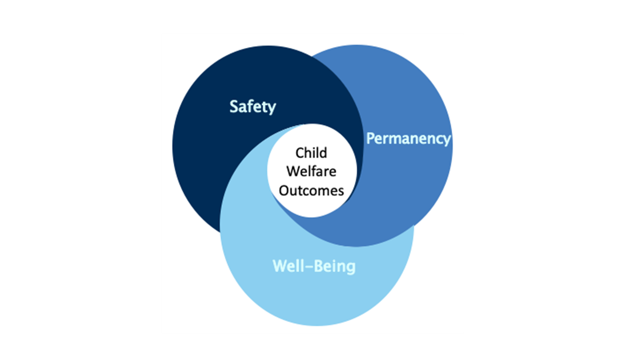
Use this space to record notes.

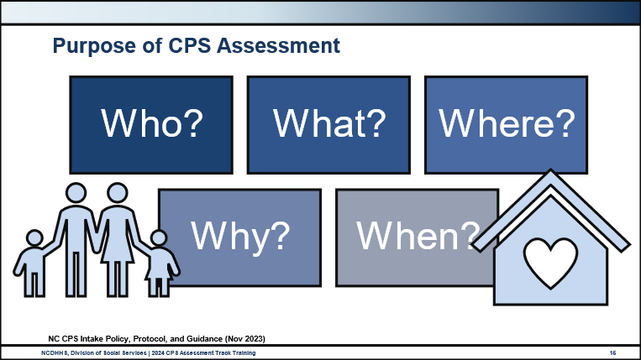
Use this space to record notes.

Handout: Intake Process Map
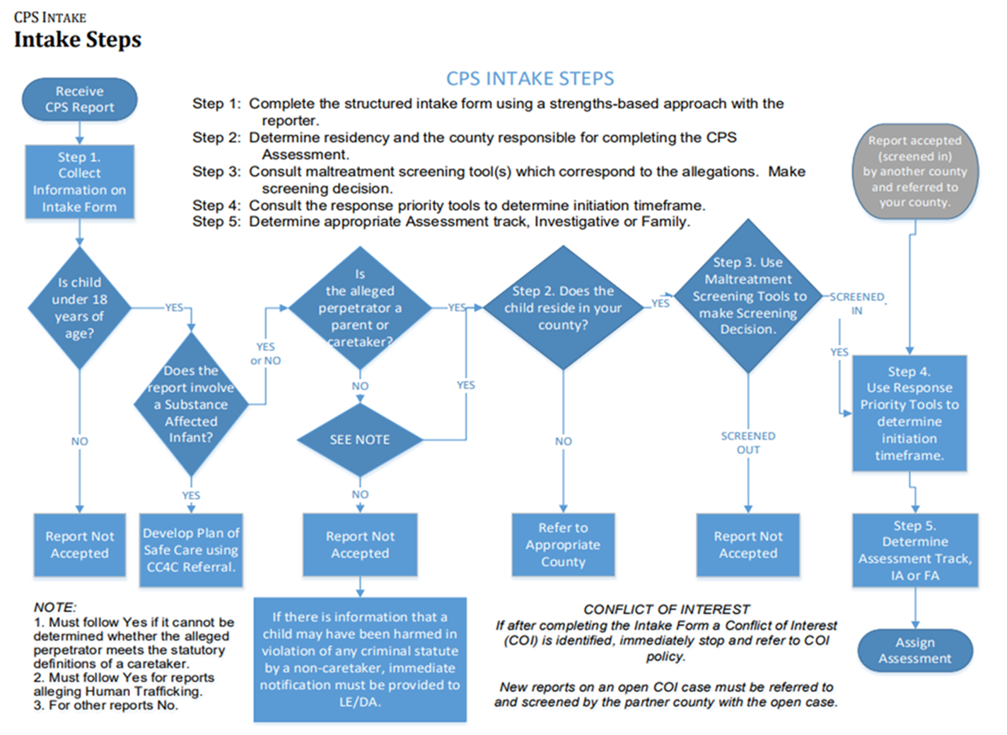
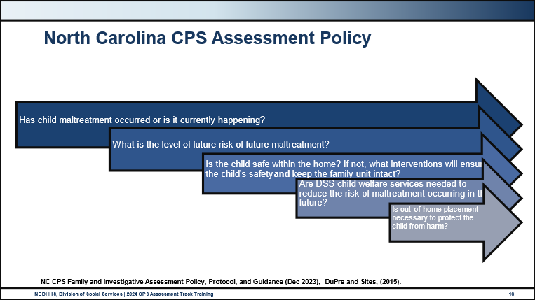
Use this space to record notes.

Handout: Policy Guidance for Making Informed Decisions
Purpose of CPS Family and Investigative Assessments
The primary goal of CPS Assessments is to protect children from further maltreatment and to support and improve parental/caregiver abilities to ensure a safe and nurturing home for each child.
The task of the CPS Assessment is to determine if the child(ren) is/are abused, neglected, and/or dependent, or if the family needs services, and what level of intervention is necessary to assure safety.
The purpose of the CPS Assessment is to gather sufficient information through interviews, observations, and, when appropriate, analysis of reports, medical records, photographs, etc. to determine if:
- Child maltreatment occurred;
- There is a risk of future maltreatment and the level of that risk;
- The child is safe within the home and, if not, what interventions can be implemented that will ensure the child's protection and maintain the family unit intact if reasonably possible;
- Ongoing agency services are needed to reduce the risk of maltreatment occurring in the future;
- Out-of-home placement is necessary to protect the child from harm.
During the course of a CPS Assessment, sufficient information must be gathered to assess:
- The safety of the child and the potential risk of harm;
- What actions might be needed to assure the safety of the child;
- Whether the facts identified through a structured gathering of information support the substantiation that a child is abused, neglected, and/or dependent as defined by statute, and the extent of the abuse, neglect, and/or dependency;
- If through observation and the gathering of information it is determined that due to the level of safety and risk, the family is in need of services; and
- Whether the specific environment in which the child is found meets the child’s need for care and protection.
Source: CPS Assessments Policy, Protocol, and Guidance (February 2024)

Multiple Response System (MRS)
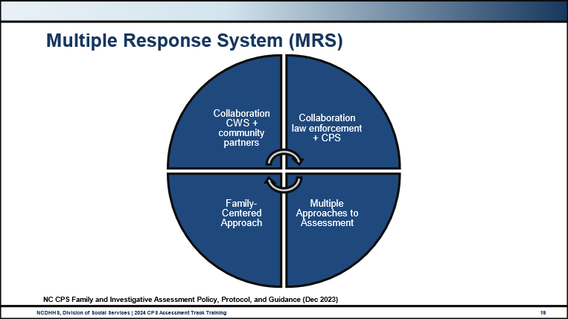
Use this space to record notes.

Activity: CPS Assessment Tracks
There are two possible tracks within CPS Assessments: Family Assessment and Investigative Assessment.
- In your groups, you will first list all the DIFFERENCES between a Family Assessment and an Investigative Assessment. Choose one person to take notes on a flipchart paper and someone to report back to the larger group at the end of the exercise.
- In your groups at your flipcharts, draw a vertical line (top-to-bottom) splitting the page in half, then label each side with SIMILAR and DIFFERENT at the top.
Use this space to record notes.

Overview of Assessment Processes and Policies

Activity: Learning Review: CPS Assessment Process
- Work with your table group to place all of the CPS Assessment Process activities in the correct order.
Use this space to record notes.

Activity: Learning Review: CPS Assessment Policy
- Work with your table group to match all of the CPS Assessment Policies with the corresponding CPS Assessment Processes from the previous activity.
Use this space to record notes.

Roles and Responsibilities of CPS Assessment Social Worker
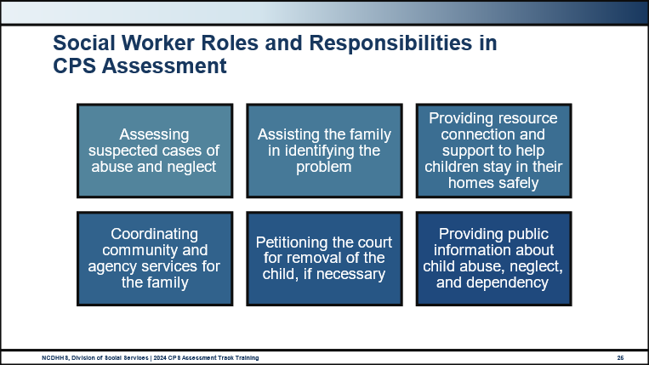
CPS staff accomplish these services through:
- Assessing suspected cases of abuse and neglect
- Assisting the family in identifying the problem
- Providing in-home counseling and supportive services to help children stay safely home with their families
- Coordinating community and agency services for the family
- Petitioning the court for removal of the child, if necessary
- Providing public information about child abuse, neglect, and dependency
Providing Child Protective Services in any capacity requires certain knowledge, skills, personal qualities, and respect for the values of others. Specific competencies are required of CPS professionals that enable staff to perform effectively the tasks associated with each stage of the CPS casework process. Supervisors and social workers are expected to meet all training requirements to perform Child Protective Services duties.
Reflection Questions
How will you accomplish these tasks and responsibilities?
What do you do when you are stuck, or can’t decide what to do?
What impact does engagement have on your ability to fulfill your responsibilities?
Source:
North Carolina Department of Health and Human Services. (n.d.). Child Protective Services. Retrieved August 8, 2024, from https://www.ncdhhs.gov/divisions/social-services/child-welfare-services/child-protective-services#:~:text=CPS%20staff%20accomplish%20these%20services%20through%3A%201%20Assessing,public%20information%20about%20child%20abuse%2C%20neglect%20and%20dependency

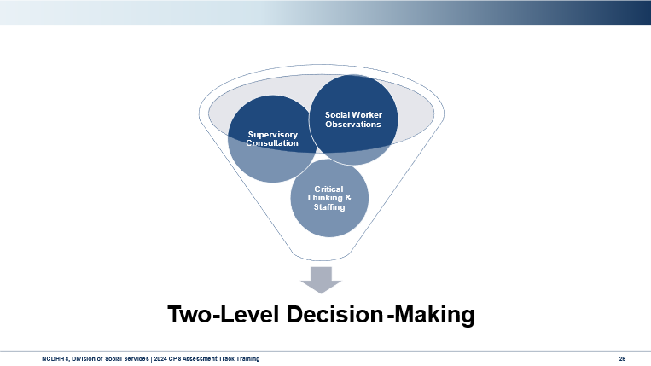
Use this space to record notes.

Legal Aspects of CPS Assessment

Activity: Legal Aspects
- Review the handout in the appendix titled Federal Child Welfare Laws Overview.
- Consider the following:
  - What resonates with you?
  - What surprises you?
  - What questions do you have?
Use this space to record notes.

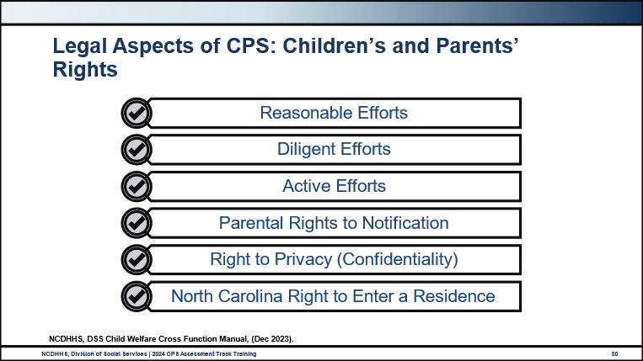
Best practice, as laid out in NC Child Welfare and System of Care policy outlines that all parents/caregivers involved in cases of abuse, neglect, or dependency must:
- Be treated in a courteous and respectful manner.
- Know DSS's legal authority and right to intervene in cases of child abuse, neglect, or dependency.
- Know the allegations of abuse, neglect, or dependency reported at the first contact with DSS.
- Know any possible action that DSS may take, including petitioning the court to remove the child in order to ensure safety and protection.
- Know DSS's expectations of the parent/caregiver.
- Know what services they can expect from DSS and other community agencies.
- Have a family services case plan that is clearly stated, measurable, and specific, that includes time-limited goals and is mutually developed by the DSS and the parent/caretaker.
Policy outlines best practice. Parent’s rights are measured against the following legal terms. Use the space below each term to record notes.
Reasonable Efforts

Diligent Efforts
Active Efforts
Parental Rights to Notification
Right to Privacy (Confidentiality)
North Carolina Right to Enter a Residence

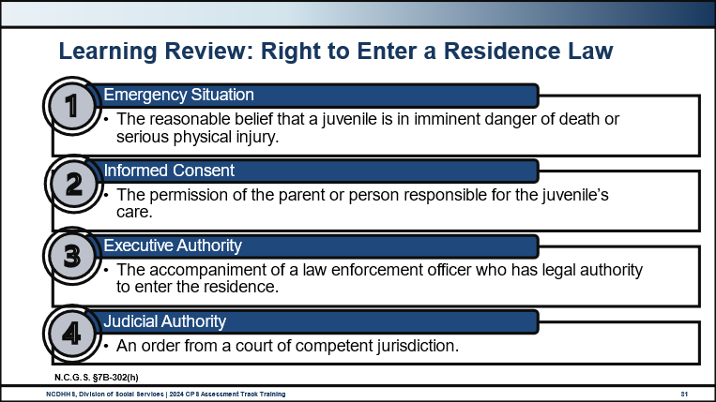
Use this space to record notes.

Handout: North Carolina Right to Enter a Residence
N.C.G.S. § 7B-302 Assessment by director; military affiliation; access to confidential information; notification of person making the report.
The director or the director's representative may not enter a private residence for assessment purposes without at least one of the following:
- The reasonable belief that a juvenile is in imminent danger of death or serious physical injury.
- The permission of the parent or person responsible for the juvenile's care.
- The accompaniment of a law enforcement officer who has the legal authority to enter the residence.
- An order from a court of competent jurisdiction

Activity: Learning Review: Applying Legal Standards
- With your partner or small group, review your assigned scenario and based on laws and policies decide the best course of action for CPS to take.
- Refer to the Federal Laws Overview in the Appendix and online resources.
- Record your recommendations on the provided flip charts.
Use this space to record notes and then transfer information to a flipchart.
What details should be considered in the scenario? | What are the next steps you should take? | What laws and/or policies inform your decision?
Notes

Essential Function: Communicating

Communicating Overview
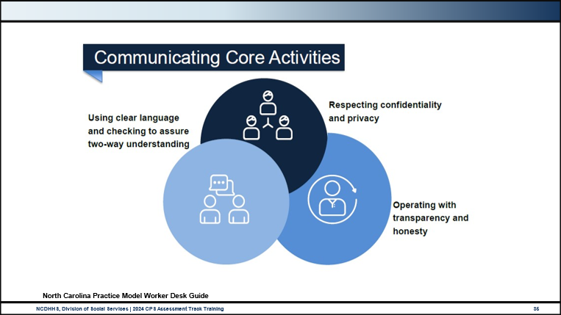
Use this space to record notes.

Self-Assessment Tool: Communicating Function
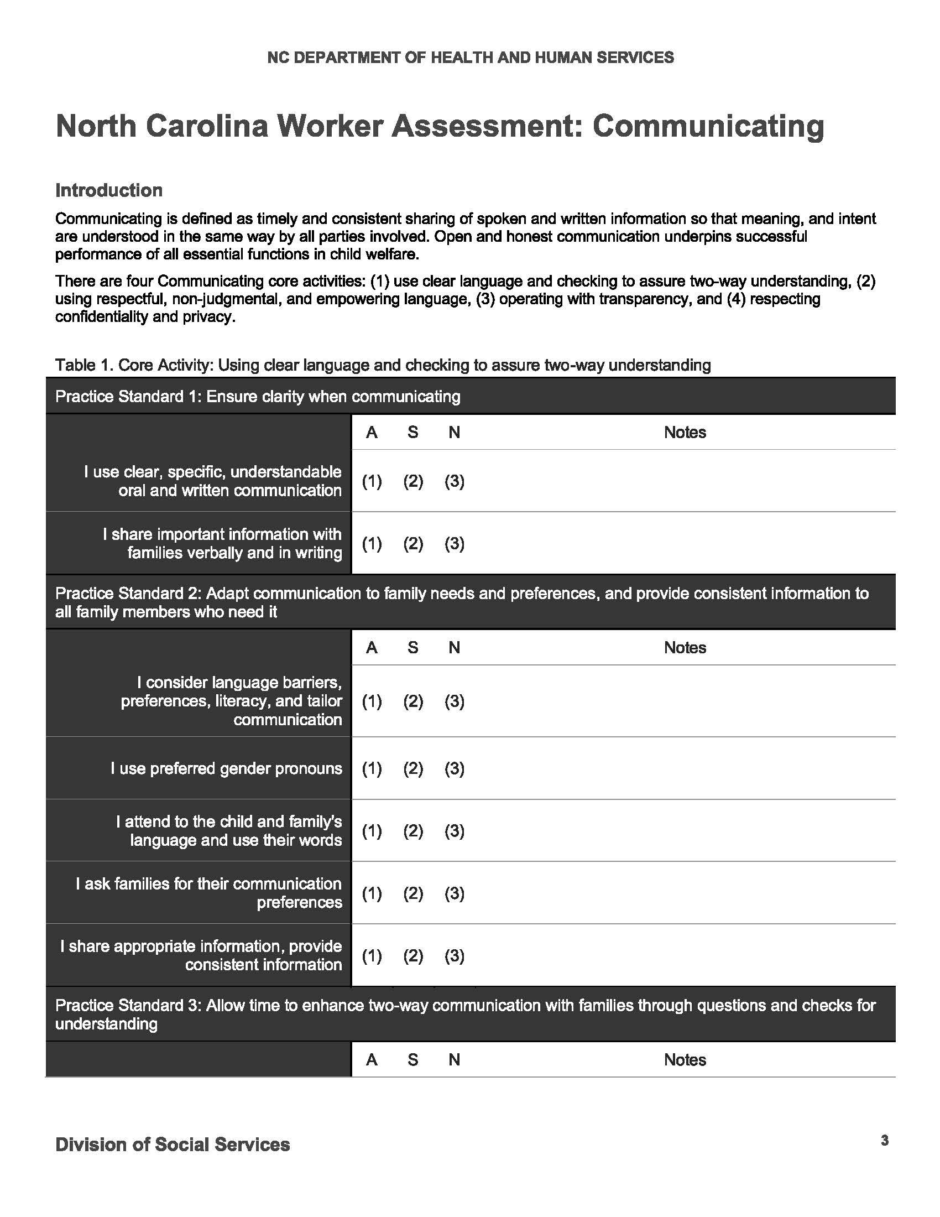

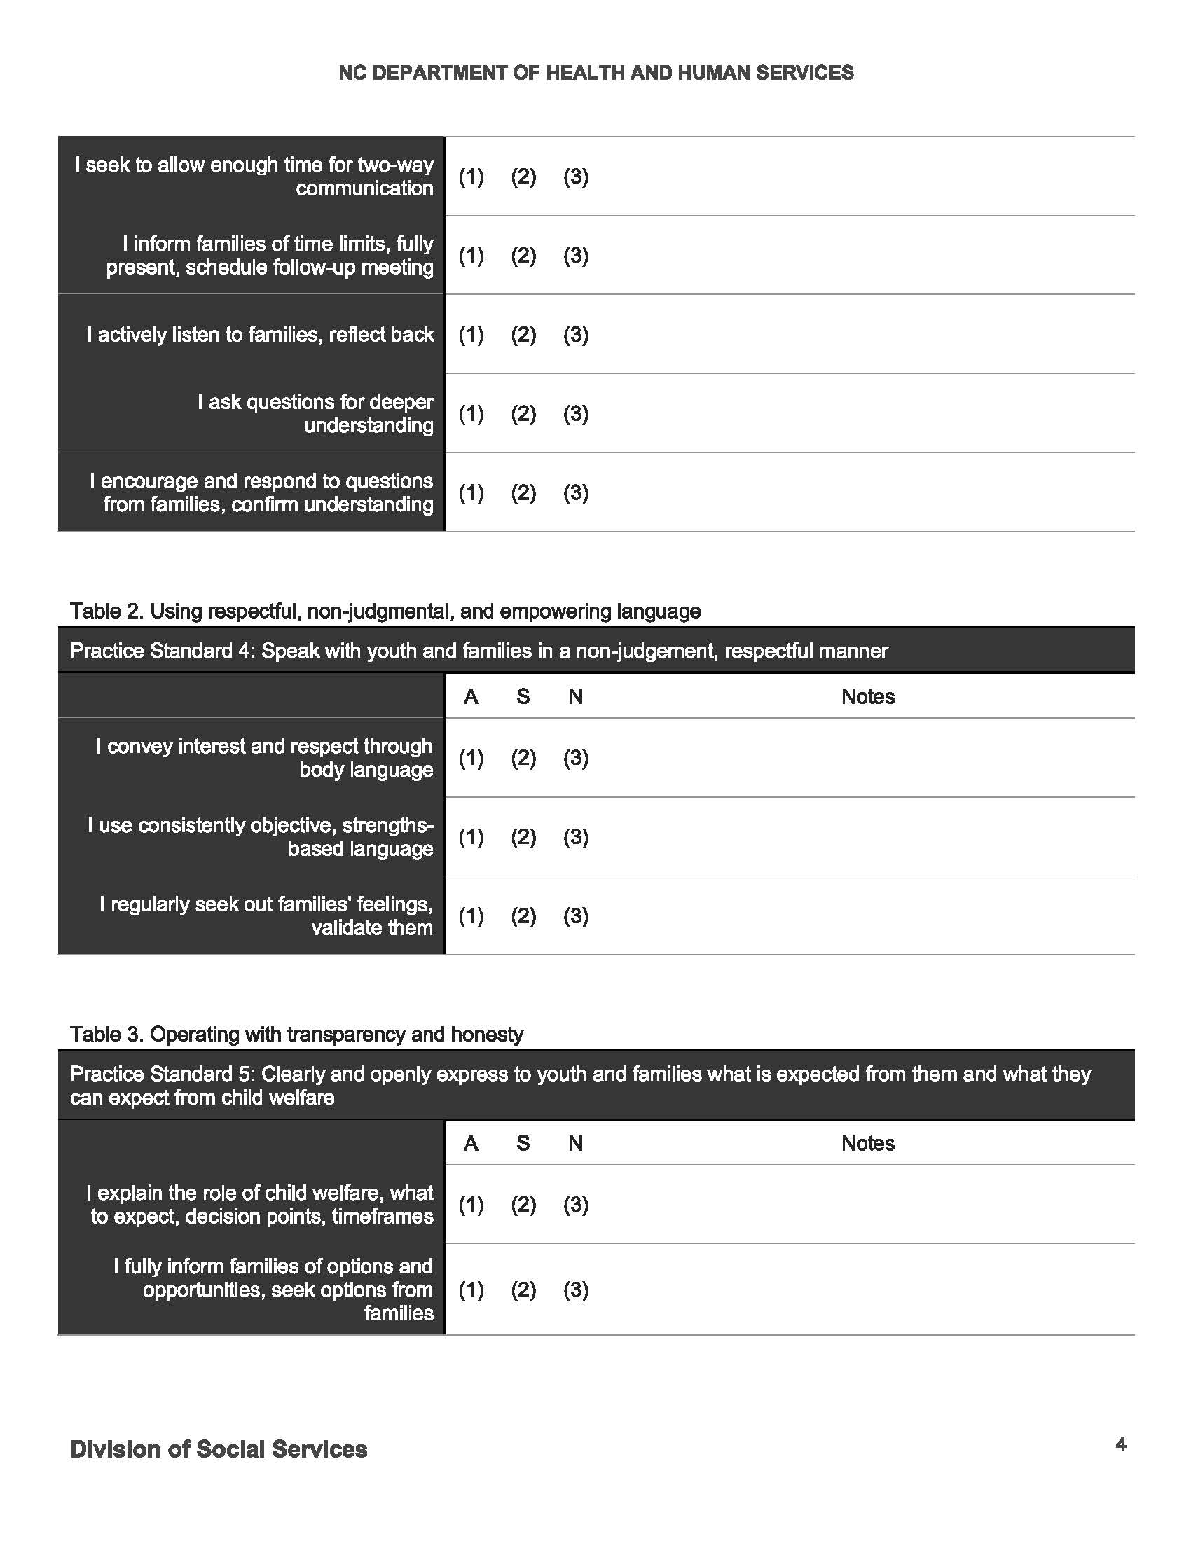

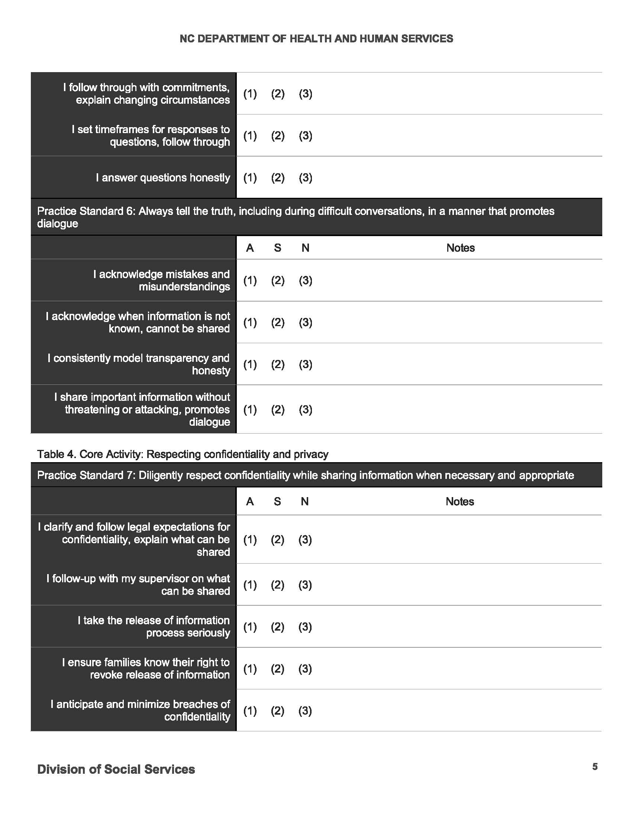

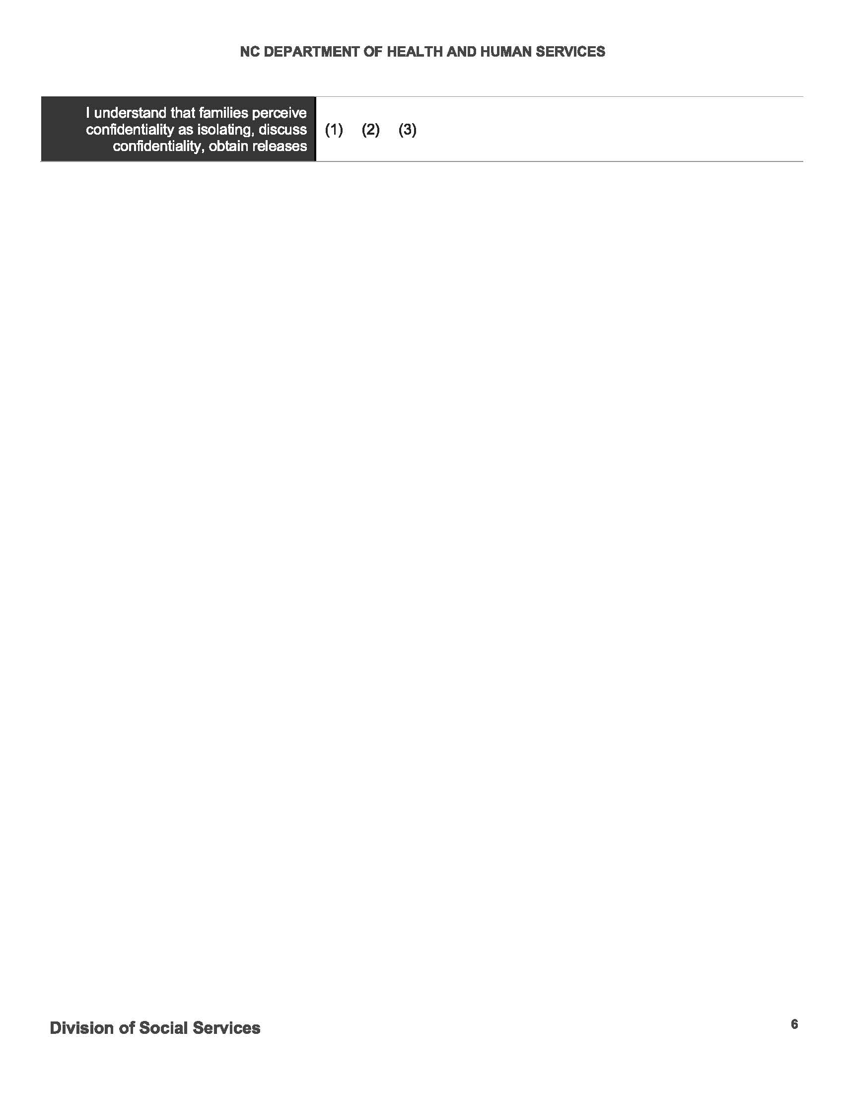

Skills Practice: Introducing Your Role
- Take turns with your partner practicing how you will introduce yourself to a family upon meeting them for the first time when you initiate a family assessment due to concerns about a hungry 7-year-old child.
- Consider the discussion from earlier about the roles and responsibilities of a CPS-Assessment social worker. Take a moment and think about how you might introduce yourself.
Report Summary:
You have received a report that 7-year-old Anita has recently lost weight. The report alleges that at breakfast and lunch, Anita is seen “shoveling” food in her mouth. Anita eats so fast; that she often throws up. In the second half of the school day, Anita lays her head down on her desk and is so lethargic she cannot really participate in school. Reporter alleges that when asked, Anita says that she doesn’t eat at home, only at school, and that her empty belly “hurts so bad all the time.” The report alleges that the parents recently lost their jobs and are probably too proud to apply for food stamps, as the parents refused the free food bag that goes home to families in need on Fridays.
This report is screened neglect-unsafe food/nutrition and assigned as family assessment response, 72-hour.
Prepare to contact the family for the initial contact.
- Consider allegations, response track, and parental rights for notification
- Consider the roles and responsibilities of CPS-Assessment Social Worker
Use this space to record notes.

Crucial Conversations
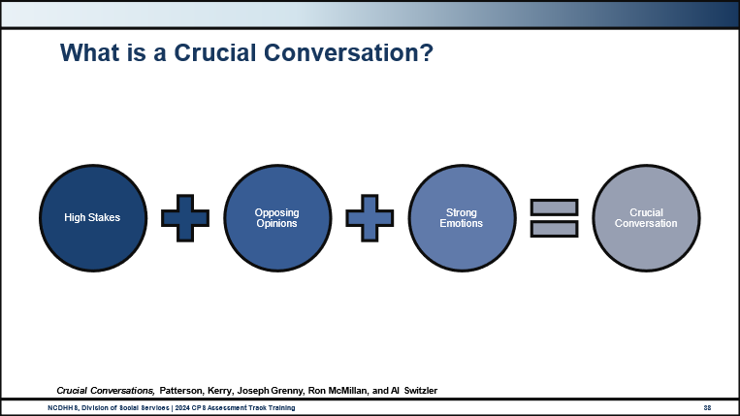
Use this space to record notes.

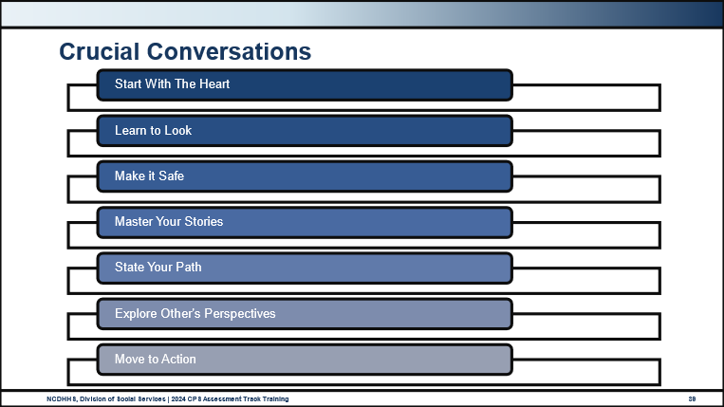
Steps | How Do I Do This?
Start with the Heart. | Start from a genuine, well-intentioned place. Stay focused on what you really want and your intentions for the conversation.
Learn to Look. | Look for signs of stress, conflict, and emotional elevation. Notice when your safety is at risk. Manage your own response tendencies. Look for language and behavior that could escalate the conversation.
Make it Safe. | Notice when others don’t feel safe to respond, check to make sure you are listening well and validating. Keep highlighting the common goal. When you notice a risk, “step out” of the conversation and work to restore safety.
Master Your Stories. | Manage intended and unintended bias and check how you see others. “Stories” are assumptions we make for why others are doing what they are doing. Assumptions can interfere with your conversation.
State Your Path. | Share very specific concerns and a clear explanation of the purpose for the conversation. Talk about your experience and inquire about the ways of others. Speak cautiously to be clear and not too soft or too firm.
Explore Others’ Perspectives. | Active listening becomes key, and empathy is critical. Validate the person’s feelings while maintaining the importance of what needs to be accomplished.
Move to Action. | Make decisions and commit to action together.

Use this space to record reflections and notes.
Source: Patterson, Kerry, Joseph Grenny, Ron McMillan, and Al Switzler. 2002. Crucial Conversations. Maidenhead, England: McGraw-Hill Contemporary.

Activity: Power Dynamics in Child Welfare Interventions
What happened in your group?
Did you get as much power as you wanted?
What surprised you?
What did it feel like to have someone try to take power away from you?
What do you think happens when people continuously have their power taken away?
How does this exercise relate to families’ experiences with child welfare services and historical distrust?
How do you define power?

Diversity, Equity, Inclusion and Belonging

Institutional Racism in Child Welfare Systems in the United States

Video: The Racist Roots of the Child Welfare System
https://www.youtube.com/watch?v=UsJCFWi_lbE
How does this history impact the work you are doing today?
How does institutional racism show up in your cases or your regions today?

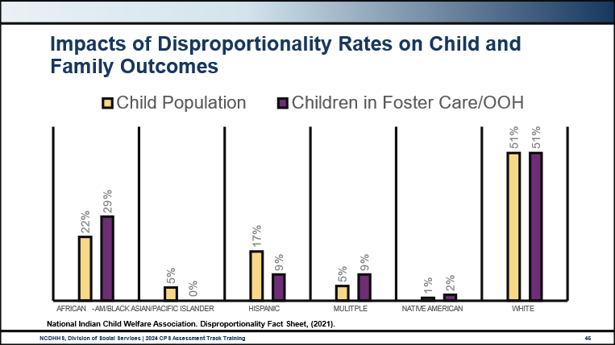
Use this space to record notes.

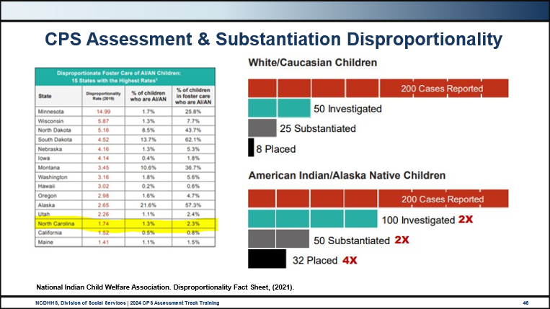
Use this space to record notes.

Video: Exploring Implicit Bias in Child Protection
https://www.youtube.com/watch?v=PsWkqtO4HLY
With your group, discuss the following questions.
What do you think contributes to or causes disproportionate CWS involvement for some children and not others?
What role do you play in disproportionality rates in NC CPS?
How will you develop self-awareness of your own implicit biases?

Debrief
What are your reflections on this information?
How does this history impact your work with children and families today?

Cultural Humility, Inclusion, and Considerations for Child Welfare Assessments and Decision-Making

Video: What Exactly is Cultural Humility?
https://www.youtube.com/watch?v=UR58nYjm5xo&t=1s
Use this space to record notes.

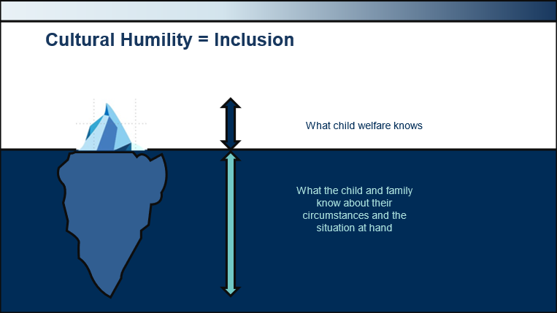
Use this space to record notes.

Activity: Child Welfare Practice Strategies to Center Families
Part 1: Create a list of aspects of your culture that make your family unique and may not be visible or known to outsiders.
What about your family culture would CPS be challenged to understand without explanation or context?
What in your culture might be interpreted negatively without that family context and information?

Part 2: Discuss your answers to Part 1 with your group and answer the following questions:
How would CPS get your family to talk about those topics?
How do you practice inclusion with families in CPS?

Identifying and Addressing Bias
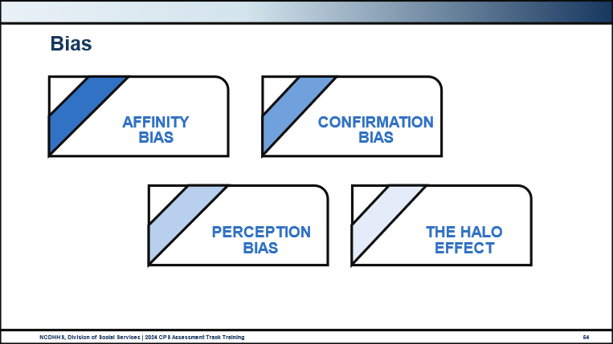
Affinity Bias: The tendency to warm up to people who are similar to ourselves; favoring those who have things in common with us.
Confirmation Bias: Seeking out evidence that confirms our initial perceptions, ignoring contrary information.
Perception Bias: The tendency to form stereotypes and assumptions about certain groups that make it difficult to make an objective judgment about individual members of those groups.
The Halo Effect: The tendency to think everything about a person is good because our first impression of them was good.
Use this space to record notes.

Activity: Learning Zones
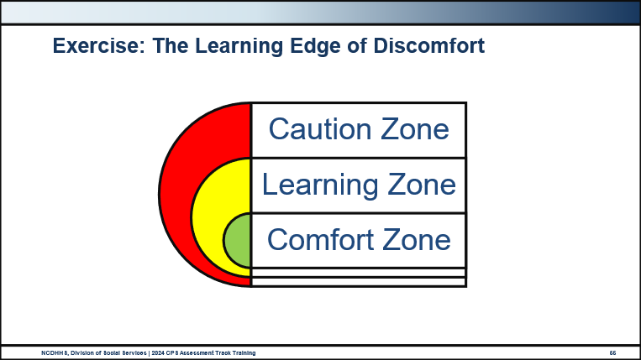
What about this work have I found challenging and what did I do about it?
How do I reflect on my own biases?
How do I mitigate or prevent negative impact from my biases?
How will you sit with the discomfort of the learning zone to learn about families?

Trauma-Informed Care

Core Value: Trauma-Informed Care
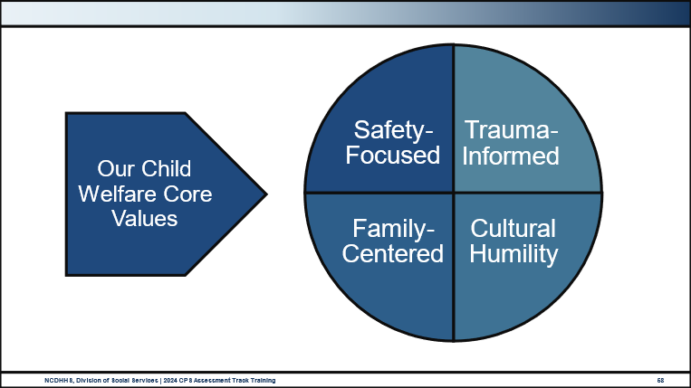
Use this space to record notes.

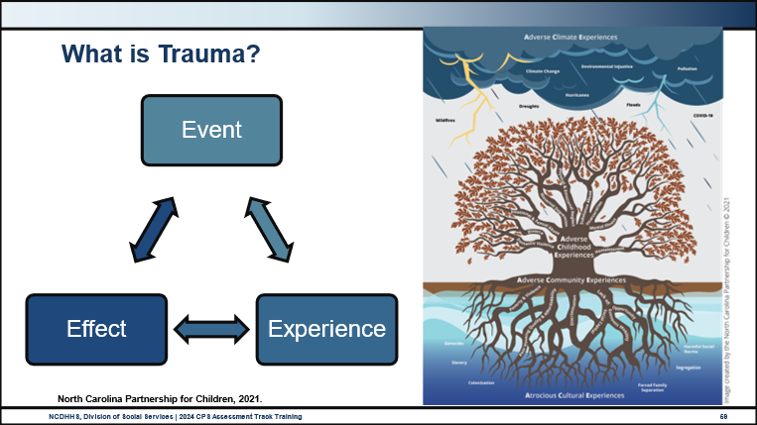
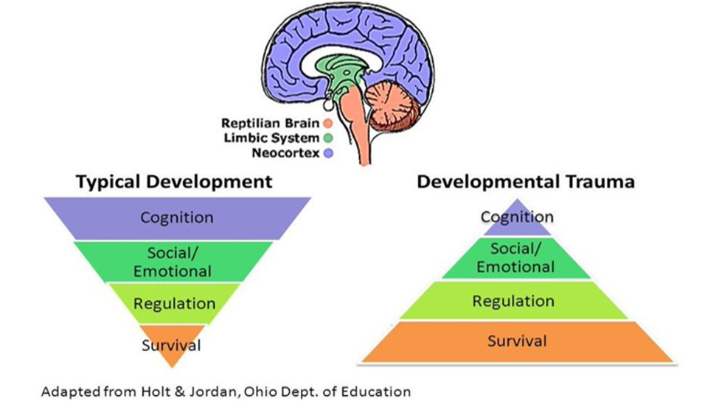

Use this space to record notes.

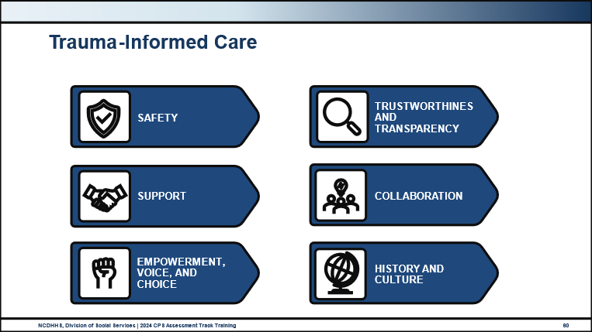
There are 6 core principles of trauma-informed care:
Safety: Families and child welfare social workers feel physically and psychologically safe.
Trustworthiness and Transparency: Decisions are made with transparency and with the goal of building and maintaining trust.
Support: Child and family safety decisions are team decisions and no one person should make decisions about families alone. Consulting with your peers and supervisor is viewed as integral to child welfare service delivery.
Collaboration: Child welfare services are family-centered interventions to assess and provide child and family safety. As a representative of the government, power differences between child welfare social workers and families, and among organizational staff, are leveled to support shared decision-making.
Empowerment: Child and family strengths are recognized, built on, and validated — this includes a belief in resilience and the ability to heal from trauma.
Humility and Responsiveness: Biases and stereotypes (e.g., based on race, ethnicity, sexual orientation, age, geography) and historical trauma are recognized and addressed. Child welfare social workers are responsible for engaging in courageous and crucial conversations with families with the understanding that families are the experts on their own lives, strengths, and challenges.

End-of-Day Values Reflection

Communicating: Build Your Own Field Guide
What are three things to remember about communicating when in the field working with families?
Think about how you learn best. What do you need to try out new skills and approaches?

Questions and Reflections:
Use this space to record reflections and questions about what you have learned today.

Bibliography of References
Day One
The Annie E Casey Foundation. (April 2023). “Children who are confirmed by child protective services as victims of maltreatment by race and Hispanic origin in the United States.” Kids Count. Retrieved from https://datacenter.aecf.org/data/tables/9906-children-who-are-confirmed-by-child-protective-services-as-victims-of-maltreatment-by-maltreatment-type#detailed/1/any/false/1095,2048,574,1729,37,871,870,573/3885,3886,3887,3888,3889,3890/19240,19241 on 6 Nov 2023.
CalSWEC Online, (2019, April 29) Child Welfare Worker Realistic Job Preview. [Video]. YouTube.com. https://www.youtube.com/watch?v=2aoOYAwgp2o&list=PLNYfSDZN2XUpWQ62KzijZDZ_g2VEjlSGD&index=1
Casey Family Programs, (2019, January 18) Jeremiah Donier: Birth dad winner. [Video]. YouTube.com. https://www.youtube.com/watch?v=yxBeN5-Rq_E&t=249s
Center for the Study of Social Policy. (June 2023). Implicit Racial Bias 101: Exploring Implicit Bias in Child Protection. [Video]. YouTube.com. https://www.youtube.com/playlist?list=PL-oK-jkL0HeVOuQKt9GTsx2df6Wfo8ZJc
Child Abuse, Prevention, and Treatment Act of 1974, P.L. 93-247. (1974, rev. 2019). Section 106 (b)(2)(A)(xviii) Assurances and Requirements, Notification of Allegations. https://policies.ncdhhs.gov/wp-content/uploads/fscw_al_0706-01.pdf
Child Welfare Information Gateway. (2020, October). How the Child Welfare System Works. Washington, DC: U.S. Department of Health and Human Services, Administration for Children and Families, Children's Bureau. https://www.childwelfare.gov/pubPDFs/cpswork.pdf
Child Welfare Information Gateway. (2023). Index of Federal laws. Washington, DC: U.S. Department of Health and Human Services, Administration for Children and Families, Children's Bureau. https://cwlibrary.childwelfare.gov/discovery/search?query=title,exact,Index%20of%20Federal%20Child%20Welfare%20Laws,AND&tab=catalog&search_scope=PublicCat&sortby=rank&vid=01CWIG_INST:01CWIG&mode=advanced&offset=0
Child and Family Services. (2014, July 23) Child and family services reviews (CFSR) quick reference items list. Washington, DC: U.S. Department of Health and Human Services, Administration for Children and Families, Children's Bureau. https://www.acf.hhs.gov/sites/default/files/documents/cb/cfsr_quick_reference_list.pdf
Children’s Bureau. (2022). Child Maltreatment 2020. Washington, DC: U.S. Department of Health and Human Services, Administration for Children and Families, Administration on Children, Youth and Families.
Children’s Bureau. (2022). National Child Abuse and Neglect Data System (NCANDS) Child File, FFY 2000–2021. Washington, DC: U.S. Department of Health and Human Services, Administration for Children and Families, Administration on Children, Youth and Families.
Children’s Bureau. (2023). Child Welfare Policy Manual. Washington, DC: United States Department of Health and Human Services, Administration for Children and Families. Retrieved from https://www.acf.hhs.gov/ on 12 Nov 2023.
Diabetes Africa. (2022, December 1). What Exactly is Cultural Humility? [Video]. YouTube.com. https://www.youtube.com/watch?v=UR58nYjm5xo&t=1s
DuPre, D.P., & Sites, J. (2015). Chapter 1: Introduction. Child Abuse Investigation Field Guide, 1-8. DOI: https://doi.org/10.1016/B978-0-12-802327-3.00001-1.
Foronda, C., Baptiste, D., Reinholdt, M.M. & Ousman, K. (2015).Cultural Humility. Journal Of Transcultural Nursing 27(3): 210-217. doi:10.1177/1043659615592677. Retrieved from https://inclusion.uoregon.edu/what-cultural-humility-basics
Garcia, A.R., Gupta, M., Greeson, J.K.P., Thompson, A., & DeNard, C. (2017, August).. Adverse childhood experiences among youth reported to child welfare: Results from the national survey of child & adolescent wellbeing. Child Abuse & Neglect 70: 292-302. https://www.sciencedirect.com/science/article/abs/pii/S0145213417302478
Juvenile Code, Article 3 – Screening of Abuse and Neglect Complaints. North Carolina Stat. §7B-302(h). (1979, rev. 2021). https://www.ncleg.net/EnactedLegislation/Statutes/HTML/ByChapter/Chapter_7B.html
Magruder, K.M., McLaughlin, K.A., & Elmore Borbon, D.L. (2017). Trauma is a public health issue. European Journal of Psychology 8(1). Retrieved from https://www.tandfonline.com/doi/full/10.1080/20008198.2017.1375338 on 8 March 2024.
McCrae, J.S., Bender, K. Brown, S.M., Phillips, J.D., & Rienks, S. (2019). Adverse childhood experiences and complex health concerns among child welfare-involved children. Children’s Health Care 48(1): 38-58. https://www.tandfonline.com/doi/abs/10.1080/02739615.2018.1446140
McPhatter, A.R. (2018). "Cultural competence in child welfare: What is it? How do we achieve it? What happens without it?." Child Welfare 76(1), 251-274. Routledge, 2018.
National Child Welfare Workforce Institute. (2022, May). Overrepresentation of Black children in Child Welfare. Washington, DC: U.S. Department of Health and Human Services, Administration for Children and Families, Children’s Bureau. https://ncwwi.org/wp-content/uploads/2022/05/Overrepresentation-of-Black-children-in-Child-Welfare.pdf
National Indian Child Welfare Association. (2021, November). Disproportionality in Child Welfare Fact Sheet. Retrieved from NICWA_11_2021-Disproportionality-Fact-Sheet.pdf on 7 Nov 2023.
New York Civil Liberties Union (NYCLU). (2023).The Racist Roots of the Child Welfare System. [Video]. YouTube.com. https://www.youtube.com/watch?v=UsJCFWi_lbE
North Carolina Department of Health and Human Services, Division of Social Services. (2020, May). CPS Purpose & Philosophy, Legal Basis, Administration: NC Child Welfare manual, 9. https://policies.ncdhhs.gov/wp-content/uploads/purpose.pdf
North Carolina Department of Health and Human Services, Division of Social Services. (2021). North Carolina practice standards worker assessment. https://www.ncdhhs.gov/cw-worker-north-carolina-worker-assessment-all-practice-standards/open
North Carolina Department of Health and Human Services, Division of Social Services. (2021). Worker practice standards desk guide. https://www.ncdhhs.gov/cw-worker-north-carolina-worker-practice-standards-desk-guide/open
North Carolina Department of Health and Human Services, Division of Social Services. (2024, April). Cross function topics: NC Child Welfare manual. https://policies.ncdhhs.gov/wp-content/uploads/In-Home_April-2024_2.pdf
North Carolina Department of Health and Human Services, Division of Social Services. (2024, August). CPS Assessments Policy, Protocol, and Guidance: NC Child Welfare manual. https://policies.ncdhhs.gov/wp-content/uploads/CPS-Assessments-Aug-2024.pdf
North Carolina Department of Health and Human Services, Division of Social Services. (2024, August). CPS Intake Policy, Protocol, and Guidance: NC Child Welfare manual. https://policies.ncdhhs.gov/wp-content/uploads/CPS-Intake_Aug-2024.pdf
Patterson, K., Grenny, J., McMillan, R., & Switzler, A. (2002). Crucial Conversations. Maidenhead, England: McGraw-Hill Contemporary.
SMART START and North Carolina Division of Public Health. (2021). Building Healthy and Resilient Communities Across North Carolina, One Community at a time. Retrieved from https://indd.adobe.com/view/f9cca8b9-d326-4666-99d0-afe7ea06bd73.
Substance Abuse and Mental Health Services Administration. (2014). SAMHSA’s Concept of Trauma and Guidance for a Trauma-Informed Approach, HHS Publication No. (SMA) 14-4884. Rockville, MD: Substance Abuse and Mental Health Services Administration. https://store.samhsa.gov/sites/default/files/sma14-4884.pdf

Appendix: Handouts
Intake Process Map 2
Policy Guidance for Making Informed Decisions 3
Federal Child Welfare Laws Overview 4
Self-Assessment Tool: Communicating Function 21
North Carolina Right to Enter a Residence 25

Intake Process Map

Policy Guidance for Making Informed Decisions
Purpose of CPS Family and Investigative Assessments
The primary goal of CPS Assessments is to protect children from further maltreatment and to support and improve parental/caregiver abilities to ensure a safe and nurturing home for each child.
The task of the CPS Assessment is to determine if the child(ren) is/are abused, neglected, and/or dependent, or if the family needs services, and what level of intervention is necessary to assure safety.
The purpose of the CPS Assessment is to gather sufficient information through interviews, observations, and, when appropriate, analysis of reports, medical records, photographs, etc. to determine if:
- Child maltreatment occurred;
- There is a risk of future maltreatment and the level of that risk;
- The child is safe within the home and, if not, what interventions can be implemented that will ensure the child's protection and maintain the family unit intact if reasonably possible;
- Ongoing agency services are needed to reduce the risk of maltreatment occurring in the future;
- Out-of-home placement is necessary to protect the child from harm.
During the course of a CPS Assessment, sufficient information must be gathered to assess:
- The safety of the child and the potential risk of harm;
- What actions might be needed to assure the safety of the child;
- Whether the facts identified through a structured gathering of information support the substantiation that a child is abused, neglected, and/or dependent as defined by statute, and the extent of the abuse, neglect, and/or dependency;
- If through observation and the gathering of information it is determined that due to the level of safety and risk, the family is in need of services; and
- Whether the specific environment in which the child is found meets the child’s need for care and protection.
Source: CPS Assessments Policy, Protocol, and Guidance (February 2024)

Federal Child Welfare Laws Overview
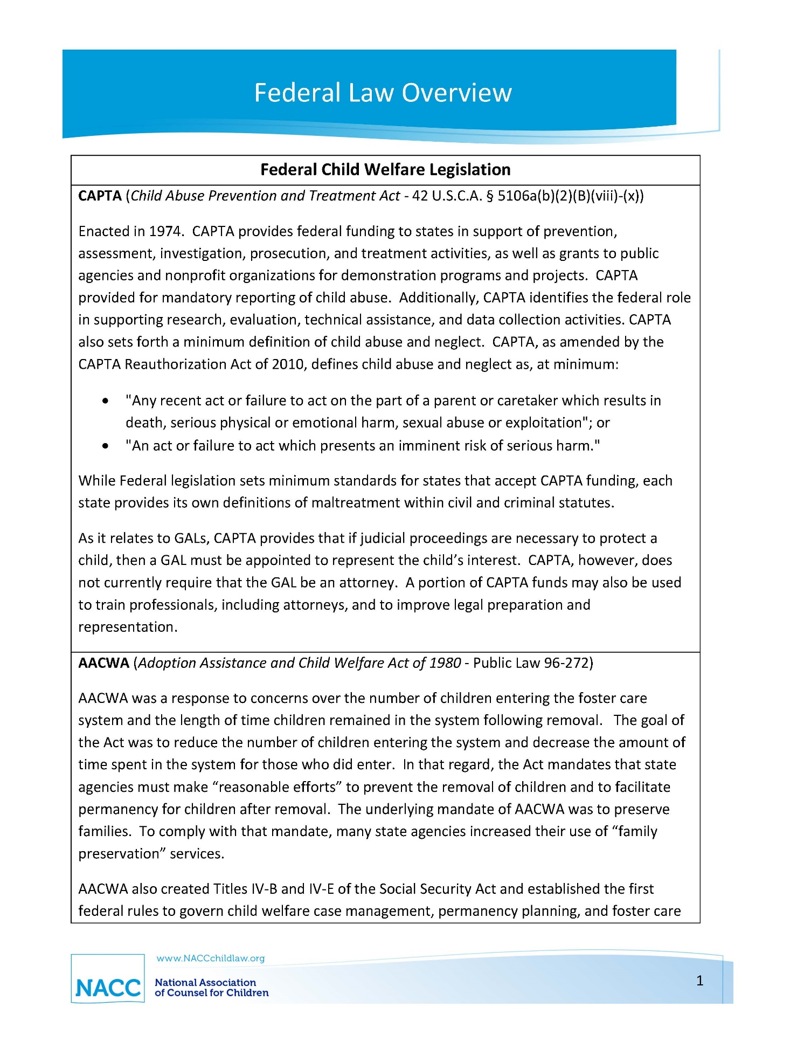
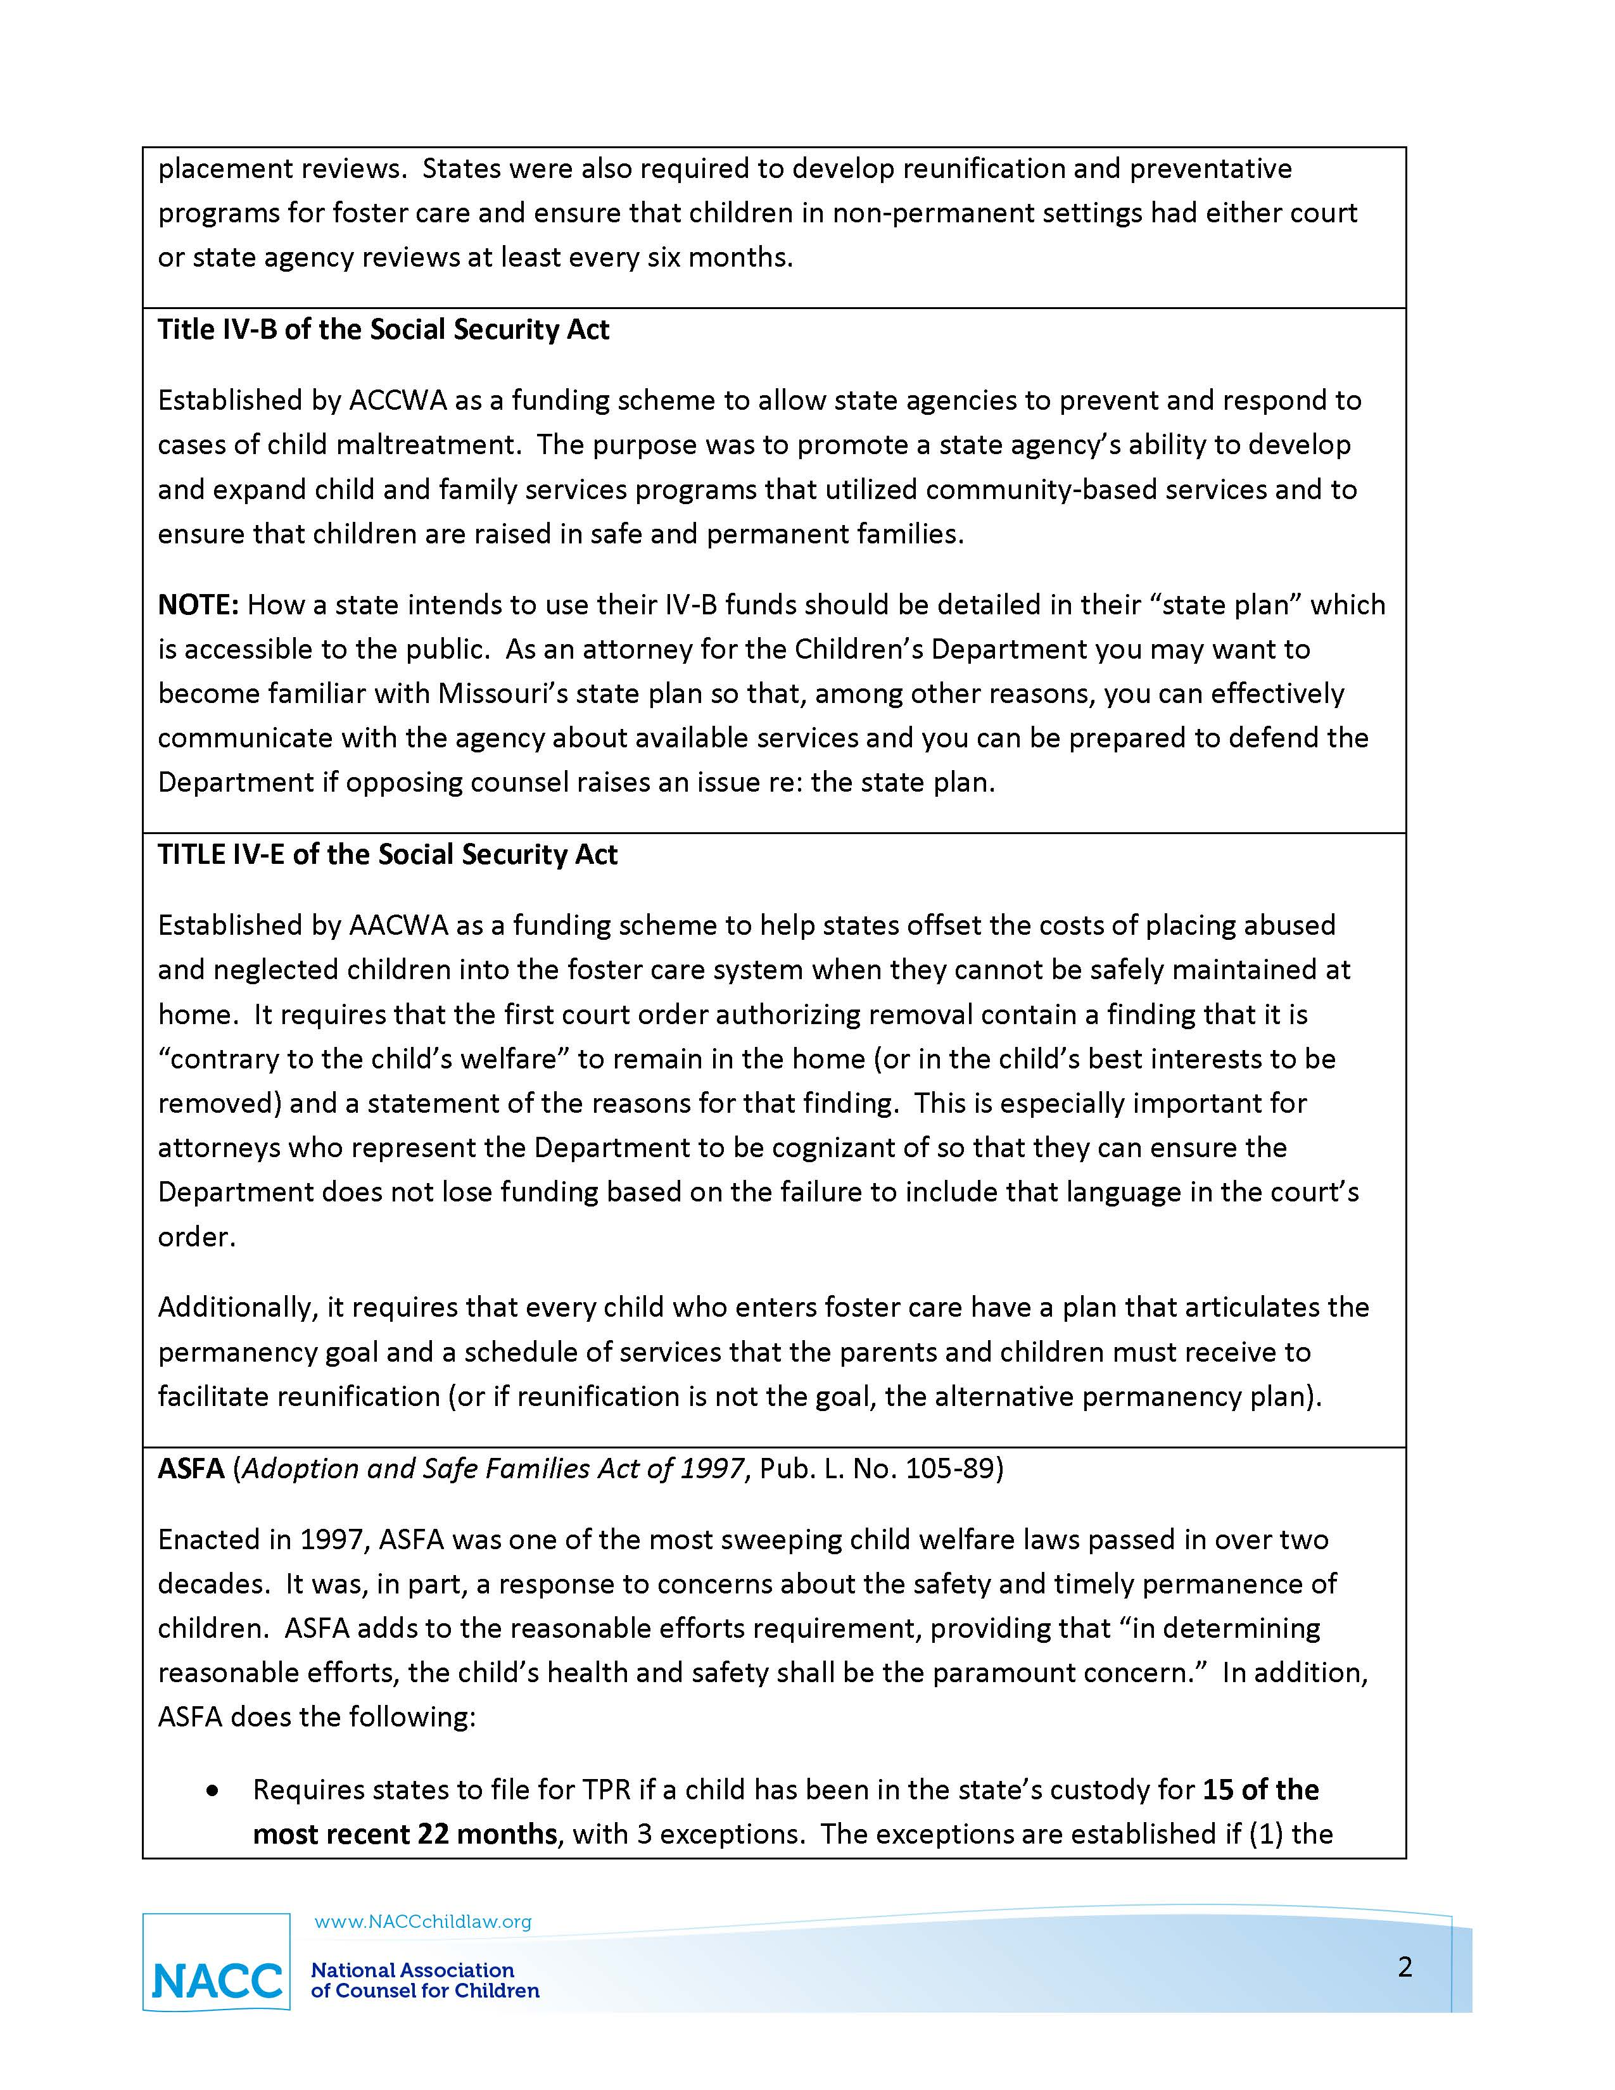
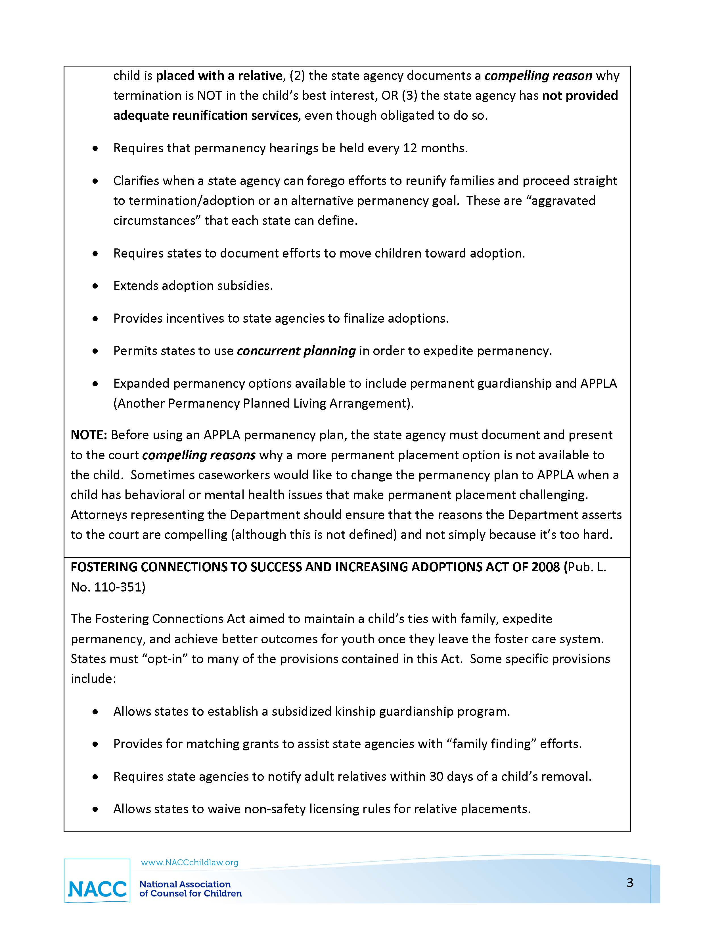
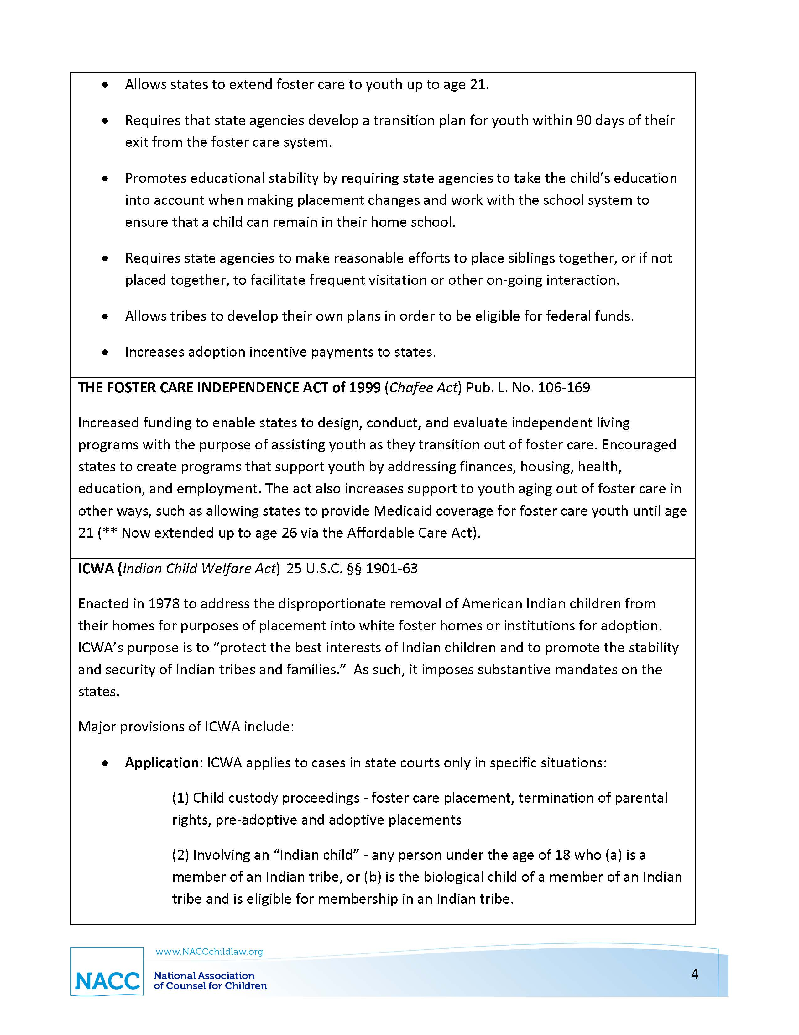
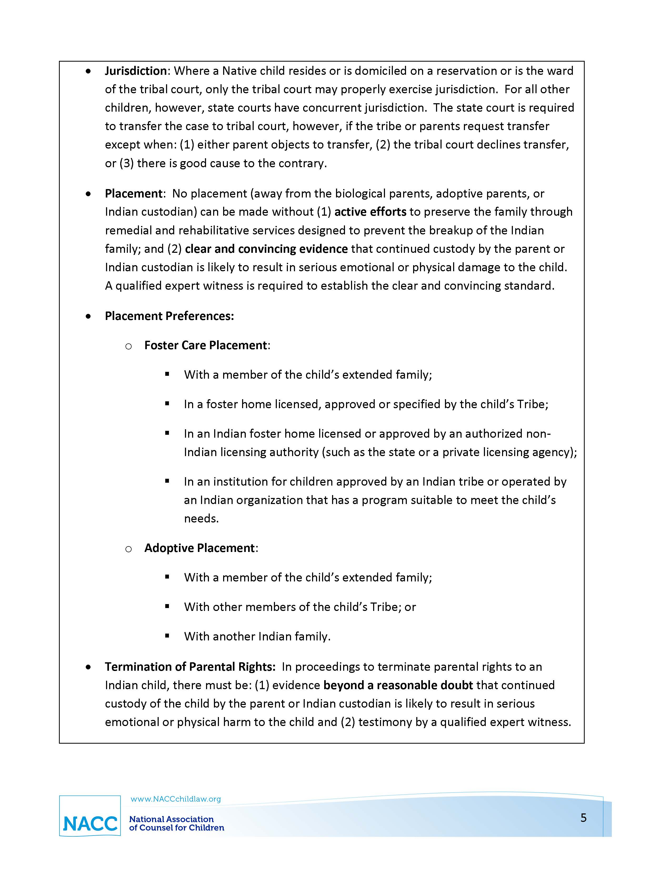
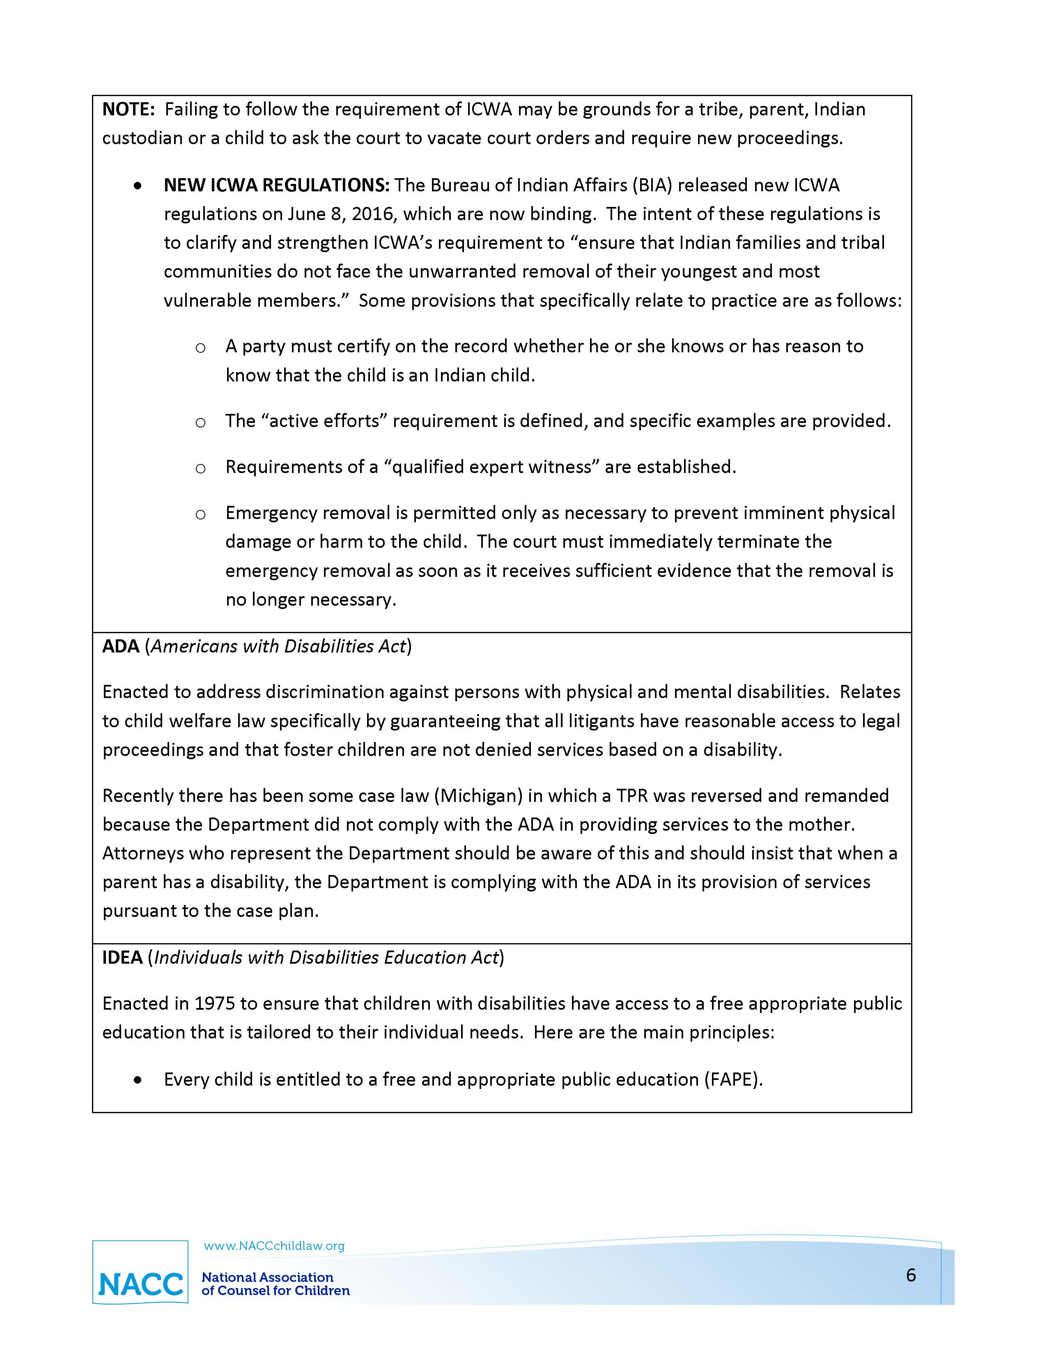
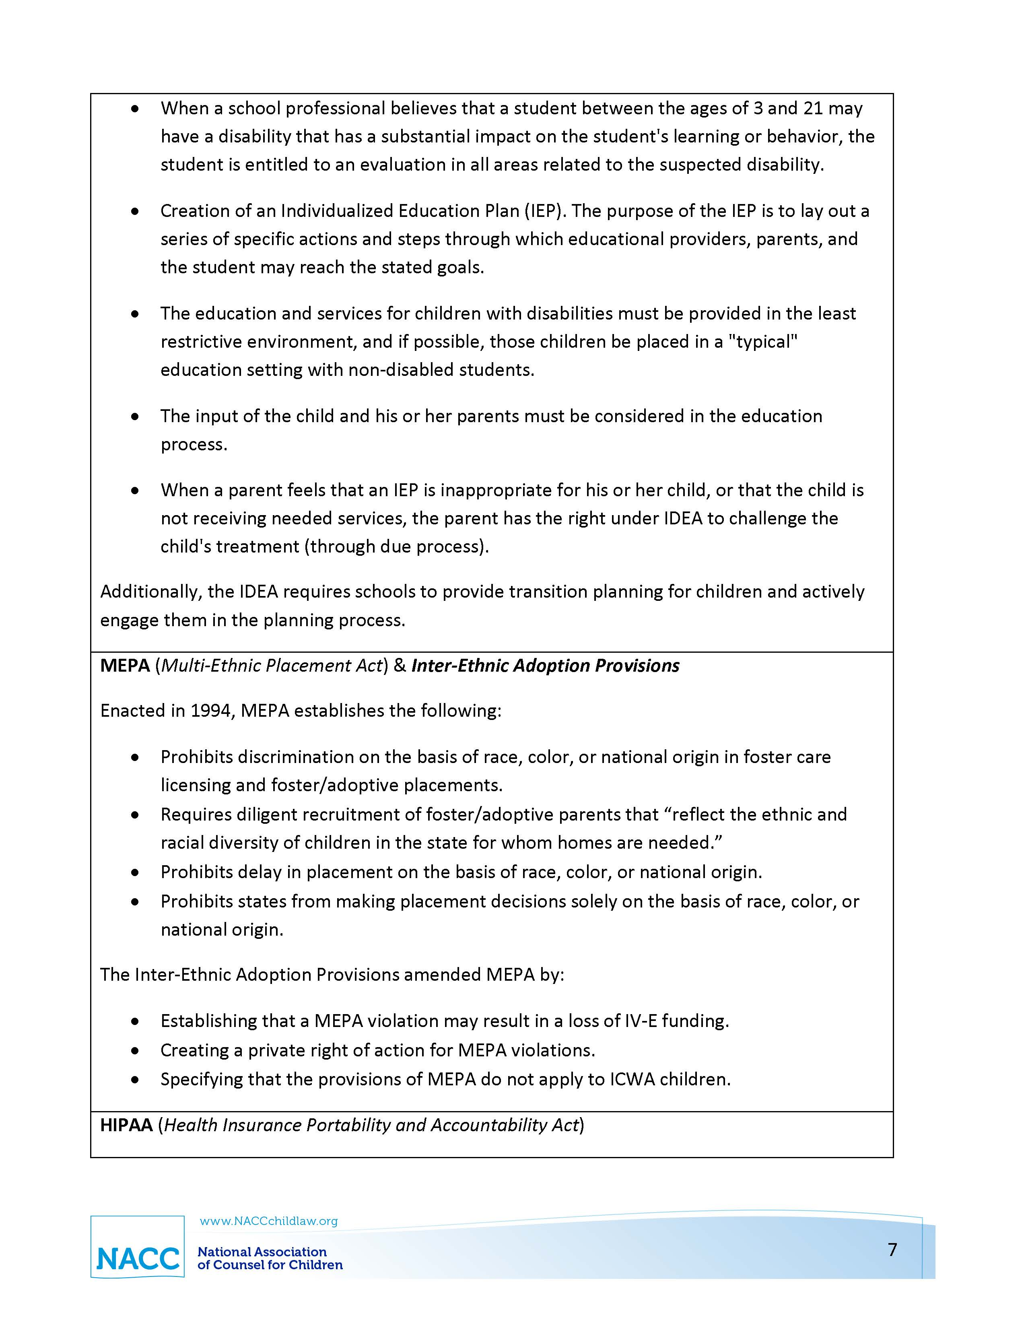
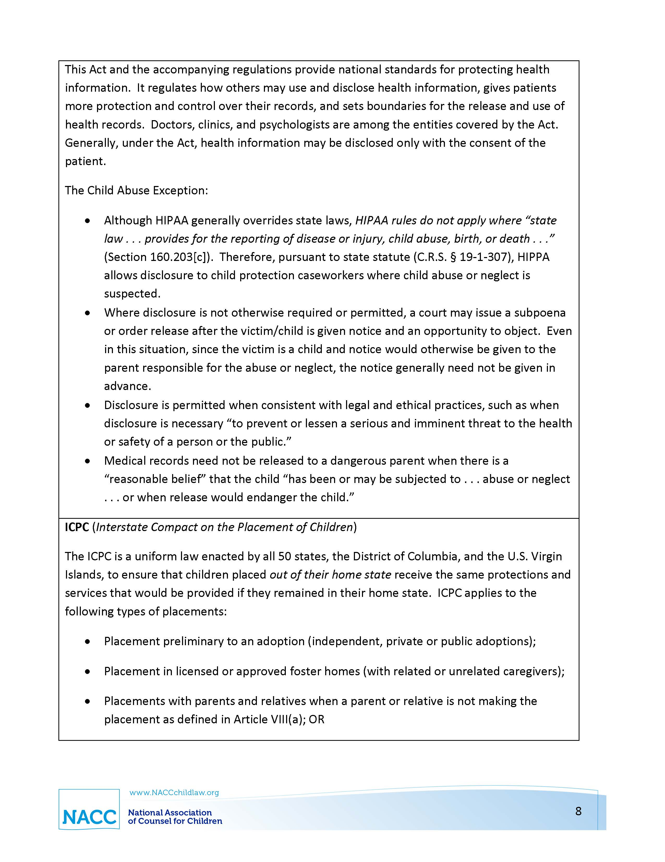
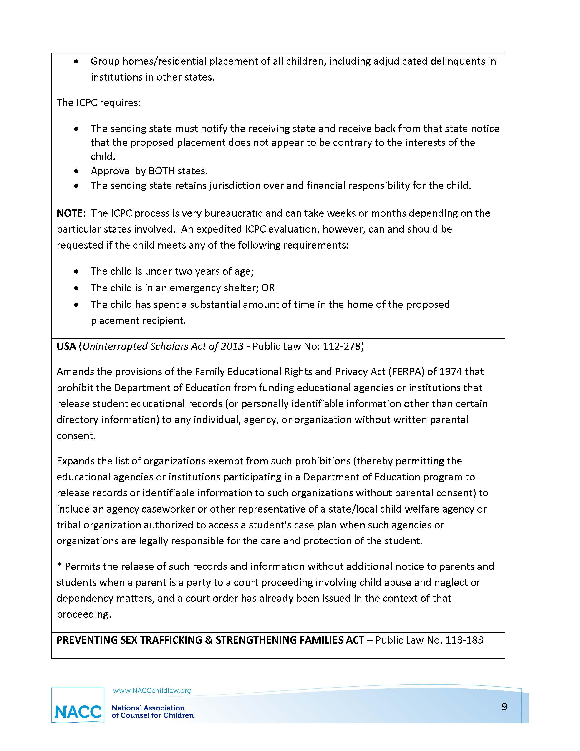
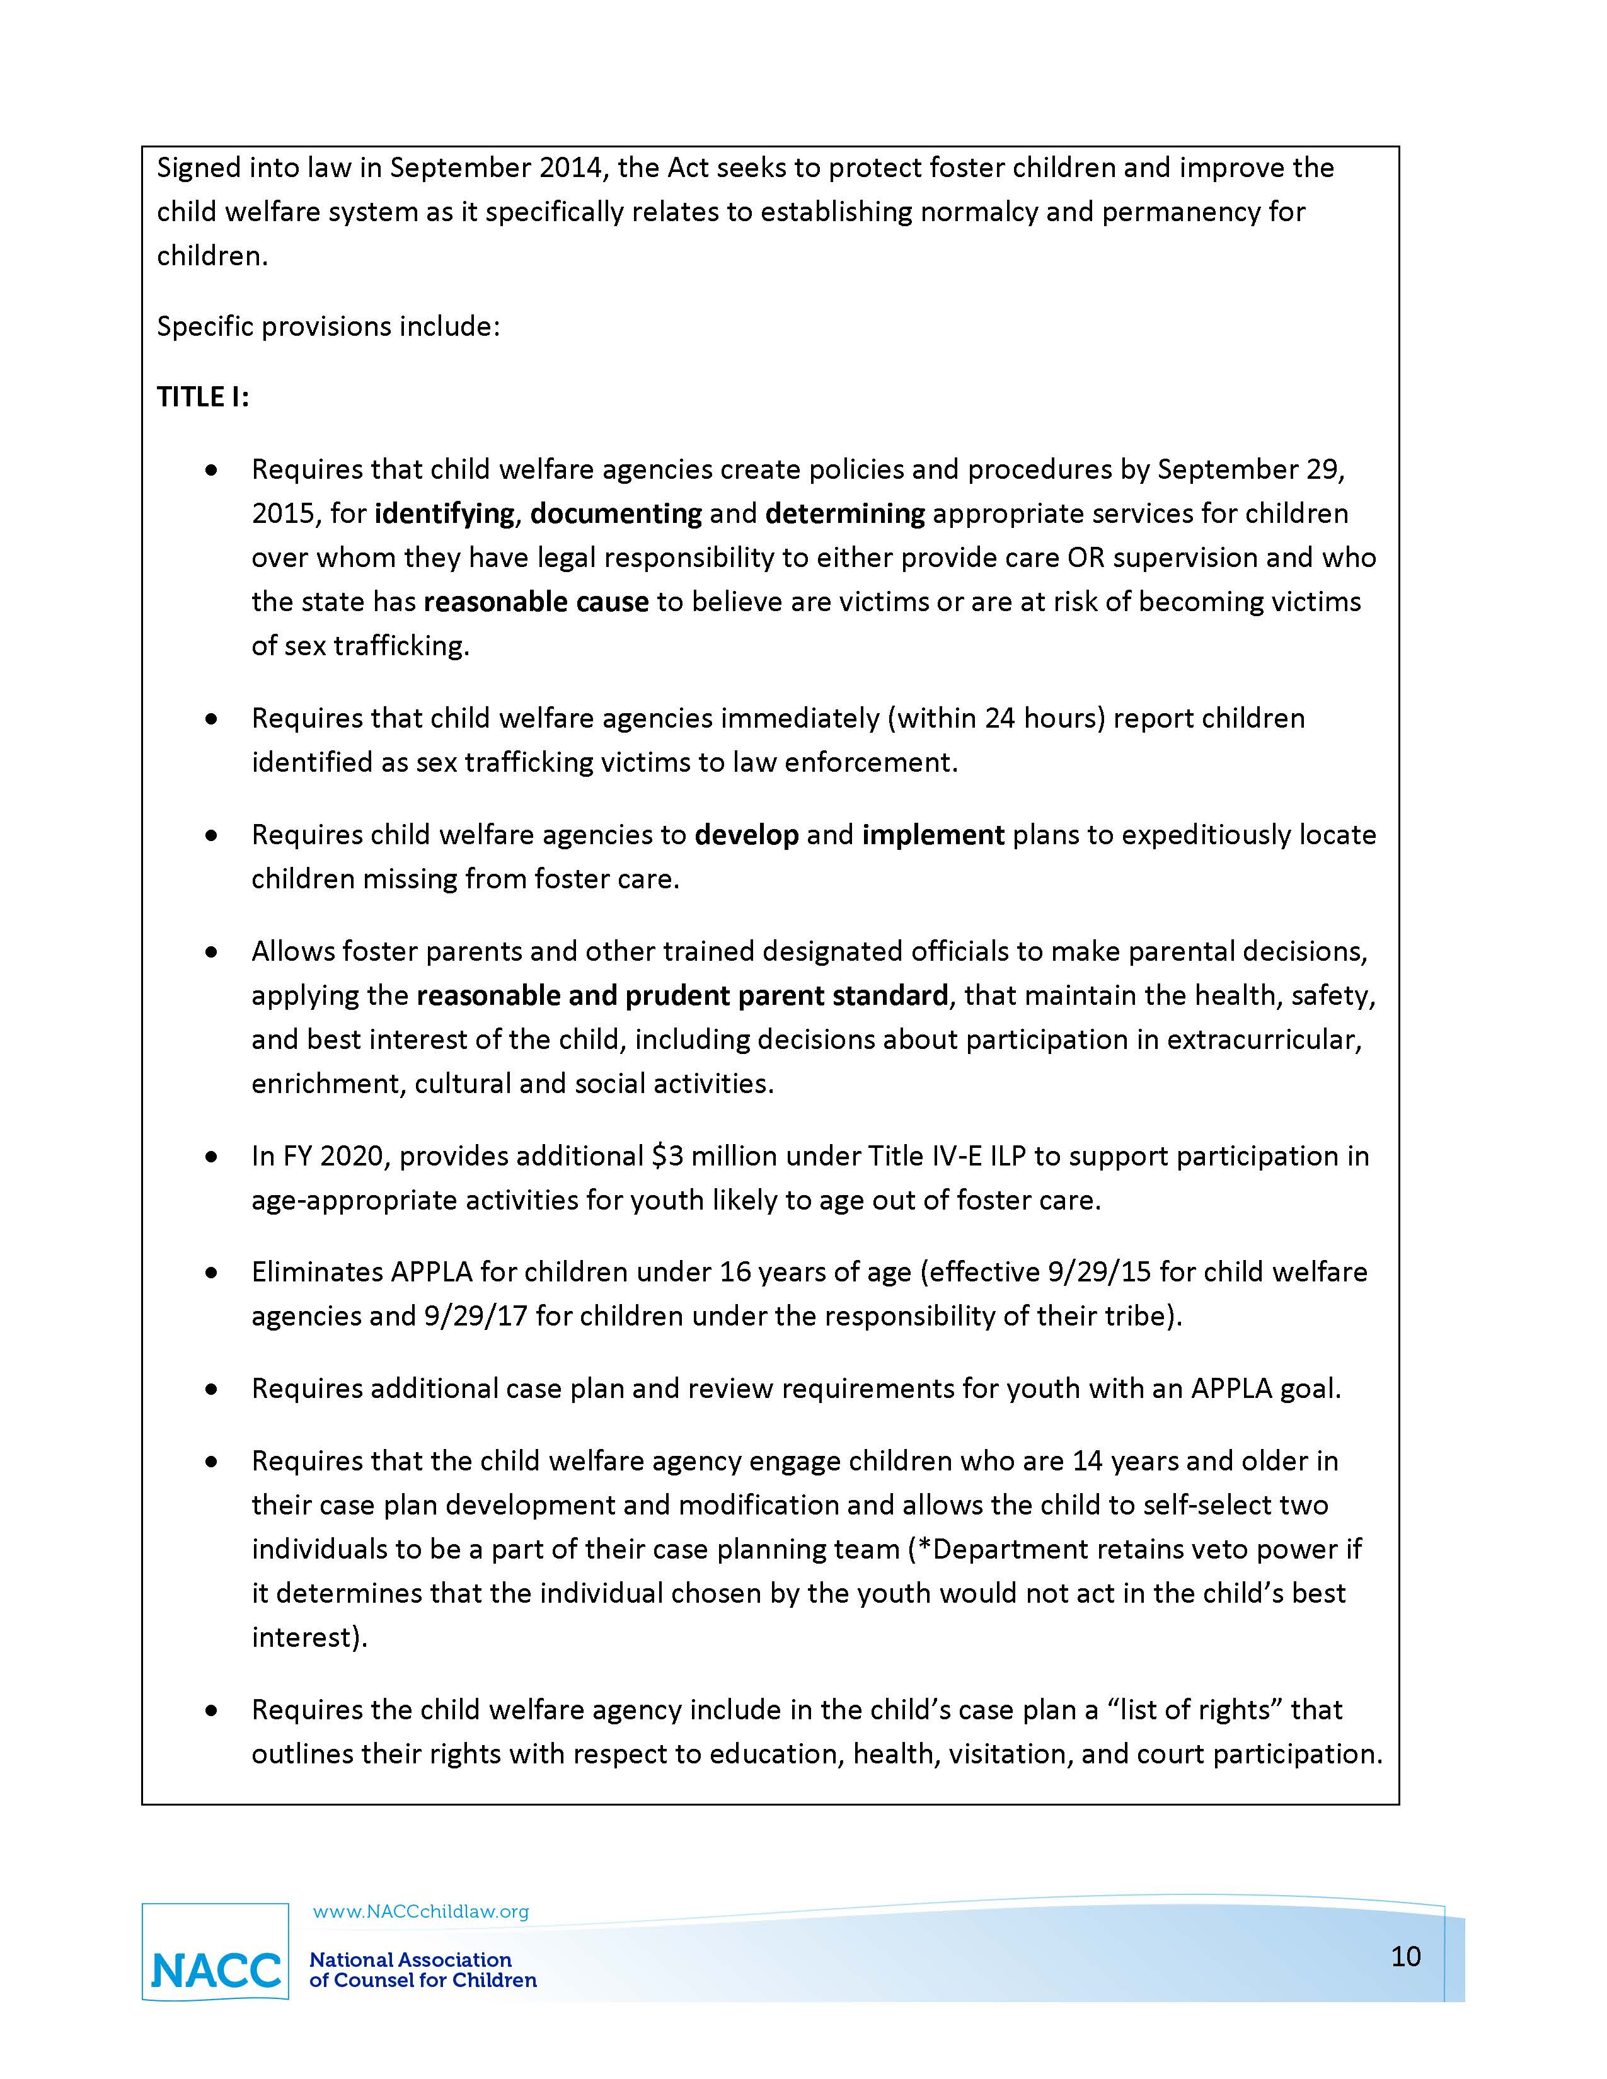
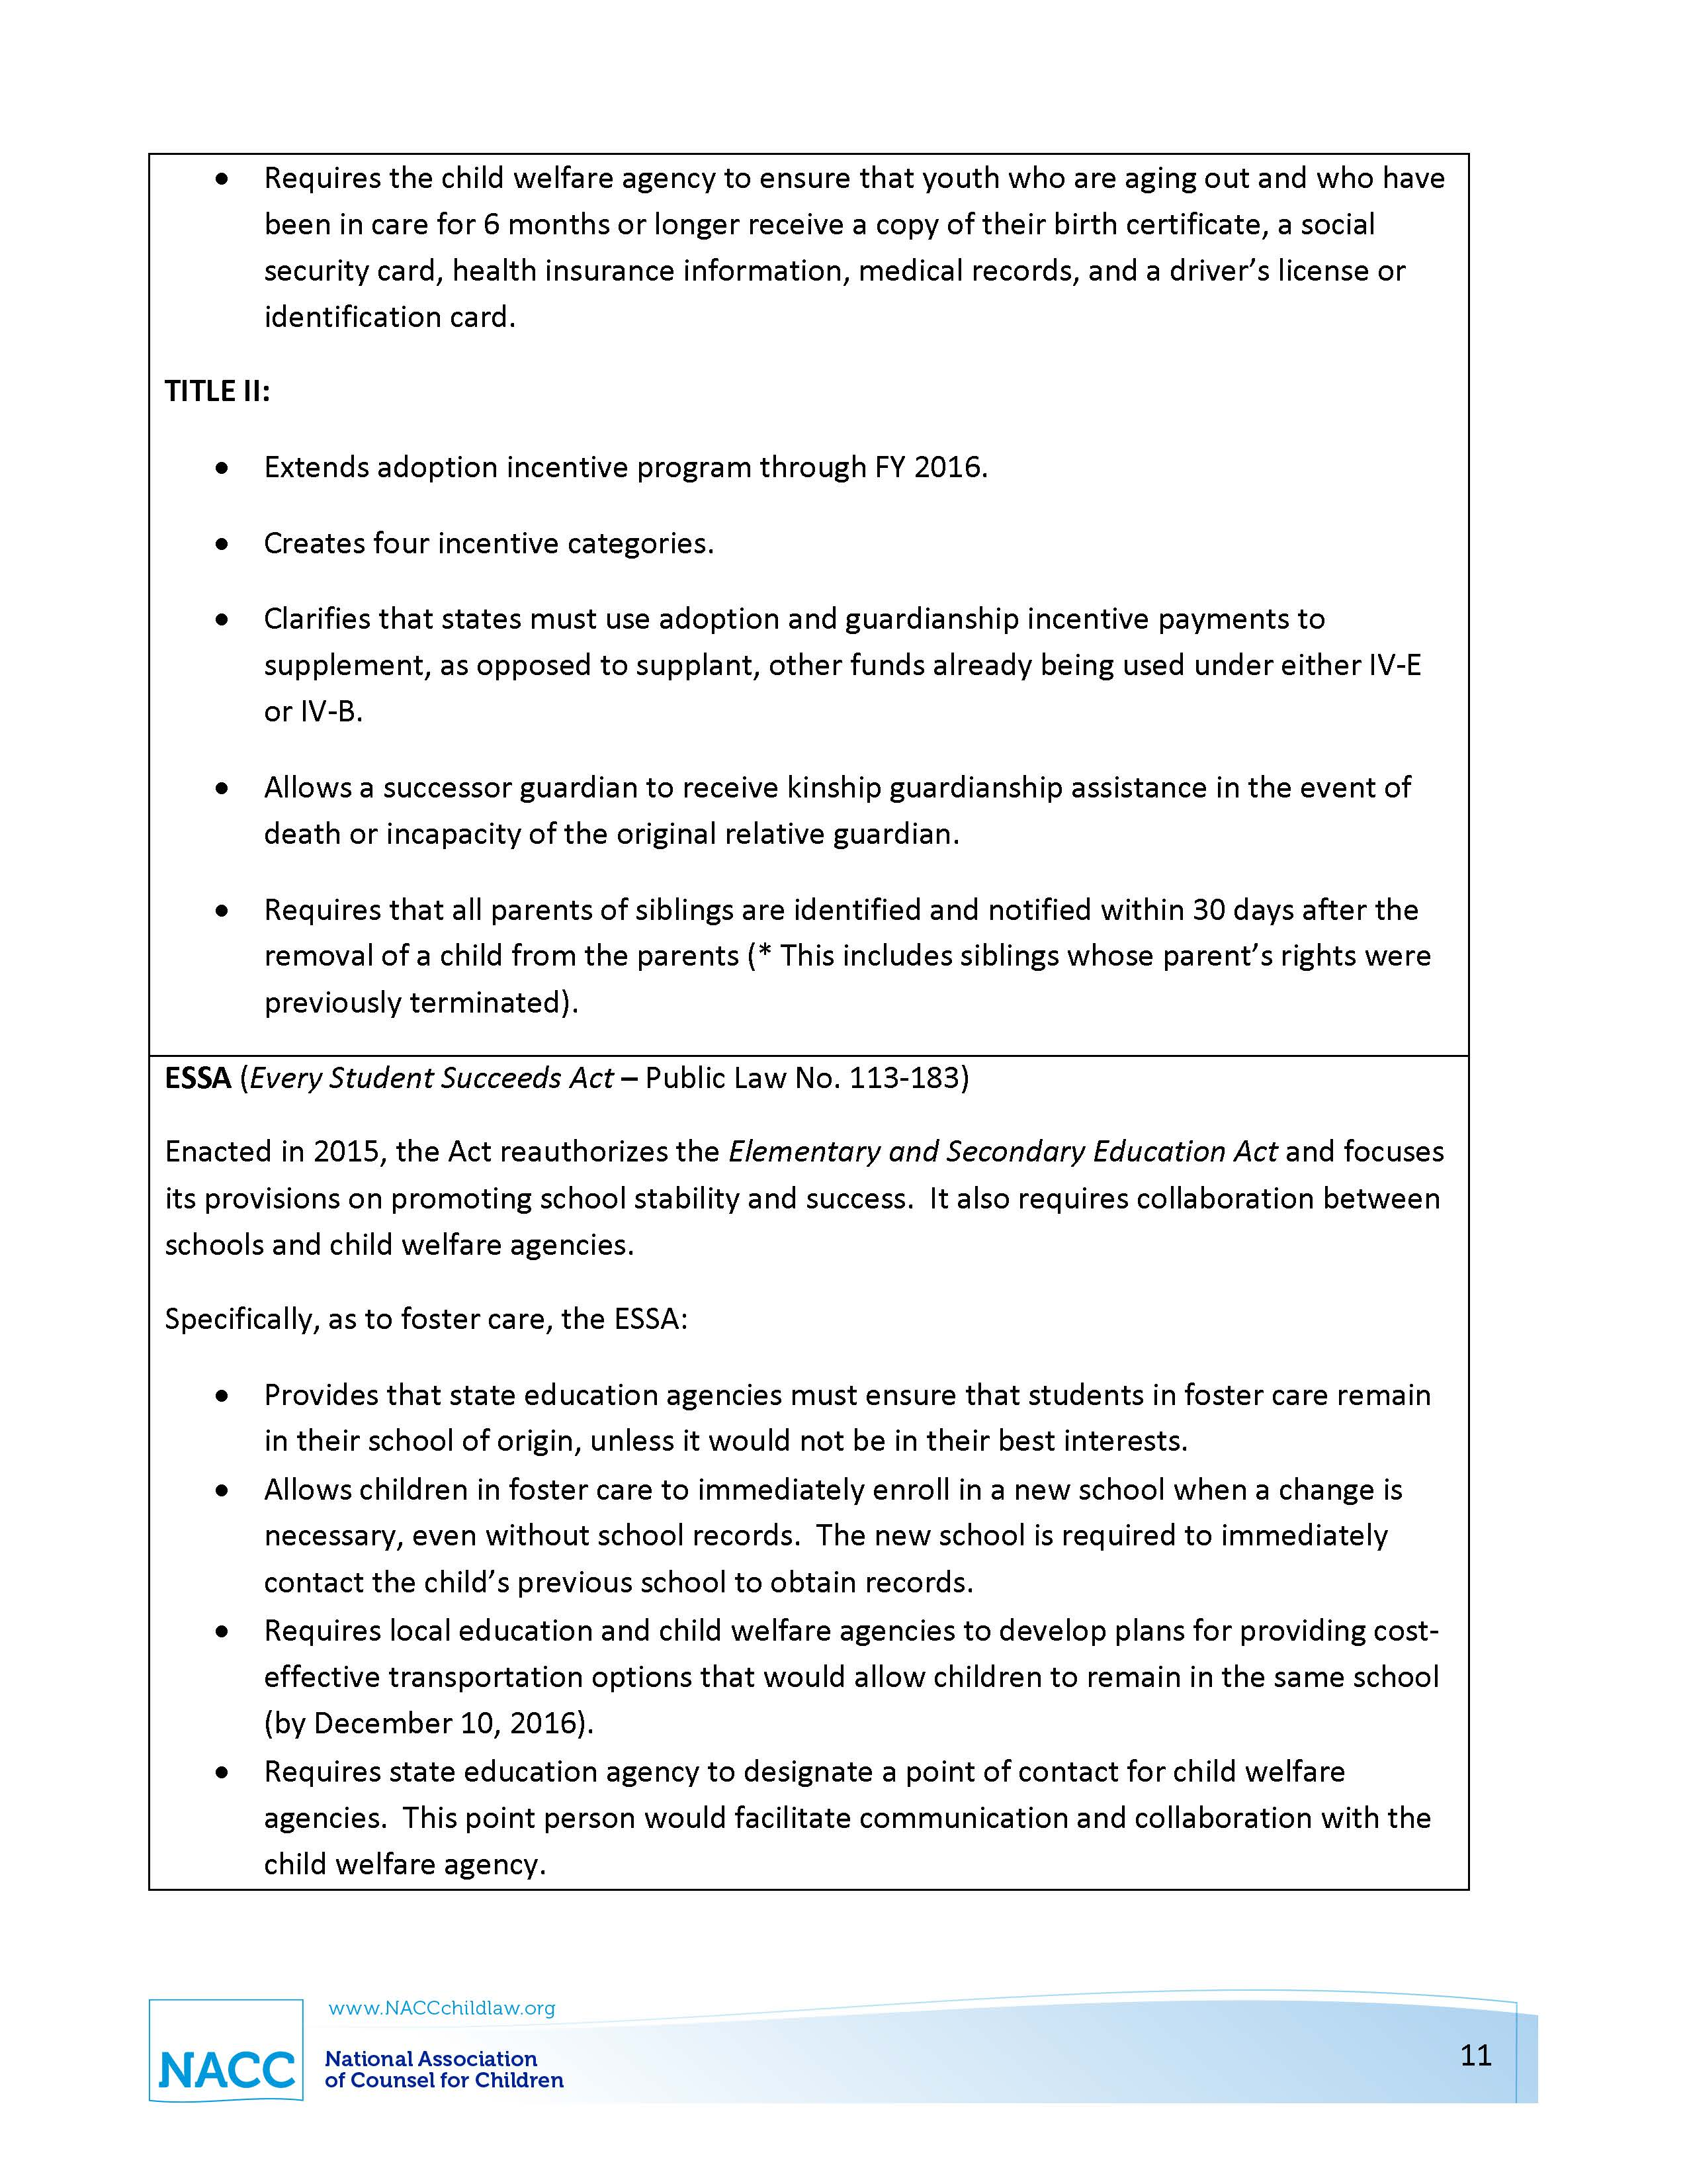
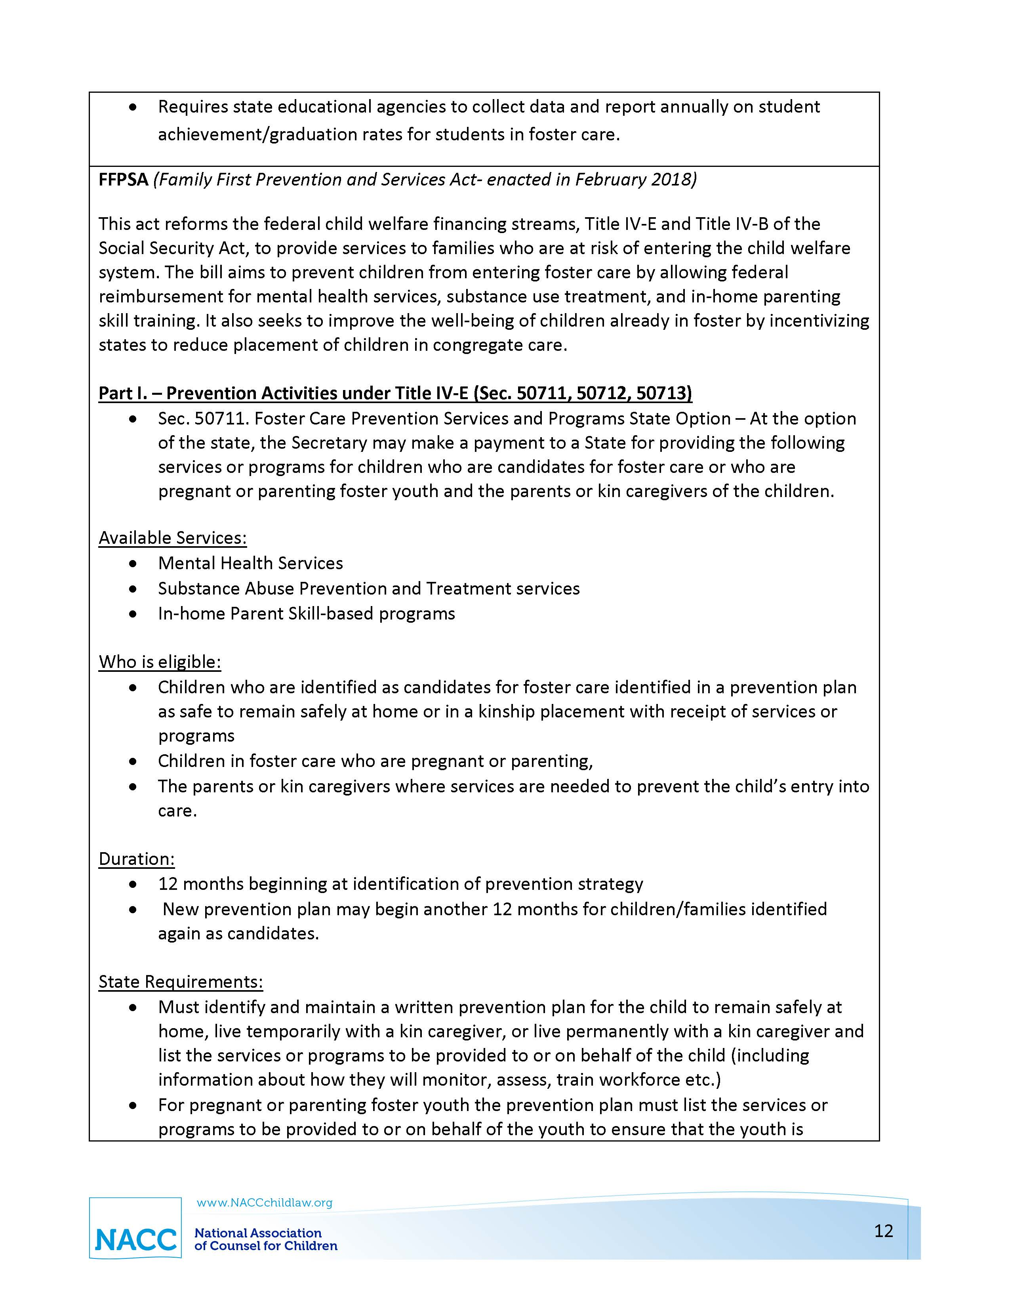
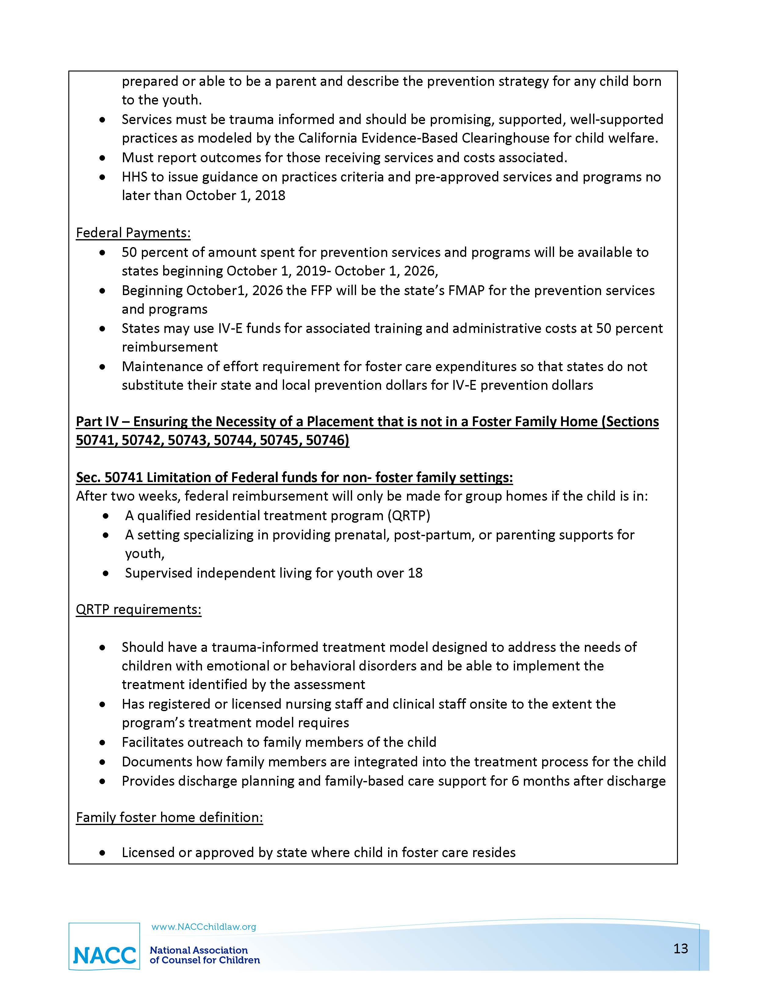
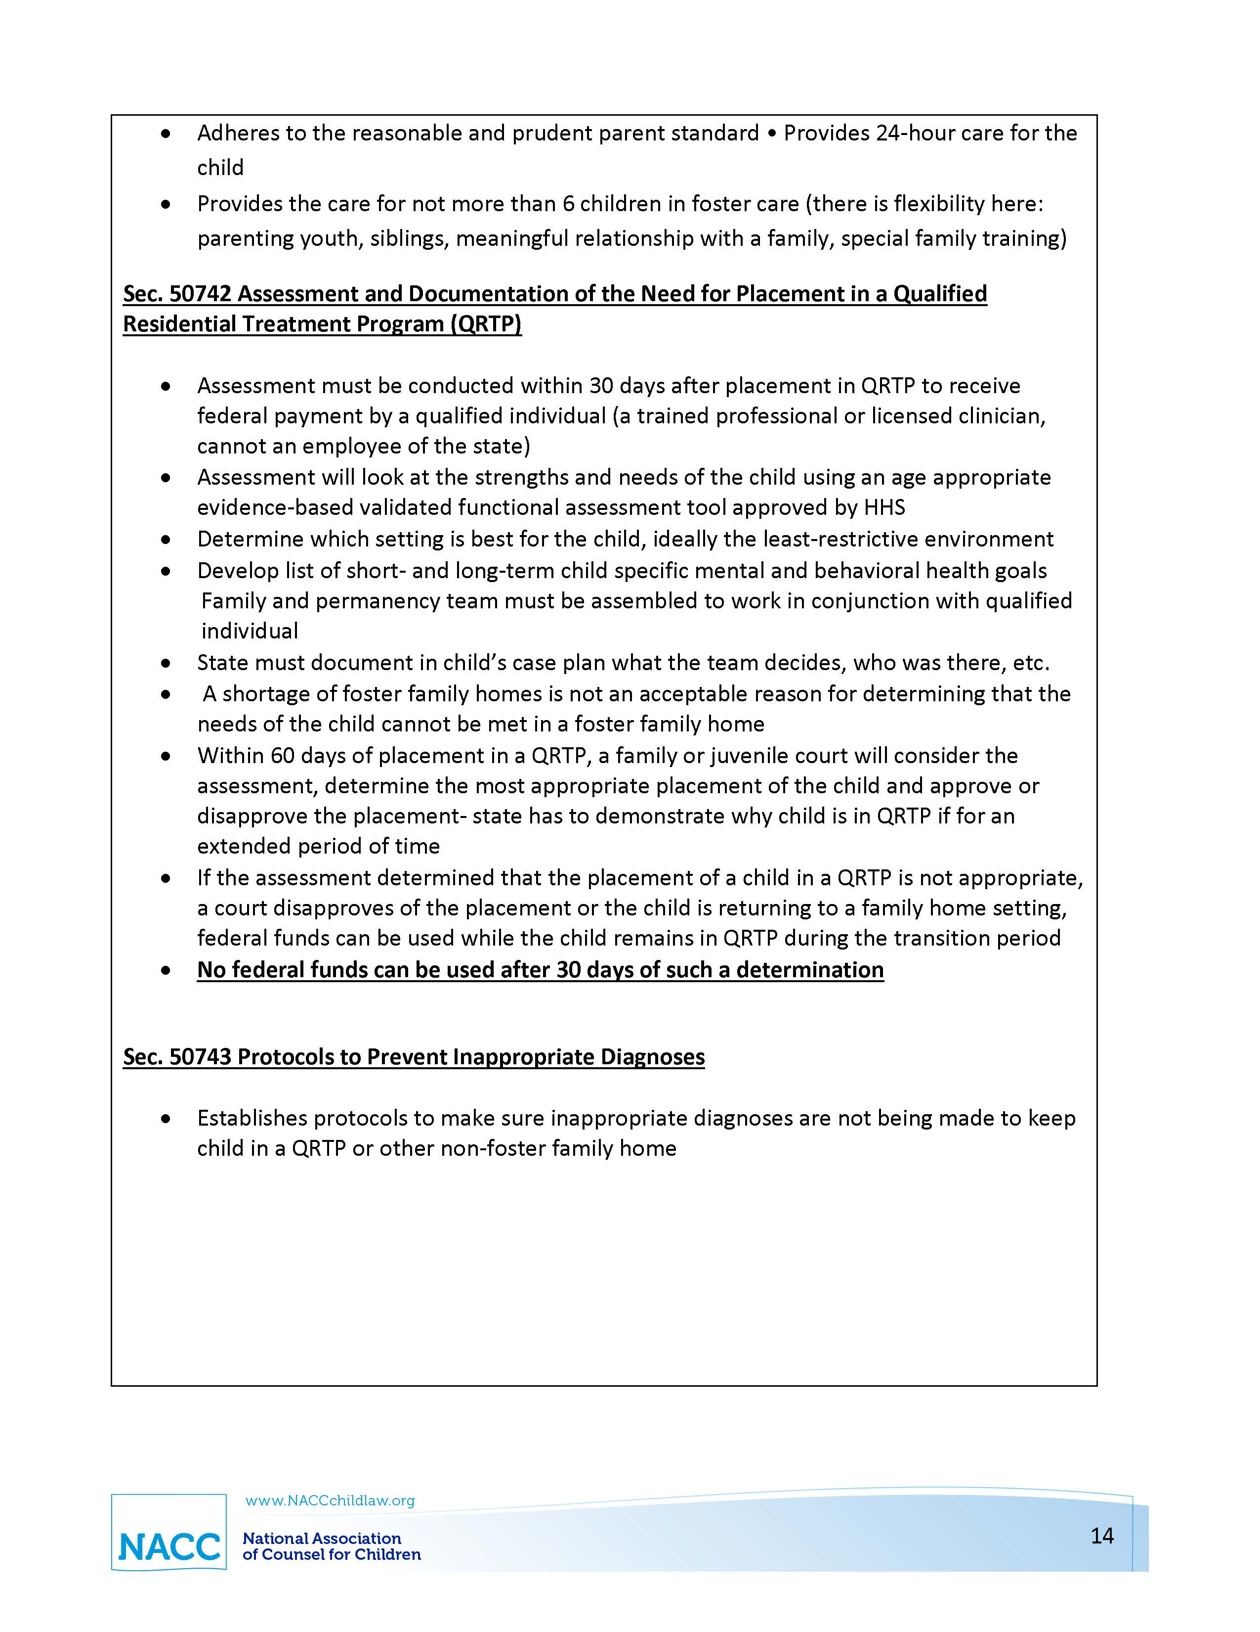

Self-Assessment Tool: Communicating Function

North Carolina Right to Enter a Residence
N.C.G.S. § 7B-302 Assessment by director; military affiliation; access to confidential information; notification of person making the report.
The director or the director's representative may not enter a private residence for assessment purposes without at least one of the following:
- The reasonable belief that a juvenile is in imminent danger of death or serious physical injury.
- The permission of the parent or person responsible for the juvenile's care.
- The accompaniment of a law enforcement officer who has the legal authority to enter the residence.
- An order from a court of competent jurisdiction

