North Carolina Department of Health and Human Services
CPS Assessment in Child Welfare Track Training

Participant’s Workbook
Day Two

October 2024


600 Airport Rd
Lakewood, NJ, 08701-5995
www.pubknow.com

info@pubknow.com
(800) 776-4229

This curriculum was developed by the North Carolina Department of Health and Human Services, Division of Social Services, and revised by Public Knowledge® in 2024.

Copyright © 2024 Public Knowledge®. All rights reserved. No part of this publication may be reproduced, distributed, or transmitted in any form without the written permission of the publisher.
Table of Contents
Instructions 4
Course Themes 4
Training Overview 5
Learning Objectives 7
Day Two Agenda 9
Welcome 10
Family-Centered Practice 11
Family-Centered Practice 11
Handout: Underlying Beliefs of Family-Centered Practice and Principles of Partnership 14
Meet the Anchor Families 18
Worksheet: Meet the Anchor Families 19
Essential Function: Engaging 23
Family-Centered Practice 23
Interviewing 28
Handout: Solution-Focused Interviewing Skills and Questions 32
Engagement Skills Practice 42
Skills Practice: Initial Engagement with Parent 42
Handout: Observation and Feedback 42
Activity: Communicating Engagement 43
Safety Focused 45
North Carolina Core Value: Safety Focused 45
Activity: Family Accessible Language and Maltreatment Definitions 50
Safety, Protective Capacities, and Risk 51
Handout: Protective Capacity 54
Worksheet: Distinguishing Safety and Risk 58
Essential Function: Assessing 61
Assessing 61
Handout: Assessing Self-Assessment 62
End-of-Day Values Reflection 72
Questions and Reflections. 72
Bibliography of References 73
Appendix: Handouts 1
Underlying Beliefs of Family-Centered Practice and Principles of Partnership 2
Family Engagement: Partnering With Families to Improve Child Welfare Outcomes 3
Beyond a Trauma-Informed Approach and Towards Shame-Sensitive Practice 20
Solution-Focused Interviewing Skills and Questions 30
Protective Capacity 38
Assessing Self-Assessment 41

Instructions
This course was designed to guide child welfare professionals through the knowledge, skills, and behaviors needed to engage with families in need of child protection services. The workbook is structured to help you engage in the lesson through reflection and analysis throughout each week of training. Have this workbook readily available as you go through each session to create a long-lasting resource you can reference in the future.
If you are using this workbook electronically: Workbook pages have text boxes for you to add notes and reflections. Due to formatting, if you are typing in these boxes, blank lines will be “pushed” forward onto the next page. To correct this when you are done typing in the text box, you may use delete to remove extra lines.

Course Themes
The central themes of the CPS Assessment Track Training are divided across several course topics.
- Purpose and Legal Basis for Child Protection Services in North Carolina
- Essential Function: Communicating
- Diversity, Equity, Inclusion, and Belonging
- Trauma-Informed Care
- Family-Centered Practice
- Essential Function: Engaging
- Safety Focused
- Essential Function: Assessing
- Interviewing Learning Lab
- The Role of Observation in Assessing for Safety
- Structured Decision-Making: Safety Assessment
- Assessment Learning Lab
- Safety Planning
- Safety Planning Learning Lab
- Trauma-Informed Practice
- Considerations for Cases Involving Special Circumstances
- Social Worker Safety
- Engaging the Family in Child Protection Services
- Risk Assessment
- Crucial Conversations
- Quality Contacts
- Assessing Family Strengths and Needs
- Secondary Traumatic Stress and Vicarious Traumatization
- Ongoing Assessment
- Family Engagement and Ongoing Assessment Learning Lab
- Documentation
- Well-Being as an Outcome
- Reasonable Efforts and Removals
- Reasonable Efforts and Removals Learning Lab
- Decision-Making
- Decision-Making and Case Closure Learning Lab

Training Overview
Training begins at 9:00 a.m. and ends at 4:00 p.m. If a holiday falls on the Monday of training, the training will begin on Tuesday at 9:00 a.m. This schedule is subject to change if a holiday falls during the training week or other circumstances occur. The time for ending training on Fridays may vary and trainees need to be prepared to stay the entire day.
Attendance is mandatory. If there is an emergency, the trainee must contact the classroom trainer and their supervisor as soon as they realize they will not be able to attend training or if they will be late to training. If a trainee must miss training time in the classroom, it is the trainee’s responsibility to develop a plan to make up missed material.
Pre-Work Online e-Learning Modules
There is required pre-work for the CPS Assessment Track Training in the form of online e-Learning modules. Completion of the e-Learnings is required prior to attendance at the classroom-based training. The following are the online e-Learning modules:
- North Carolina Worker Practice Standards
- Safety Organized Practice
- Understanding and Assessing Safety and Risk
- Understanding and Screening for Trauma
Transfer of Learning
The CPS Assessment Track Training Transfer of Learning (ToL) tool is a comprehensive and collaborative activity for workers and supervisors to work together in identifying worker goals, knowledge gain, and priorities for further development throughout the training process. In four distinct steps, the worker and supervisor will highlight their goals and action plan related to participating in training, reflect on lessons and outstanding questions, and create an action plan to support worker growth. The tool should be started prior to beginning the CPS Assessment Track Training and re-visited on an ongoing basis to assess growth and re-prioritize actions for development.
- Part A: Training Preparation: Prior to completing any eLearning and in-person Track Training sessions, the worker and supervisor should meet to complete Part A: Training Preparation. In this step, the worker and supervisor will discuss their goals for participation in training and develop a plan to meet those goals through pre-work, other opportunities for learning, and support for addressing anticipated barriers.
- Part B: Worker Reflections During Training: The worker will document their thoughts, top takeaways, and outstanding questions regarding each section. This level of reflection serves two purposes. First, the practice of distilling down a full section of training into three takeaways and three remaining questions requires the worker to actively engage with the material, subsequently forming cognitive cues related to the information for future use in case practice. Second, prioritizing takeaways and questions by section allows workers to continually review information to determine if questions are answered in future sessions and supports the development of an action plan by requiring workers to highlight the questions they find most important.
- Part C: Planning for Post-Training Debrief with Supervisor: The worker considers the takeaways and questions they identified in each section and creates a framework to transfer those takeaways and questions into an action plan.
- Part D: Post-Training Debrief with Supervisor: Provides an opportunity for the supervisor and worker to determine a specific plan of action to answer outstanding questions and to further support worker training.
While this ToL is specific to the Track Training in North Carolina, workers and supervisors can review the takeaways and questions highlighted by the worker in each section of training on an ongoing basis, revising action steps when prior actions are completed, and celebrating worker growth and success along the way.
Training Evaluations
At the conclusion of each training, learners will complete a training evaluation tool to measure satisfaction with training content and methods. The training evaluation tool is required to complete the training course. Training evaluations will be evaluated and assessed to determine the need for revisions to the training curriculum.
All matters as stated above are subject to change due to unforeseen circumstances and with approval.

Learning Objectives
Day Two
Family-Centered Practice
- Learners will be able to explain how family-centered practice increases family engagement.
Essential Function: Engaging
- Learners will be able to include children and youth in decisions made about their placements and services.
- Learners will be able to demonstrate strategies for engaging families in the assessment process.
- Learners will be able to explain policy requirements and interview protocols for different types of assessments.
- Learners will be able to formulate different types of interview questions.
- Learners will be able to demonstrate narrative interviewing techniques.
- Learners will be able to describe strategies for interviewing children.
- Learners will be able to describe strategies for interviewing adults.
- Learners will be able to outline how to integrate active listening skills into their interviewing techniques.
Safety Focused
- Learners will be able to distinguish between safety and risk when considering instances of abuse and neglect.
- Learners will be able to identify and describe danger indicators and risk factors when working with children and families.
- Learners will be able to distinguish between safety and risk when considering instances of abuse and neglect.
- Learners will be able to identify and describe danger indicators and risk factors when working with children and families.
- Learners will be able to distinguish between safety and risk when considering instances of abuse and neglect.
Essential Function: Assessing
- Learners will be able to identify strategies to help elicit family voice when conducting interviews.
- Learners will be able to describe the benefit of developing harm and worry statements to communicate concerns related to child maltreatment.
- Learners will be able to describe how caregiver behavior impacts child safety.

Day Two Agenda
CPS Assessment Track Training
Welcome
Family-Centered Practice
Family-Centered Practice
Meet the Anchor Families
Essential Function: Engaging
Engaging Overview
Interviewing
Engagement Skills Practice
Safety Focused
North Carolina Core Value: Safety Focused
Safety, Protective Capacities, and Risk
Essential Function: Assessing
Assessing
End-of-Day Values Reflection

Welcome
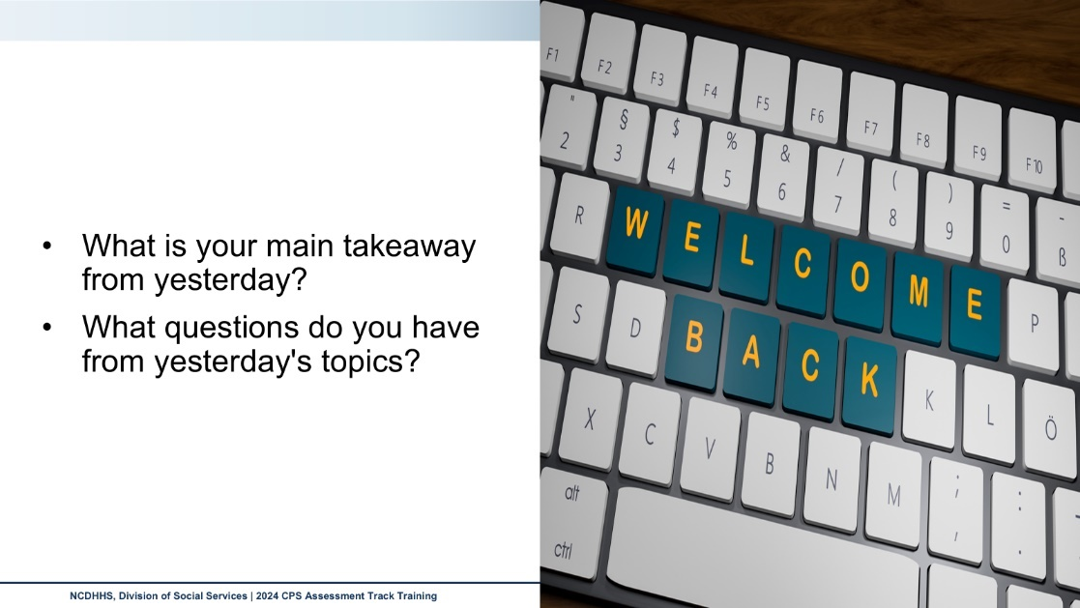
Use this outlined space to record notes from the introduction activity.

Family-Centered Practice

Family-Centered Practice
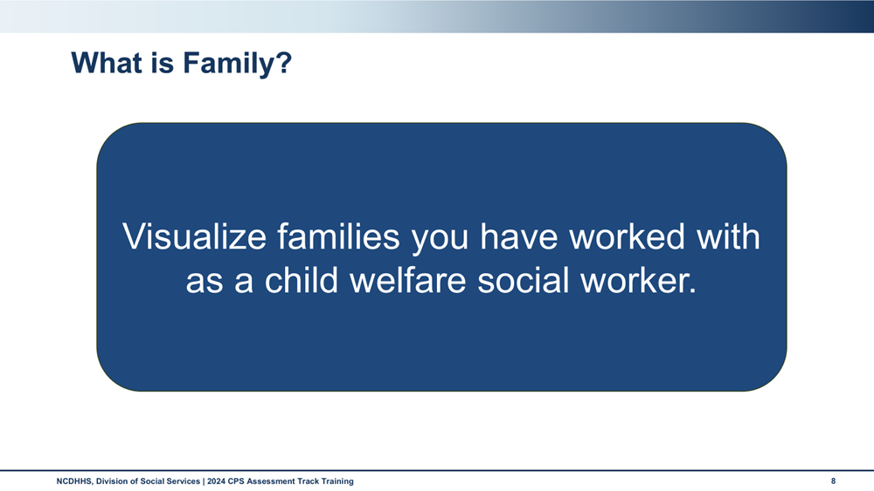
How do the families that you considered define the concept of “family”?
What definition of family do you use when working with families?
What are we missing when we make assumptions or limitations on the definition of family?

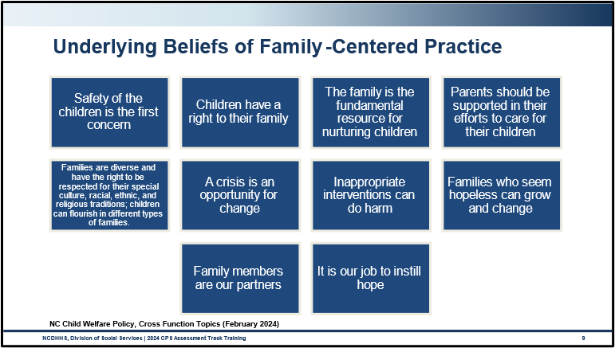
Use this space to record notes.

Handout: Underlying Beliefs of Family-Centered Practice and Principles of Partnership
Underlying Beliefs of Family-Centered Practice
Safety of the children is the first concern.
Children have a right to their family.
The family is the fundamental resource for nurturing children.
Parents should be supported in their efforts to care for their children.
Families are diverse and have the right to be respected for their special culture, racial, ethnic, and religious traditions; children can flourish in different types of families.
A crisis is an opportunity for change.
Inappropriate interventions can do harm.
Families who seem hopeless can grow and change.
Family members are our partners.
It is our job to instill hope.
Principles of Partnership
Everyone desires respect.
Everyone needs to be heard.
Everyone has strengths.
Judgments can wait.
Partners share power.
Partnership is a process.
Inappropriate interventions can do harm.
Families who seem hopeless can grow and change.
Family members are our partners.
It is our job to instill hope.

Use the space below as you consider the tasks and activities you do with families and on behalf of families that demonstrate each belief and principle.

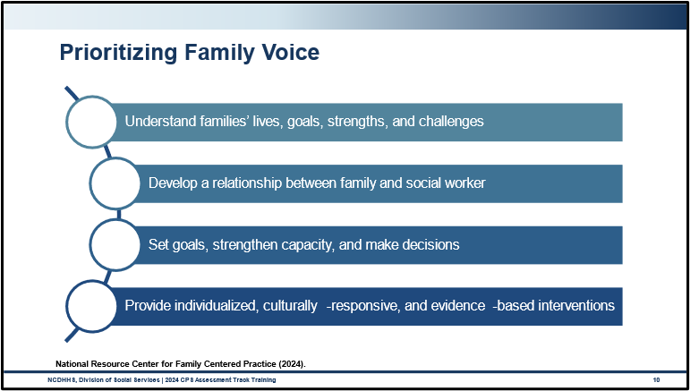
What difference does it make for families when you spend time engaging and building rapport?
Share a few examples of when our practice may be centered on the family and not “family-friendly.

What are some techniques you use to build relationships with families?
How do you elevate families’ voices?

Meet the Anchor Families
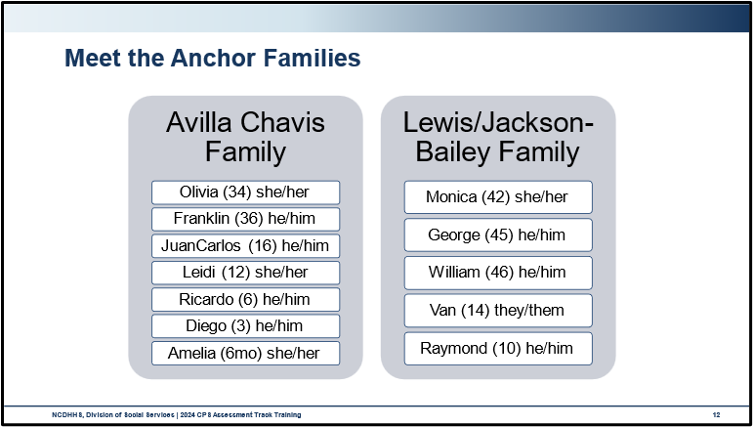
Use this space to record notes.

Worksheet: Meet the Anchor Families
Meet the Anchor Families
Avilla Chavis Family
Mother | Olivia Avilla Chavis, she/her, 34-year-old, Hispanic, radiology technician at a hospital
Father | Franklin Morelos Esquivel, he/him, 36-year-old, Hispanic, mechanic at an auto repair shop
Child | Amelia Morelos Avilla, female, 6 months, Hispanic, at home
Child | Diego Morelos Avilla, male, 3-year-old, Hispanic, at home
Child | Ricardo Morelos Avilla, he/him, 6-year-old, Hispanic, 1st grade Pineville Elementary
Child | Leidi Morelos Avilla, she/her 12-year-old, Hispanic, 6th grade, Williams Middle School
Child | JuanCarlos Morelos Garcia, he/him, 16-year-old, Hispanic, 11th grade, Williams High School
CPS History
11 years ago: CPS Assessment finding: Services provided; child protective services no longer needed. Report alleged chronic diaper rash and no supplies at daycare for 5-month-old Leidi. Infant was observed with red and raw diaper rash and mother, Olivia, was diagnosed with post-partum depression, with little support from father, Franklin. Interviews and collateral information indicated that this is an isolated incident for the family. Olivia was referred for mental health services and both parents were referred to parenting classes/birth to age 5.
2 years ago: CPS Assessment finding: Services Provided, child protective services no longer needed. Report alleged Diego and Ricardo were found alone in the neighborhood by a neighbor. Law enforcement and CPS responded to the scene and returned the children to the home, where they found the mother asleep and seemingly intoxicated. Interviews and collateral information indicated that this is an isolated incident for the family. Olivia was referred to behavioral health services.
Intake Report
The report was made by a neighbor, Tammy Kirby.
Report alleged that Ricardo, age 6, was at the park with his brother, Diego, age 3. Diego was running around on the playground and Ricardo was sitting on the swing when Reporter found them. Ricardo told Reporter that he “often” takes Diego to the park when he babysits for his mom. Reporter walked Ricardo and Diego home and when they entered the home, the Reporter observed that the children were home alone, with Leidi, age 12, left in charge. Leidi was putting Amelia, age 6mo down to nap and knew the children were at the park and did not think this was a problem. Reporter also observed that the home was very cluttered and had trash and spoiled food strewn about the living room.
The report was screened in for neglect, unsafe supervision, Family Assessment, immediate response time.
Provisional Harm: The parents leave Leidi (12) to supervise three children, Amelia (6mo), Ricardo (6), and Diego (3) which is more responsibility than a 12-year-old can manage. Ricardo took Diego to the park without an adult, which is dangerous as Ricardo is not old enough to supervise himself or babysit a younger child.
Provisional Worry: The reporter is worried Amelia, Diego, and Ricardo could be seriously hurt or injured or something bad might happen to them if they go to the park alone or are at home without an adult.
Reflection
What were your initial reactions to what you read about the Avilla Chaves family?
What are some alternative hypotheses for what may be going on or not going on with the family?

Lewis Family
Mother | Monica Lewis, she/her, 42, White, incarcerated
Father | George Jackson-Bailey, he/him, 45, White, shift manager at McDonald's
Stepfather | William Bailey-Jackson, he/him, 46, White, cashier/stocker at a grocery store
Child | Van (legal Vanessa) Jackson, they/them, 14, White, 8th Grade at Johnson Middle School
Child | Raymond Jackson, he/him, 10, White, 4th Grade at Johnson Elementary School
CPS History
6 months ago: CPS Family Assessment for neglect, unsafe discipline. Report alleged marks and bruises left on Raymond's buttocks because of spanking by his father, George. Slight bruising was observed on the upper buttocks. George expressed remorse. Interviews and collaterals indicated it was an isolated incident. Child Protective Services not needed as the safety of the children was not an issue and there was no concern for the future risk of harm to the children.
CPS Report
The report was made by Ms. McIntyre, the school counselor at Johnson Elementary School.
Report alleges that Raymond came to school today complaining of pain. Raymond told his teacher that he got into trouble the night before for “talking back” to his dad. The teacher sent Raymond to the school counselor who observed redness, light bruising, and swelling on Raymond’s buttocks, visible just above the waistband of his shorts which sit lower on his hips, and bruising that could be fingerprints on Raymond's left arm. When the school counselor asked Raymond about what happened, Raymond said “I don’t want to get Dad into trouble.” He wouldn’t speak about the matter any further.
The report was screened in as neglect, unsafe discipline. Family Assessment, 24-hour response.
Provisional Harm: Reporter believes that Raymond’s father hurt Raymond and Raymond has bruising and swelling on his buttocks and bruises that look like fingerprints on his arm. Raymond is in pain and is afraid his dad will get into trouble if he shares any more about what happened.
Provisional Worry: Raymond may be seriously injured and feel scared to the point of not being able to participate in school if his dad continues to hurt him.

Reflection
What were your initial reactions to what you read about the Lewis family?
What are some alternative hypotheses for what may be going on or not going on with the family?

Essential Function: Engaging

Family-Centered Practice
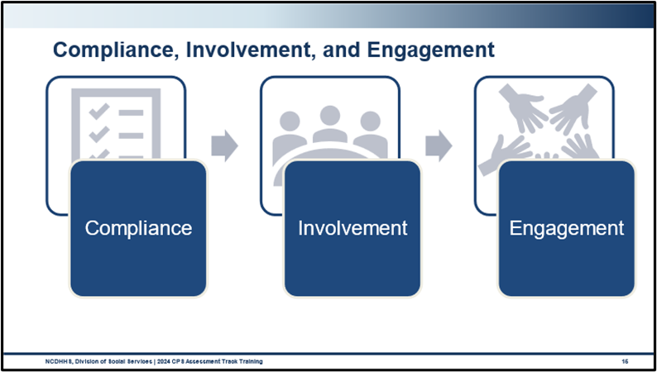
What is similar between these three concepts?
What is the difference between these concepts?
Are each of these terms important? How so?
Which concept will result in the best outcomes for children and families?
Why does this matter to your work with children and families?
What stands out to you in this discussion?
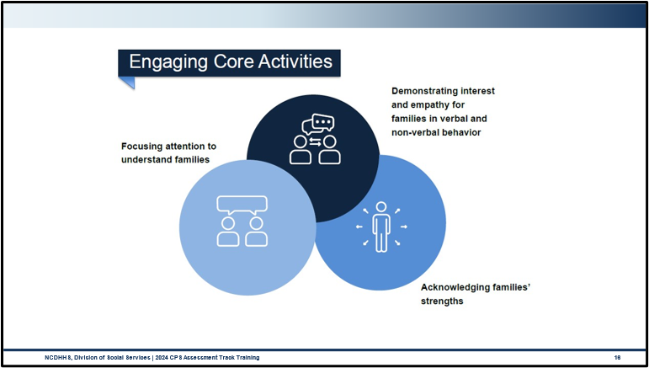
Were you aware of all the strategies that you employ to engage with children and families?
Are there activities, standards, or strategies that come more easily to you?
Are there activities, standards, or strategies that feel more challenging?
What do you need to grow your skill across all these areas?

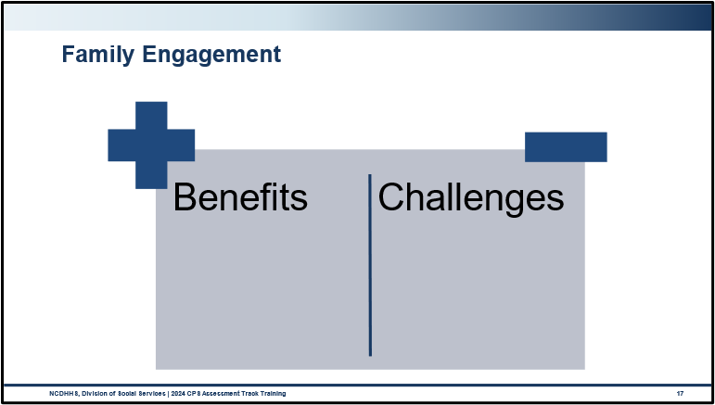
What are the benefits of family engagement?
What are the challenges of family engagement?

Interviewing
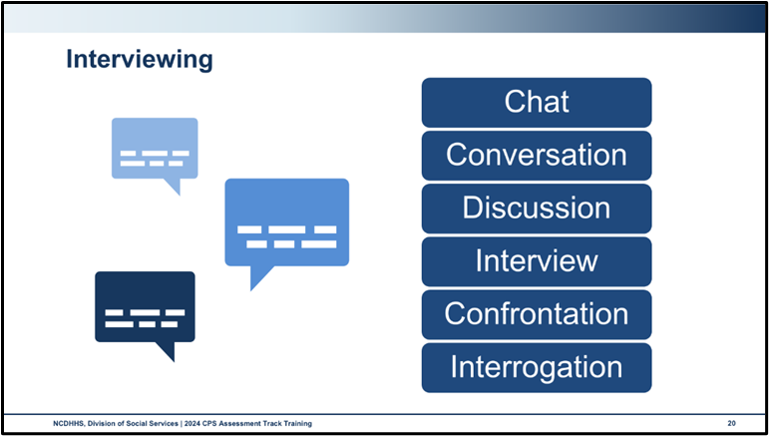
In what ways would you consider an interview practicing the engagement function?
What could happen if we rush through introductions and rapport building and move straight to discussions of the allegations?

What could happen if we miss planning and implementing components of interviewing and just focus on information gathering and assessing aspects?

As we delve into the skill of interviewing, keep in mind our role in CPS-Assessments is to ensure child safety.
The tools, concepts, and frameworks we are about to cover support us to engage families, build relationships, and support the fullest understanding of a family’s functioning, all of which support us in having a clear picture of a child’s safety within the home.

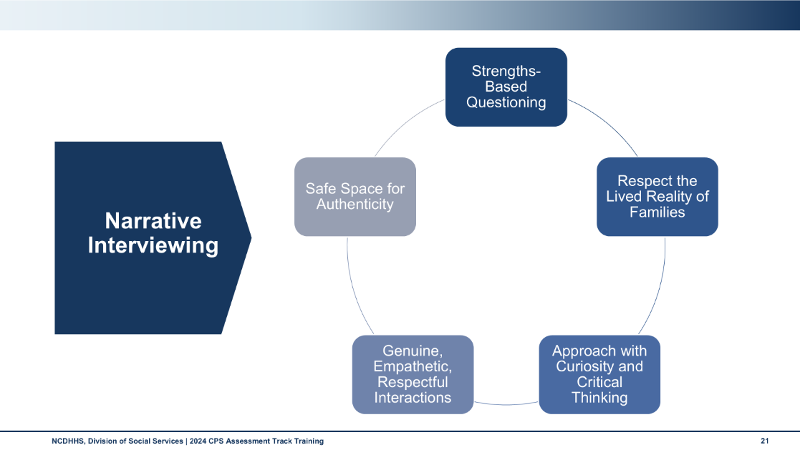
Use this space to record notes.

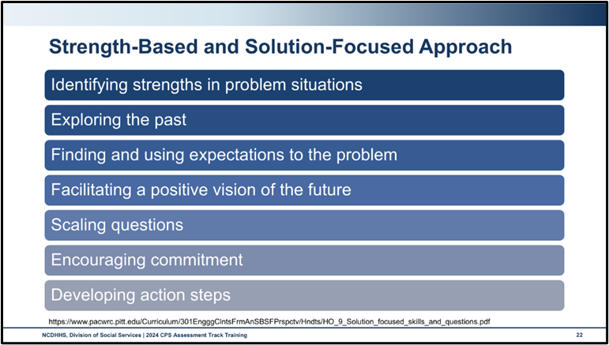
Use this space to record notes.

Handout: Solution-Focused Interviewing Skills and Questions
Open Ended Questions
Questions that encourage the client to use their own words and to elaborate on a topic. | Can you tell me about your relationship with your parents?  Tell me about your parenting experience.  Who are your supports and how do they help you?  Note: identify and reflect to clients any strengths or positive qualities clients may reveal in their responses to the open-ended questions.
Summarizing
Periodically state back to the client his/her thoughts, actions, and feelings. | So, what I hear you say is…  If I understand you correctly, you are saying that...  So, what you are saying is...  Right?
Tolerating/Using Silence
Allow 10, 15, 20 seconds or so to allow clients to come up with their own responses. Avoid the temptation to fill in silence with advice.
Complimenting
Acknowledging client strengths and past success. | As you were talking, I noticed that you have many strengths. You have...,  In the past, you have had successes evident by your ability to....
Affirming Client’s Perception
Perception is some aspect of a person’s self-awareness or awareness of their life. They include a person’s thoughts, feelings, behaviors, and experiences. Affirmation of the client’s perceptions is similar to reflective listening in form but does not isolate and focus on the feeling component per se, but on the client’s larger awareness. | That is very smart of you, let us explore this further...  You have a high-level of self-awareness, how would you like to use this information to move forward....

Working with Client’s Negative or Inaccurate Perceptions
Perceptions, even negative ones like suicide or assaultive behaviors should be explored to understand the full context.  Some perceptions may be obviously inaccurate and reflect a person’s denial of a problem. Avoid an immediate educative or dissuading response to negative or inaccurate perceptions. Listening and understanding are the social worker’s first obligations. | What’s happening in your life that tells you that hitting or suicide might be helpful in this situation?  How does it feel to say, “I don’t want to do this anymore?”  How might your life be different if you did hit him?  What are the pros and cons of your reaction?
Returning the Focus to the Client
Clients tend to focus on the problem and/or what they would like others to do differently. In the Solution-Focused approach, the client is encouraged to return the focus to themselves and to possible solutions. | “My kids are lazy. They don’t realize that I need help sometimes.” Response: “What gives you hope that this problem can be solved?” “I wish my parents would get with it. A 10:00 pm curfew on weekends is ridiculous.” Response: “When things are going better, what will your parents notice you doing differently?”  “My teachers are too hard. If they would back off all the homework and give more help my grades would improve.” Response “What is it going to take to make things even a little bit better?”  “If my boss would stop criticizing me and treating me like a child, I could be more productive.” Response “If your boss was here and I asked him what you could do differently to make it just a little easier for him not to be so critical, what do you think he would say?”

Exception Questions
Exception questions help clients think about times when their problems could have occurred but did not or at least were less severe. Exception questions focus on who, what, when, and where (the conditions that helped the exception to occur) NOT WHY; should be related to client goals. | Are there times when the problem does not happen or is less serious? When? How does this happen?  Have there been times in the last couple of weeks when the problem did not happen or was less severe?  How was it that you were able to make this exception happen?  What was different about that day?  If your friend (teacher, relative, spouse, partner, etc.) were here and I were to ask him what he noticed you doing differently on that day, what would he say? What else?
Coping Questions
Coping questions attempt to help the client shift his/her focus away from the problem elements and toward what the client is doing to survive the painful or stressful circumstances. They are related in a way to exploring for exceptions. | What have you found that is helpful in managing this situation?  Considering how depressed and overwhelmed you feel, how is it that you were able to get out of bed this morning and make it to our appointment (or make it to work)?  You say that you’re not sure that you want to continue working on your goals. What is it that has helped you to work on them up to now?

Scaling Questions
Scaling questions invite clients to put their observations, impressions, and predictions on a scale from 0 to 10, with 0 being no chance, and 10 being every chance. Questions need to be specific, citing specific times and circumstances. | On a scale of 0 to 10, with 0 being not serious at all and 10 being the most serious, how serious do you think the problem is now?  On a scale of 0 to 10, what number would it take for you to consider the problem to be sufficiently solved?  On a scale of 0 to 10, with 0 being no confidence and 10 being very confident, how confident are you that this problem can be solved?  On a scale of 0 to 10, with 0 being no chance and 10 being every chance, how likely is it that you will be able to say “No” to your boyfriend when he offers you drugs?  What would it take for you to increase, by just one point, your likelihood of saying “No”?  What’s the most important thing you have to do to keep things at a 7 or 8?
Indirect Relationship Questions
Indirect questions invite the client to consider how others might feel or respond to some aspect of the client’s life, behavior, or future changes. Indirect questions can be useful in asking the client to reflect on narrow or faulty perceptions without the worker directly challenging those perceptions or behaviors. | How is it that someone might think that you are neglecting or mistreating your children?  Has anyone ever told you that they think you have a drinking problem?  If your children were here (and could talk, if the children are infants or toddlers) what might they say about how they feel when you and your wife have one of those serious arguments?  At the upcoming court hearing, what changes do you think the judge will expect from you to consider returning your children?  How do you think your children (spouse, relative, caseworker, employer) will react when you make the changes we talked about?

Miracle Questions
The Miracle Question is a special type of preferred future question that can help people get clarity on how the problem impacts their daily life and what life would look like without the problem happening. | Imagine you woke up tomorrow and a miracle had happened overnight, and all the trouble was gone. How would you know it was over? What would be different that would tell you the problem was no longer happening? What is the first thing you would be doing to start the day? What would the rest of your day look like? What would things look like for your children?  If you could wave a magic wand and things, be different, what would that new state of being look like? What would it take to get there without the magic wand?

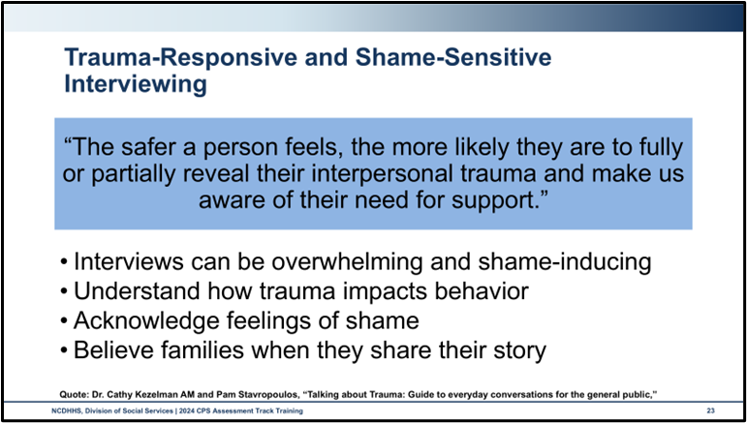
Use this space to record notes.

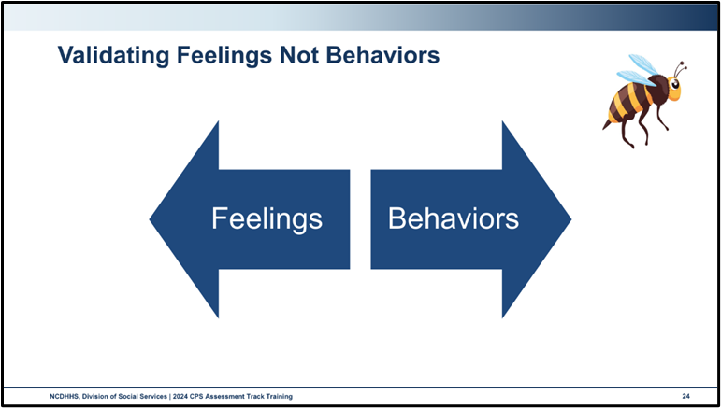
Use this space to record notes.

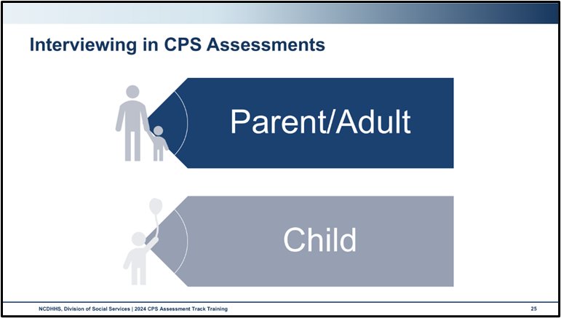
What is the definition of child development?
What are the key tasks in early childhood development?
What do children learn about the world from having secure, safe relationships with caregivers?
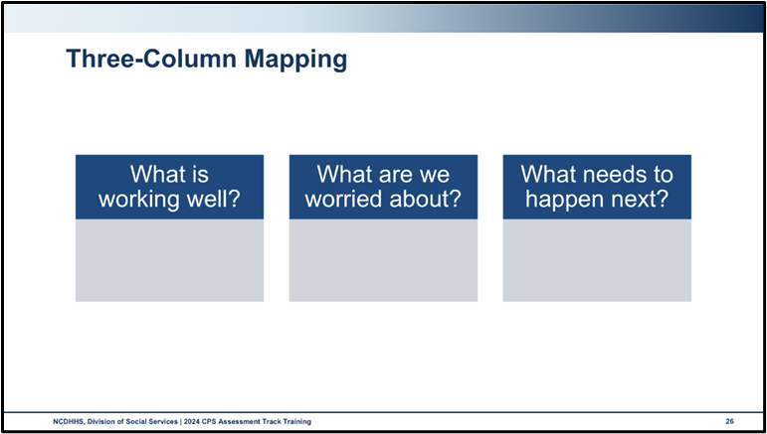
Use this space to record notes.

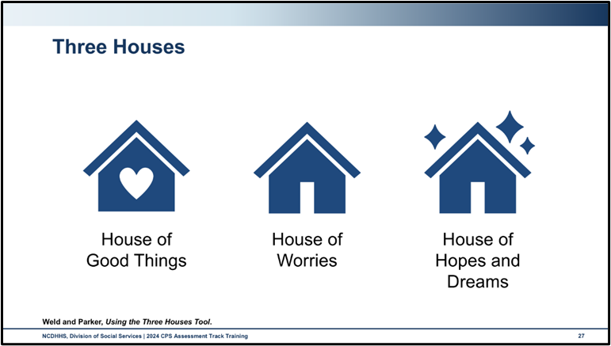
Use this space to record notes.

Engagement Skills Practice

Skills Practice: Initial Engagement with Parent

Handout: Observation and Feedback
Observation Quick Tips:
- Clear your mind and practice area of distractions
- Listen and observe intently and with purpose
- Look for strengths and opportunities for growth
Feedback Quick Tips:
- Ask your partner what they felt most comfortable doing and what was more difficult for them.
- Actively listen to your partner.
- Provide feedback building upon their self-assessment.
- Be clear, concise, and behaviorally specific.
- Be open and honest
- Start by identifying their strengths.
- Provide feedback on opportunities for improvement.
- Maintain their self-esteem without diminishing attention to the opportunities.
- Provide tips and suggestion
- Guide them in brainstorming and selecting the next steps.
Note: Apply SMART to feedback: Specific, Measurable, Achievable, Realistic., and Timely with feedback.
Receiving Feedback Tips:
- Be open
- Understand that growth is a constant process.
- We all learn from each other no matter what our role.
- Accept positive feedback.
- Have grace for yourself.
- The classroom is a safe place to practice and make mistakes.
- Strategize the next steps.
- Be clear about what works for you and what doesn’t in the learning process so the next steps are tailored to your needs.

Activity: Communicating Engagement
Scenario Updates
Avilla Chavis Family
Initial phone call:
Social Worker contacted Olivia via phone call. Immediately upon hearing Social Worker introduction, Olivia indicated she was on her way home because Leidi had called her and told her DSS was on their way. Olivia shared that Leidi is a good girl and that she watches the other children carefully. Olivia indicated that the social worker will see this when the social worker comes to the home. Olivia agreed to have all household members, including JuanCarlos and Franklin home as soon as possible, as social worker was leaving the office immediately and about fifteen minutes away from the home.
Entry into the home:
Franklin answered the door and told Social Worker that everything is fine. He indicated that there was no need for the Social Worker to enter the home or to check on everyone, as his family is okay; he makes sure of that. Olivia then came to the door and told Franklin that he needed to let the social worker in, that the social worker was just doing their job. Franklin sat on the couch and Olivia granted permission for the social worker to enter the home.
Observations of tour of the home:
- The family resides in a three-bedroom manufactured home. No concerns regarding sleeping space were noted.
  - Ricardo and JuanCarlos share one bedroom, with bunk beds and a desk in the room.
  - Diego and Amelia share a bedroom, with Diego in a toddler bed and Amelia sleeping in a crib. Crib was observed to have several stuffed animals and a blanket. Safe sleeping was discussed with parents, and items were removed before completion of the home visit.
  - Leidi sleeps in a small room off the living room that used to be Olivia’s office for privacy.
  - Olivia and Franklin share a bedroom.
- The home has working smoke detectors. Fire safety discussed with family.
- One shotgun reported and observed in the home. The shotgun with trigger lock stored separately from bullets in a locked closet of the parents’ bedroom. Firearm safety discussed with family with no concerns noted regarding firearm access.
- Adequate food was observed in the cabinets, pantry, and refrigerator.
- Home is free of hazards on initial walk through although kitchen requires further assessment, as bags of trash, food in various stages of preparedness, dirty dishes, etc. were observed piled on the counter and kitchen table.

Lewis Family
Initial phone call:
Social Worker contacted George via phone call to explain report had been received. George indicated that he couldn’t believe someone would report him, that everyone today has gotten soft with parenting.
Home Visit scheduled for 4 pm same day to initiate report with all household members.
Entry into the home:
William answered the door and immediately granted permission for the social worker to enter the home.
Observations of tour of the home:
- Raymond and Van share a bedroom in the two-bedroom apartment. No concerns noted regarding sleeping space.
- The home has working smoke detectors. Fire safety discussed with family.
- No firearms were reported nor observed. Firearm safety discussed with family.
- Adequate food was observed in the cabinets, pantry, and refrigerator.
- Social Worker toured the home and noted no concerns.
Use the space below to create a few narrative statements and open-ended questions to utilize in your interview with the parent.

Safety Focused

North Carolina Core Value: Safety Focused
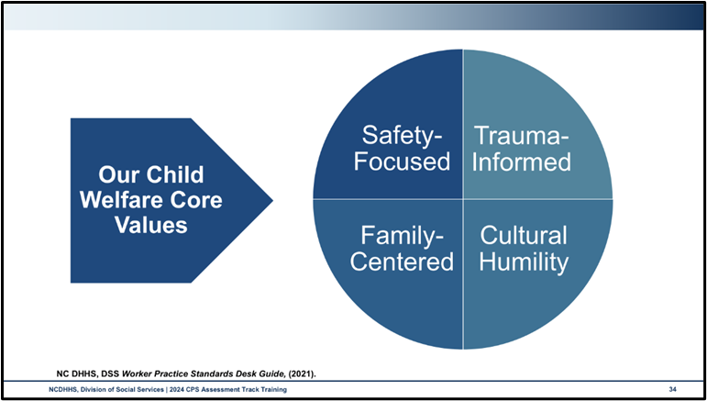
What role do you play in assuring your own personal safety?
What role do you play in assuring a child’s safety whose CPS Assessment has been assigned to you?
How do you prepare for this role?
How do you fulfill this role?
What is the likelihood that you will encounter domestic violence in your work with families?

What role do you play when you are responding as part of a larger, multidisciplinary team responding to concerns of child maltreatment?

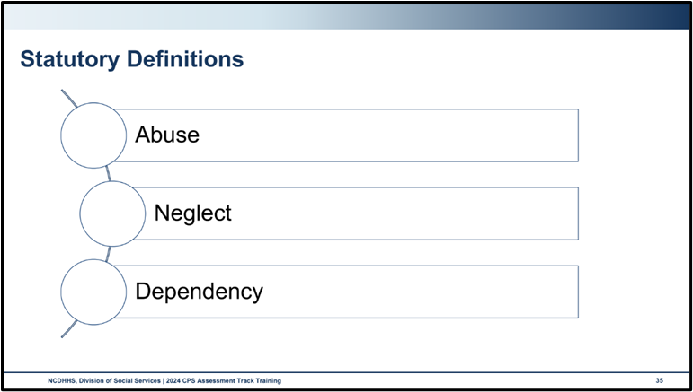
Definitions for Abused, Neglected, and Dependent Juvenile can be found in NCGS § 7B-101. Definitions.
Use this space to record notes.

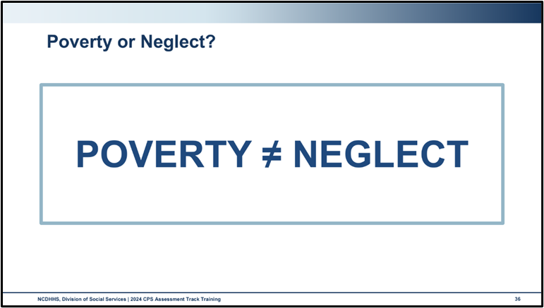
Use this space to record notes.

Activity: Family Accessible Language and Maltreatment Definitions
Create a poster with your group that includes:
- The definition as outlined in policy (for sexual abuse, it is okay to summarize)
- A list of behaviors or conditions that may be present in a home or family where this form of maltreatment is or has occurred
- A list of ways in which children are impacted by this form of maltreatment
- A revised definition in language you could use with a family
How was this activity?
What was the most challenging part?
After looking at each of the posters, are there any questions that came up for you?

Safety, Protective Capacities, and Risk
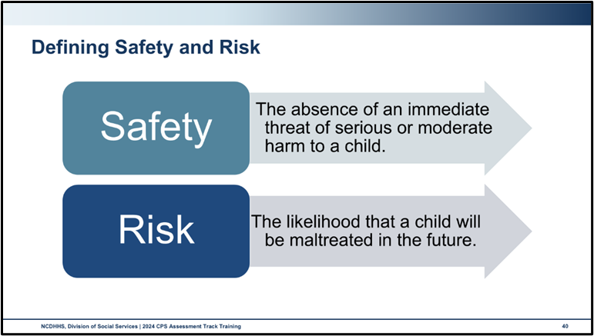
Use this space to record notes.

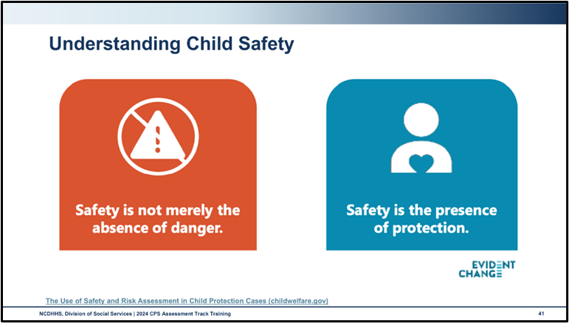
Use this space to record notes.

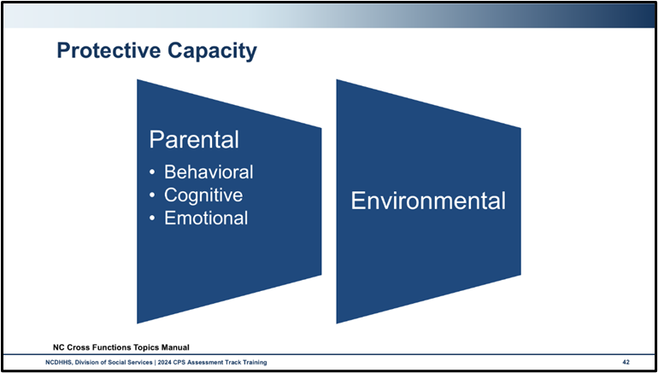
Use this space to record notes.

Handout: Protective Capacity
Protective capacity is defined as the ability and willingness to mitigate or ameliorate the identified safety and risk concerns. Protective capacity can be demonstrated by a parent through their statements, actions, and reactions. Protective capacity exists both within the parent/caretaker and within the family environment.
Parent/caretaker protective capacity should be assessed in three domains:
- Behavior characteristics
- Cognitive characteristics
- Emotional characteristics
Behavioral characteristics are defined as specific actions and activities consistent with and resulting in parenting and protective vigilance. Questions to consider include:
- Does the parent/caretaker have the capacity to care for the child? If the parent/caretaker has a disability(ies) (e.g., blindness, deafness, paraplegia, chronic illness), how has the parent/caretaker addressed the disability in parenting the child?
- Has the parent/caretaker acknowledged and acted to provide the needed support to effectively parent and protect the child?
- Does the parent/caretaker demonstrate activities that indicate putting aside one’s own needs in favor of the child’s needs (if appropriate)?
- Does the parent/caretaker demonstrate adaptability in a changing environment or during a crisis?
- Does the parent/caretaker demonstrate actions to protect the child?
- Does the parent/caretaker demonstrate impulse control related to a risk factor?
- Does the parent/caretaker have a history of protecting the child given any threats to the safety of the child?

Cognitive characteristics are defined as the parent/caretaker’s specific intellect, knowledge,
understanding, and perception that contributes to protective vigilance. Questions to consider include:
- Is the parent/caretaker oriented to time, place, and space? (i.e., reality orientation)
- Does the parent/caretaker have an accurate perception of the child? Does the parent/caretaker see the child as having strengths and weaknesses, or do they see the child as “all good” or “all bad”?
- Can the parent/caretaker recognize the child’s developmental needs or if the child has special needs?
- How does the parent/caretaker process the external stimuli? (e.g., a battered woman who believes she deserves to be beaten, because of something she has done)
- Does the parent/caretaker understand their role to provide protection to the child?
- Does the parent/caretaker have the intellectual ability to understand what is needed to raise and protect a child?
- Does the parent/caretaker accurately assess potential threats to the child?

Emotional characteristics are defined as the parent/caretaker’s specific feelings, attitudes, and identification with the child and motivation that results in parenting and protective vigilance. Questions to consider include:
- Does the parent/caretaker have an emotional bond with the child? Is there a reciprocal connectedness between the parent/caretaker and the child? Is there a positive connection to the child?
- Does the parent/caretaker have empathy for the child when the child is hurt or afraid?
- Is the parent/caretaker flexible under stress? Can the parent/caretaker manage adversity?
- Is the parent/caretaker able to control their emotions? If emotionally overwhelmed, does the parent/caretaker reach out to others or expect the child to meet the parent/caretaker’s emotional needs?
- Does the parent/caretaker consistently meet their own emotional needs via other adults, services?

Environmental Protective Capacities
While the assessment of the parent/caretaker’s protective capacities is critical, an assessment of environmental capacities may also mitigate the safety concerns/risk of harm to a child. Below are several categories of environmental protective capacities to be considered.
- Family/kinship relationships that contribute to the protection of the child; • Informal relationships
- Agency supports
- Community supports
- Financial status
- Spiritual supports
- For American Indians, the tribe
- Concrete needs being met (e.g., for food, clothing, shelter).
Citation: Cross Function Topics

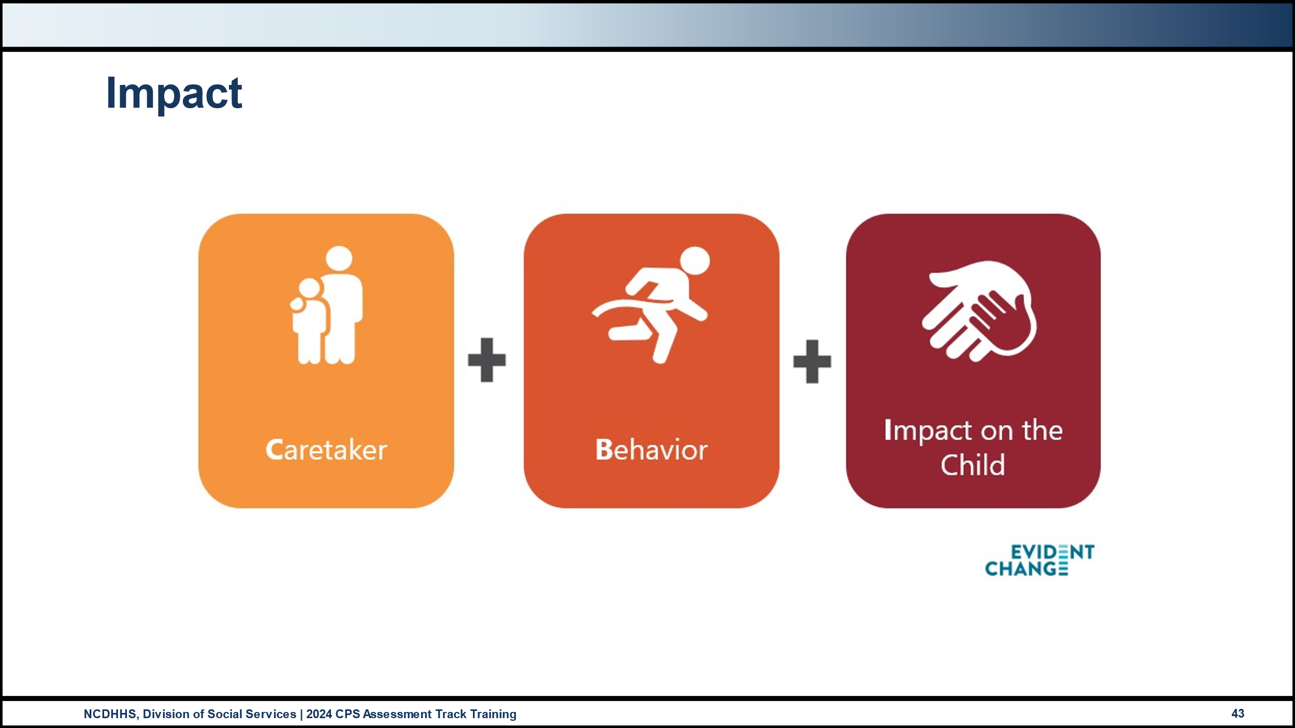
Use this space to record notes.

Worksheet: Distinguishing Safety and Risk
Read the scenario below. For each, decide if the scenario represents a safety threat or a risk factor. If a risk factor is decided, write one way that a parent or caregiver might mitigate or eliminate the risk.
Scenario One
A father was arrested for DWI after he was seen swerving and crossing the center line of the road. The three-year-old was in the car with him, as they were on the way to school.

Circle One: Safety Threat Risk Factor
If Risk Factor, one idea to mitigate or eliminate the risk:

Scenario Two
The mother is a single mother of five children. Two of the children are under 2 years old. She has limited support and inconsistently takes her medication for depression.. Her 12-year-old daughter takes on a parenting role when the mother has a mental health crisis.
Circle One: Safety Threat Risk Factor
If Risk Factor, one idea to mitigate or eliminate the risk:

Scenario Three
The mother and father are young parents of a toddler and an infant. They have unrealistic expectations of a two-year-old. They use physical discipline when their toddler does not listen to their directions. The toddler has no marks or bruises. The parents are tired and often have the infant sleep in the bed with them. The infant’s crib has stuffed animals and cute blankets in it.
Circle One: Safety Threat Risk Factor
If Risk Factor, one idea to mitigate or eliminate the risk:

Scenario Four
A mother has a history of substance use disorder involving alcohol. She has several past DWIs, the most recent 6 months ago. She is the only adult in the household and the 6-year-old has been suspended from the bus for the next two weeks due to aggressive behavior.

Circle One: Safety Threat Risk Factor
If Risk Factor, one idea to mitigate or eliminate the risk:

Scenario Five
The father is a person with Schizophrenia. He is a single father of five children. Two of the children are under 2 years old. He recently moved to North Carolina from Florida and has limited support. His 12-year-old daughter called 911 when her father had a psychosis episode and attempted to drown his 4-year-old son stating that he was the devil. Emergency technicians verified that the daughter had successfully resuscitated her brother.
Circle One: Safety Threat Risk Factor
If Risk Factor, one idea to mitigate or eliminate the risk:

Essential Function: Assessing

Assessing
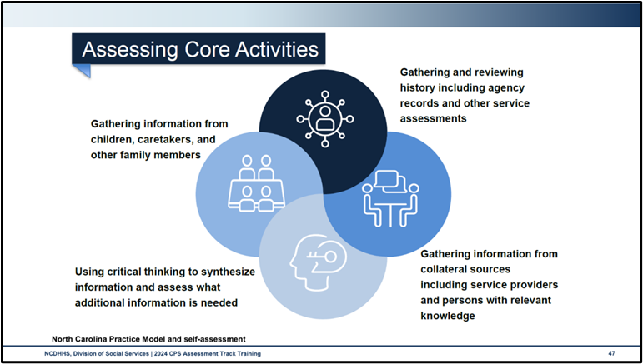
Use this space to record notes.

Handout: Assessing Self-Assessment
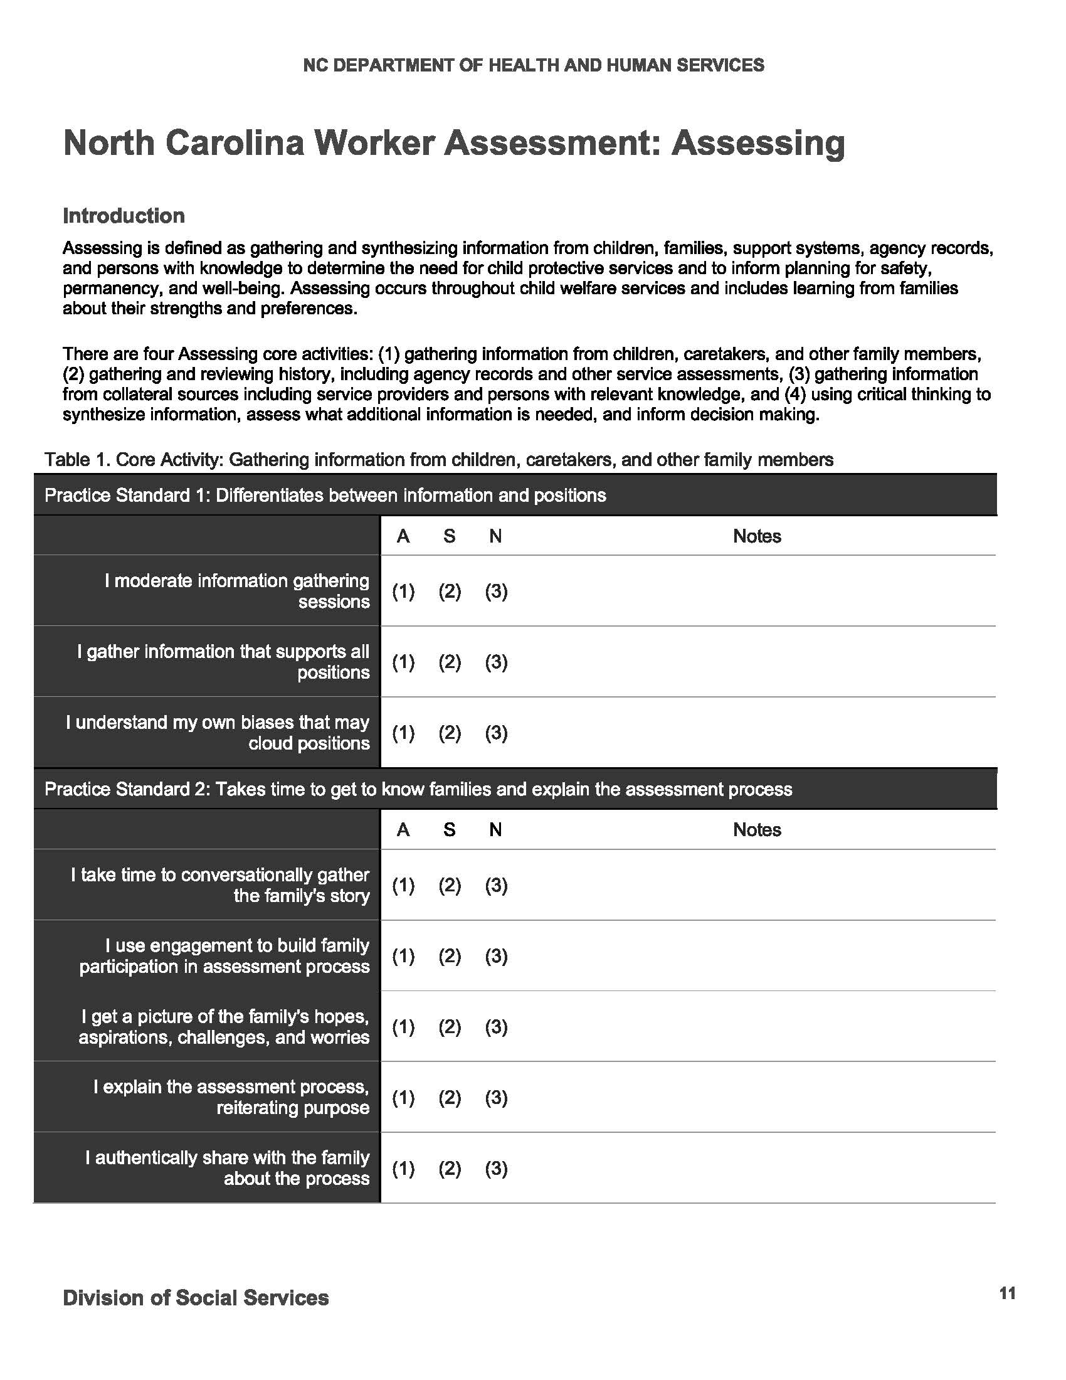

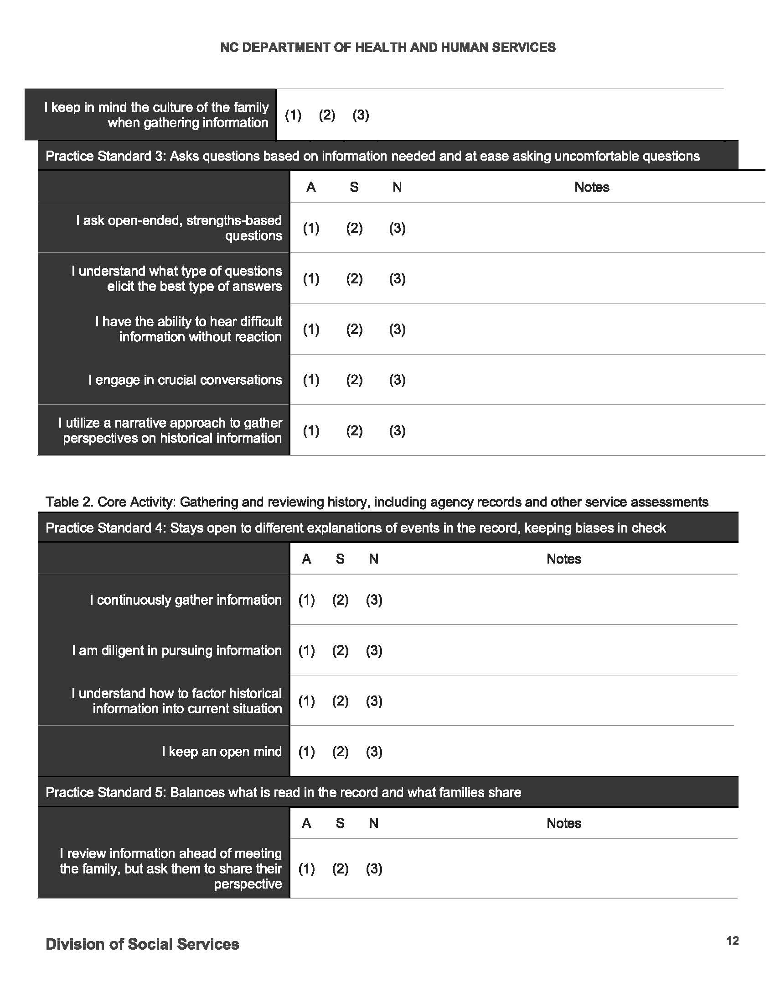

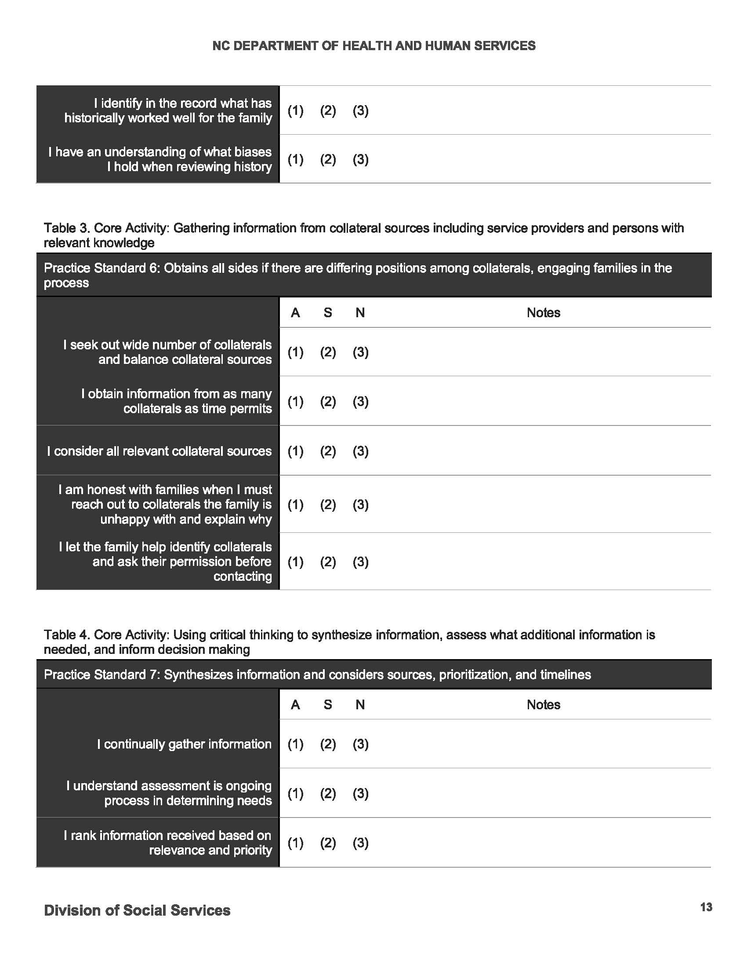

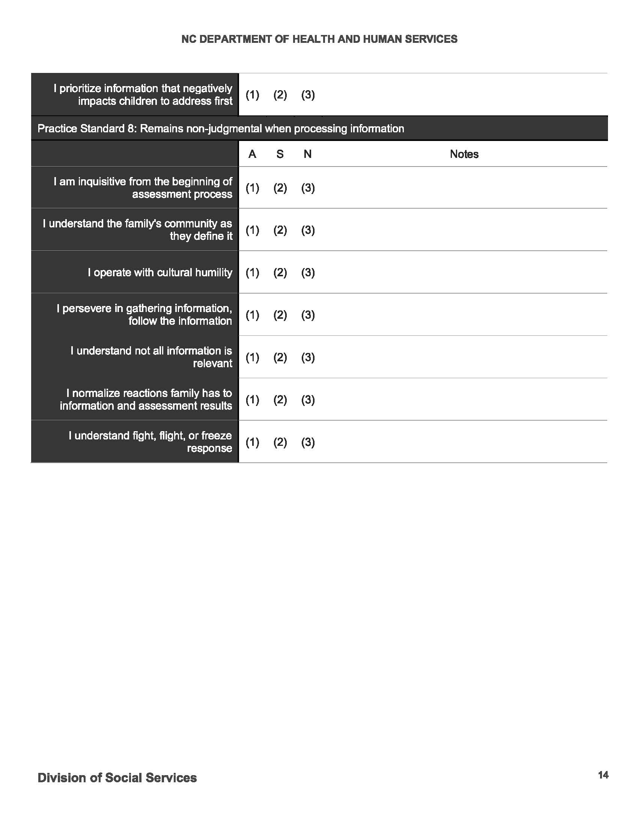

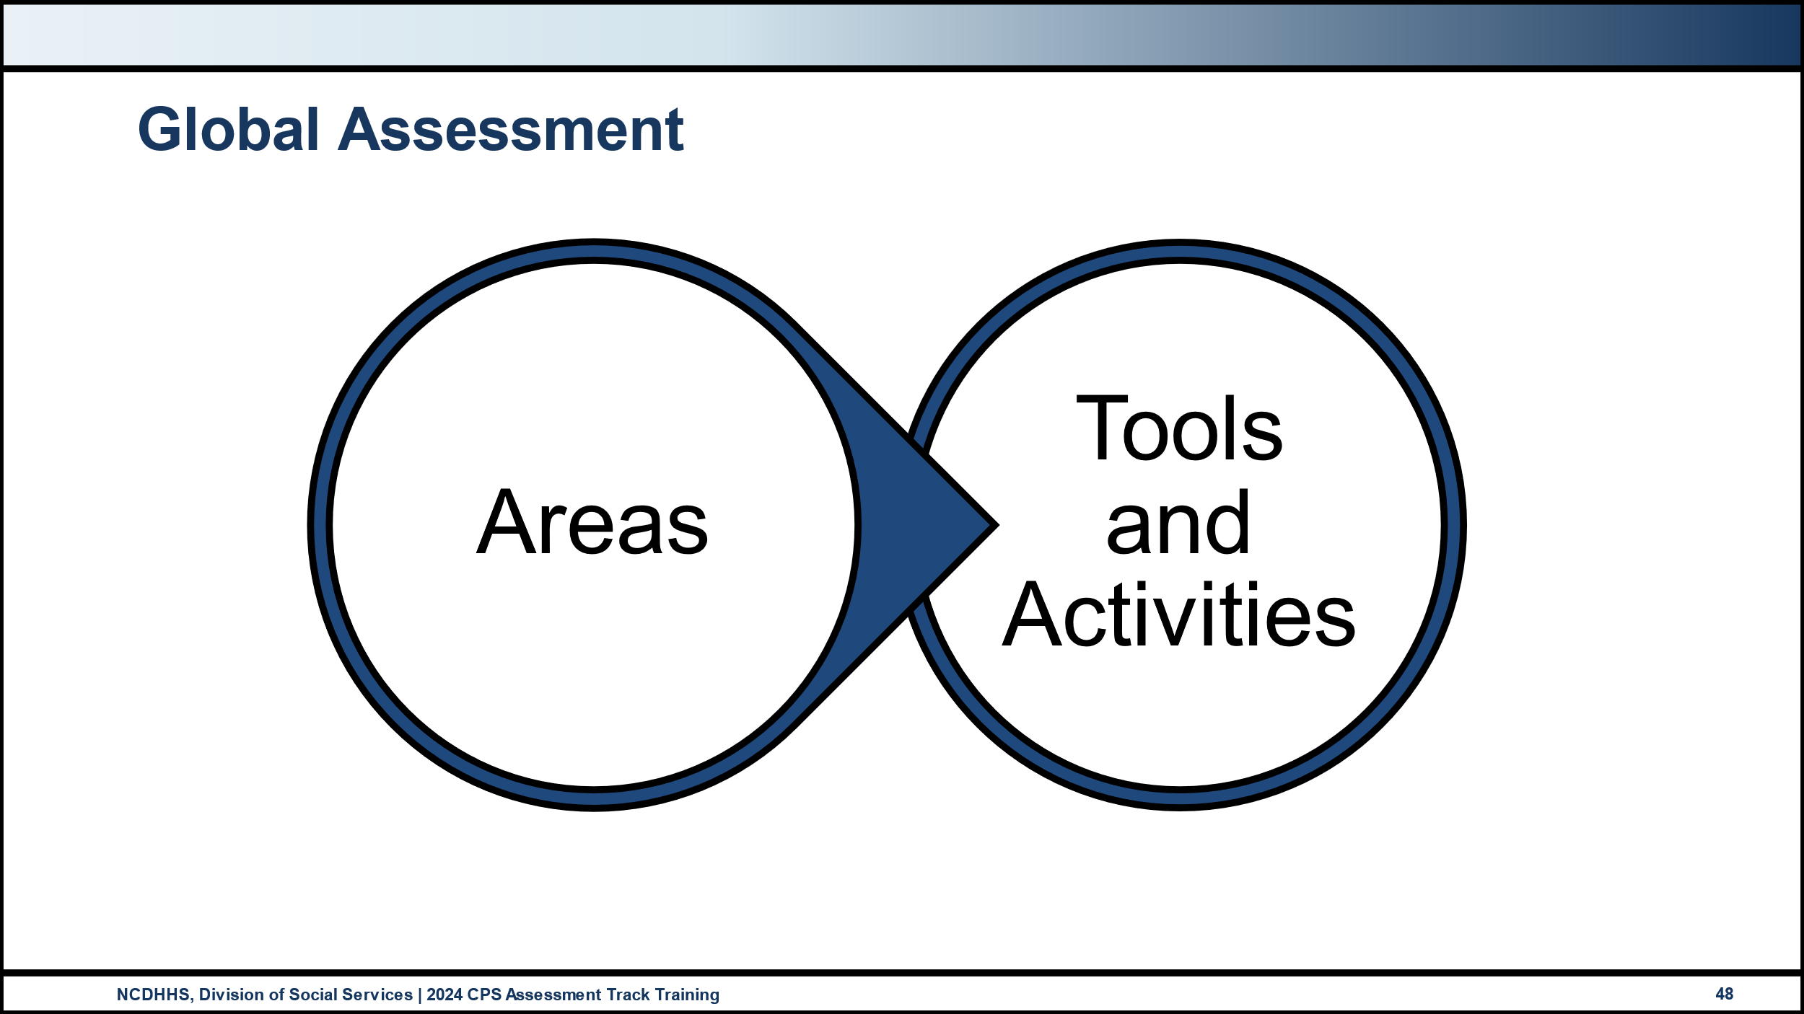
Use this space to record notes.

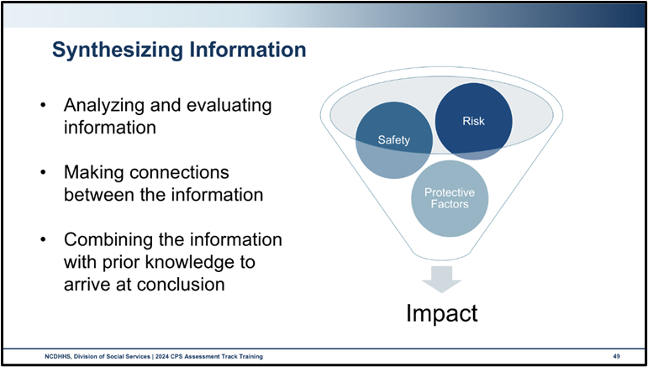
Use this space to record notes.

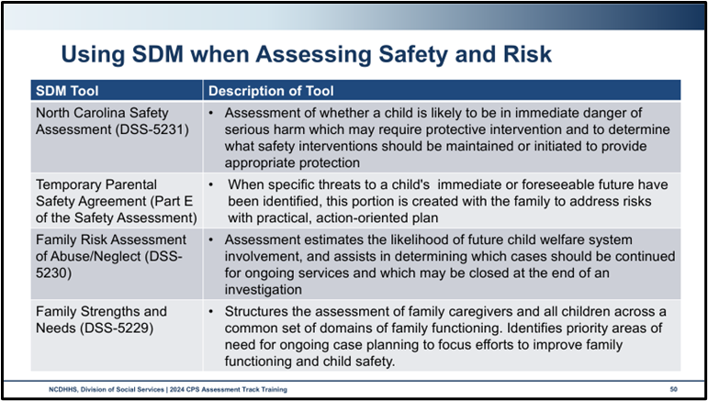
Why is it best practice to complete the SDM tools in collaboration with the family?

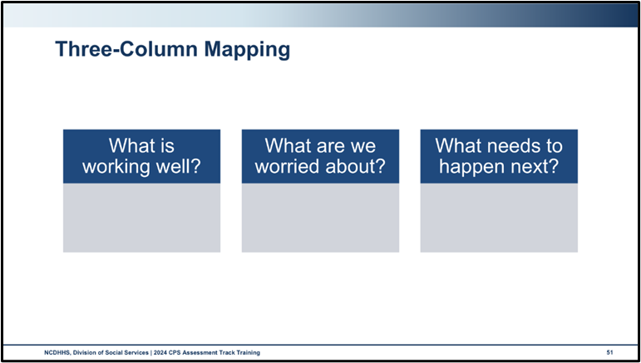
How might using Three-Column Mapping support you in your assessment?

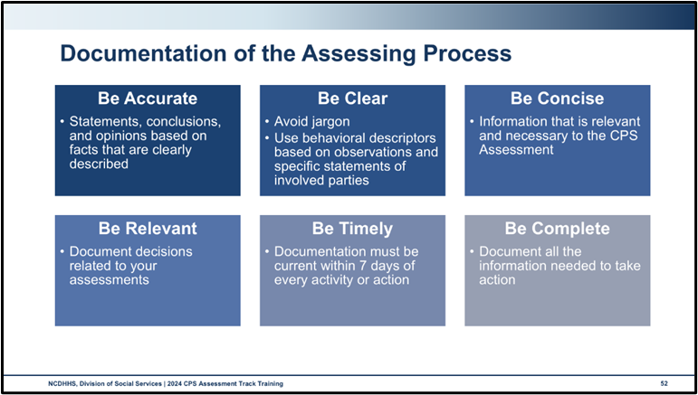
What are some of the ways you demonstrate non-judgmental and respectful documentation?

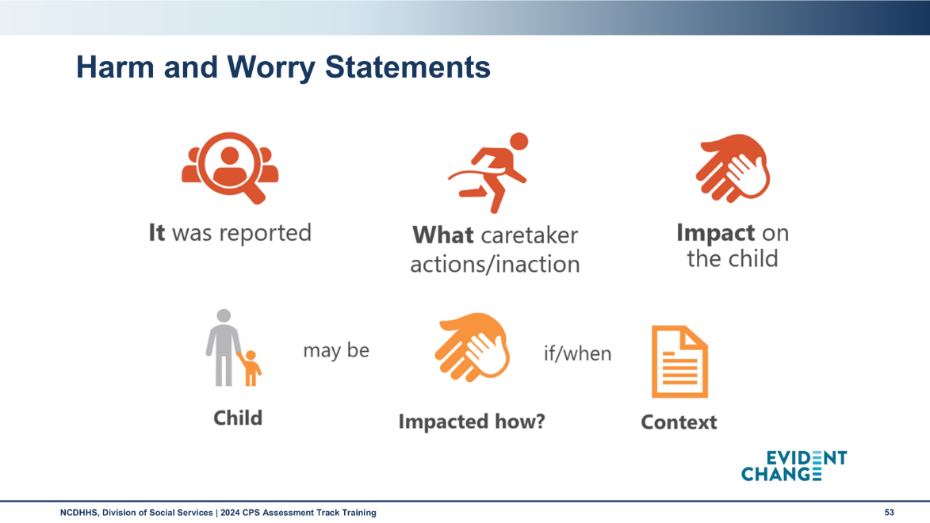
Use this space to record notes.

End-of-Day Values Reflection

Questions and Reflections.
Use this space to record questions and reflections about what you have learned.

Bibliography of References
Day Two
Adverse childhood experiences study. (2024). Acestudy.org. [Website]. www.acestudy.org
Alliance for Child Welfare Excellence. (2020, October 1). Regional Core Training – Interviewing Adults Handouts. Rise with the Alliance. https://risewiththealliance.org/home/regional-core-training-interviewing-adults-handouts/
CalSWEC Online, (2019, April 29) Child Welfare Worker Realistic Job Preview. [Video]. YouTube.com.https://www.youtube.com/watch?v=2aoOYAwgp2o&list=PLNYfSDZN2XUpWQ62KzijZDZ_g2VEjlSGD&index=1
Casey Family Programs, (2019, January 18) Jeremiah Donier: Birth dad winner. [Video]. YouTube.com. https://www.youtube.com/watch?v=yxBeN5-Rq_E&t=249s
Child Welfare Information Gateway. (n.d.). Separating poverty from neglect. Washington, DC: U.S. Department of Health and Human Services, Administration for Children and Families, Children's Bureau. https://www.childwelfare.gov/topics/prevention/separating-poverty-neglect/?top=89
Child Welfare Information Gateway. (2020, October) How the Child Welfare system works. Washington, DC: U.S. Department of Health and Human Services, Administration for Children and Families, Children's Bureau. https://www.childwelfare.gov/pubPDFs/cpswork.pdf
Child Welfare Information Gateway. (2021, March). The use of safety and risk assessments in Child Protection cases. Washington, DC: U.S. Department of Health and Human Services, Administration for Children and Families, Administration on Children, Youth, and Families, Children’s Bureau. (March 2021). https://cwig-prod-prod-drupal-s3fs-us-east-1.s3.amazonaws.com/public/documents/safety_risk.pdf?VersionId=ssUjM9eGAF05e9YAiAkm8zjJ_AibAyRS
Child Welfare Information Gateway. (2021). Family engagement: Partnering with families to improve child welfare outcomes. Washington, DC: U.S. Department of Health and Human Services, Administration for Children and Families, Children's Bureau. https://www.childwelfare.gov/pubs/f-fam-engagement/
Child Welfare Information Gateway. (2014, July 23) Child and family services reviews quick reference items list. Washington, DC: U.S. Department of Health and Human Services, Administration for Children and Families, Children’s Bureau. https://www.acf.hhs.gov/sites/default/files/documents/cb/cfsr_quick_reference_list.pdf.
Child Welfare Information Gateway. (2023). Child Welfare Policy Manual. Washington, DC: United States Department of Health and Human Services, Administration for Children and Families, Children’s Bureau. Retrieved from https://www.acf.hhs.gov/ on 12 Nov 2023.
D’Aunno, L.E., Boel-Studt, S., & Landsman, M.J. (2014). Evidence-based elements of Child Welfare in-home services. Journal of Family Strengths 14(1): Article 3. DOI: https://doi.org/10.58464/2168-670X.1247
Dolezal, L., & Gibson, M. (2022). Beyond a trauma-informed approach and towards shame-sensitive practice. Humanities & social science communities 9: 214. https://doi.org/10.1057/s41599-022-01227-z
Evident Change. (2022, March 30). Back To Basics-Safety and Risk Webinar #2/Safety and Risk Assessment Key Elements. Family & Children’s Resource Program. https://fcrp.unc.edu/resources/back-to-basics-safety-and-risk-webinar-2-safety-and-risk-assessment-key-elements/
Evident Change. (2024). Three Questions: Making a Rigorous and Balanced Assessment eLearning. Safety-Organized Practice.
Gerald R. Sherratt Library. (2024). Information Synthesis. Cedar City, Utah: Southern Utah University. https://library.suu.edu/LibraryResearch/information-synthesis
Juvenile Code, Article 1 – Abuse, Neglect, Dependency Definitions. North Carolina Stat. §7B-101. (1979, rev. 2021). https://www.ncleg.net/EnactedLegislation/Statutes/HTML/ByChapter/Chapter_7B.html
Kezelman C., & Stavropoulos P. (2017) Talking about Trauma: Guide to Everyday Conversations for the General Public. Milsons Point, NSW, Australia: Blue Knot Foundation. https://www.tfec.org/wp-content/uploads/Talking-About-Trauma-in-Public.pdf
Lund, T.R. & Renne, J. (2009). Child safety: A guide for judges and attorneys. Washington, DC: American Bar Association. https://www.americanbar.org/content/dam/aba/administrative/child_law/child-safety-guide.pdf
National Council of Juvenile and Family Court Judges. (2018). Distinguishing Poverty Experienced by Families from Child Neglect. Linking Systems of Care for Children and Youth Project. https://www.ncjfcj.org/wp-content/uploads/2021/11/Distinguishing-Poverty.pdf
Newlin, C., Cordisco Steele, L., Chamberlin, A., Anderson, J., Kenniston, J., Russell, A., Stewart, H., & Vaughan-Eden, V. (2015). Child forensic interviewing: Best practices. (2015). Retrieved from https://www.ojjdp.gov/pubs/248749.pdf on 30 January 2024.
North Carolina Department of Health and Human Services, Division of Social Services. (2002). What is forensic interviewing? Children’s services practice notes 8(2). https://practicenotes.org/vol8_no1/what_is.htm
North Carolina Department of Health and Human Services, Division of Social Services, Child Welfare Services. (2017). North Carolina Safety Assessment. https://policies.ncdhhs.gov/wp-content/uploads/dss-5231-ia.pdf
North Carolina Department of Health and Human Services, Division of Social Services. (2019). Assessing safety and risk. Children’s services practice notes 24(2). https://practicenotes.org/v24n2.htm
North Carolina Department of Health and Human Services, Division of Social Services. (2020, May). CPS Purpose & Philosophy, Legal Basis, Administration: NC Child Welfare manual, 9. https://policies.ncdhhs.gov/wp-content/uploads/purpose.pdf
North Carolina Department of Health and Human Services, Division of Social Services. (2021). North Carolina practice standards worker assessment. https://www.ncdhhs.gov/cw-worker-north-carolina-worker-assessment-all-practice-standards/open
North Carolina Department of Health and Human Services, Division of Social Services. (2021). Worker practice standards desk guide. https://www.ncdhhs.gov/cw-worker-north-carolina-worker-practice-standards-desk-guide/open
North Carolina Department of Health and Human Services, Division of Social Services. (2024, April). Cross function topics: NC Child Welfare manual. https://policies.ncdhhs.gov/wp-content/uploads/In-Home_April-2024_2.pdf
North Carolina Department of Health and Human Services, Division of Social Services. (2024, August). CPS Assessments Policy, Protocol, and Guidance: NC Child Welfare manual. https://policies.ncdhhs.gov/wp-content/uploads/CPS-Assessments-Aug-2024.pdf
North Carolina Department of Health and Human Services, Division of Social Services. (2024, August). CPS Intake Policy, Protocol, and Guidance: NC Child Welfare manual. https://policies.ncdhhs.gov/wp-content/uploads/CPS-Intake_Aug-2024.pdf
The Pennsylvania Child Welfare Resource Center. (n.d.). Engaging Clients from a Strength-Based, Solution-Focused Perspective, Handout #9, Page 1 of 4. Pittsburgh, PA: University of Pittsburgh. https://www.pacwrc.pitt.edu/Curriculum/301EngggClntsFrmAnSBSFPrspctv/Hndts/HO_9_Solution_focused_skills_and_questions.pdf
Platt, D. (2012, May). Understanding parental engagement with child welfare services: An integrated model, Child and family social work 17(2): 138-148. https://doi.org/10.1111/j.1365-2206.2012.00828.x
Roose, R., Roets, G., Van Houte, W., Vandenhole, W., & Reynaert, D. (2013). From parental engagement to the engagement of social work services: Discussing reductionist and democratic forms of partnership with families. Child & Family Social Work 18(4): 449-457.
Toros, K., DiNitto, D.M., & Tiko, A. (2018, May). Family Engagement in the child welfare system: A scoping review. Children and youth services review 88: 598-607. https://doi.org/10.1016/j.childyouth.2018.03.011.
Weld, N. & Parker, S. (n.d.). Using the Three Houses Tool. Partnering for Safety. https://www.partneringforsafety.com/uploads/2/2/3/9/22399958/three_houses_booklet_updated.pdf
Wessells, M.G. (2015). Bottom-up approaches to strengthening child protection systems: Placing children, families, and communities at the center. Child abuse & neglect 43: 8-21.
Yordy, J. (2023, February 1). Poverty and Child Neglect: How did we get it wrong? Washington, DC: National Conference of State Legislatures. https://www.ncsl.org/state-legislatures-news/details/poverty-and-child-neglect-how-did-we-get-it-wrong

Appendix: Handouts
Underlying Beliefs of Family-Centered Practice and Principles of Partnership 2
Family Engagement: Partnering With Families to Improve Child Welfare Outcomes 3
Beyond a Trauma-Informed Approach and Towards Shame-Sensitive Practice 20
Solution-Focused Interviewing Skills and Questions 30
Protective Capacity 38
Assessing Self-Assessment 41

Underlying Beliefs of Family-Centered Practice and Principles of Partnership
Underlying Beliefs of Family-Centered Practice
Safety of the children is the first concern.
Children have a right to their family.
The family is the fundamental resource for nurturing children.
Parents should be supported in their efforts to care for their children.
Families are diverse and have the right to be respected for their special culture, racial, ethnic, and religious traditions; children can flourish in different types of families.
A crisis is an opportunity for change.
Inappropriate interventions can do harm.
Families who seem hopeless can grow and change.
Family members are our partners.
It is our job to instill hope.
Principles of Partnership
Everyone desires respect.
Everyone needs to be heard.
Everyone has strengths.
Judgments can wait.
Partners share power.
Partnership is a process.
Inappropriate interventions can do harm.
Families who seem hopeless can grow and change.
Family members are our partners.
It is our job to instill hope.

Family Engagement: Partnering With Families to Improve Child Welfare Outcomes
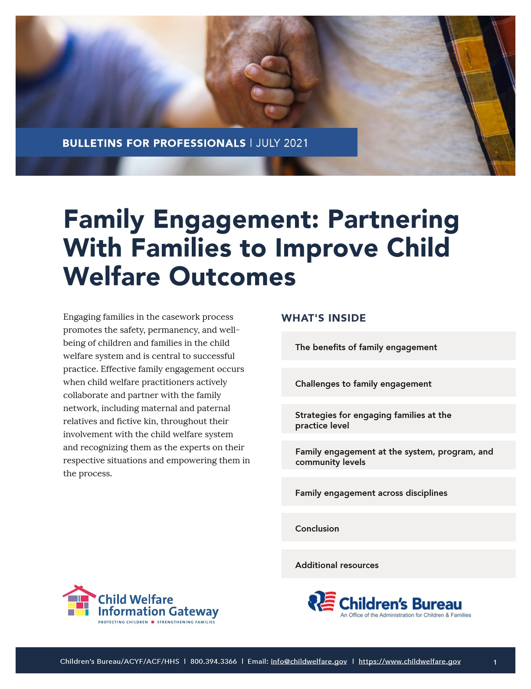
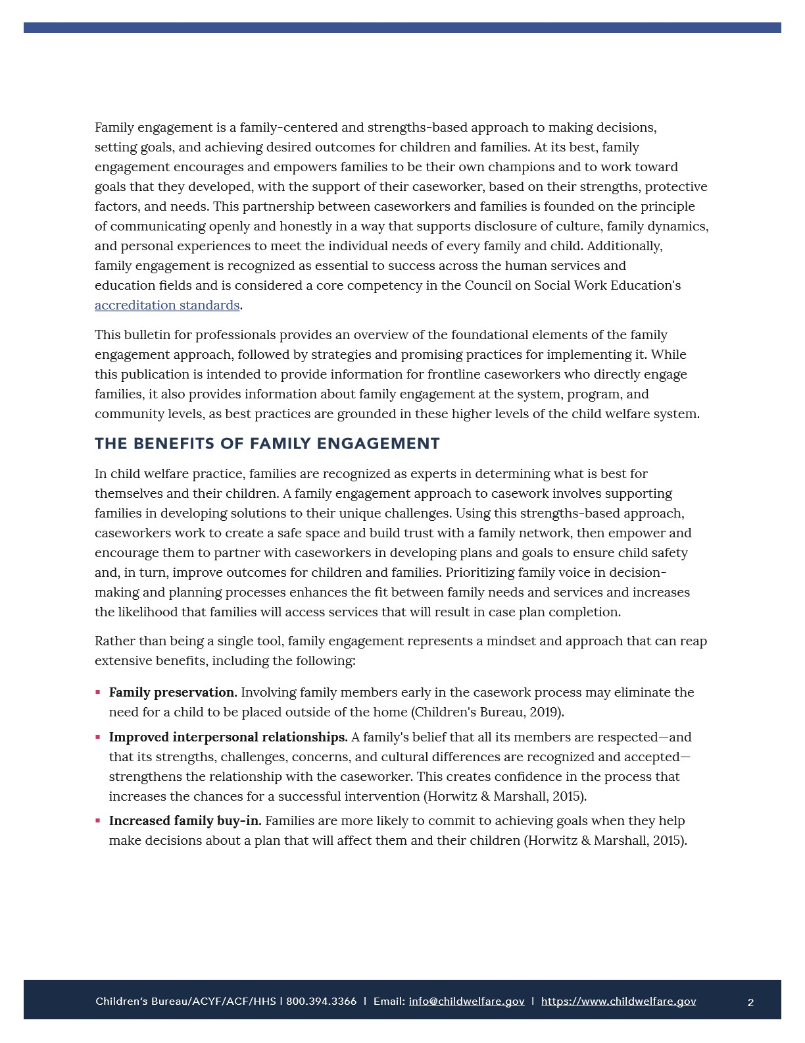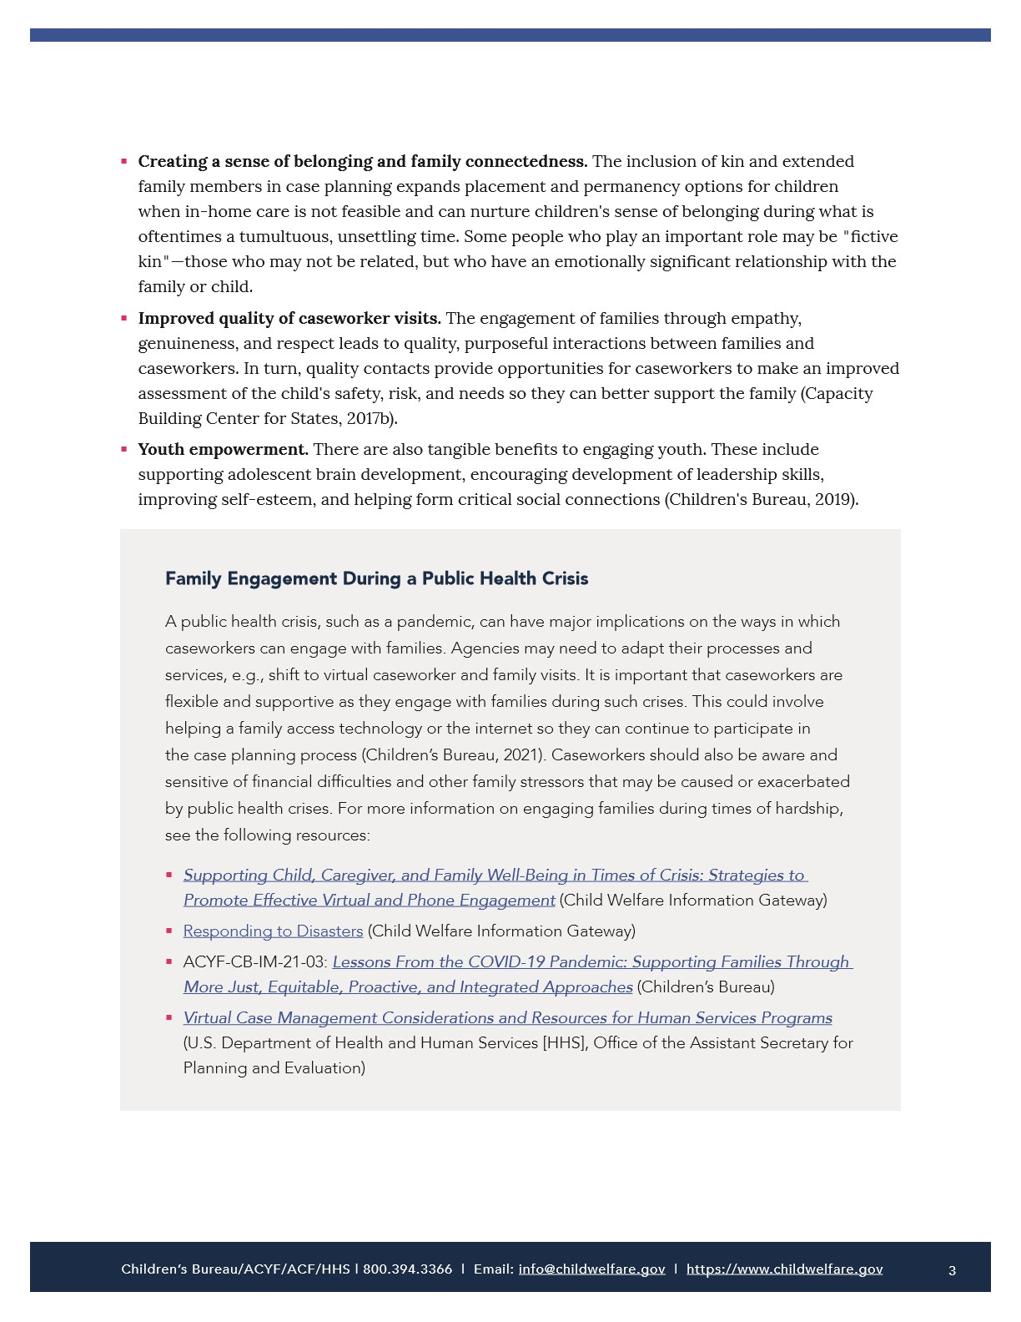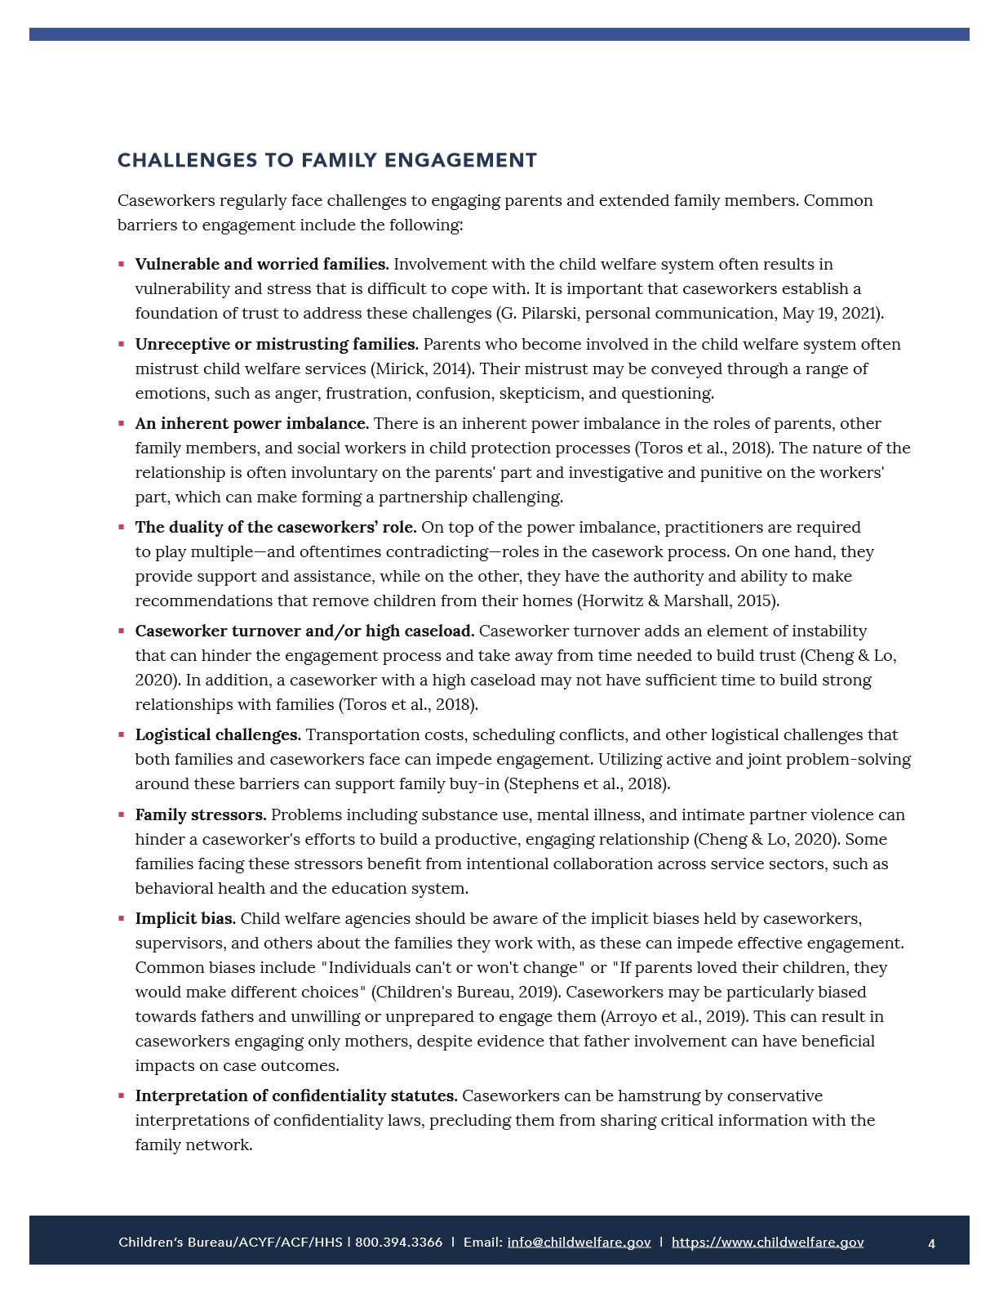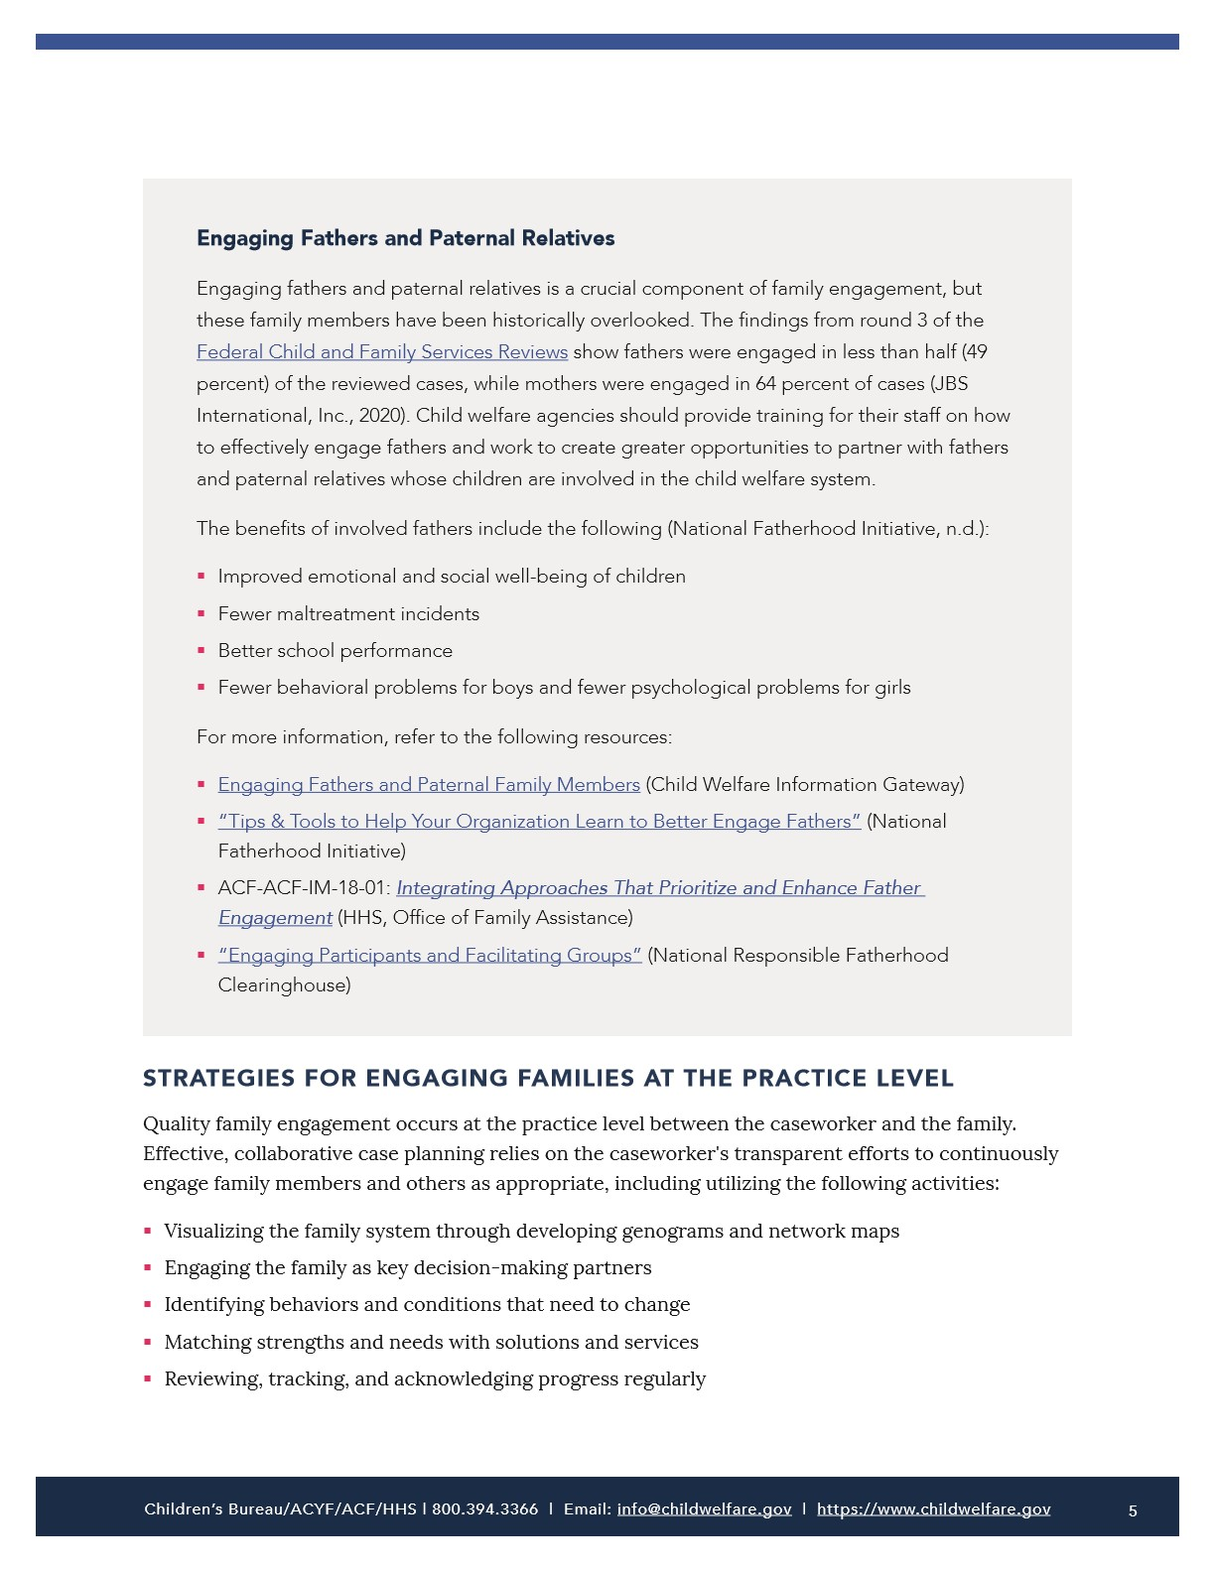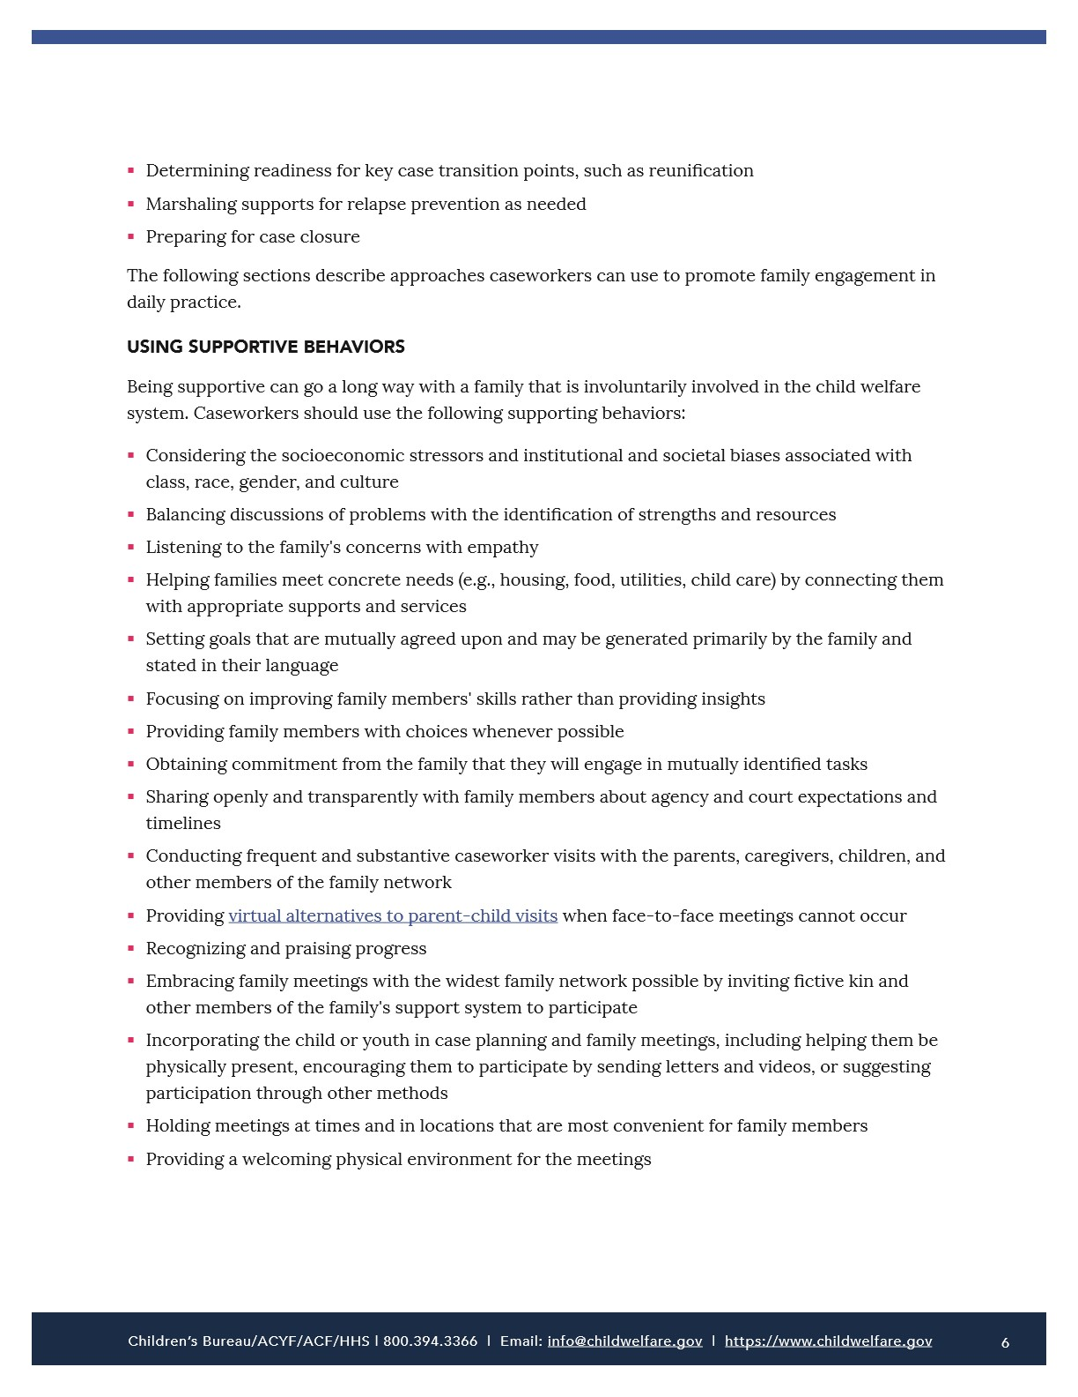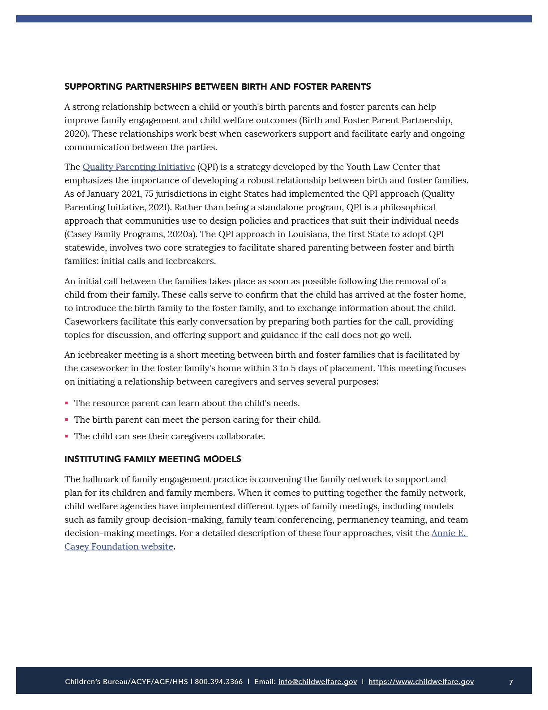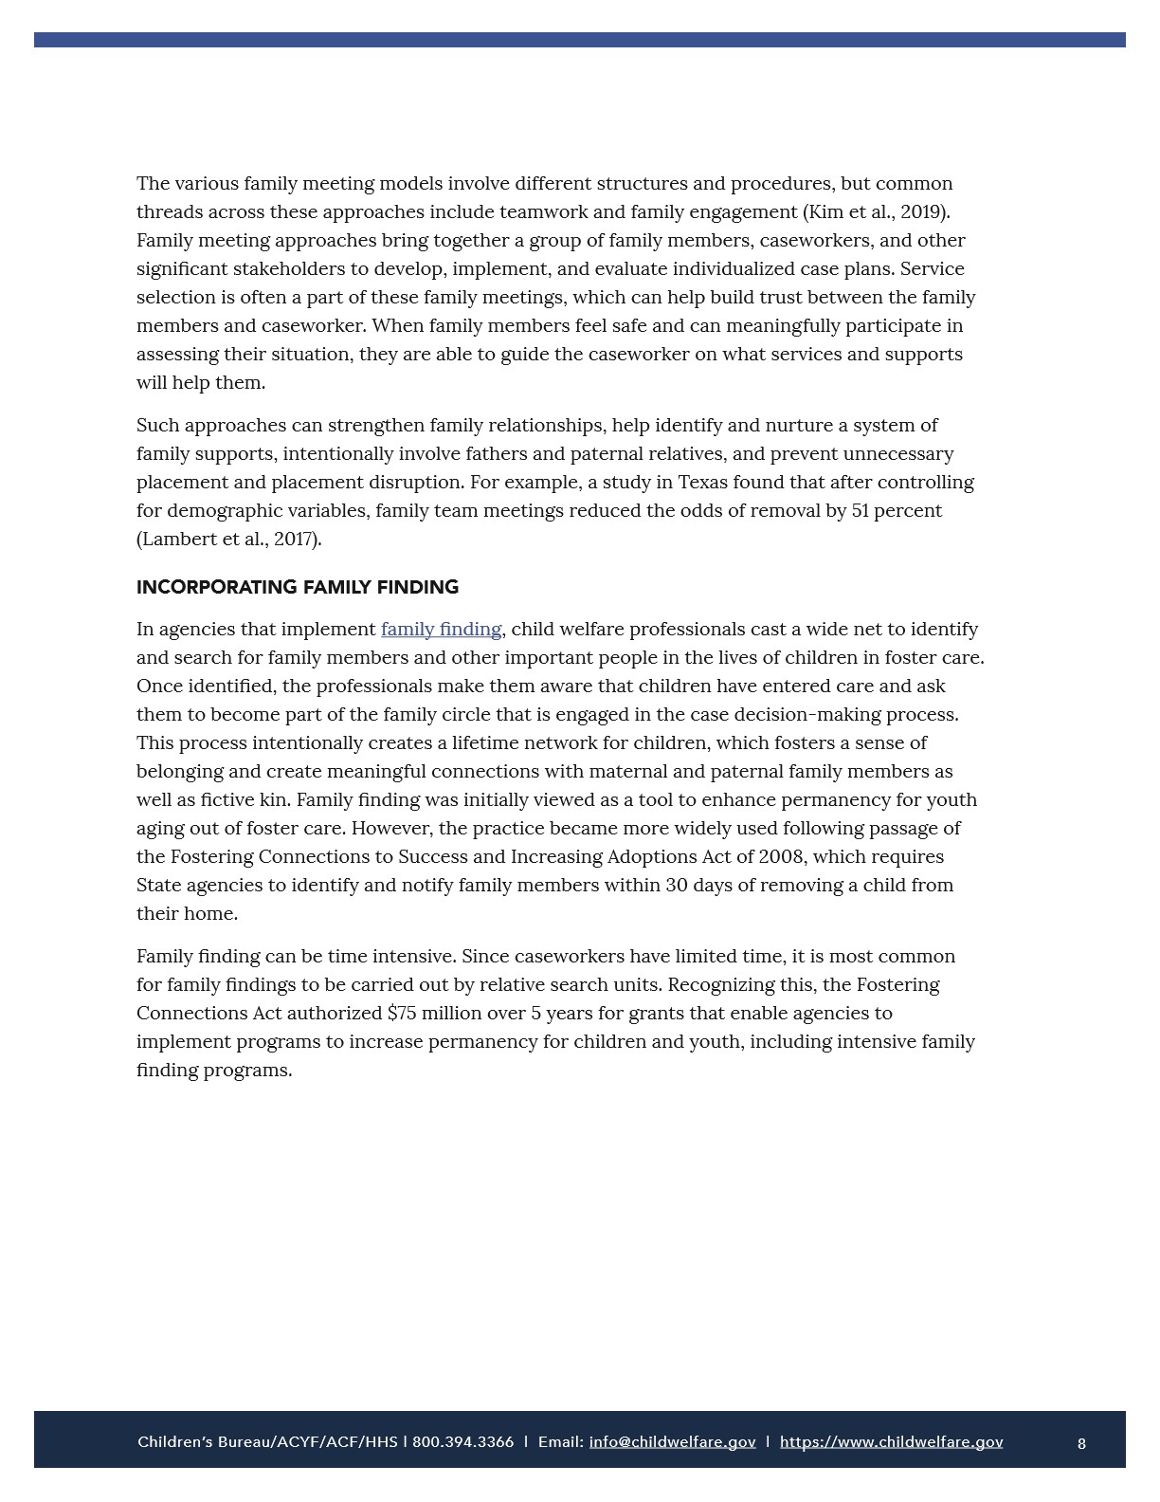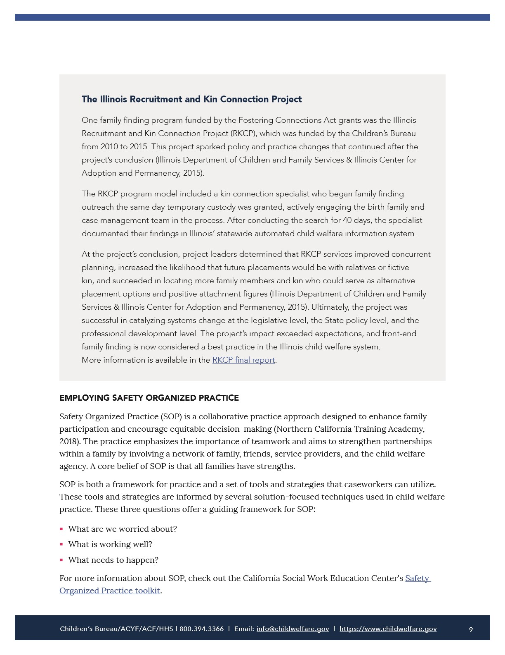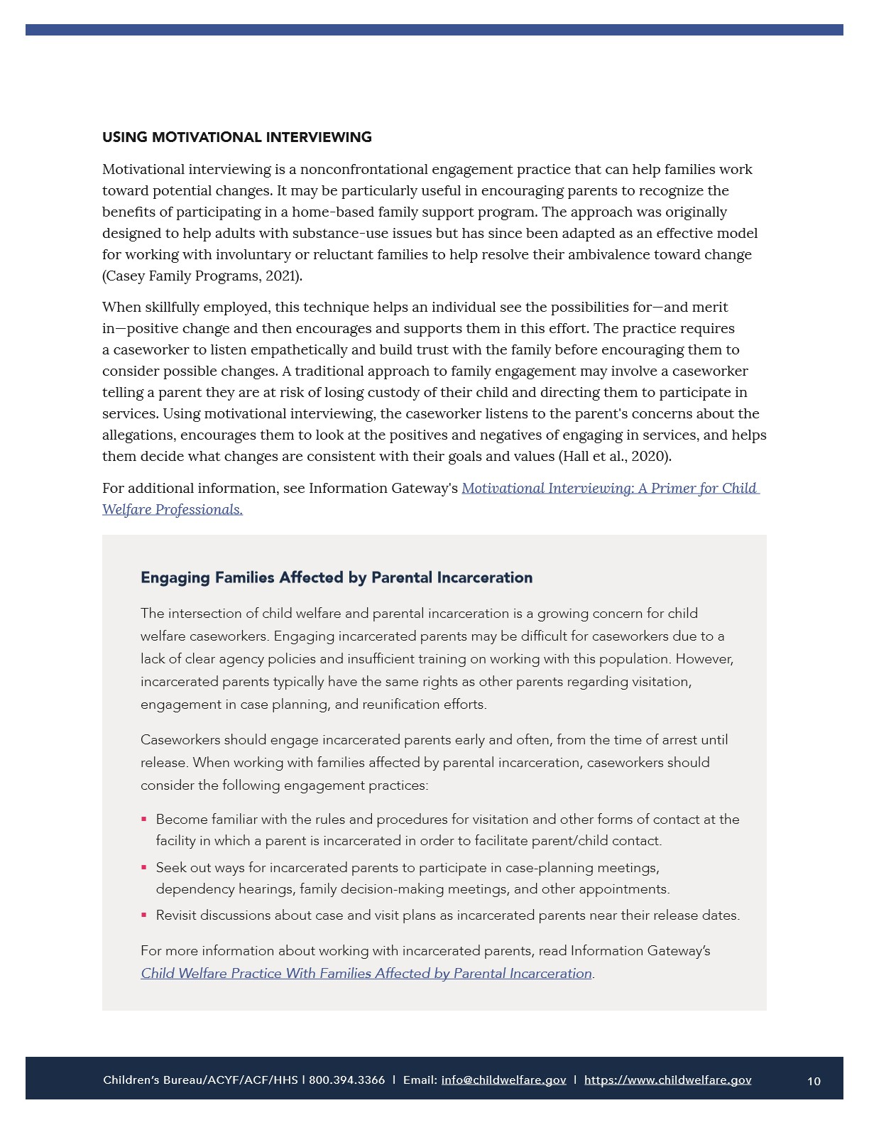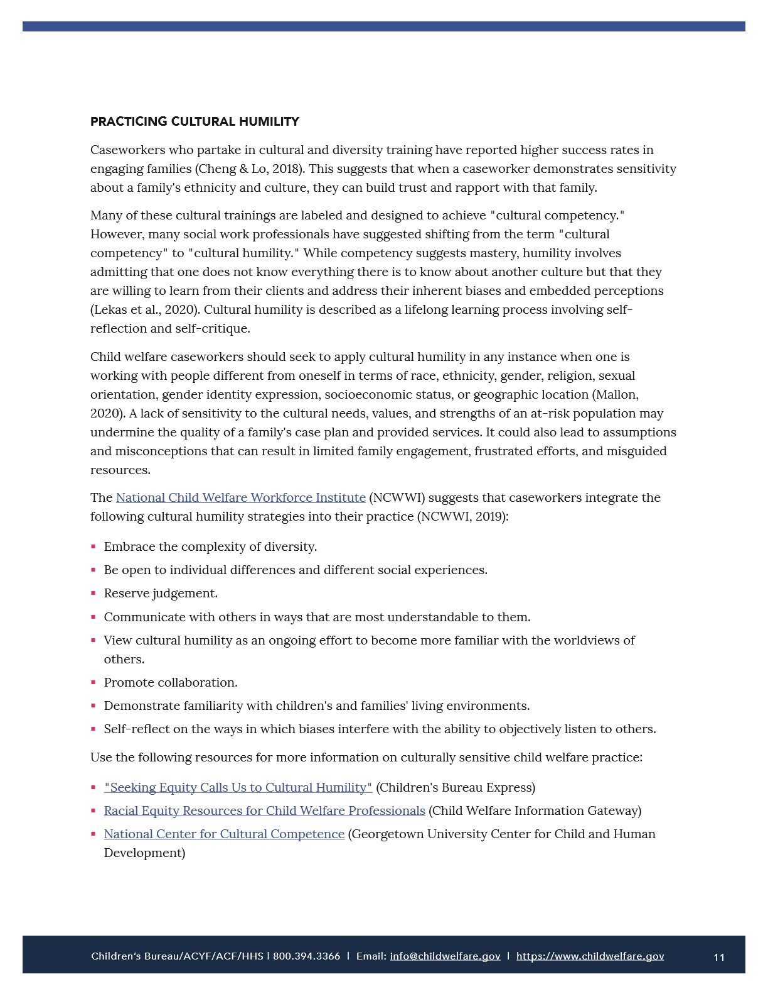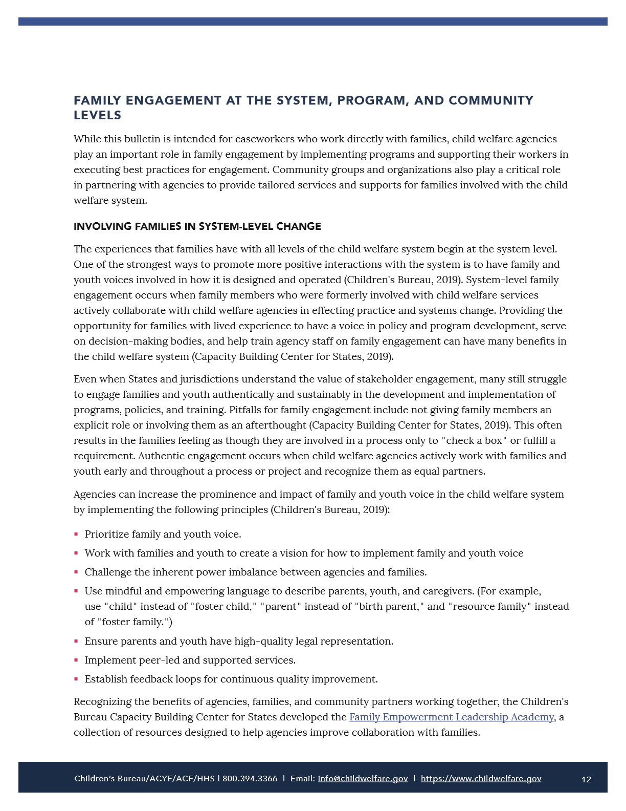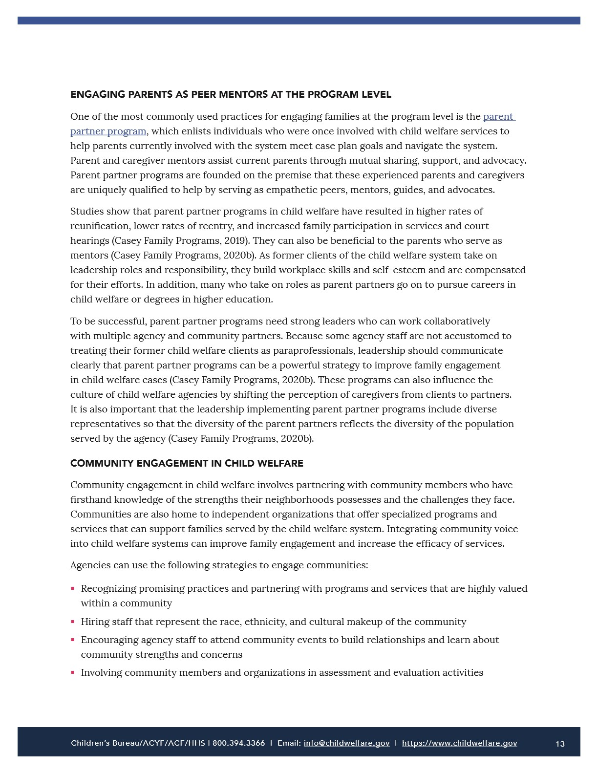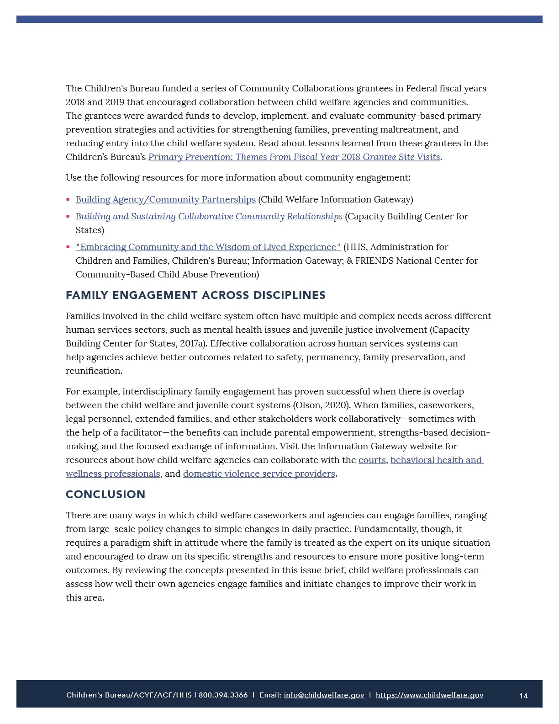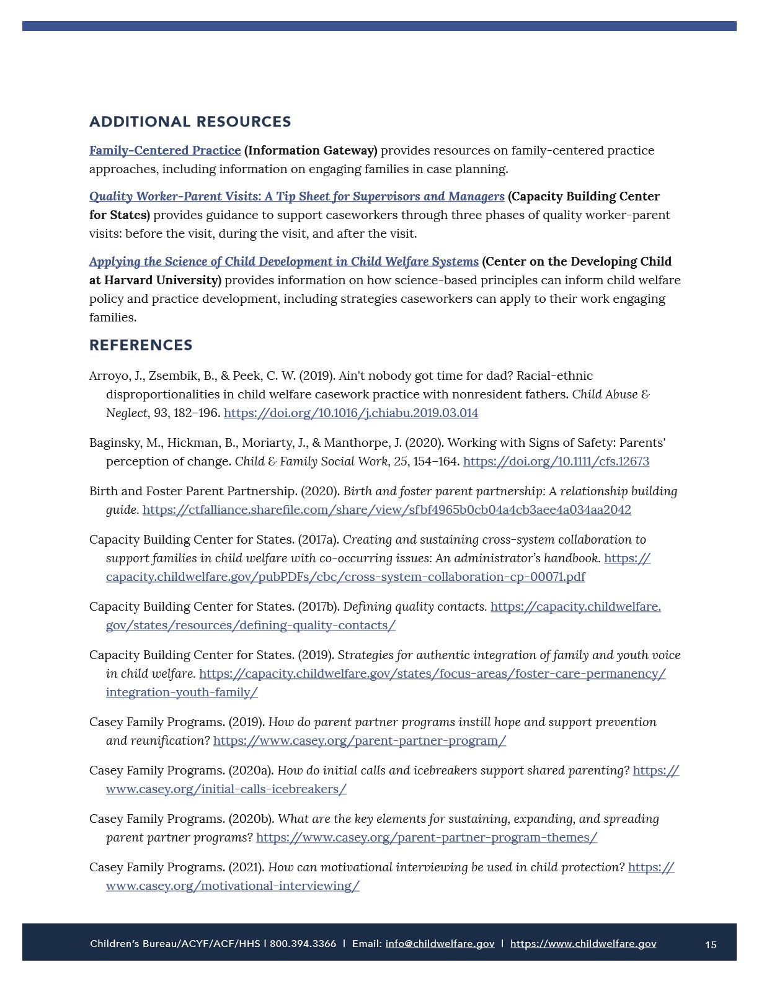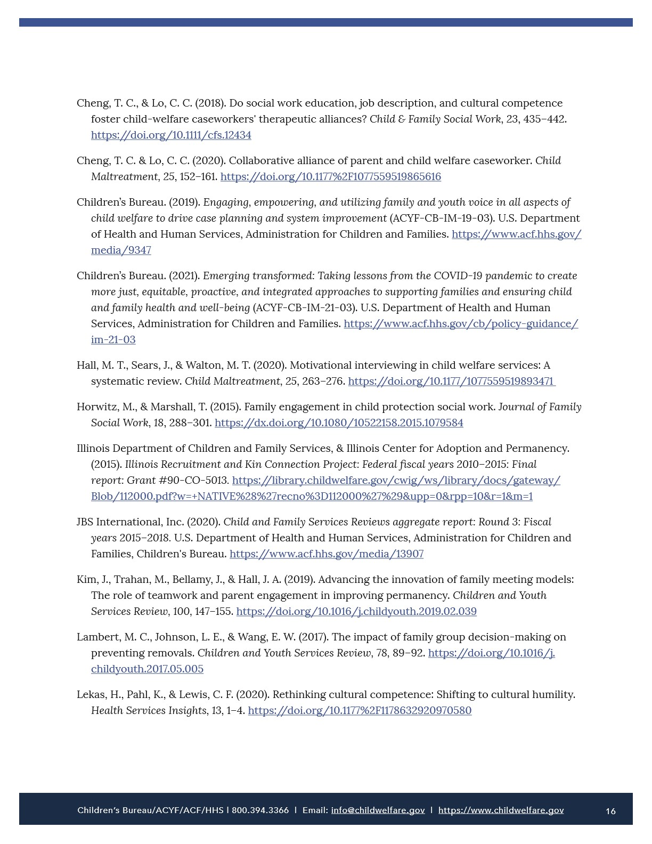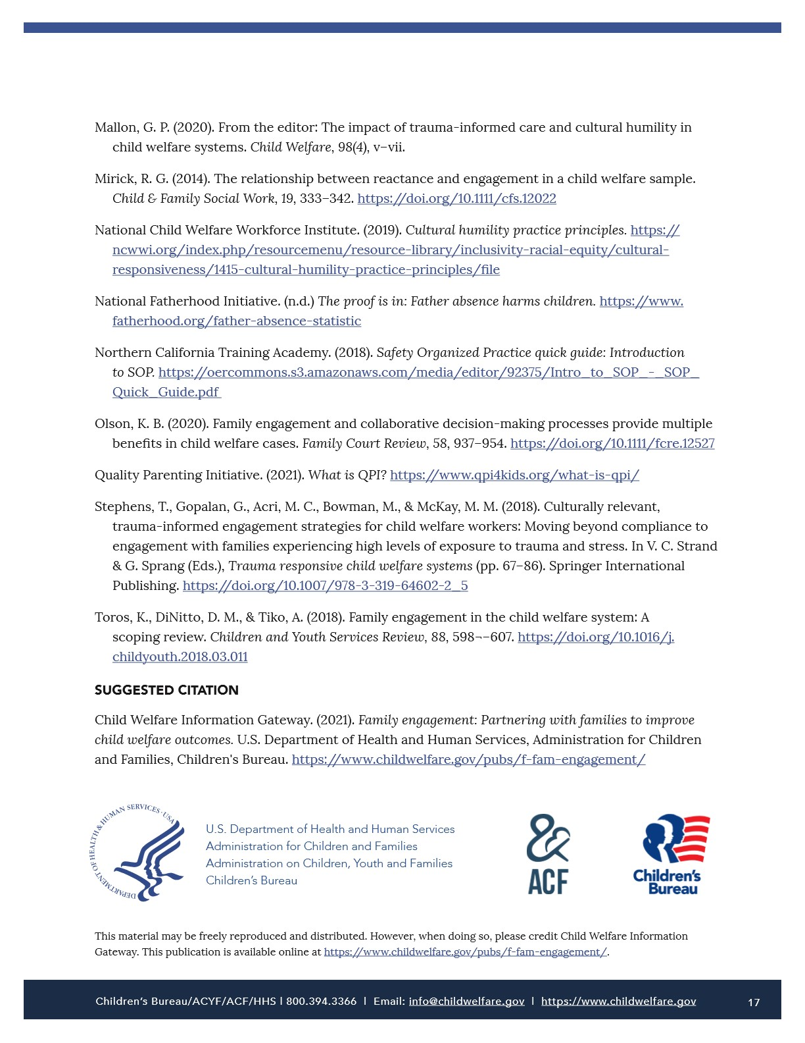

Beyond a Trauma-Informed Approach and Towards Shame-Sensitive Practice
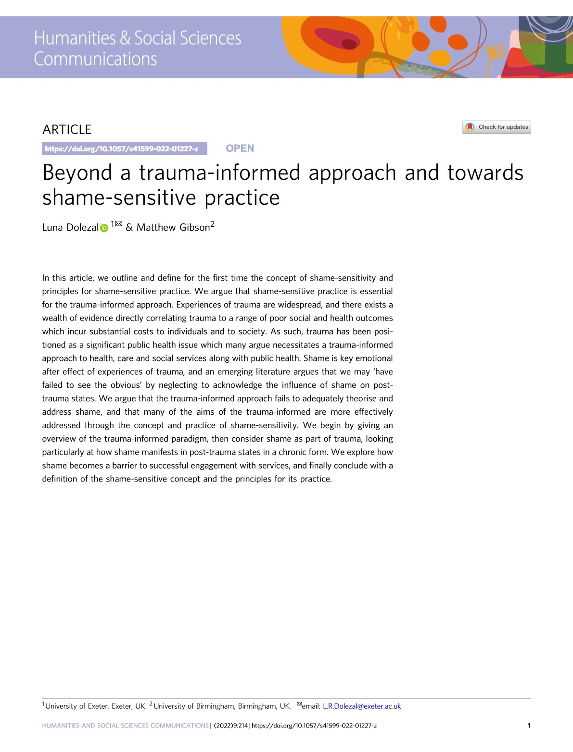
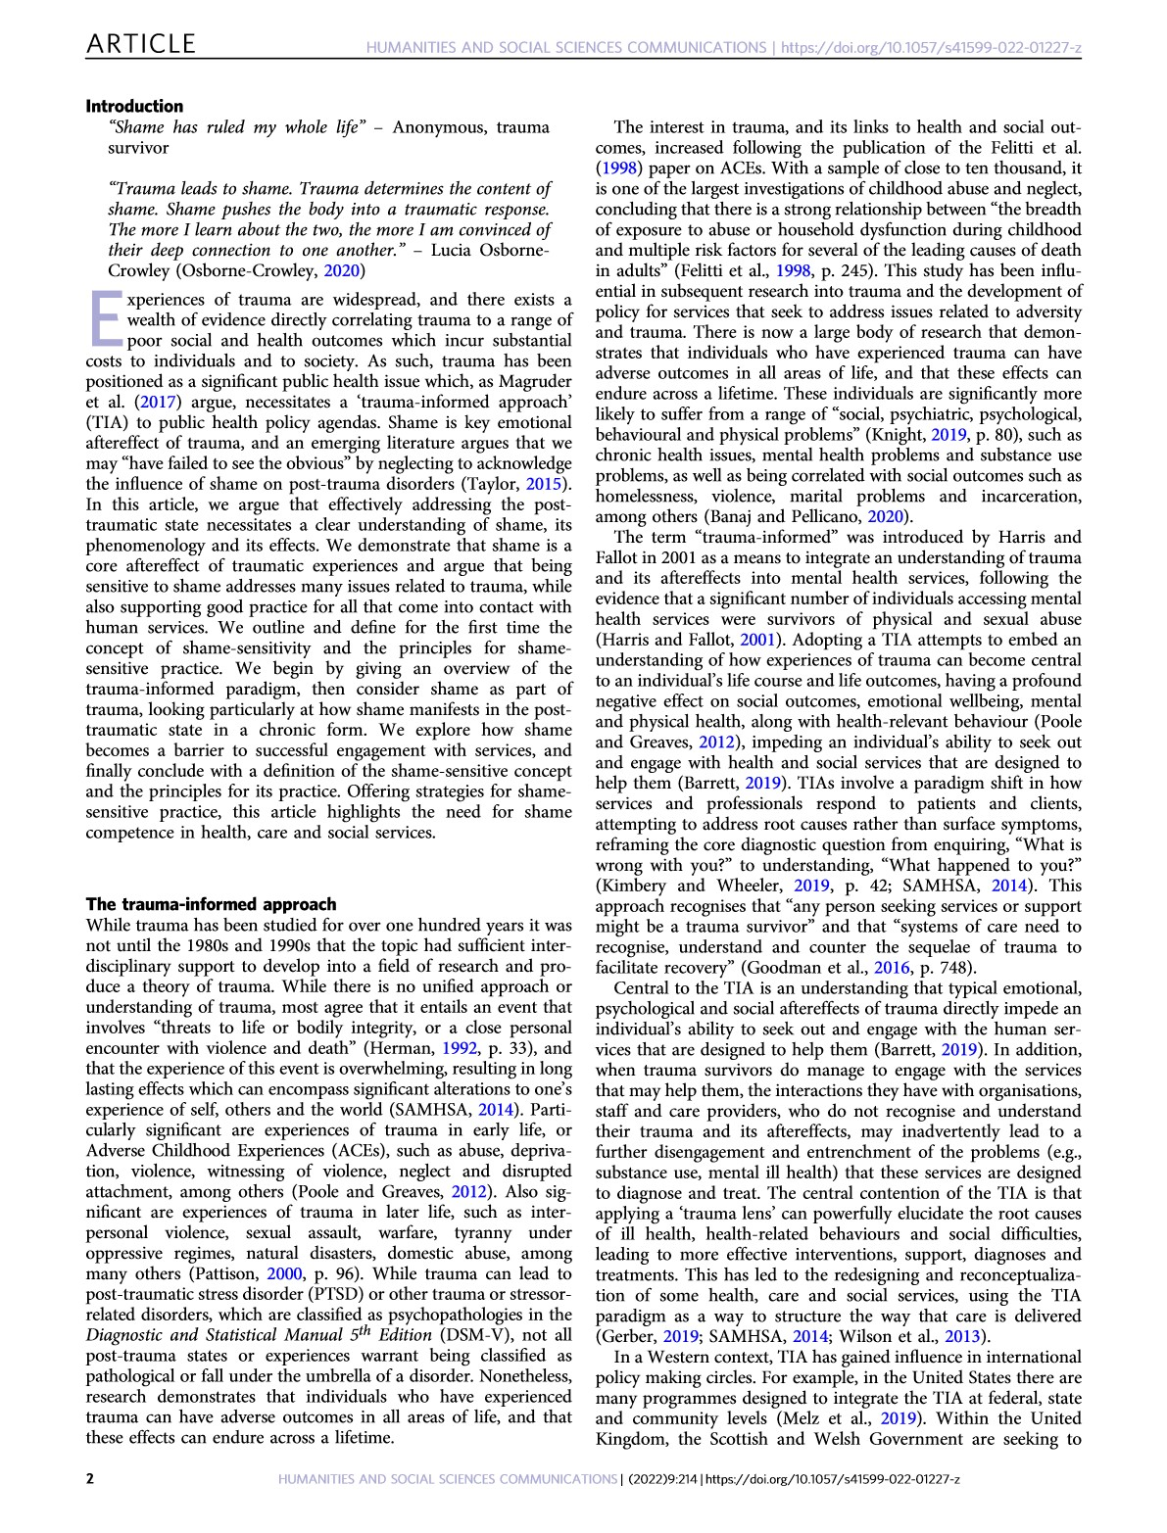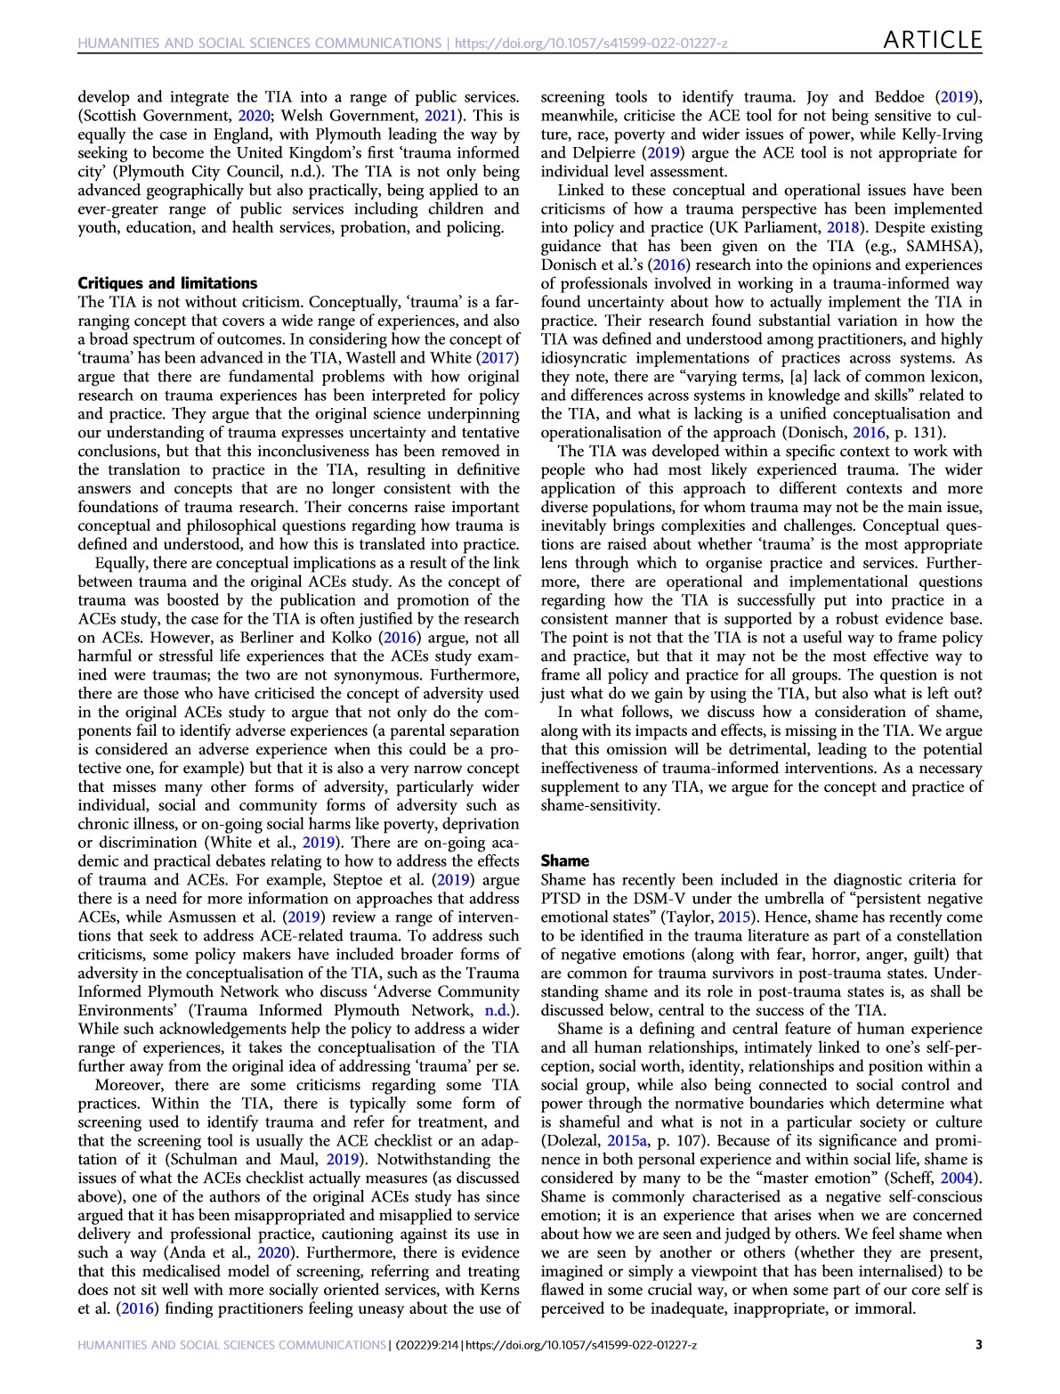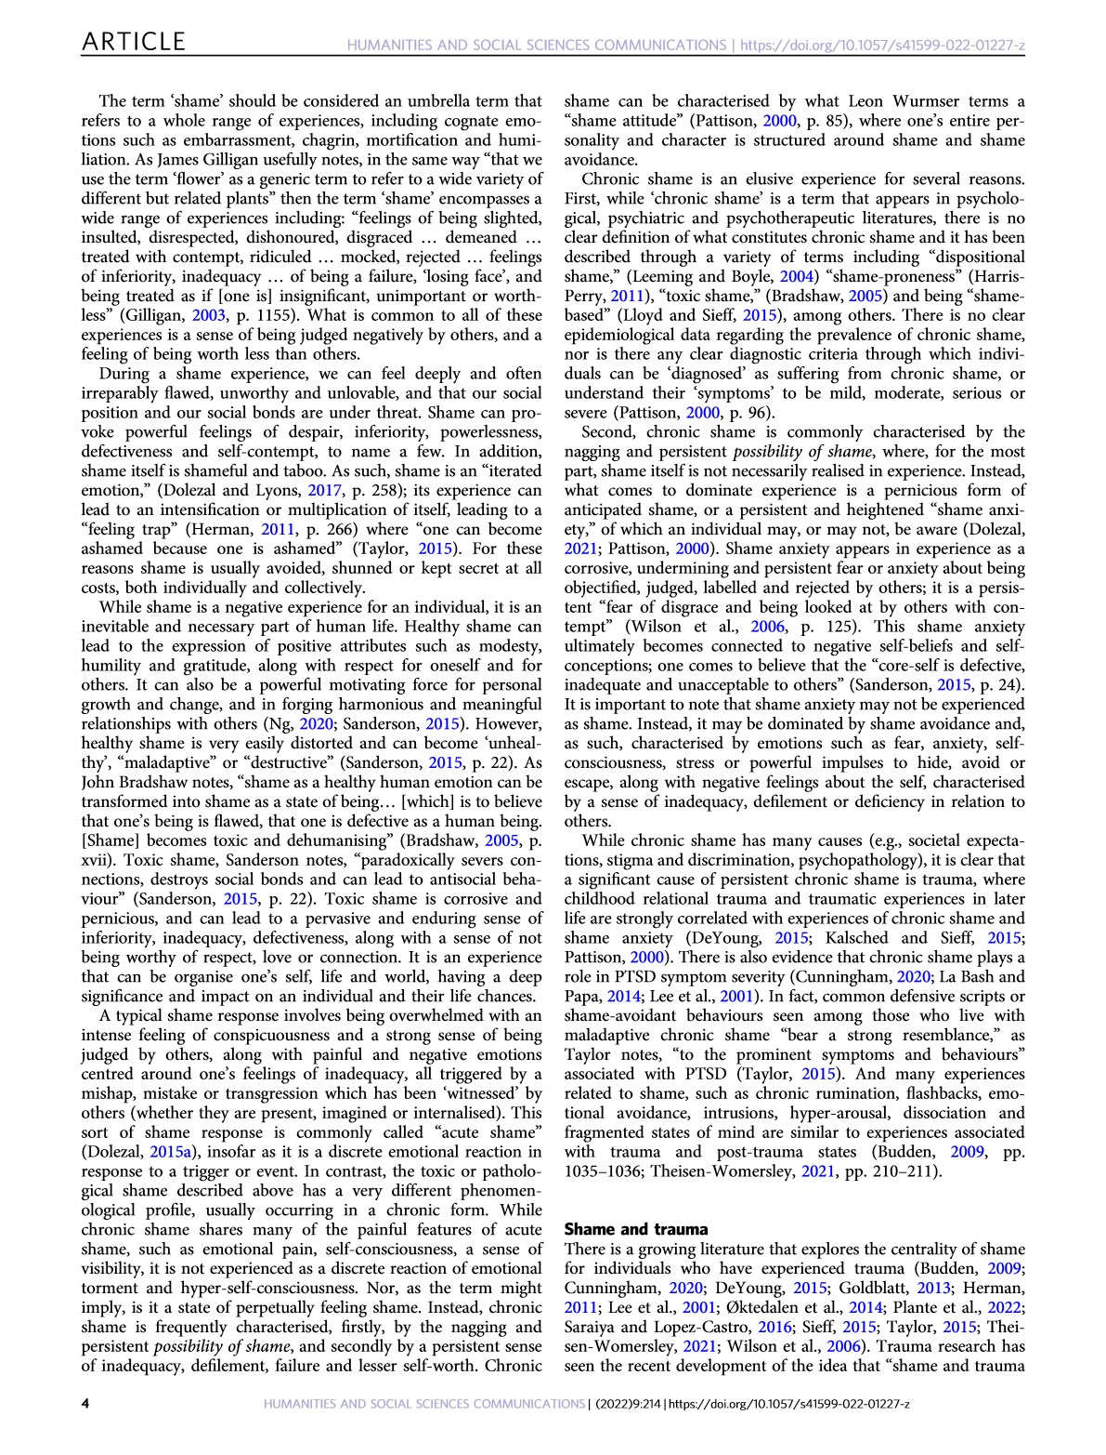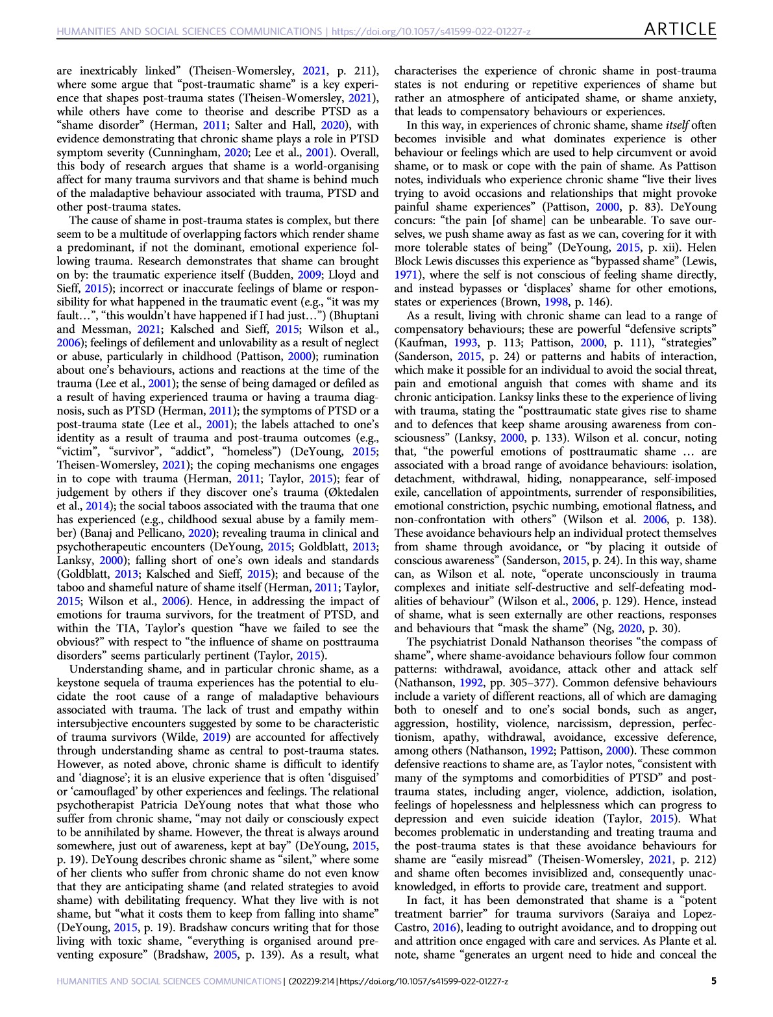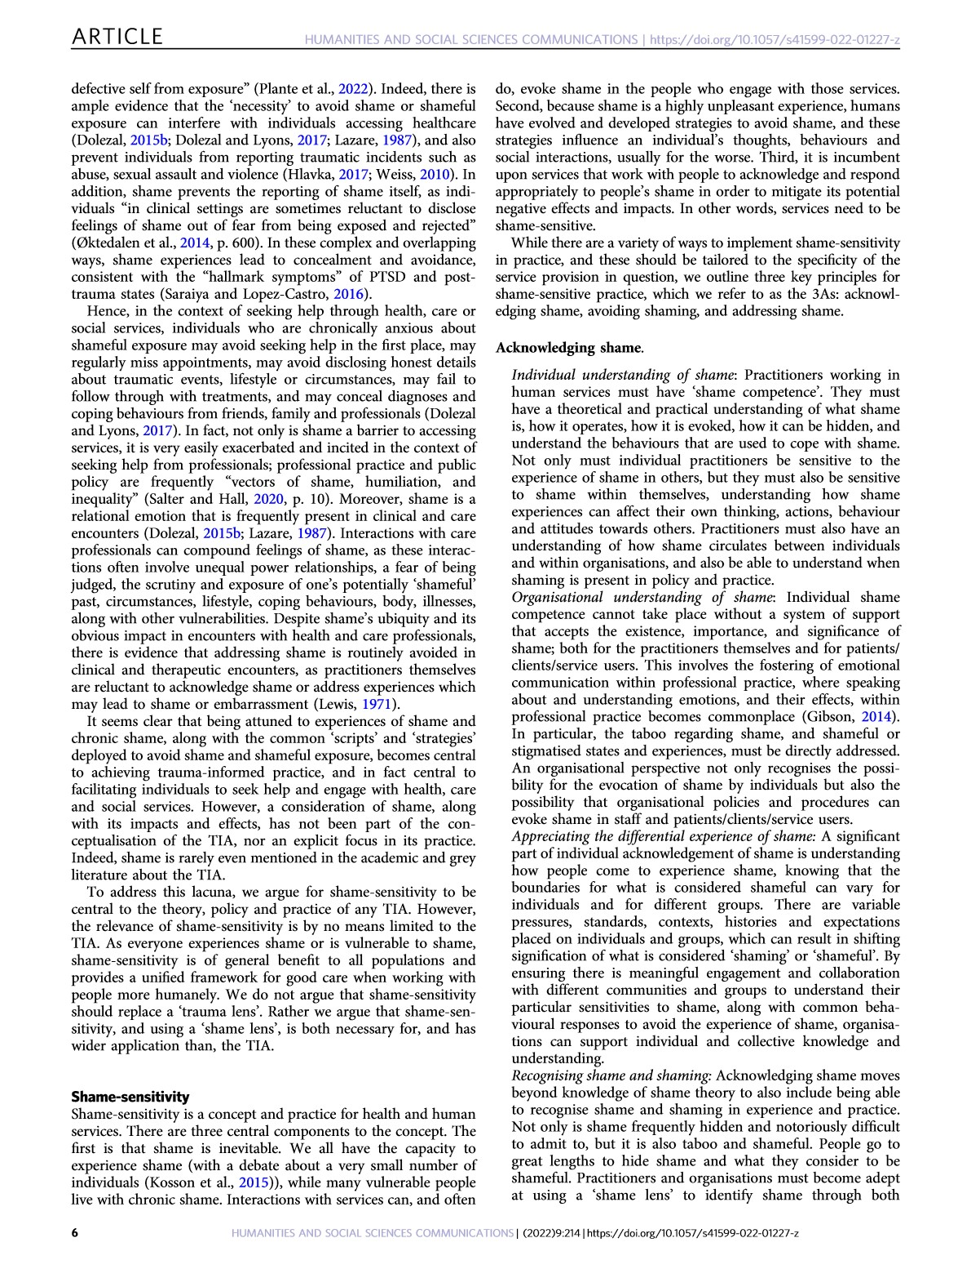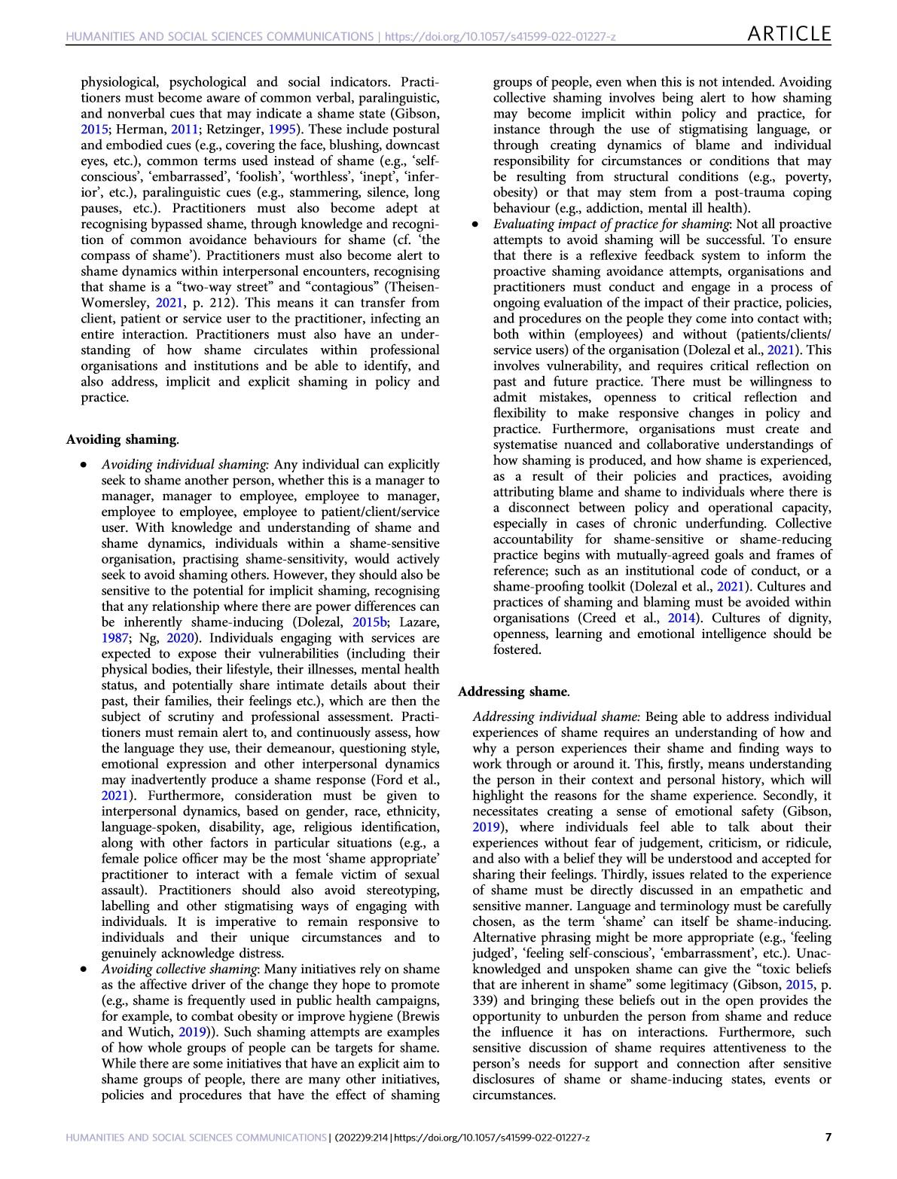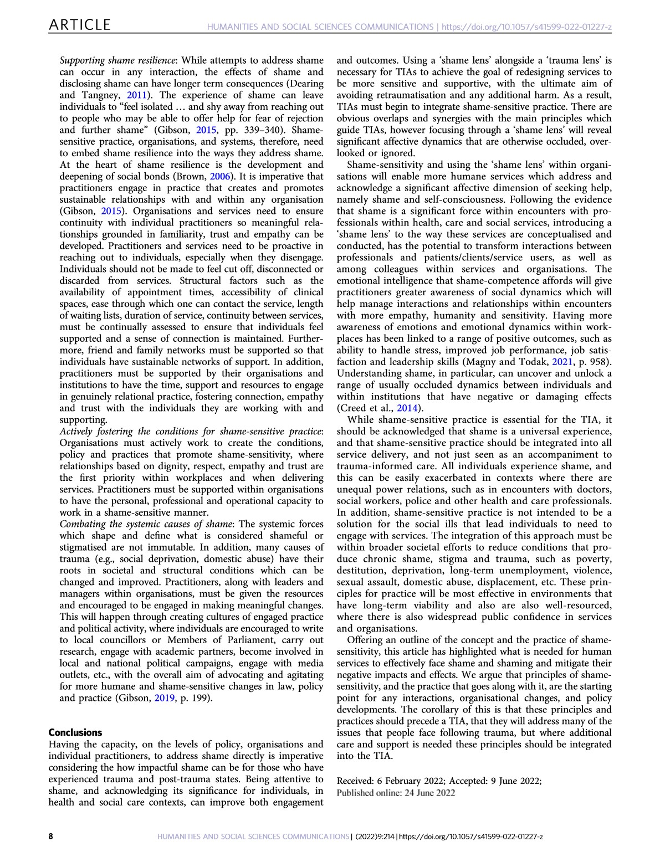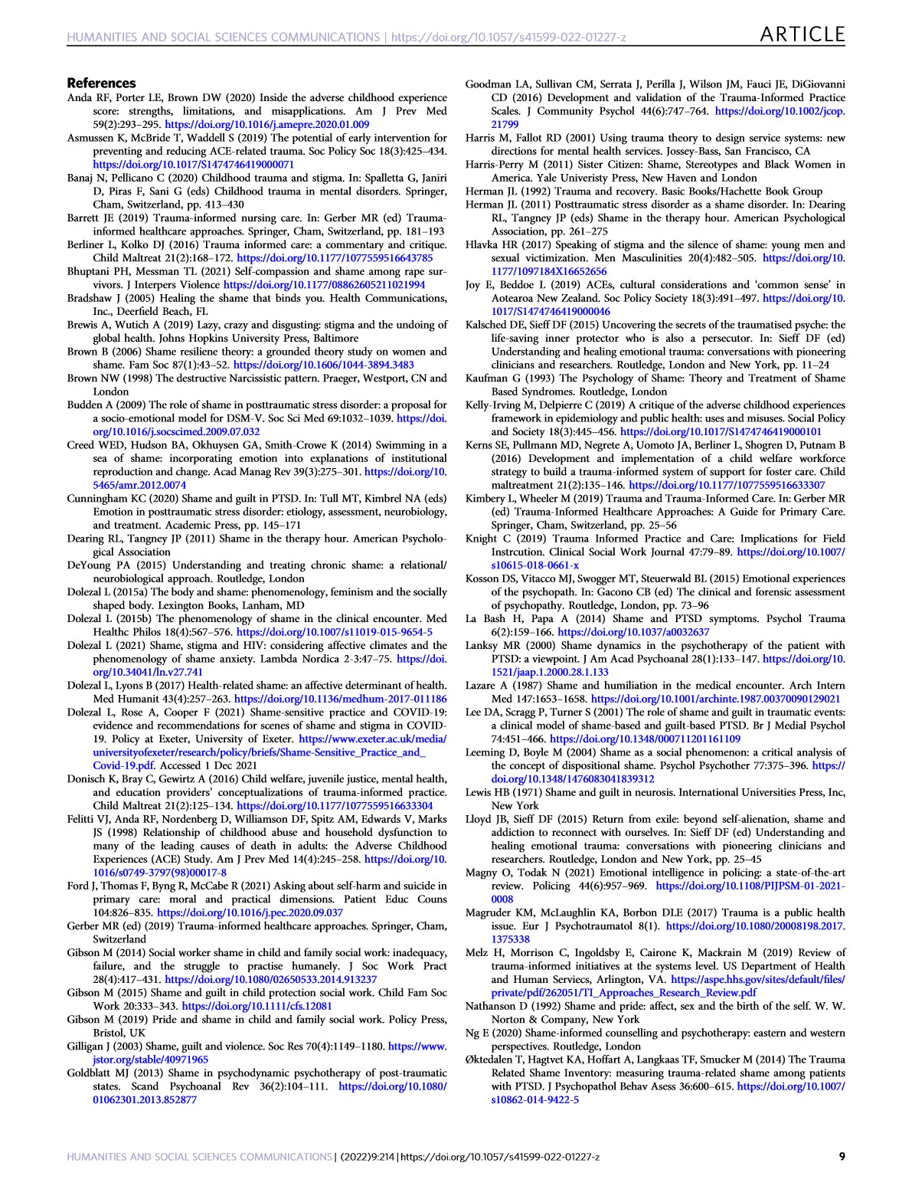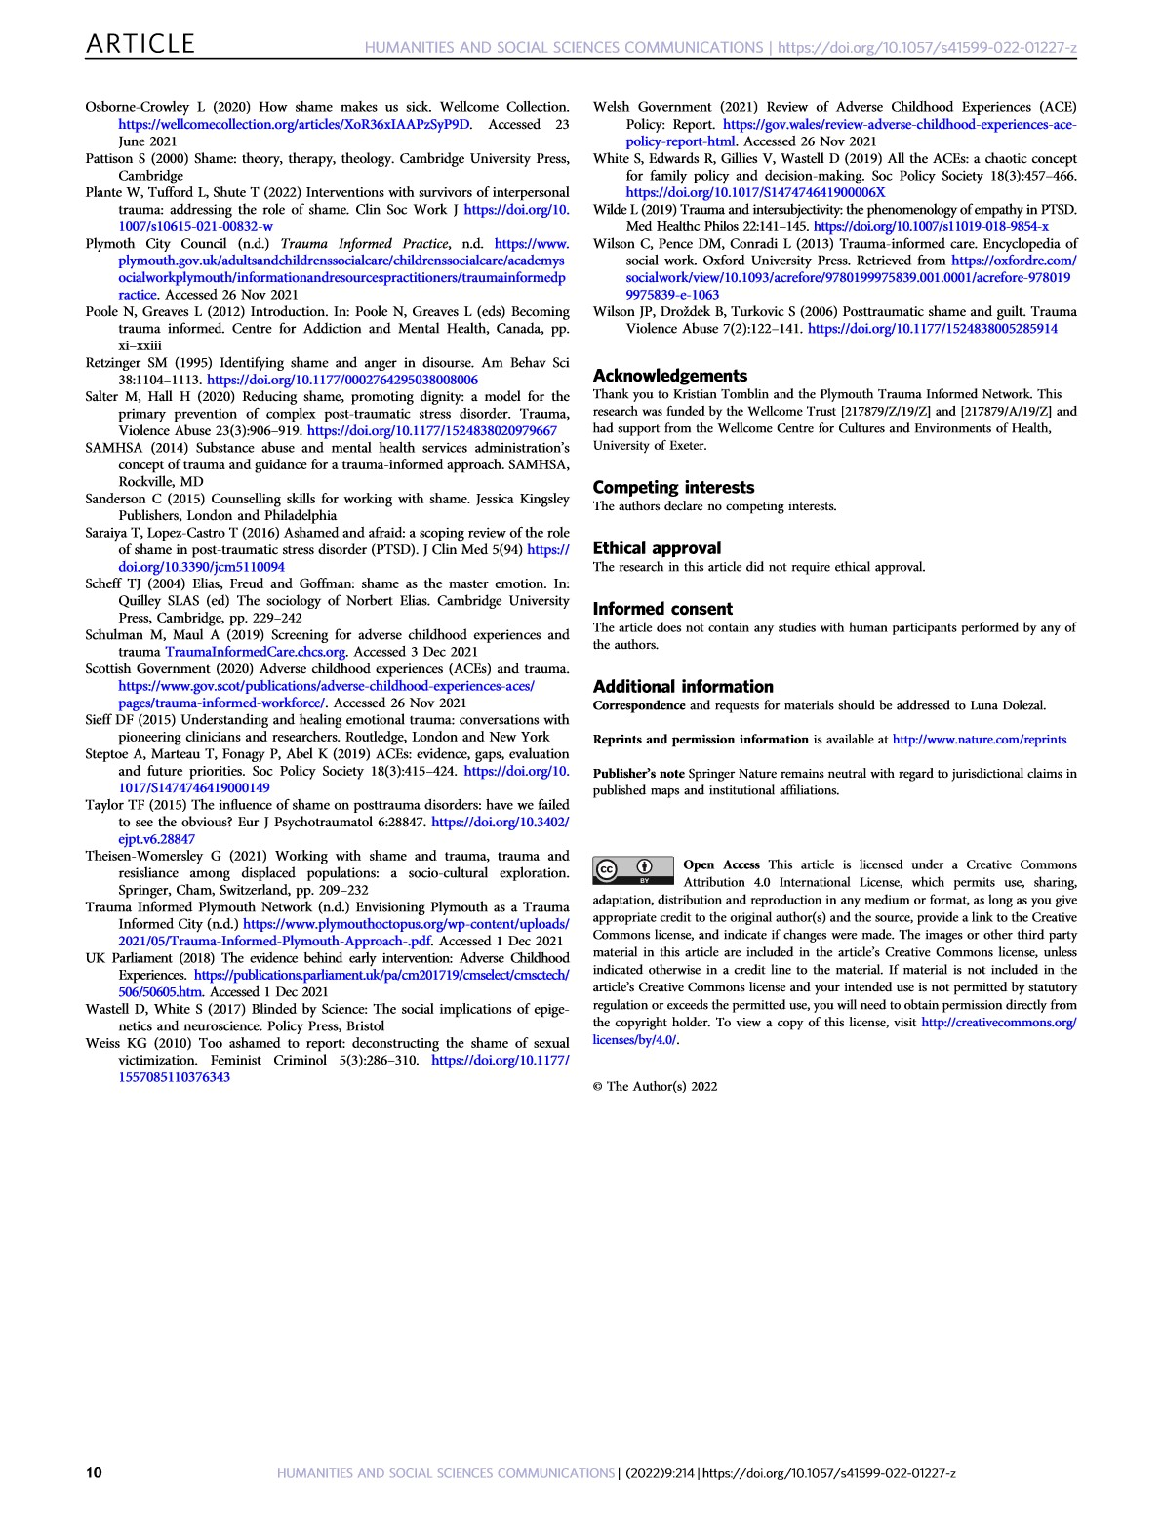

Solution-Focused Interviewing Skills and Questions
Open Ended Questions
Questions that encourage the client to use their own words and to elaborate on a topic. | Can you tell me about your relationship with your parents?  Tell me about your parenting experience.  Who are your supports and how do they help you?  Note: identify and reflect to clients any strengths or positive qualities clients may reveal in their responses to the open-ended questions.
Summarizing
Periodically state back to the client his/her thoughts, actions, and feelings. | So, what I hear you say is…  If I understand you correctly, you are saying that...  So, what you are saying is...  Right?
Tolerating/Using Silence
Allow 10, 15, 20 seconds or so to allow clients to come up with their own responses. Avoid the temptation to fill in silence with advice.
Complimenting
Acknowledging client strengths and past success. | As you were talking, I noticed that you have many strengths. You have...,  In the past, you have had successes evident by your ability to....
Affirming Client’s Perception
Perception is some aspect of a person’s self-awareness or awareness of their life. They include a person’s thoughts, feelings, behaviors, and experiences. Affirmation of the client’s perceptions is similar to reflective listening in form but does not isolate and focus on the feeling component per se, but on the client’s larger awareness. | That is very smart of you, let us explore this further...  You have a high-level of self-awareness, how would you like to use this information to move forward....

Working with Client’s Negative or Inaccurate Perceptions
Perceptions, even negative ones like suicide or assaultive behaviors should be explored to understand the full context.  Some perceptions may be obviously inaccurate and reflect a person’s denial of a problem. Avoid an immediate educative or dissuading response to negative or inaccurate perceptions. Listening and understanding are the social worker’s first obligations. | What’s happening in your life that tells you that hitting or suicide might be helpful in this situation?  How does it feel to say, “I don’t want to do this anymore?”  How might your life be different if you did hit him?  What are the pros and cons of your reaction?
Returning the Focus to the Client
Clients tend to focus on the problem and/or what they would like others to do differently. In the Solution-Focused approach, the client is encouraged to return the focus to themselves and to possible solutions. | “My kids are lazy. They don’t realize that I need help sometimes.” Response: “What gives you hope that this problem can be solved?” “I wish my parents would get with it. A 10:00 pm curfew on weekends is ridiculous.” Response: “When things are going better, what will your parents notice you doing differently?”  “My teachers are too hard. If they would back off all the homework and give more help my grades would improve.” Response “What is it going to take to make things even a little bit better?”  “If my boss would stop criticizing me and treating me like a child, I could be more productive.” Response “If your boss was here and I asked him what you could do differently to make it just a little easier for him not to be so critical, what do you think he would say?”
Exception Questions
Exception questions help clients think about times when their problems could have occurred but did not or at least were less severe. Exception questions focus on who, what, when, and where (the conditions that helped the exception to occur) NOT WHY; should be related to client goals. | Are there times when the problem does not happen or is less serious? When? How does this happen?  Have there been times in the last couple of weeks when the problem did not happen or was less severe?  How was it that you were able to make this exception happen?  What was different about that day?  If your friend (teacher, relative, spouse, partner, etc.) were here and I were to ask him what he noticed you doing differently on that day, what would he say? What else?
Coping Questions
Coping questions attempt to help the client shift his/her focus away from the problem elements and toward what the client is doing to survive the painful or stressful circumstances. They are related in a way to exploring for exceptions. | What have you found that is helpful in managing this situation?  Considering how depressed and overwhelmed you feel, how is it that you were able to get out of bed this morning and make it to our appointment (or make it to work)?  You say that you’re not sure that you want to continue working on your goals. What is it that has helped you to work on them up to now?
Scaling Questions
Scaling questions invite clients to put their observations, impressions, and predictions on a scale from 0 to 10, with 0 being no chance, and 10 being every chance. Questions need to be specific, citing specific times and circumstances. | On a scale of 0 to 10, with 0 being not serious at all and 10 being the most serious, how serious do you think the problem is now?  On a scale of 0 to 10, what number would it take for you to consider the problem to be sufficiently solved?  On a scale of 0 to 10, with 0 being no confidence and 10 being very confident, how confident are you that this problem can be solved?  On a scale of 0 to 10, with 0 being no chance and 10 being every chance, how likely is it that you will be able to say “No” to your boyfriend when he offers you drugs?  What would it take for you to increase, by just one point, your likelihood of saying “No”?  What’s the most important thing you have to do to keep things at a 7 or 8?

Indirect Relationship Questions
Indirect questions invite the client to consider how others might feel or respond to some aspect of the client’s life, behavior, or future changes. Indirect questions can be useful in asking the client to reflect on narrow or faulty perceptions without the worker directly challenging those perceptions or behaviors. | How is it that someone might think that you are neglecting or mistreating your children?  Has anyone ever told you that they think you have a drinking problem?  If your children were here (and could talk, if the children are infants or toddlers) what might they say about how they feel when you and your wife have one of those serious arguments?  At the upcoming court hearing, what changes do you think the judge will expect from you to consider returning your children?  How do you think your children (spouse, relative, caseworker, employer) will react when you make the changes we talked about?
Miracle Questions
The Miracle Question is a special type of preferred future question that can help people get clarity on how the problem impacts their daily life and what life would look like without the problem happening. | Imagine you woke up tomorrow and a miracle had happened overnight, and all the trouble was gone. How would you know it was over? What would be different that would tell you the problem was no longer happening? What is the first thing you would be doing to start the day? What would the rest of your day look like? What would things look like for your children?  If you could wave a magic wand and things, be different, what would that new state of being look like? What would it take to get there without the magic wand?
Affirming Client’s Perception
Perception is some aspect of a person’s self-awareness or awareness of their life. They include a person’s thoughts, feelings, behaviors, and experiences. Affirmation of the client’s perceptions is similar to reflective listening in form but does not isolate and focus on the feeling component per se, but on the client’s larger awareness. |  | - That is very smart of you, let us explore this further...  - You have a high-level of self-awareness, how would you like to use this information to move forward....

Working with Client’s Negative or Inaccurate Perceptions
Perceptions, even negative ones like suicide or assaultive behaviors should be explored to understand the full context.  Some perceptions may be obviously inaccurate and reflect a person’s denial of a problem. Avoid an immediate educative or dissuading response to negative or inaccurate perceptions. Listening and understanding are the social worker’s first obligations. | - What’s happening in your life that tells you that hitting or suicide might be helpful in this situation?  - How does it feel to say, “I don’t want to do this anymore?”  - How might your life be different if you did hit him?  - What are the pros and cons of your reaction?
Returning the Focus to the Client
Clients tend to focus on the problem and/or what they would like others to do differently. In the Solution-Focused approach, the client is encouraged to return the focus to themselves and to possible solutions. | - “My kids are lazy. They don’t realize that I need help sometimes.” Response: “What gives you hope that this problem can be solved?” “I wish my parents would get with it. A 10:00 pm curfew on weekends is ridiculous.” Response: “When things are going better, what will your parents notice you doing differently?”  - “My teachers are too hard. If they would back off all the homework and give more help my grades would improve.” Response “What is it going to take to make things even a little bit better?”  - “If my boss would stop criticizing me and treating me like a child, I could be more productive.” Response “If your boss was here and I asked him what you could do differently to make it just a little easier for him not to be so critical, what do you think he would say?”

Exception Questions
Exception questions help clients think about times when their problems could have occurred but did not – or at least were less severe. Exception questions focus on who, what, when, and where (the conditions that helped the exception to occur) - NOT WHY; should be related to client goals. | - Are there times when the problem does not happen or is less serious? When? How does this happen?  - Have there been times in the last couple of weeks when the problem did not happen or was less severe?  - How was it that you were able to make this exception happen?  - What was different about that day?  - If your friend (teacher, relative, spouse, partner, etc.) were here and I were to ask him what he noticed you doing differently on that day, what would he say? What else?
Coping Questions
Coping questions attempt to help the client shift his/her focus away from the problem elements and toward what the client is doing to survive the painful or stressful circumstances. They are related in a way to exploring for exceptions. | - What have you found that is helpful in managing this situation?  - Considering how depressed and overwhelmed you feel, how is it that you were able to get out of bed this morning and make it to our appointment (or make it to work)?  - You say that you’re not sure that you want to continue working on your goals. What is it that has helped you to work on them up to now?

Scaling Questions
Scaling questions invite clients to put their observations, impressions, and predictions on a scale from 0 to 10, with 0 being no chance, and 10 being every chance. Questions need to be specific, citing specific times and circumstances. | - On a scale of 0 to 10, with 0 being not serious at all and 10 being the most serious, how serious do you think the problem is now?  - On a scale of 0 to 10, what number would it take for you to consider the problem to be sufficiently solved?  - On a scale of 0 to 10, with 0 being no confidence and 10 being very confident, how confident are you that this problem can be solved?  - On a scale of 0 to 10, with 0 being no chance and 10 being every chance, how likely is it that you will be able to say “No” to your boyfriend when he offers you drugs?  - What would it take for you to increase, by just one point, your likelihood of saying “No”?  - What’s the most important thing you have to do to keep things at a 7 or 8?
Indirect Relationship Questions
Indirect questions invite the client to consider how others might feel or respond to some aspect of the client’s life, behavior, or future changes. Indirect questions can be useful in asking the client to reflect on narrow or faulty perceptions without the worker directly challenging those perceptions or behaviors. | - How is it that someone might think that you are neglecting or mistreating your children?  - Has anyone ever told you that they think you have a drinking problem?  - If your children were here (and could talk, if the children are infants or toddlers) what might they say about how they feel when you and your wife have one of those serious arguments?  - At the upcoming court hearing, what changes do you think the judge will expect from you to consider returning your children?  - How do you think your children (spouse, relative, caseworker, employer) will react when you make the changes we talked about?

Miracle Questions
The Miracle Question is a special type of preferred future question that can help people get clarity on how the problem impacts their daily life and what life would look like without the problem happening. | - Imagine you woke up tomorrow and a miracle had happened overnight, and all the trouble was gone. How would you know it was over? What would be different that would tell you the problem was no longer happening? What is the first thing you would be doing to start the day? What would the rest of your day look like? What would things look like for your children?  - If you could wave a magic wand and things, be different, what would that new state of being look like? What would it take to get there without the magic wand?

Protective Capacity
Protective capacity is defined as the ability and willingness to mitigate or ameliorate the identified safety and risk concerns. Protective capacity can be demonstrated by a parent through their statements, actions, and reactions. Protective capacity exists both within the parent/caretaker and within the family environment.
Parent/caretaker protective capacity should be assessed in three domains:
- Behavior characteristics
- Cognitive characteristics
- Emotional characteristics
Behavioral characteristics are defined as specific actions and activities consistent with and resulting in parenting and protective vigilance. Questions to consider include:
- Does the parent/caretaker have the capacity to care for the child? If the parent/caretaker has a disability(ies) (e.g., blindness, deafness, paraplegia, chronic illness), how has the parent/caretaker addressed the disability in parenting the child?
- Has the parent/caretaker acknowledged and acted to provide the needed support to effectively parent and protect the child?
- Does the parent/caretaker demonstrate activities that indicate putting aside one’s own needs in favor of the child’s needs (if appropriate)?
- Does the parent/caretaker demonstrate adaptability in a changing environment or during a crisis?
- Does the parent/caretaker demonstrate actions to protect the child?
- Does the parent/caretaker demonstrate impulse control related to a risk factor?
- Does the parent/caretaker have a history of protecting the child given any threats to the safety of the child?

Cognitive characteristics are defined as the parent/caretaker’s specific intellect, knowledge,
understanding, and perception that contributes to protective vigilance. Questions to consider include:
- Is the parent/caretaker oriented to time, place, and space? (i.e., reality orientation)
- Does the parent/caretaker have an accurate perception of the child? Does the parent/caretaker see the child as having strengths and weaknesses, or do they see the child as “all good” or “all bad”?
- Can the parent/caretaker recognize the child’s developmental needs or if the child has special needs?
- How does the parent/caretaker process the external stimuli? (e.g., a battered woman who believes she deserves to be beaten, because of something she has done)
- Does the parent/caretaker understand their role to provide protection to the child?
- Does the parent/caretaker have the intellectual ability to understand what is needed to raise and protect a child?
- Does the parent/caretaker accurately assess potential threats to the child?

Emotional characteristics are defined as the parent/caretaker’s specific feelings, attitudes, and identification with the child and motivation that results in parenting and protective vigilance. Questions to consider include:
- Does the parent/caretaker have an emotional bond with the child? Is there a reciprocal connectedness between the parent/caretaker and the child? Is there a positive connection to the child?
- Does the parent/caretaker have empathy for the child when the child is hurt or afraid?
- Is the parent/caretaker flexible under stress? Can the parent/caretaker manage adversity?
- Is the parent/caretaker able to control their emotions? If emotionally overwhelmed, does the parent/caretaker reach out to others or expect the child to meet the parent/caretaker’s emotional needs?
- Does the parent/caretaker consistently meet their own emotional needs via other adults, services?

Environmental Protective Capacities
While the assessment of the parent/caretaker’s protective capacities is critical, an assessment of environmental capacities may also mitigate the safety concerns/risk of harm to a child. Below are several categories of environmental protective capacities to be considered.
- Family/kinship relationships that contribute to the protection of the child; • Informal relationships
- Agency supports
- Community supports
- Financial status
- Spiritual supports
- For American Indians, the tribe
- Concrete needs being met (e.g., for food, clothing, shelter).
Citation: Cross Function Topics

Assessing Self-Assessment

