North Carolina Department of Health and Human Services

CPS Assessment in Child Welfare Track Training

Participant’s Workbook

Day Four

October 2024



600 Airport Rd

Lakewood, NJ, 08701-5995

www.pubknow.com

info@pubknow.com

(800) 776-4229

This curriculum was developed by the North Carolina Department of Health and Human Services, Division of Social Services and revised by Public Knowledge® in 2024.

Copyright © 2024 Public Knowledge®. All rights reserved. No part of this publication may be reproduced, distributed, or transmitted in any form without the written permission of the publisher.

**Table of Contents**

Instructions 4

Course Themes 4

Training Overview 5

Learning Objectives 7

Day Four Agenda 9

Welcome 10

Safety Planning 11

Essential Function: Planning 11

Activity: Stages of Change 12

Worksheet: Accountability and Support 15

Safety Interventions and Safety Decisions 17

Activity: Safety Interventions 20

Safety Planning and Temporary Parental Safety Agreements 23

Applying Cultural Humility to Safety Assessments 26

Safety Planning Learning Lab 27

Safety Planning 27

Worksheet: Self-Care Health Plan Check-In 27

Activity: Avilla Chavis and Lewis Family Safety Assessment Decision 28

Skills Practice: Building Safety Agreements 30

Applying Cultural Humility to Safety Planning 31

Activity: Applying Cultural Humility to Assessing and Planning 31

Trauma-Informed Practice 32

Trauma-Informed Practice 32

Video: Step Inside the Circle 33

Considerations for Cases Involving Special Circumstances 35

Considerations for Cases Involving Special Circumstances 35

Domestic and Intimate Partner Violence 36

Activity: Policy and Procedures in Cases with Family Violence 38

Worksheet: Brown Family Case Scenario 39

Human Trafficking 41

Video: Erica’s Story 41

Debrief: Policy and Procedures in Cases with Human Trafficking 42

Worksheet: Human Trafficking 42

Sexual Abuse and Exploitation 44

Worksheet: Sexual Abuse and Exploitation 45

Mental and Behavioral Health 46

Video: Children, Violence, and Trauma: Treatments that Work 46

Substance Misuse 47

Handout: Substance Use Disorder and Recovery in a Family 48

Assessing for Special Circumstances 51

Activity: Special Circumstances Impacting Families 51

Social Worker Safety 53

Considerations for Social Worker Safety 53

Skills Practice: Safety Concerns 53

End-of-Day Values Reflection 57

Questions and Reflections 57

Bibliography of References 58

Appendix: Handouts 1

Substance Use Disorder and Recovery in a Family 2

# Instructions

This course was designed to guide child welfare professionals through the knowledge, skills, and behaviors needed to engage with families in need of child protection services. The workbook is structured to help you engage in the lesson through reflection and analysis throughout each week of training. Have this workbook readily available as you go through each session to create a long-lasting resource you can reference in the future.

If you are using this workbook electronically: Workbook pages have text boxes for you to add notes and reflections. Due to formatting, if you are typing in these boxes, blank lines will be “pushed” forward onto the next page. To correct this when you are done typing in the text box, you may use delete to remove extra lines.

# Course Themes

The central themes of the CPS Assessment Track Training are divided across several course topics.

* Purpose and Legal Basis for Child Protection Services in North Carolina
* Essential Function: Communicating
* Diversity, Equity, Inclusion, and Belonging
* Trauma-Informed Care
* Family-Centered Practice
* Essential Function: Engaging
* Safety Focused
* Essential Function: Assessing
* Interviewing Learning Lab
* The Role of Observation in Assessing for Safety
* Structured Decision-Making: Safety Assessment
* Assessment Learning Lab
* Safety Planning
* Safety Planning Learning Lab
* Trauma-Informed Practice
* Considerations for Cases Involving Special Circumstances
* Social Worker Safety
* Engaging the Family in Child Protection Services
* Risk Assessment
* Crucial Conversations
* Quality Contacts
* Assessing Family Strengths and Needs
* Secondary Traumatic Stress and Vicarious Traumatization
* Ongoing Assessment
* Family Engagement and Ongoing Assessment Learning Lab
* Documentation
* Well-Being as an Outcome
* Reasonable Efforts and Removals
* Reasonable Efforts and Removals Learning Lab
* Decision-Making
* Decision-Making and Case Closure Learning Lab

# Training Overview

Training begins at 9:00 a.m. and ends at 4:00 p.m. If a holiday falls on the Monday of training, the training will begin on Tuesday at 9:00 a.m. This schedule is subject to change if a holiday falls during the training week or other circumstances occur. The time for ending training on Fridays may vary and trainees need to be prepared to stay the entire day.

Attendance is mandatory. If there is an emergency, the trainee must contact the classroom trainer and their supervisor as soon as they realize they will not be able to attend training or if they will be late to training. If a trainee must miss training time in the classroom, it is the trainee’s responsibility to develop a plan to make up missed material.

**Pre-Work Online e-**Learning **Modules**

There is required pre-work for the CPS Assessment Track Training in the form of online e-Learning modules. Completion of the e-Learnings is required prior to attendance at the classroom-based training. The following are the online e-Learning modules:

1. North Carolina Worker Practice Standards
2. Safety Organized Practice
3. Understanding and Assessing Safety and Risk
4. Understanding and Screening for Trauma

**Transfer of Learning**

The CPS Assessment Track Training Transfer of Learning (ToL) tool is a comprehensive and collaborative activity for workers and supervisors to work together in identifying worker goals, knowledge gain, and priorities for further development throughout the training process. In four distinct steps, the worker and supervisor will highlight their goals and action plan related to participating in training, reflect on lessons and outstanding questions, and create an action plan to support worker growth. The tool should be started prior to beginning the CPS Assessment Track Training and re-visited on an ongoing basis to assess growth and re-prioritize actions for development.

* Part A: Training Preparation: Prior to completing any eLearning and in-person Track Training sessions, the worker and supervisor should meet to complete Part A: Training Preparation. In this step, the worker and supervisor will discuss their goals for participation in training and develop a plan to meet those goals through pre-work, other opportunities for learning, and support for addressing anticipated barriers.
* Part B: Worker Reflections During Training: The worker will document their thoughts, top takeaways, and outstanding questions regarding each section. This level of reflection serves two purposes. First, the practice of distilling down a full section of training into three takeaways and three remaining questions requires the worker to actively engage with the material, subsequently forming cognitive cues related to the information for future use in case practice. Second, prioritizing takeaways and questions by section allows workers to continually review information to determine if questions are answered in future sessions and supports the development of an action plan by requiring workers to highlight the questions they find most important.
* Part C: Planning for Post-Training Debrief with Supervisor: The worker considers the takeaways and questions they identified in each section and creates a framework to transfer those takeaways and questions into an action plan.
* Part D: Post-Training Debrief with Supervisor: Provides an opportunity for the supervisor and worker to determine a specific plan of action to answer outstanding questions and to further support worker training.

While this ToL is specific to the Track Training in North Carolina, workers and supervisors can review the takeaways and questions highlighted by the worker in each section of training on an ongoing basis, revising action steps when prior actions are completed, and celebrating worker growth and success along the way.

Training Evaluations

At the conclusion of each training, learners will complete a training evaluation tool to measure satisfaction with training content and methods. The training evaluation tool is required to complete the training course. Training evaluations will be evaluated and assessed to determine the need for revisions to the training curriculum.

**All** matters **as stated above are subject to change due to unforeseen circumstances and with approval.**

# Learning Objectives

**Day** Four

|  |
| --- |
| Safety Planning |
| * Learners will be able to articulate the connection between current danger indicators and Temporary Parental Safety Agreements. |
| * Learners will be able to describe when TSPs are appropriate. |
| * Learners will be able to explain the process for assessing a TSP. |
| * Learners will be able to articulate policy requirements for monitoring TSPs. |
| * Learners will be able to identify how a family’s culture may impact the worker’s approach to courageous conversations. |
| Safety Planning Learning Lab |
| * Learners will be able to identify danger indicators. |
| * Learners will be able to describe how caregiver behavior impacts child safety. |
| * Learners will be able to identify safety interventions based on case scenarios. |
| * Learners will be able to demonstrate family engagement skills when safety planning with children, families, and safety networks. |
| * Learners will be able to articulate the connection between current danger indicators and Temporary Parental Safety Agreements. |
| * Learners will be able to describe the importance of identifying their own biases. |
| * Learners will be able to explain how they will maintain cultural humility in their work. |
| Considerations for Cases Involving Special Circumstances |
| * Learners will be able to describe policy requirements and strategies to ensure the safety of children and non-offending parents in cases involving domestic violence. |
| * Learners will be able to describe the dynamics of human trafficking cases and specific considerations for safety planning. |
| * Learners will be able to describe how to incorporate mental health and substance use knowledge to develop behaviorally specific case plans. |
| * Learners will be able to articulate specific strategies to ensure the safety of children who have been sexually abused. |
| * Learners will be able to describe the dynamics of domestic violence and discuss the direct impact on child safety. |
| * Learners will be able to identify common risk factors that may indicate human trafficking and describe required DSS policies and procedures in cases involving human trafficking. |
| * Learners will be able to apply an understanding of mental health and substance use concerns to the assessment of safety and risk. |
| * Learners will be able to describe considerations for interviewing children and parents in cases involving sexual abuse. |
| Social Worker Safety |
| * Learners will recognize and describe at least three signs of danger and at least three methods of avoiding or mitigating danger when conducting home visits and after-hours or on-call tasks. |
| * Learners will develop and utilize a safety plan that describes methods of preventive, environmentally and situationally aware, and responsive behavior. |
| * Learners will be able to incorporate safety and threat and risk identification and mitigation into their self-care plan. |

# Day Four Agenda

|  |
| --- |
| CPS Assessment Track Training |
| Welcome | |
| Safety Planning | |
| Essential Function: Planning | |
| Safety Interventions and Safety Decisions | |
| Safety Planning and Temporary Parental Safety Agreements | |
| Applying Cultural Humility to Safety Agreements | |
| Safety Planning Learning Lab | |
| Safety Planning | |
| Applying Cultural Humility to Safety Planning | |
| Trauma-Informed Practice | |
| Trauma-Informed Practice | |
| Considerations for Cases Involving Special Circumstances | |
| Considerations for Cases Involving Special Circumstances | |
| Domestic and Intimate Partner Violence | |
| Human Trafficking | |
| Sexual Abuse and Exploitation | |
| Mental Health and Behavioral Health | |
| Substance Misuse | |
| Assessing for Special Circumstances | |
| Social Worker Safety | |
| Considerations for Social Worker Safety | |
| End-of-Day Values Reflection | |

# Welcome

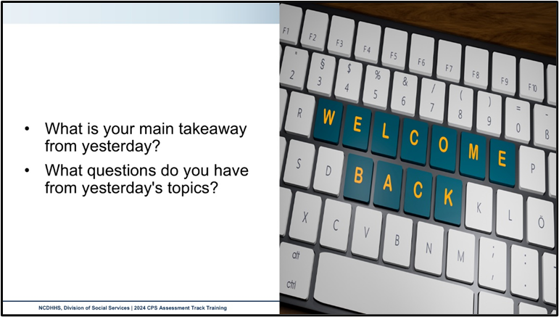

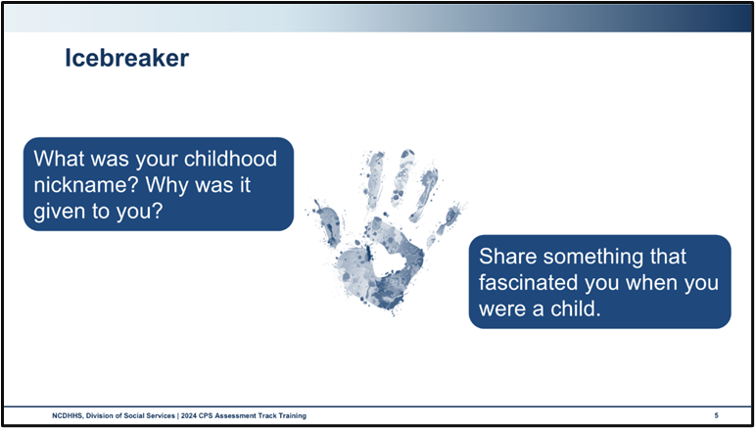

Use this outlined space to record notes from the introduction activity.

|  |
| --- |
|  |

# Safety Planning

## Essential Function: Planning

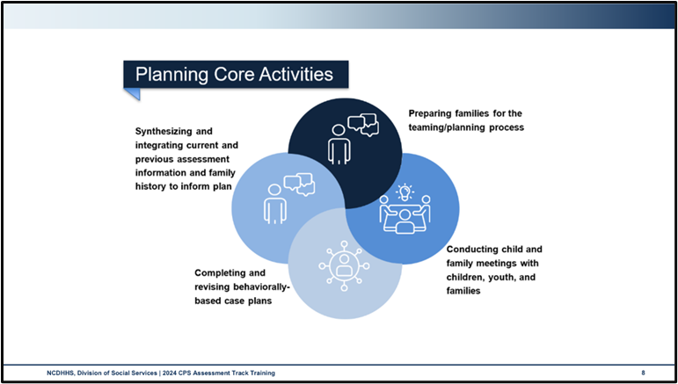

Use this space to record notes.

|  |
| --- |
|  |

### Activity: Stages of Change

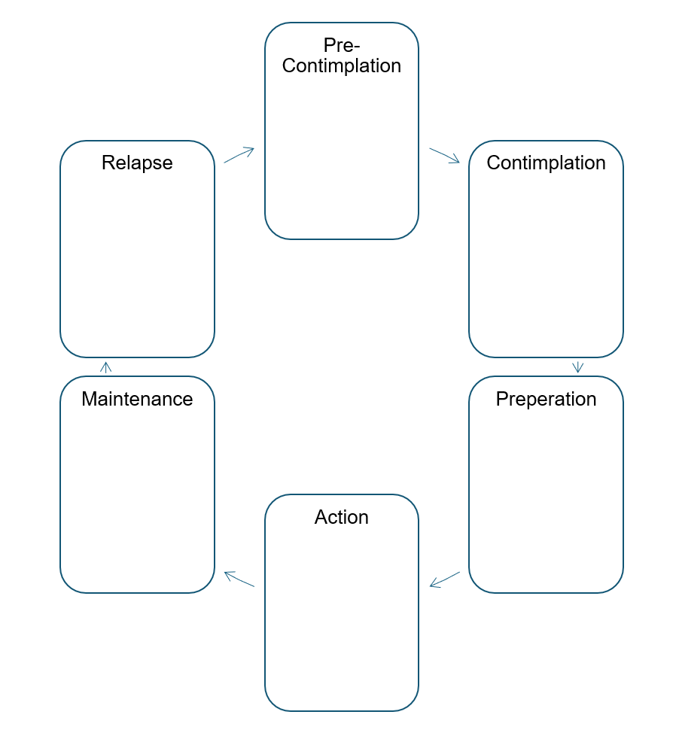

* Think of a time when you were forced to change. This could be a pleasant change, like becoming an older sibling or becoming a parent, or an unpleasant change, like the death of a parent, spouse, sibling, or child, or a health diagnosis causing a great change in your daily life, diet, or habits.
* Take turns with your partner and share the change you were forced to make and how you experienced the stages of change. Discuss with your partner what and who was most helpful to you in making the change, and what or who was least helpful in supporting your change.

What was most helpful in maintaining your changed behavior? Did you ever relapse?

|  |
| --- |
|  |

What helped get you back into action, or even maintenance of your changed behavior?

|  |
| --- |
|  |

How does this activity relate to the experiences of families involved with CPS Assessment interventions?

|  |
| --- |
|  |

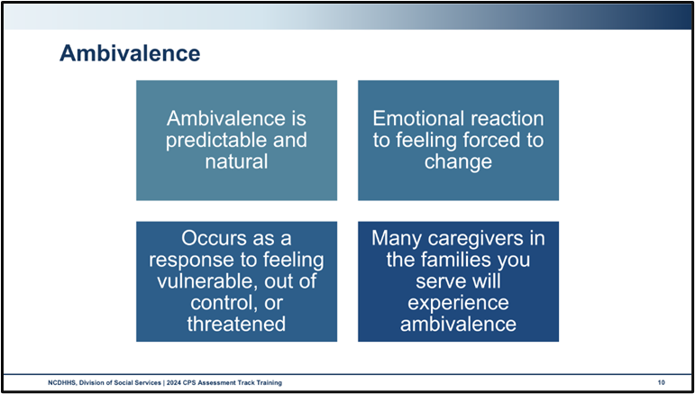

What emotions might you encounter when working with a family about change?

|  |
| --- |
|  |

How will you know when you are encountering ambivalence when working with a family? What are some behavioral indicators?

|  |
| --- |
|  |

How have you responded in interactions influenced by a family member’s ambivalence?

|  |
| --- |
|  |

### Worksheet: Accountability and Support

Accountability

|  |
| --- |
|  |

Support

|  |
| --- |
|  |

**Each person is more than the harm they have caused.** Understanding the interplay of accountability and support gives your families the best chance for change.

|  |  |
| --- | --- |
| Doing To  High Accountability and Low Support | Doing With  High Accountability and High Support |
| Not Doing  Low Accountability and Low Support | Doing For  Low Accountability and High Support |

Additional resources to learn more:

Barnard Center for Research on Women, Accountability Series, specifically the following two videos:

* What is Accountability? <https://www.youtube.com/watch?v=QZuJ55iGI14&list=RDCMUCQlRhZk3WxSLPKxrFUGfUlw&index=1>
* How to Support Harm Doers in Being Accountable. <https://www.youtube.com/watch?v=AhANo6wzBAA&list=RDCMUCQlRhZk3WxSLPKxrFUGfUlw&index=2>

## Safety Interventions and Safety Decisions

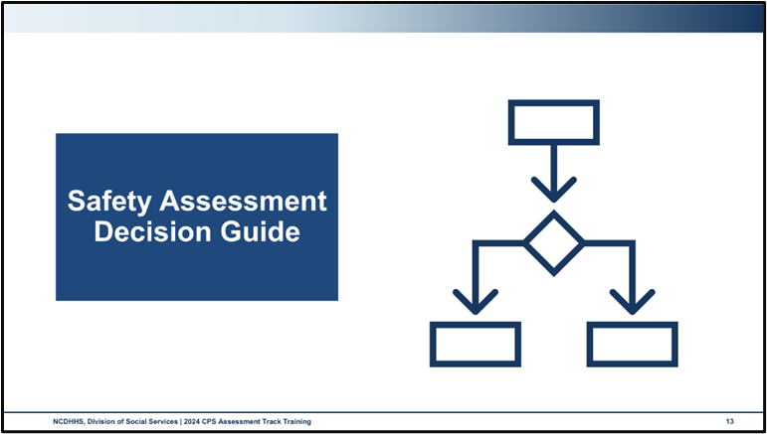

Use this space to record notes.

|  |
| --- |
|  |

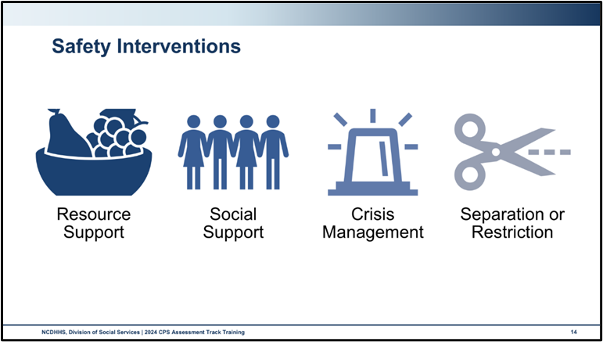

Policy outlines four main categories for safety interventions that may be incorporated into safety agreements:

* **Resource support** refers to safety actions that address a shortage of family resources and resource utilization (such as obtaining heat, water, electricity, food, childcare, etc.), the absence of which directly threatens the safety of the child.
* **Social support** includes actions that reduce social isolation. Social support may be used alone or in combination with other actions to reinforce and support the capacity of the parents or other caretakers.
* **Crisis management** is specifically concerned with intervening to halt a crisis and to facilitate problem-solving to bring a state of calm to a family. The purpose of crisis management is to quickly control the threat to the child’s safety. Crisis management will often be employed along with other safety actions.
* **Separation or restriction** refers to the removal of any household member from the home for a period or otherwise interfering with a parent’s custodial rights. Separation is viewed as a temporary action. Separation may involve, among other things, the child temporarily moving to a safe environment, a friend or relative moving into the home, the protective parent moving with the child to a safe environment, a parent agreeing not to have unsupervised contact with the child, a parent agreeing to forfeit decision-making authority over the child, or the alleged perpetrator agreeing to leave the home.

Within these categories of intervention, the roles of those who carry out these interventions are defined by the DSS-5231 NC Safety Assessment, Part C: Safety Interventions. Those choices include:

* **Monitoring and/or use of direct services by county child welfare agency**: DO NOT include the assessment itself as an intervention. Actions taken or planned by the assessment social worker or other CPS staff that specifically address one or more of the safety indicators.
* **Use family, neighbors, or other individuals in the community in the development and implementation of a safety agreement**. Engaging the family’s natural safety network to mitigate safety concerns.
* **Use community agencies or services**. Involving community or faith-based organizations or other agencies in activities to address safety indicators. This DOES NOT INCLUDE long-term therapy or treatment or being put on a waiting list for those services.
* **The alleged perpetrator will leave or has left the home, either voluntarily or in response to legal action**. Temporary or permanent removal of the alleged perpetrator.
* **A protective caregiver will move or has moved to a safe environment with the children and there are no restrictions on the protective caregiver’s access to the children**. A caretaker not suspected of harming the child has taken or plans to take the child to an alternative location to which the alleged perpetrator will not have access.
* **Use of a Temporary Safety Provider (TSP)**:
  + Explain why responses 1-5 were insufficient. An alleged perpetrator leaving the home.
  + A TSP must be identified, assessed, and approved for any TPSA that requires restriction of access, supervision, or separation of a child from parental care.

### Activity: Safety Interventions

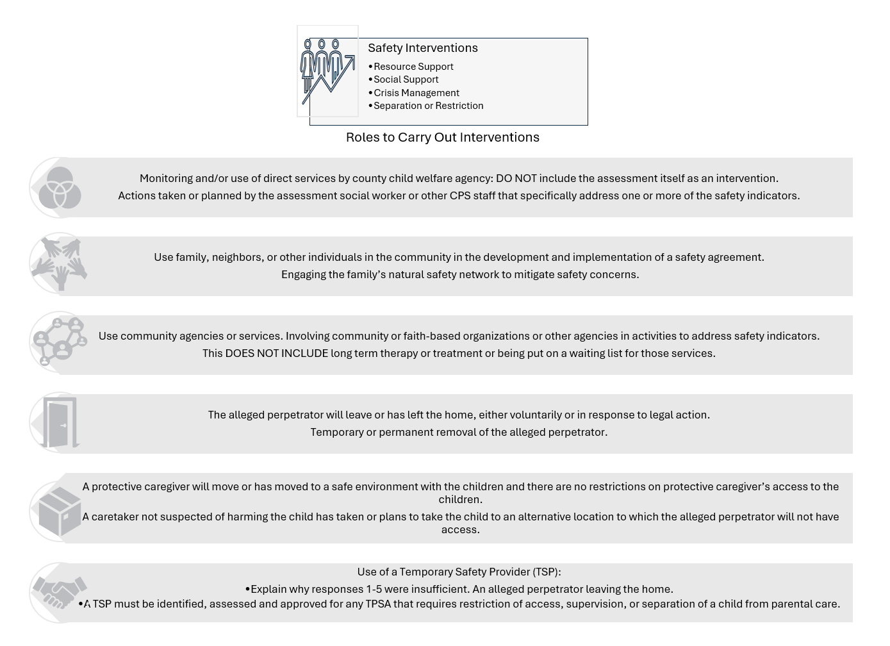

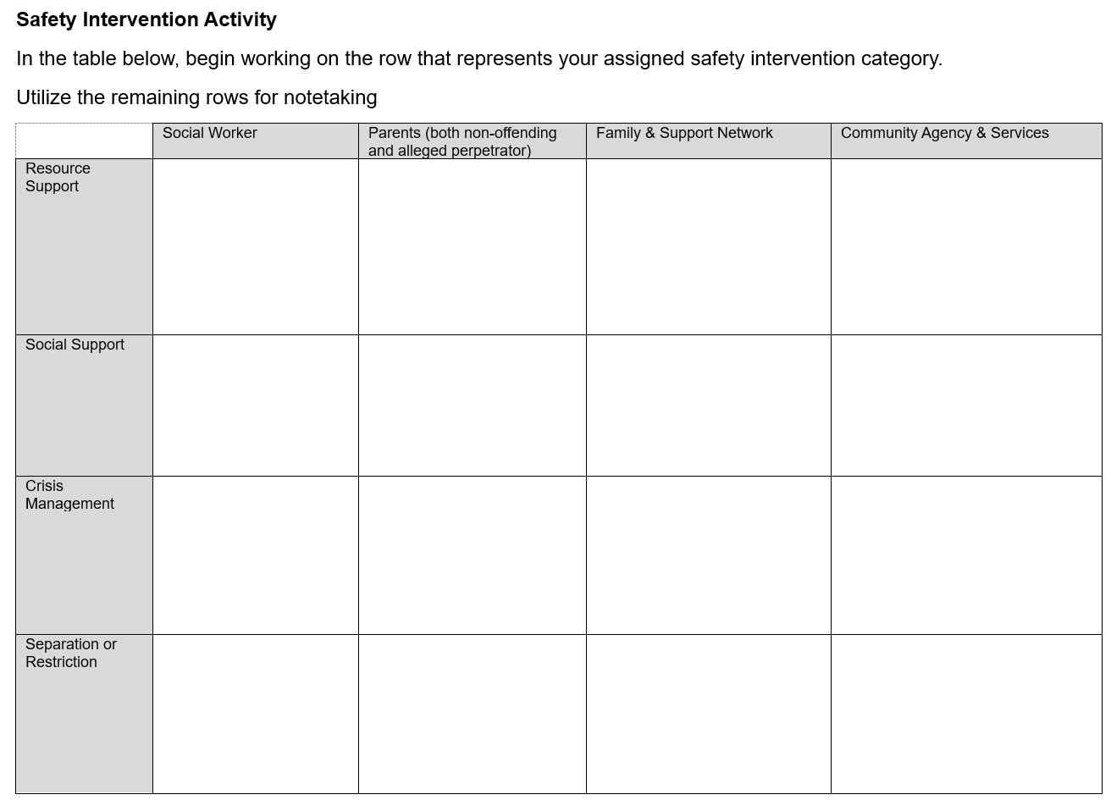

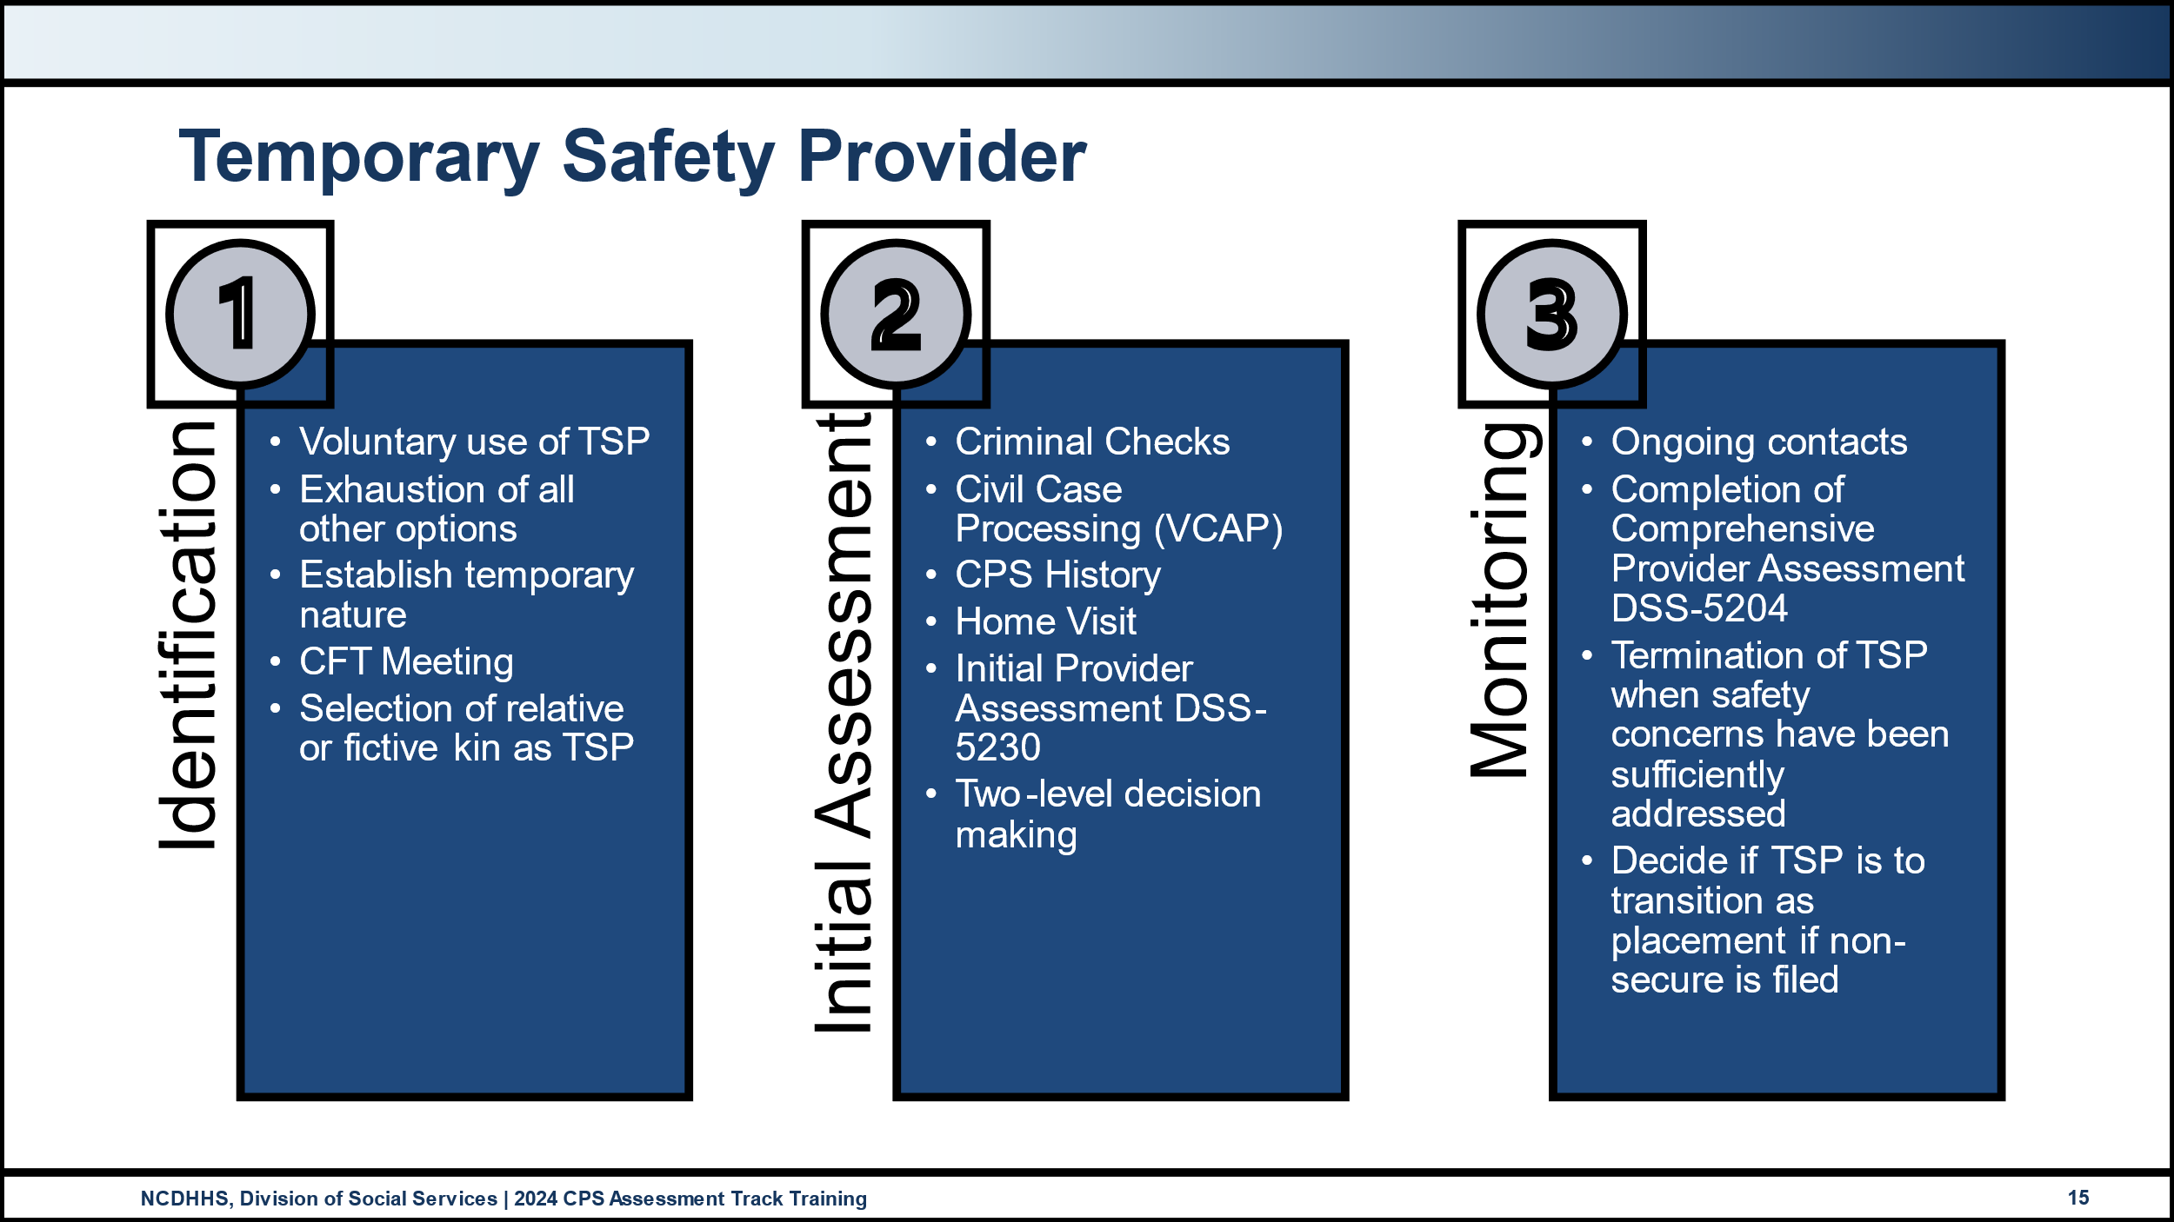

Use this space to record notes.

|  |
| --- |
|  |

## Safety Planning and Temporary Parental Safety Agreements

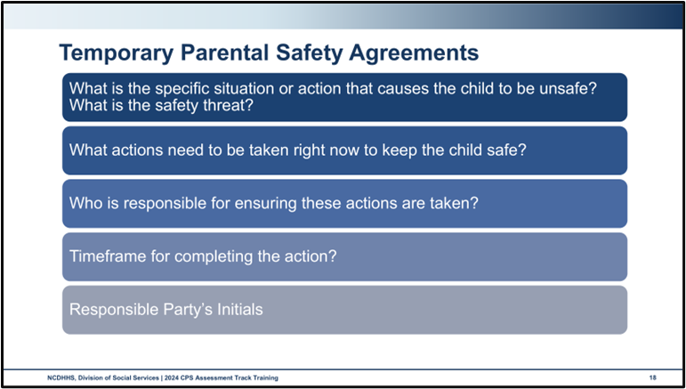

Use this space to record notes.

|  |
| --- |
|  |

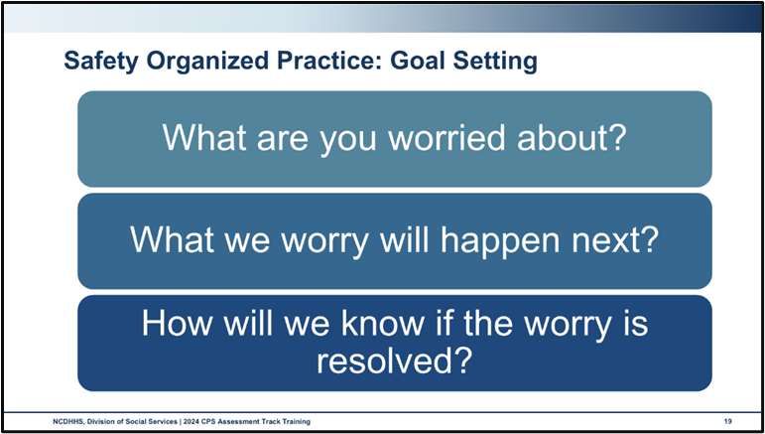

Solution-Focused Questions

* **Exception questions** to help the family and their team/network identify when the concerning behavior wasn’t happening.
  + Has there been a time when you were able to stay sober? How did you manage to do that?
  + How was your parenting different when you were sober? What did it look like?
* **Position or relationship questions** to identify behavior from other perspectives
  + What would your son say is his favorite thing about you as a mom when you’re sober?”
  + What new behaviors might your children want to see you doing to feel safe that no one will get hurt in your house again?
* **Preferred future questions** to identify the family’s vision for what could be
  + When this is all behind you, what will be different for you and your children?
  + If you woke up tomorrow and all of your problems were gone, how would things be different for you and your family?
* **Scaling** to identify the family’s and network’s willingness to participate in the plan, agreement to the plan, and confidence that the plan will ensure safety. Remember to ask how the person got to the number they picked and what it would take to move up one (or why they did not pick a lower number).
  + On a scale of 0 to 10, with 0 being unable to picture anything different and 10 being having a clear dream, how would you rate your ability to imagine life to be different than it is now?

Questions to build on Harm and Worry Statements

* What are you worried about? What brought us here?
* What do we worry will happen next, if there is no behavior change?
* How will we know if the worry is resolved?

SMART format:

* **Specific**: Goals should be written simply and clearly outline exactly what is expected.
* **Measurable**: Goals must identify ways to gather tangible evidence that change has occurred.
* **Achievable**: Goals must be possible and feasible, given the resources and circumstances.
* **Realistic**: Goals should matter to those involved and focus on things that relate to why the family is involved with child welfare. Sometimes the “R” also is referred to as “relevant,” which has the same intent as “realistic.”
* **Timely**: Goals should be linked to a timeframe.

## Applying Cultural Humility to Safety Assessments

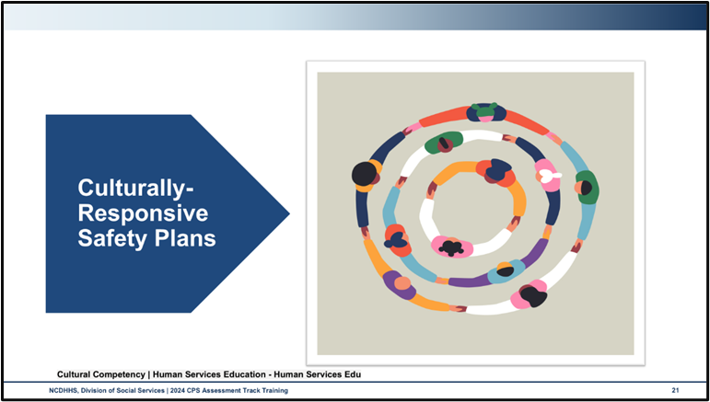

Cultural humility describes an ongoing process of self-exploration and self-critique combined with a willingness to learn from others.

Cultural competence is the ability to engage knowledgeably with people across cultures

Culturally responsive practices in human services include:

* Have staff who can speak the language of the community or offer easy access to interpreters.
* Deliver services at hours and locations that are accessible.
* Be considerate of cultural mores and taboos.
* Be intentional about learning from clients about their culture.
* Employ diverse and multilingual staff.
* Educate staff about the populations with whom they will most commonly be in contact.

The actions of a culturally responsive human services professional include:

* Monitor and apply knowledge of self and others as cultural beings.
* Identify the relationship of social and cultural factors in the development of problems.
* Asking and listening.
* Respect and awareness, that is respect for ideas and perspectives coming from other cultures, even when they are totally unfamiliar or even offensive by your own cultural standards. An open-minded approach is required. A good poker face can be important for human services staff to avoid appearing judgmental. Acceptance of other views is key to cultural competency.
* Education. The dynamic nature of cultural competence requires continuing education. You’ll always be learning new things about your community if you are culturally competent.

# Safety Planning Learning Lab

## Safety Planning

### Worksheet: Self-Care Health Plan Check-In

The trainers will provide a worksheet for the completion of the self-care health plan check-in.

Use this space to record notes.

|  |
| --- |
|  |

### Activity: Avilla Chavis and Lewis Family Safety Assessment Decision

Utilizing the information gathered throughout the learning labs, brainstorm possible safety interventions for your assigned anchor family. Consider the following questions for each of the identified Safety Threats:

* What are you worried about?
* What are we worried will happen next, if the concern is not resolved?
* How will we know if the worry is resolved?

Allow the answers to the questions above to guide your brainstorm for specific interventions that address the underlying threats. Consider the four categories of safety intervention and the safety intervention contributors specific to the case scenario.

|  |  |  |  |  |
| --- | --- | --- | --- | --- |
|  | Social Worker | Parents (both non-offending and alleged perpetrator) | Family & Support Network | Community Agency & Services |
| Resource Support |  |  |  |  |
| Social Support |  |  |  |  |
| Crisis Management |  |  |  |  |
| Separation or restriction |  |  |  |  |

### Skills Practice: Building Safety Agreements

Utilizing ideas from the safety intervention activity you just completed, work in your triad to generate a Temporary Parental Safety Agreement for your assigned family. Remember your specific role in this brainstorming process:

* Ones: Represent the parent advocating for the least restrictive intervention possible.
* Twos: Represent DSS, accurately describing the Safety Threats
* Threes: Represent objectivity

Use the space below to brainstorm and draft your statements. Once completed, transfer your completed TPSA to Part E of your Safety Assessment DSS-5231.

|  |  |  |  |
| --- | --- | --- | --- |
| What specific situation or action caused the child to be unsafe? | What actions need to be taken right now to keep the child safe? | Who is responsible for ensuring that these actions are taken? | When will the actions be complete? |
|  |  |  |  |
|  |  |  |  |
|  |  |  |  |

## Applying Cultural Humility to Safety Planning

### Activity: Applying Cultural Humility to Assessing and Planning

* Listen as the activity or decision is read by the trainer.
  + Is the activity or decision appropriate?
  + At what age is the activity appropriate?
* Hold up your sticky note with your response for others to see

How would you reconcile some of these in your responses?

|  |
| --- |
|  |

How does this get decided when what you think is different than what the family believes?

|  |
| --- |
|  |

# Trauma-Informed Practice

## Trauma-Informed Practice

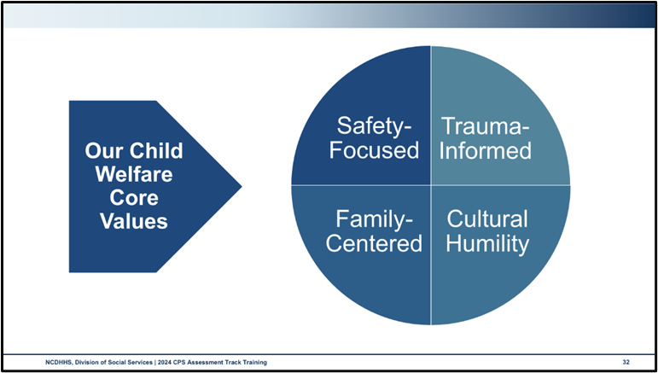

What does it look like to practice safety-focused, family-centered, trauma-informed child welfare?

|  |
| --- |
|  |

### Video: Step Inside the Circle

<https://youtu.be/FVxjuTkWQiE>

As you watch the video, make note of what is said about:

* Physical safety
* Psychological safety
* Feelings associated with trauma
* Personal histories
* Community histories
* Feelings when trauma is discussed

|  |
| --- |
|  |

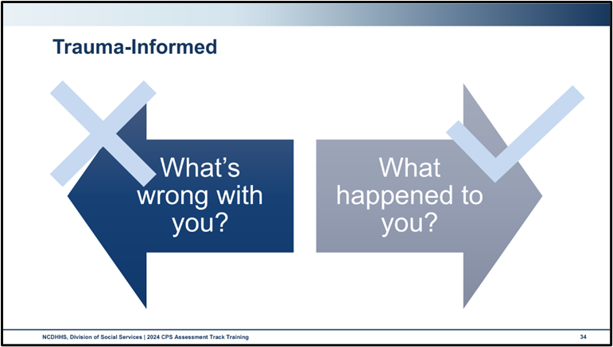

Use this space to record notes.

|  |
| --- |
|  |

# Considerations for Cases Involving Special Circumstances

## Considerations for Cases Involving Special Circumstances

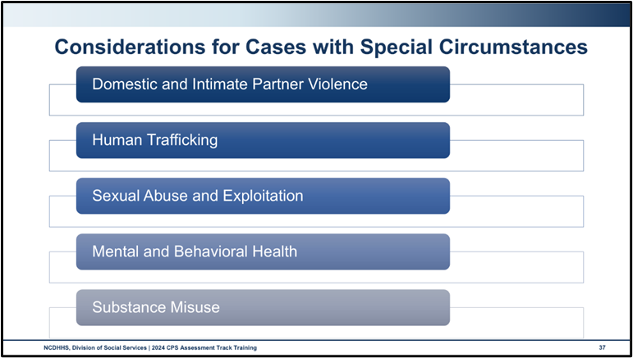

Use this space to record notes.

|  |
| --- |
|  |

## Domestic and Intimate Partner Violence

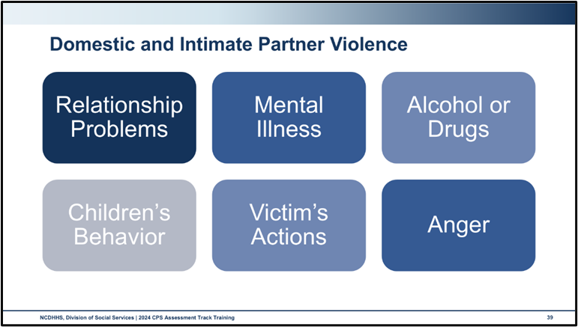

Use this space to record notes.

|  |
| --- |
|  |

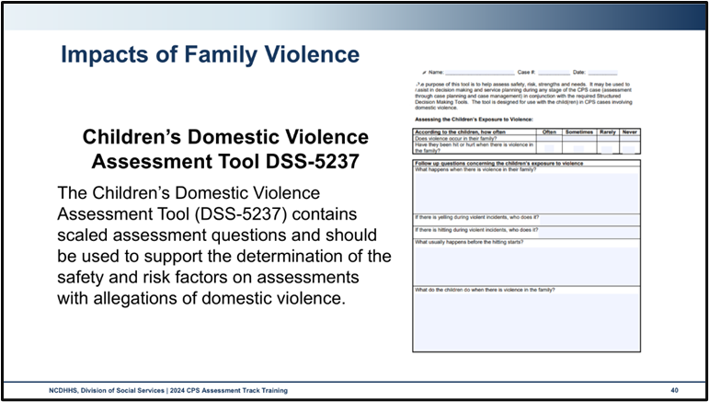

Use this space to record notes.

|  |
| --- |
|  |

### Activity: Policy and Procedures in Cases with Family Violence

Child Well-being and Domestic Violence Principles

Six Principles to address the intersection of child safety, permanency, well-being, and domestic violence:

1. Enhancing a non-offending parent/adult victim’s safety enhances their child(ren)’s safety.
2. Domestic violence perpetrators may cause serious harm to the child(ren).
3. Domestic violence perpetrators, not their victims, should be held accountable for their actions and the impact on the well-being of the non-offending parent/adult victim and child victims.
4. Appropriate services, tailored to the degree of violence and risk, should be available for non-offending parent/adult victims leaving, returning to, or staying in abusive relationships. These services should also be available for child victims and perpetrators of domestic violence.
5. Child(ren) should remain in the care of the non-offending parent/adult victim whenever possible.
6. When the risk of harm to the child(ren) outweighs the detriment of being separated from the non-offending parent/adult victim, alternative placement should be considered.

### Worksheet: Brown Family Case Scenario

Sheila-mother, she/her

Aaron-father, he/him

Jeremiah-6 month old

Nia- 2.5 years old

In interviews with the mother and children, you learn that Aaron recently pushed Shelia while she was holding Jeremiah. As Sheila stumbled, Jeremiah fell out of her arms. Jeremiah bumped his head and suffered a minor concussion, and his right knee ligament was slightly stretched requiring a splint for healing.

Sheila and Aaron are married. Aaron works and provides for the family financially. Sheila is a stay-at-home mom. Aaron has control of all the finances. Sheila had postpartum after the birth of Jeremiah. Aaron used this information to say she was unfit and to keep the children with him most of the time.

Aaron has kept Sheila away from her family and friends, stating that her focus must be on “the home.” Aaron has very strict expectations of Sheila that change all the time.

Sheila indicated that things haven’t always been this bad. Things got worse after Jeremiah was born. After what happened, Sheila is scared. She is afraid Aaron will hurt her and the children.

When asked about what she would like to see happen, she said she would like the children to be safe and to see her sister again. Shelia had a close bond with her sister, Deidra before she married Aaron.

* Using the Brown Family case scenario and the six principles to address the intersection of child safety, permanency, well-being, and domestic violence, consider the following questions:

How are you able to enhance the non-offending parent’s safety? How does this impact the children’s safety??

|  |
| --- |
|  |

What is your plan if an alleged perpetrator of violence wants to be made aware of the non-offending parent’s plan for safety?

|  |
| --- |
|  |

How do you perform a holistic CPS Assessment in cases with domestic violence?

|  |
| --- |
|  |

What do you commit to doing to maximize your own and the family’s safety in cases with domestic violence allegations?

|  |
| --- |
|  |

List three resources in your community that can receive referrals regarding family violence, domestic violence, or intimate partner violence.

|  |
| --- |
|  |

## Human Trafficking

### Video: Erica’s Story

<https://www.youtube.com/watch?v=Zv9HoHB0akI>

Use this space to record notes.

|  |
| --- |
|  |

### Debrief: Policy and Procedures in Cases with Human Trafficking

### Worksheet: Human Trafficking

When conducting a CPS Assessment involving allegations of human trafficking, county child welfare workers should assess the circumstances with consideration to the known risk factors and indicators of human trafficking:

* Human Trafficking Risk factors:
* History of running away or getting kicked out of home
* History of homelessness or housing instability
* History of sexual abuse
* History of physical abuse
* History of sexual offense
* History of delinquent or reckless behavior (involvement with law enforcement or juvenile justice)
* History of neglect or basic needs not having been met
* History of alcohol or substance use disorder
* Current or past involvement in the child welfare system
* History of depression/mood disorder
* Exposure to domestic violence
* Family instability
* Excessive absences from school
* Identifies as lesbian, gay, bisexual, or transgender (LGBT)
* Has disabilities, especially intellectual disability
* Immigration status
* Poverty
* Unemployment
* Lack of transportation.

Indicators or Red Flags for Potential Human Trafficking:

* Visible signs of abuse such as unexplained bruises, cuts, marks
* Fear of the person accompanying them
* Wearing new clothes of any style or getting hair or nails done with no financial means to do this independently
* Exhibit hyper-vigilance or paranoid behavior
* A young person with a tattoo which he or she is reluctant to explain
* Frequent or multiple sexually transmitted diseases, STIs, or pregnancies
* Truancy or tardiness from school
* Unaccounted for times, vagueness concerning whereabouts, and/or defensiveness in response to questions or concerns.

The following risk factors, indicators and vulnerabilities should be considered for foreign nationals:

* History of trauma, including civil unrest or prolonged community violence
* Social isolation
* Lack of legal status (documentation).

What red flags were present in Erica’s foster home that a child welfare social worker might have explored during home visits?

|  |
| --- |
|  |

How does policy guide what the social worker needs to do next for Erica?

|  |
| --- |
|  |

Find and list culturally appropriate resources to support Erica and her future caregivers.

|  |
| --- |
|  |

What do you commit to doing to explore the potential for human trafficking in your cases with risk factors and/or red flags?

|  |
| --- |
|  |

Source: CPS Assessments Policy, Protocol, and Guidance (February 2024)

## Sexual Abuse and Exploitation

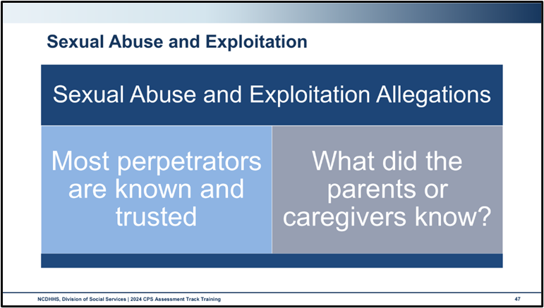

Use this space to record notes.

|  |
| --- |
|  |

### Worksheet: Sexual Abuse and Exploitation

Utilize the Cross Function Topics and CPS Assessments policies specific to sexual abuse allegations and the case scenario to answer the questions below.

Case Scenario

The report states that Maria 14 was sexually abused by her parent’s living together partner. The medical doctor states that Maria indicated that Sam has been buying her special gifts and providing her with a lot of attention since she was 12. The report states that Sam gradually moved from fondling to penetration. Maria stated to the doctor that Sam threatened to hurt her and her family if she told anyone. Maria speaks English as a second language and reverts to Spanish when she is upset. The report states that Maria said that Sam spent time in prison for things Sam did to a young girl but that her parent did not believe Sam did it. Maria has a younger sister who is 9 years old (Martina). The report alleges that Maria has not told anyone because she doesn’t want things to get worse. Maria is afraid if her other parent found out, that parent would kill Sam.

What do you do differently to initiate a case where sexual abuse or exploitation is alleged?

|  |
| --- |
|  |

How does the presence of sexual abuse in the home impact your safety assessment?

|  |
| --- |
|  |

How can you support a child’s recovery from sexual assault and exploitation?

|  |
| --- |
|  |

## Mental and Behavioral Health

### Video: Children, Violence, and Trauma: Treatments that Work

<https://www.youtube.com/watch?v=3EyvaEk0K-k>

Use this space to record notes.

|  |
| --- |
|  |

## Substance Misuse

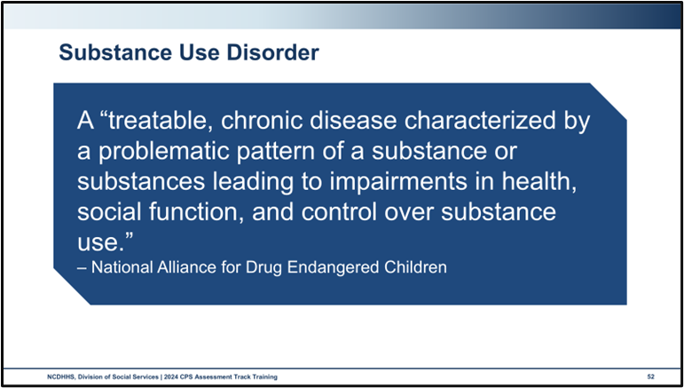

Use this space to record notes.

|  |
| --- |
|  |

### Handout: Substance Use Disorder and Recovery in a Family

Use this space to record notes.

|  |
| --- |
|  |

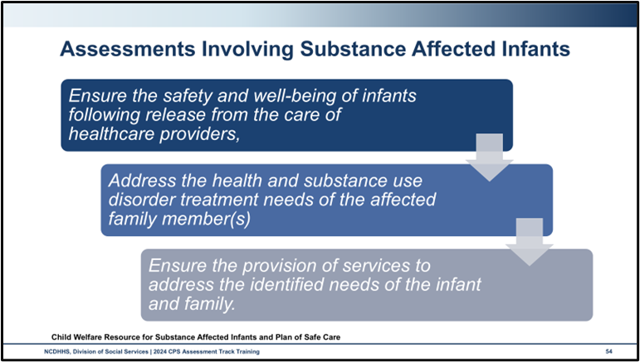

Use this space to record notes.

|  |
| --- |
|  |

## Assessing for Special Circumstances

### Activity: Special Circumstances Impacting Families

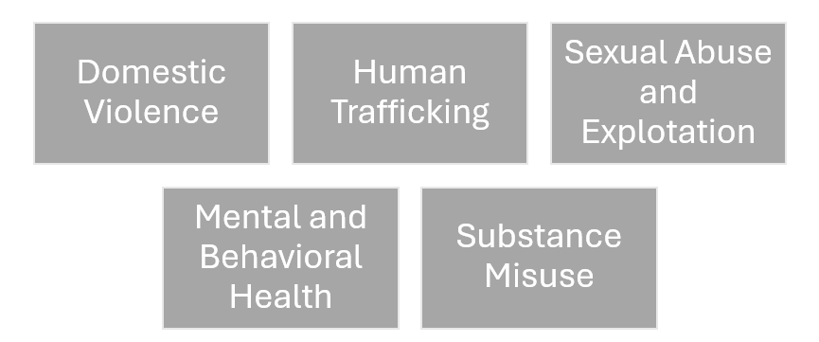

List the ways in which this factor may impact child safety and parental capacity.

|  |
| --- |
|  |

List activities and tools that are available to support your assessment.

|  |
| --- |
|  |

List the ways you can measure impact on children including:

* **List behavioral indicators**
* **Consider the physical and emotional impact**

|  |
| --- |
|  |

Name stereotypes or biases that impact the assessment of this factor.

|  |
| --- |
|  |

# Social Worker Safety

## Considerations for Social Worker Safety

### Skills Practice: Safety Concerns

* List your group’s safety concerns from the large group brainstorm in the column on the left.
* In the middle column, brainstorm techniques and ideas to prevent this safety concern.
* In the right-hand column, generate strategies to intervene if the safety concern occurs.

|  |  |  |
| --- | --- | --- |
| Safety Concern | Prevention | Intervention |
|  |  |  |

Considerations for Worker Safety

Consider NC DSS Best Practice for Social Worker Well-Being Appendix 6 (July 2019) found at <https://policies.ncdhhs.gov/wp-content/uploads/appendix-6-best-practice-for-social-worker-well-being.pdf>

What does policy say about social worker safety in the field?

|  |
| --- |
|  |

What procedures do you use to inform others of where you will be, when, and why?

|  |
| --- |
|  |

Name four reasons why you would not enter a home.

|  |
| --- |
|  |

Name two reasons you would request law enforcement assistance in the field.

|  |
| --- |
|  |

Where should you keep your personal items while you conduct a home visit?

|  |
| --- |
|  |

How might you make your field work safer?

|  |
| --- |
|  |

What should you carry with you in your vehicle (as a roadside safety kit)?

|  |
| --- |
|  |

Once you have been invited inside and have entered the home, what are three ways to assess your safety?

|  |
| --- |
|  |

How much personal information is okay to share with children and families?

|  |
| --- |
|  |

How does social media influence your safety as a child welfare social worker?

|  |
| --- |
|  |

For more information on promoting child welfare worker safety, consider The Child Welfare Worker Safety Guide created by the Child Welfare Capacity Building Center for States. <file:///C:/Users/ASturtevant/Downloads/worker-safety-guide-cp-00121.pdf>

# End-of-Day Values Reflection

### Questions and Reflections

Use this space to record reflections and questions about what you have learned today.

|  |
| --- |
|  |

# Bibliography of References

Day Four

American Speech-Language-Hearing Association. (2024). *Cultural Responsiveness.* [Webpage]. ASHA.org/Practice-Portal. https://www.asha.org/practice-portal/professional-issues/cultural-responsiveness/#collapse_1

BigFoot, D.S., & Deframboise, T. (2023, March 21). A trauma-Informed Approach to working with Tribes. [Webinar, PowerPoint presentation]. Collaborating with Tribal Communities Webinar Series: Webinar 3. (2018). Suicide Prevention Resource Center, sprc.org. https://view.officeapps.live.com/op/view.aspx?src=https%3A%2F%2Fsprc.org%2Fwp-content%2Fuploads%2F2023%2F05%2FFINAL_Webinar-3_A-Trauma-Informed-Approach-to-Working-with-Tribes.pptx&wdOrigin=BROWSELINK

Buffalo Center for Social Research. (2024). *What is trauma-informed care?* Buffalo, NY: University at Buffalo, Institute on Trauma and Trauma-Informed Care. https://socialwork.buffalo.edu/social-research/institutes-centers/institute-on-trauma-and-trauma-informed-care/what-is-trauma-informed-care.html

CalSWEC Online, (2019, April 29) Child Welfare Worker Realistic Job Preview. [Video]. Youtube.com. https://www.youtube.com/watch?v=2aoOYAwgp2o&list=PLNYfSDZN2XUpWQ62KzijZDZ_g2VEjlSGD&index=1

Casey Family Programs, (2019, January 18) Jeremiah Donier: Birth dad winner. [Video]. YouTube.com. https://www.youtube.com/watch?v=yxBeN5-Rq_E&t=249s

Centers for Disease Control and Prevention, Child Abuse and Neglect Prevention. (2018, August). *About Child Sexual Abuse.* [Website]. [www.cdc.gov](http://www.cdc.gov). Washington, DC: U.S. Department of Health and Human Services. https://www.cdc.gov/child-abuse-neglect/about/about-child-sexual-abuse.html

Centers for Disease Control and Prevention. (2024). *Youth Risk Behavior Survey Data Summary & Trends Report: 2013–2023*. [Report]. Washington, DC: U .S. Department of Health and Human Services. https://www.cdc.gov/yrbs/dstr/index.html

Child Welfare Information Gateway. (2020, October) *How the Child Welfare system works*. Washington, DC: U.S. Department of Health and Human Services, Administration for Children and Families, Children’s Bureau. https://www.childwelfare.gov/pubPDFs/cpswork.pdf

Child Welfare Information Gateway. (2014, July 23) *Child and family services reviews quick reference items list*. Washington, DC: U.S. Department of Health and Human Services, Administration for Children and Families, Children’s Bureau. https://www.acf.hhs.gov/sites/default/files/documents/cb/cfsr_quick_reference_list.pdf

Childhood Domestic Violence Association. (n.d.). *How does domestic violence impact children?* [Website].Childhood Domestic Violence, cdv.org. https://cdv.org/2022/12/how-does-domestic-violence-impact-children/.

Fong, R., & Berger Cardoso, J.. (2010). Child human trafficking victims: Challenges for the child welfare system. *Evaluation and program planning, 33*(3): 311-316.DOI: 10.1016/j.evalprogplan.2009.06.018.

Gibbs, Deborah A., Hardison Walkers, J.L., Lutnick, A., Miller, S. & Kluckman, M. (2015, July). Services to domestic minor victims of sex trafficking: Opportunities for engagement and support. *Children and Youth Services Review 54*(July 2015): 1-7. DOI: https://doi.org/10.1016/j.childyouth.2015.04.003.

Global Health Equity. (n.d.). Chapter 1: Embracing Cultural Humility and Community Engagement. *Guiding Principles for Global Communication.* Washington, DC: U.S. Centers for Disease Control and Prevention. https://www.cdc.gov/global-health-equity/php/publications/cultural-humility.html?CDC_AAref_Val=https://www.cdc.gov/globalhealth/equity/guide/cultural-humility.html

Hopf, S. C., Crowe, K., Verdon, S., Blake, H. L., & McLeod, S. (2021). Advancing workplace diversity through the culturally responsive teamwork framework. *American Journal of Speech-Language Pathology, 30(*5), 1949–1961. https://doi.org/10.1044/2021_AJSLP-20-00380

Horstman, F. (2020, June 21). *Step inside the circle.* [Video]. YouTube.com. https://www.youtube.com/watch?v=FVxjuTkWQiE

Ignacio. (2012, January 9). Intervention: The cycle of change. Socialworktech.com. <https://socialworktech.com/2012/01/09/stages-of-change-prochaska-diclemente/>.

Mental Health Coordinating Council. (2022). *Recovery Oriented Language Guide: WORDS MATTER*. Lilyfield, NSW, Australia: Mental Health Coordinating Council NSW. https://mhcc.org.au/wp-content/uploads/2022/10/Recovery-Oriented-Language-Guide-3rd-edition.pdf

Miller, W.R. and Rollnick, S. (2013). *Motivational interviewing: Helping people change, 3rd Ed.* New York, NY: Guilford Press.

National Alliance for Drug Endangered Children (National DEC). (n.d.). *Who are d rug endangered children?* Westminster, CO: National Alliance for Drug Endangered Children. https://nationaldec.org/wp-content/uploads/Who-are-Drug-Endangered-Children.pdf

National Center on Substance Abuse and Child Welfare. (n.d.). *Module 5: Case planning, family strengthening, and planning for safety for families with a substance use disorder*. Washington, DC: U.S. Department of Health and Human Services, Administration for Children and Families, Substance Abuse and Mental Health Services Administration. https://ncsacw.acf.hhs.gov/files/toolkitpackage/mod5/module-5-case-guide-508.pdf

National Institute of Mental Health. (2023, March). *Mental Illness.* [Website]. [www.nimh.nih.gov](http://www.nimh.nih.gov). Washington, DC: U .S. Department of Health and Human Services. https://www.nimh.nih.gov/health/statistics/mental-illness

North Carolina Department of Health and Human Services, Division of Social Services. (2002). What is forensic interviewing? *Children’s services practice notes 8*(2). https://practicenotes.org/vol8_no1/what_is.htm

North Carolina Department of Health and Human Services, Division of Social Services. (2004, September 4). *DSS-5237: Children’s Domestic Violence Assessment Tool.* https://policies.ncdhhs.gov/wp-content/uploads/dss-5237-ia.pdf

North Carolina Department of Health and Human Services, Division of Social Services, Child Welfare Services. (2017). *DSS-5231: North Carolina safety assessment. https://policies.ncdhhs.gov/wp-content/uploads/dss-5231-ia.pdf*

North Carolina Department of Health and Human Services, Division of Social Services, Child Welfare Services. (2017). *DSS-5231ins: North Carolina safety assessment instructions.* https://policies.ncdhhs.gov/wp-content/uploads/DSS-5231ins.pdf

North Carolina Department of Health and Human Services, Division of Social Services, Child Welfare Services. (2017). *NC Domestic Violence Policy and Best Practice in Child Welfare*. https://www.ncdhhs.gov/documents/files/dss/training/domestic-violence-workbook/download

North Carolina Department of Health and Human Services, Division of Social Services. (2019). Assessing safety and risk. *Children’s services practice notes 24*(2). https://practicenotes.org/v24n2.htm

North Carolina Department of Health and Human Services, Division of Social Services. (2020, May). *CPS Purpose & Philosophy, Legal Basis, Administration: NC Child Welfare manual*, 9. https://policies.ncdhhs.gov/wp-content/uploads/purpose.pdf

North Carolina Department of Health and Human Services, Division of Social Services. (2021). *North Carolina practice standards worker assessment*. https://www.ncdhhs.gov/cw-worker-north-carolina-worker-assessment-all-practice-standards/open

North Carolina Department of Health and Human Services, Division of Social Services. (2021). *Worker practice standards desk guide.* https://www.ncdhhs.gov/cw-worker-north-carolina-worker-practice-standards-desk-guide/open

North Carolina Department of Health and Human Services, Division of Social Services. (2022). *DSS-6191 – North Carolina division of social services plan of safe care*. https://policies.ncdhhs.gov/wp-content/uploads/DSS-6191.pdf

North Carolina Department of Health and Human Services, Division of Social Services. (2024, April). *Cross function topics: NC Child Welfare manual*. https://policies.ncdhhs.gov/wp-content/uploads/In-Home_April-2024_2.pdf

North Carolina Department of Health and Human Services, Division of Social Services. (2024, August). *CPS Assessments Policy, Protocol, and Guidance: NC Child Welfare manual*. https://policies.ncdhhs.gov/wp-content/uploads/CPS-Assessments-Aug-2024.pdf

North Carolina Department of Health and Human Services, Division of Social Services. (2024, August). *CPS Intake Policy, Protocol, and Guidance: NC Child Welfare manual*. https://policies.ncdhhs.gov/wp-content/uploads/CPS-Intake_Aug-2024.pdf

Northern California Training Academy. (n.d.).*Safety organized practice quick guide: Behaviorally-based case plans.* https://oercommons.s3.amazonaws.com/media/editor/92375/Behaviorally-Based_Case_Plans_-_SOP_Quick_Guide_2018-10-24.pdf.

Office for Victims of Crime. (2013, February 27). *Children, violence, and trauma – Treatments that work.* [Video]. YouTube.com. Washington, DC: U.S. Department of Justice. https://www.youtube.com/watch?v=3EyvaEk0K-k

Oklahoma Human Services, Child Welfare Services. (2021). *OHS CWS CORE training, Module 3, Day 4*. With permission from author.

The Pennsylvania Child Welfare Resource Center. (n.d.). *Field Safety Checklist for Child Welfare Professionals.* Pittsburgh, PA: University of Pittsburgh, School of Social Work. https://www.pacwrc.pitt.edu/ELearn/CaseworkerSafety/Field_Safety-checklist.pdf

The Pennsylvania Child Welfare Resource Center. (n.d.). *Engaging Clients from a Strength-Based, Solution-Focused Perspective, Handout #9, Page 1 of 4*. Pittsburgh, PA: University of Pittsburgh, School of Social Work. https://www.pacwrc.pitt.edu/Curriculum/301EngggClntsFrmAnSBSFPrspctv/Hndts/HO_9_Solution_focused_skills_and_questions.pdf

Soundscaping Source. (2013, April 17). *Cultural humility vs. cultural competence.* [Blog.]. soundscapingsource.com. https://soundscapingsource.com/cultural-humility-vs-cultural-competence/.

Stroud, L. R., Paster, R. L., Papandonatos, G. D., Niaura, R., Salisbury, A. L., Battle, C., Lagasse, L. L., & Lester, B. (2009). Maternal smoking during pregnancy and newborn neurobehavior: Effects at 10 to 27 days. *The Journal of pediatrics, 154*(1), 10–16. https://doi.org/10.1016/j.jpeds.2008.07.048

Trauma-Informed Care Implementation Resource Center. (2024). *What is trauma-informed care?* Traumainformedcare.chcs.org. Center for Health Care Strategies. https://www.traumainformedcare.chcs.org/.

Upendra. (November 232, 2017). *Difference between anger, aggression, and violence*. [Website]. DifferenceBetween.com. https://www.differencebetween.com/difference-between-anger-and-vs-aggression-and-vs-violence/

Watchel, T. (1999, February 18). *Restorative practices in business: Builidng a community for learning and change within organizations.* International Institute for Restorative Practices, [www.iirp.edu](http://www.iirp.edu). https://www.iirp.edu/news/restorative-practices-in-business-building-a-community-for-learning-and-change-within-organizations

# Appendix: Handouts

Substance Use Disorder and Recovery in a Family 2

## Substance Use Disorder and Recovery in a Family

