North Carolina Department of Health and Human Services
CPS Assessment in Child Welfare Track Training

Participant’s Workbook
Day Five

October 2024


600 Airport Rd
Lakewood, NJ, 08701-5995
www.pubknow.com

info@pubknow.com
(800) 776-4229

This curriculum was developed by the North Carolina Department of Health and Human Services, Division of Social Services, and revised by Public Knowledge® in 2024.

Copyright © 2024 Public Knowledge®. All rights reserved. No part of this publication may be reproduced, distributed, or transmitted in any form without the written permission of the publisher.
Table of Contents
Instructions 4
Course Themes 4
Training Overview 5
Learning Objectives 7
Day Five Agenda 9
Welcome 10
Engaging the Family in Child Protection Services 11
Engaging the Non-Resident Parent 11
Cultural Considerations in Engaging Families 13
Activity: Considerations for Diverse Communities 13
Risk Assessment 14
Identifying and Understanding Risk Factors 14
Protective Factors 17
Activity: Protective Factors Exploration 19
Risk Assessment Tool 20
Skills Practice: Family Risk Assessment of Child Abuse and Neglect 22
Crucial Conversations 23
Crucial Conversations and Managing Conflict 23
Handout: Managing Crucial Conversations 24
Skills Practice: Crucial Conversations 25
Debrief: Crucial Conversations Practice 27
Quality Contacts 28
Quality Contacts 28
Worksheet: Competing Factors in Quality Contacts 30
Quiz: True or False 31
Activity: Planning for Quality Contacts 32
Activity: Perspective Taking: Assessing Safety and Risk Through Quality Contacts 33
Activity: Contacts and Frequency Fill in the Blank 34
Assessing Family Strengths and Needs 35
Strengths-Based Approach to Assessment 35
Skills Practice: Strengths-Based Approach 36
Family Strengths and Needs Assessment 37
Worksheet: Family Assessment of Strengths and Needs 38
Social Worker Safety 39
Secondary Traumatic Stress and Vicarious Traumatization 39
Video: Impacts of Secondary Traumatic Stress on the Child Welfare Workforce 39
Worksheet: Socio-Ecological Model 41
End-of-Day Values Reflection 43
Questions and Reflections 43
Bibliography of References 44
Appendix: Handouts 1
Protective Factors Action Sheets 2
DSS-5230: Family Risk Assessment of Child Abuse/Neglect 12
Managing Crucial Conversations 23
Defining Quality Contacts 24

Instructions
This course was designed to guide child welfare professionals through the knowledge, skills, and behaviors needed to engage with families in need of child protection services. The workbook is structured to help you engage in the lesson through reflection and analysis throughout each week of training. Have this workbook readily available as you go through each session to create a long-lasting resource you can reference in the future.
If you are using this workbook electronically: Workbook pages have text boxes for you to add notes and reflections. Due to formatting, if you are typing in these boxes, blank lines will be “pushed” forward onto the next page. To correct this when you are done typing in the text box, you may use delete to remove extra lines.

Course Themes
The central themes of the CPS Assessment Track Training are divided across several course topics.
- Purpose and Legal Basis for Child Protection Services in North Carolina
- Essential Function: Communicating
- Diversity, Equity, Inclusion, and Belonging
- Trauma-Informed Care
- Family-Centered Practice
- Essential Function: Engaging
- Safety Focused
- Essential Function: Assessing
- Interviewing Learning Lab
- The Role of Observation in Assessing for Safety
- Structured Decision-Making: Safety Assessment
- Assessment Learning Lab
- Safety Planning
- Safety Planning Learning Lab
- Trauma-Informed Practice
- Considerations for Cases Involving Special Circumstances
- Social Worker Safety
- Engaging the Family in Child Protection Services
- Risk Assessment
- Crucial Conversations
- Quality Contacts
- Assessing Family Strengths and Needs
- Secondary Traumatic Stress and Vicarious Traumatization
- Ongoing Assessment
- Family Engagement and Ongoing Assessment Learning Lab
- Documentation
- Well-Being as an Outcome
- Reasonable Efforts and Removals
- Reasonable Efforts and Removals Learning Lab
- Decision-Making
- Decision-Making and Case Closure Learning Lab

Training Overview
Training begins at 9:00 a.m. and ends at 4:00 p.m. If a holiday falls on the Monday of training, the training will begin on Tuesday at 9:00 a.m. This schedule is subject to change if a holiday falls during the training week or other circumstances occur. The time for ending training on Fridays may vary and trainees need to be prepared to stay the entire day.
Attendance is mandatory. If there is an emergency, the trainee must contact the classroom trainer and their supervisor as soon as they realize they will not be able to attend training or if they will be late to training. If a trainee must miss training time in the classroom, it is the trainee’s responsibility to develop a plan to make up missed material.
Pre-Work Online e-Learning Modules
There is required pre-work for the CPS Assessment Track Training in the form of online e-Learning modules. Completion of the e-Learnings is required prior to attendance at the classroom-based training. The following are the online e-Learning modules:
- North Carolina Worker Practice Standards
- Safety Organized Practice
- Understanding and Assessing Safety and Risk
- Understanding and Screening for Trauma
Transfer of Learning
The CPS Assessment Track Training Transfer of Learning (ToL) tool is a comprehensive and collaborative activity for workers and supervisors to work together in identifying worker goals, knowledge gain, and priorities for further development throughout the training process. In four distinct steps, the worker and supervisor will highlight their goals and action plan related to participating in training, reflect on lessons and outstanding questions, and create an action plan to support worker growth. The tool should be started prior to beginning the CPS Assessment Track Training and re-visited on an ongoing basis to assess growth and re-prioritize actions for development.
- Part A: Training Preparation: Prior to completing any eLearning and in-person Track Training sessions, the worker and supervisor should meet to complete Part A: Training Preparation. In this step, the worker and supervisor will discuss their goals for participation in training and develop a plan to meet those goals through pre-work, other opportunities for learning, and support for addressing anticipated barriers.
- Part B: Worker Reflections During Training: The worker will document their thoughts, top takeaways, and outstanding questions regarding each section. This level of reflection serves two purposes. First, the practice of distilling down a full section of training into three takeaways and three remaining questions requires the worker to actively engage with the material, subsequently forming cognitive cues related to the information for future use in case practice. Second, prioritizing takeaways and questions by section allows workers to continually review information to determine if questions are answered in future sessions and supports the development of an action plan by requiring workers to highlight the questions they find most important.
- Part C: Planning for Post-Training Debrief with Supervisor: The worker considers the takeaways and questions they identified in each section and creates a framework to transfer those takeaways and questions into an action plan.
- Part D: Post-Training Debrief with Supervisor: Provides an opportunity for the supervisor and worker to determine a specific plan of action to answer outstanding questions and to further support worker training.
While this ToL is specific to the Track Training in North Carolina, workers and supervisors can review the takeaways and questions highlighted by the worker in each section of training on an ongoing basis, revising action steps when prior actions are completed, and celebrating worker growth and success along the way.
Training Evaluations
At the conclusion of each training, learners will complete a training evaluation tool to measure satisfaction with training content and methods. The training evaluation tool is required to complete the training course. Training evaluations will be evaluated and assessed to determine the need for revisions to the training curriculum.
All matters as stated above are subject to change due to unforeseen circumstances and with approval.

Learning Objectives
Day Five
Engaging the Family in Child Protection Services
- Learners will be able to explain how the needs of children and youth in diverse populations impact assessment decisions.
- Learners will be able to identify appropriate resources specific for families of children and youth in diverse populations.
- Learners will be able to describe strategies to identify and locate non-resident parents.
- Learners will be able to identify strategies to engage and involve fathers, estranged parents, or incarcerated parents.
Risk Assessment
- Learners will be able to describe the purpose of SDM tools used to support assessments.
- Learners will be able to identify risk factors in child welfare cases and discuss how they relate to concerns of future maltreatment.
- Learners will be able to define protective factors.
- Learners will be able to distinguish protective capacities from protective factors.
- Learners will be able to identify protective factors in case scenarios and discuss how they mitigate risk.
- Learners will be able to describe how and when to complete the North Carolina Risk Assessment.
- Learners will be able to apply the definitions of risk factors to case examples.
Crucial Conversations
- Learners will be able to outline different approaches in preparing for courageous conversations.
- Learners will be able to discuss how their own biases may impact courageous conversations.
- Learners will be able to identify points of conflict and various strategies to help children and families resolve conflict.
Quality Contacts
- Learners will be able to explain the importance of quality contacts.
- Learners will be able to outline NC policy related to quality contacts.
- Learners will be able to describe the use of quality contacts to assess and monitor child safety.
- Learners will be able to conduct contact interviews while maintaining child and family confidentiality.
Assessing Family Strengths and Needs
- Learners will be able to describe the purpose of SDM tools used to support assessments.
- Learners will be able to describe the skills needed to engage all family members in identifying strengths and needs in the assessment process.
- Learners will be able to describe the importance of using the Family Assessment of Strengths and Needs Tool in case planning.
- Learners will be able to outline the requirements in the assessment policy.
- Learners will be able to explain how to use the NC Family Strengths and Needs Assessment in case planning activities.
Social Worker Safety
- Learners will share and discuss examples of vicarious traumatization and STS.
- Learners will be able to identify at least three risk factors associated with STS.
- Learners will be able to identify the impacts of STS on the emotional, physical, and psychological health and decision-making of child welfare professionals and themselves.
- Learners will be able to recognize and discuss burnout and compassion fatigue.

Day Five Agenda
CPS Assessment Track Training
Welcome
Engaging the Family in Child Protection Services
Engaging the Non-Resident Parent
Cultural Consideration in Engaging Families
Risk Assessment
Identifying and Understanding Risk Factors
Protective Factors
Risk Assessment Tool
Crucial Conversations
Crucial Conversations and Managing Conflict
Quality Contacts
Quality Contacts
Assessing Family Strengths and Needs
Strengths-Based Approach to Assessment
Family Strengths and Needs Assessment
Social Worker Safety
Secondary Traumatic Stress and Vicarious Traumatization
End-of-Day Values Reflection

Welcome
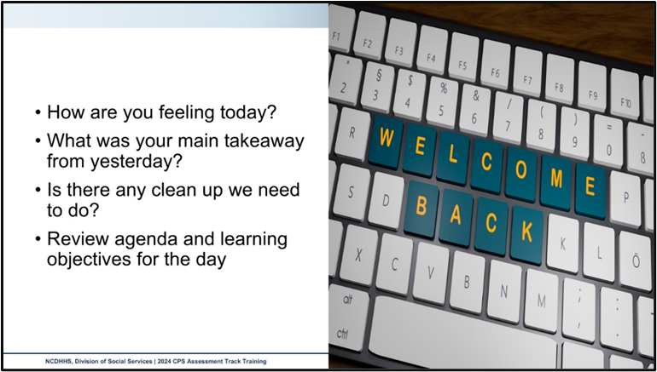
Use this outlined space to record notes from the introduction activity.

Engaging the Family in Child Protection Services

Engaging the Non-Resident Parent
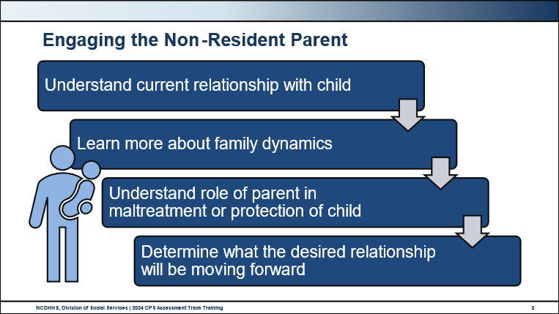
Use this space to record notes.

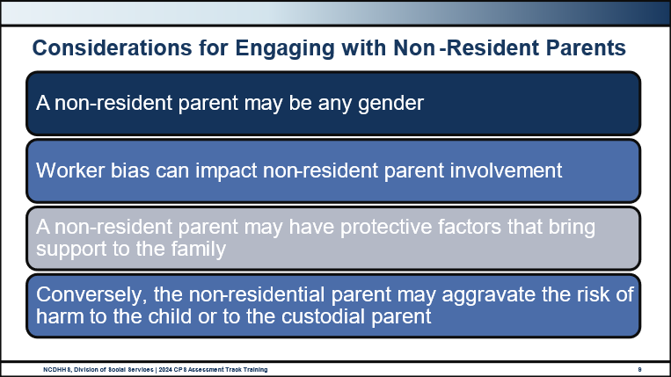
Use this space to record notes.

Cultural Considerations in Engaging Families

Activity: Considerations for Diverse Communities
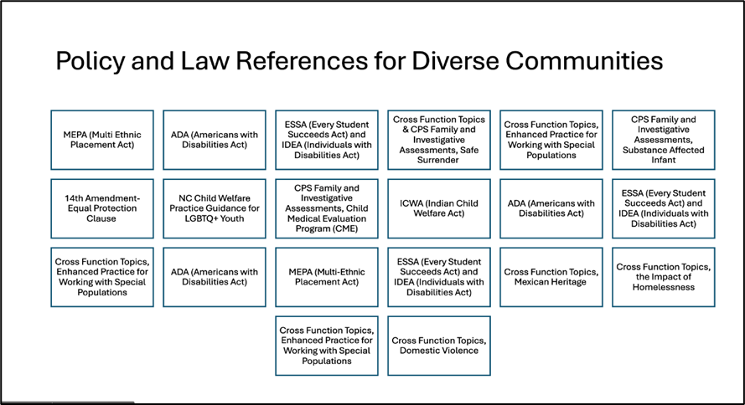
Family Member Name
Key Points about Family Member
Applicable Laws and Policy to Consider
Additional Considerations

Risk Assessment

Identifying and Understanding Risk Factors
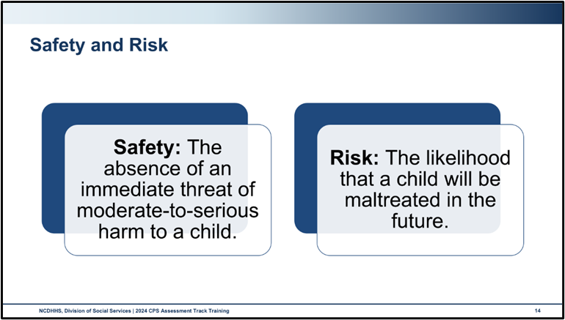
Use this space to record notes.

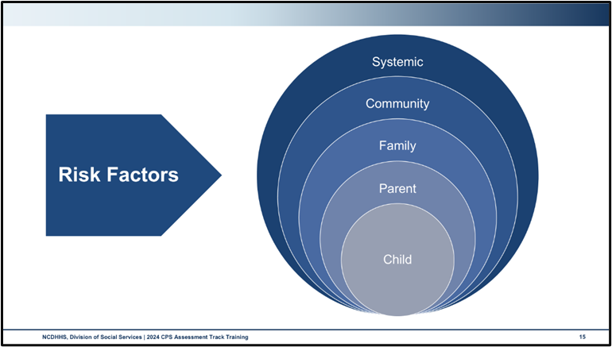
Use this space to record notes.

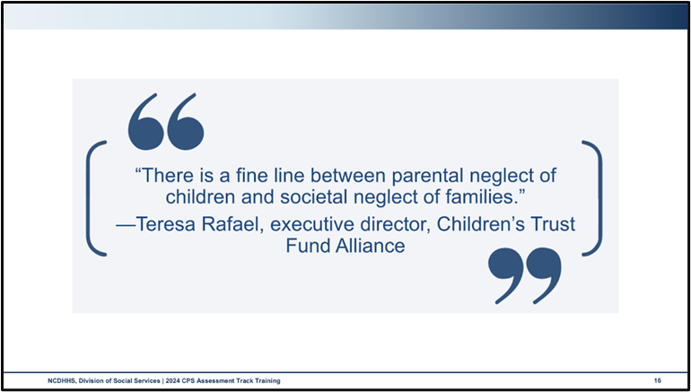
Use this space to record notes.

Protective Factors
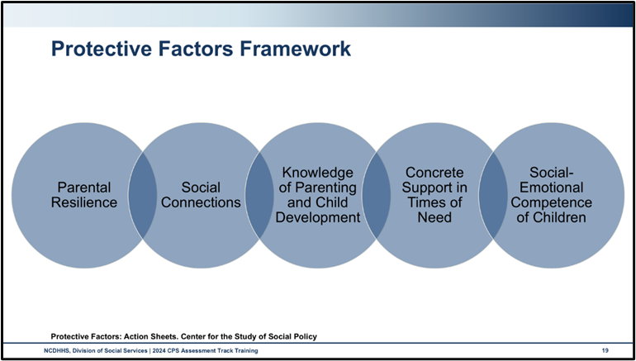
Parental Resilience: Managing stress and functioning well when faced with challenges, adversity, and trauma
Social Connections: Positive relationships that provide emotional, informational, instrumental, and spiritual support
Knowledge of Parenting and Child Development: Understanding child development and parenting strategies that support physical, cognitive, language, social, and emotional development
Concrete Supports in Times of Need: Access to concrete support and services that address a family’s need and help minimize stress caused by challenges
Social and Emotional Competence of Children: Family and child interactions that help children develop the ability to communicate clearly, recognize and regulate their emotions, and establish and maintain relationships
Some strategies that can be used to mitigate risk and strengthen families include:
- Parental Resilience: Encourage parents to take care of themselves, seek support from others, and develop problem-solving skills.
- Social Connections: Help parents build a support network, connect with other families, and participate in community activities.
- Knowledge of Parenting and Child Development: Provide parents with accurate information about child development, positive parenting practices, and child safety.
- Concrete Support in Times of Need: Connect families with resources such as housing, food, and healthcare, and help them navigate complex systems.
- Social and Emotional Competence of Children: Promote children’s social and emotional development through positive interactions with caregivers, peers, and the community.
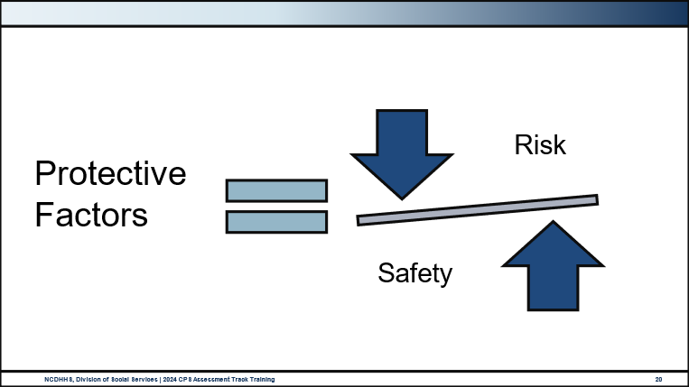
Use this space to record notes.

Activity: Protective Factors Exploration
In your groups, create a poster by answering the following. In addition to your own knowledge and experience, please feel free to use the handout in your appendix entitled Protective Factors: Action Sheets.
Define the Protective Factor in family-accessible language.
Name at least 5 ways that the presence of this protective factor buffers from risk and trauma.
Name at least 5 ways that this protective factor shows up in a family’s life.

Risk Assessment Tool
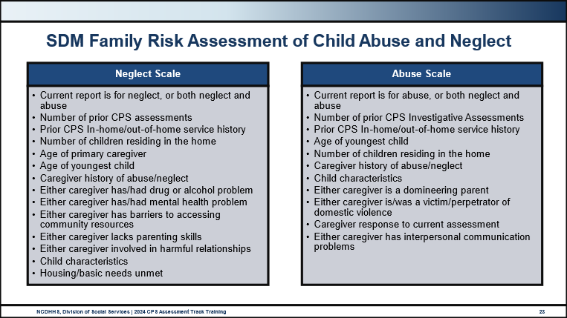
Please refer to the DSS–5230: SDM Family Risk Assessment of Child Abuse/Neglect in the Appendix.
Use this space to record notes.

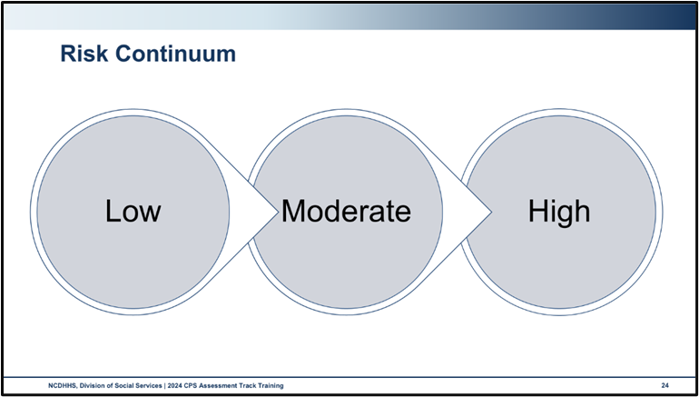
Use this space to record notes.

Skills Practice: Family Risk Assessment of Child Abuse and Neglect
Work with your group to:
- Review the information you have gathered about the family so far
- Complete a Family Risk Assessment of Child Abuse/Neglect for the family
- Answer the following questions.
What future risk of abuse did you identify?
What future risk of neglect did you identify?
How might the family mitigate harm from the risks you identified?

Crucial Conversations

Crucial Conversations and Managing Conflict
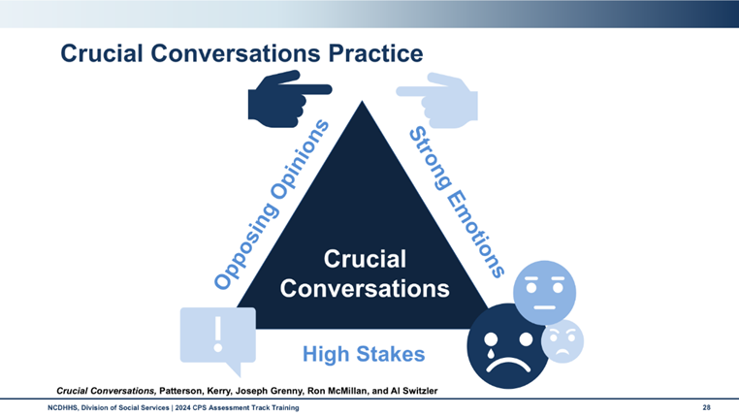
Use this space to record notes.

Handout: Managing Crucial Conversations
Steps | How Do I Do This?
Start with the Heart. | Start from a genuine, well-intentioned place. Stay focused on what you really want and your intentions for the conversation.
Learn to Look. | Look for signs of stress, conflict, and emotional elevation. Notice when your safety is at risk. Manage your own response tendencies. Look for language and behavior that could escalate the conversation.
Make it Safe. | Notice when others don’t feel safe to respond, check to make sure you are listening well and validating. Keep highlighting the common goal. When you notice a risk, “step out” of the conversation and work to restore safety.
Master Your Stories. | Manage intended and unintended bias and check how you see others. “Stories” are assumptions we make for why others are doing what they are doing. Assumptions can interfere with your conversation.
State Your Path. | Share very specific concerns and a clear explanation of the purpose for the conversation. Talk about your experience and inquire about the ways of others. Speak cautiously to be clear and not too soft or too firm.
Explore Others’ Perspectives. | Active listening becomes key, and empathy is critical. Validate the person’s feelings while maintaining the importance of what needs to be accomplished.
Move to Action. | Make decisions and commit to action together.

Skills Practice: Crucial Conversations
Create a conversation plan for this crucial conversation with your assigned family member.
Step 1: Start With Heart (Stay focused on what you really want)
What do you need to accomplish in this conversation? How will you approach this conversation?

Step 2: Learn to Look: (be aware of when a conversation is crucial and look for signs of risk to safety.
What factors about this conversation do you anticipate will be crucial? What parts of the conversation may put safety at risk?

Step 3: Make it Safe (Create a Safe Environment for Dialogue)
How will you invite this family member to feel safe in this conversation?

Step 4: Master My Stories (Challenge Assumptions and Fill in the Blanks)
What assumptions need to be eliminated? What circumstances need to be addressed? What is not being considered here?

Step 5: State Your Path (Share Your Facts, Story, and Purpose)
How will you present the specific concerns? What will you say to share the purpose of the conversation?

Step 6: Explore Others’ Perspectives (Encourage Dialogue and Seek Mutual Understanding)
What questions will you ask to encourage the family member to share their perspective? What will you say to validate the family member’s feelings while emphasizing the importance of children’s safety?

Step 7: Move to Action (Make Decisions and Commit to Action)
How will you work with the family member to create an action plan? What needs to be included in that plan?

Debrief: Crucial Conversations Practice
What went well? What didn't?
What impact did your planning make on your conversation?
In thinking about your conversation, which components do you think you'll need to work on?

Quality Contacts

Quality Contacts
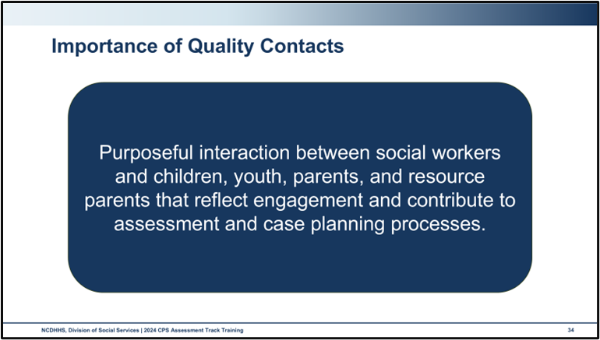
Use this space to record notes.

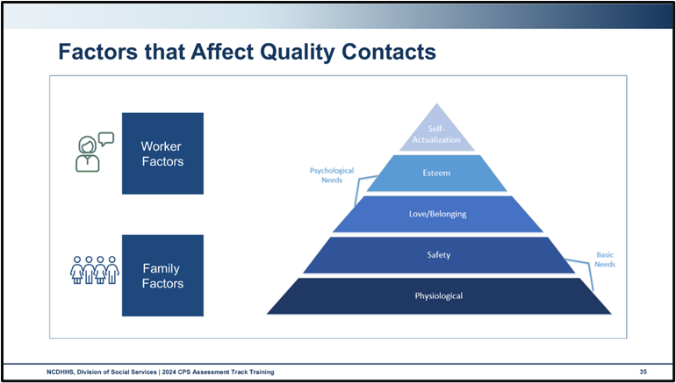
Use this space to record notes.

Worksheet: Competing Factors in Quality Contacts
- Work with your group to brainstorm ideas on how to overcome barriers presented in each scenario.
During your visit to the home, Mom’s boss calls and texts several times during your visit.
Random people are coming in and out of the home during the visit, bringing up concerns about what can be shared due to confidentiality.
Children are in the room while discussing sensitive topics, such as intimate partner violence or parental substance misuse.
Suspected criminal activity is occurring during the visit, such as selling or using drugs.

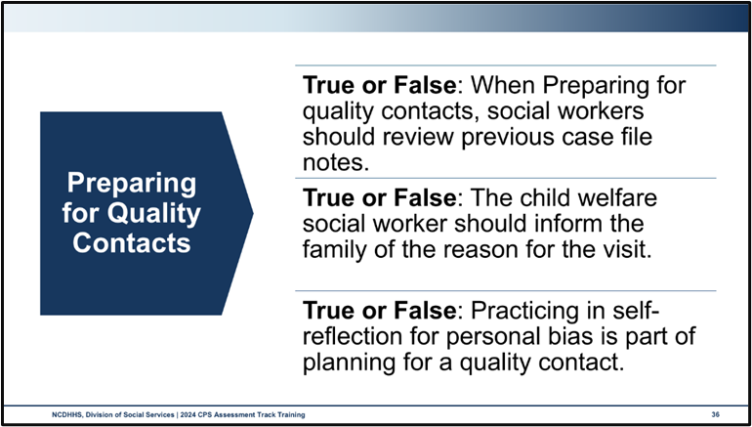

Quiz: True or False
When preparing for quality contacts social workers should review previous case file notes. | ☐ True  ☐ False
The child welfare social worker should inform the family of the reason for the visit. | ☐ True  ☐ False
Practicing self-reflection for personal bias is part of planning for a quality contact. | ☐ True  ☐ False
What are four things you need to do to prepare for quality contact with a family member or collateral contact?

Activity: Planning for Quality Contacts
Ensuring quality contacts requires intentionality and planning. Work with your table group to list elements that require attention when planning your follow-up visit with the family, taking into consideration your group’s assigned quality contact audience.
Consider the following:
Questions and actions to assess if the safety plan is implemented and followed or requires adjustments.
Ideas to engage children of different ages and stages of development.
Education, information, referrals, or other support to provide to ensure the visit is meaningful.

Activity: Perspective Taking: Assessing Safety and Risk Through Quality Contacts
This is a perspective-taking activity. Perspective-taking requires that you share thoughts, feelings, and ideas that center on the perspective of the person you represent. It is different than role play in that your goal is to keep your assigned perspective in mind when engaging in the discussion, not act or pretend like you are in that role.
- Instead of pretending or acting like you feel an emotion, you could share considerations about how actions or statements could affect someone in your role.
  - Instead of acting or presenting to be offended, you could say “a statement like that could be offensive to someone in this role.”
- Focus on your assigned perspective only. This means that if you assigned a family member, you would not share a perspective with the social worker and vice versa.
Assigned Person
As you hear the presentation for the Quality Contact Visit approach, what thoughts, feelings, or ideas do you have from the perspective of your assigned person?
Debrief

Activity: Contacts and Frequency Fill in the Blank
- At what visit, if needed, is the Temporary Parental Safety Agreement first developed?
When information is received and confirmed that a safety threat exists, often during _________________ contact although may occur at a subsequent visit. TPSA must be revisited at each visit with the family to assess appropriateness of safety plan.
- How is the frequency of ongoing contact determined?
Safety and Risk to the children, determined by __________ and __________ Assessment.
- What is the minimum frequency of face-to-face contact with victim children and parents?
Twice monthly at least __________ calendar days apart.
- Are children interviewed with their parents during follow-up contacts?
The interview must be __________ from the parent/caretaker for at least part of the contact.
- How often must you visit the home during an open CPS Assessment?
Initiation and then __________ a month with the child in the home.
- Under what circumstances are you required to visit a non-resident parent’s home?
If __________ are made against the non-resident parent, a home visit must be conducted prior to the child visiting that home.
- In addition to assessing for general safety, what three areas must you assess within the home at your visits?
__________ safety, __________ safety, and __________ sleep for infants.
- What is the minimum number of collateral contacts you are to contact during a CPS Assessment?
At least __________.
- Who should be included in family home visits/contacts?
All other __________ and __________ living in the home.
- At what visits do you review the TPSA?
At each __________ contact.
- When do you document case activities and actions?
Within __________ calendar days.

Assessing Family Strengths and Needs

Strengths-Based Approach to Assessment
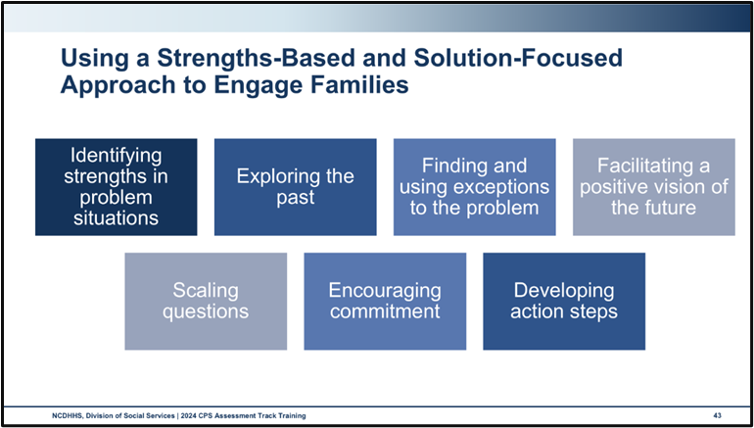
Use this space to record notes.

Skills Practice: Strengths-Based Approach
- Take turns focusing on your partner’s strengths in an area of their personal life.
- Your partner can choose any topic and share the topic with you before time begins.
- Interviewers will engage your partner, learn about the topic from them, and focus on strengths.
What was that approach like for you?
How did your partner respond when you focused on their strengths?
How did it feel to have someone remark on and explore your strengths?
What of the strengths-based approach will you remember to do when you are in the field with families?

Family Strengths and Needs Assessment
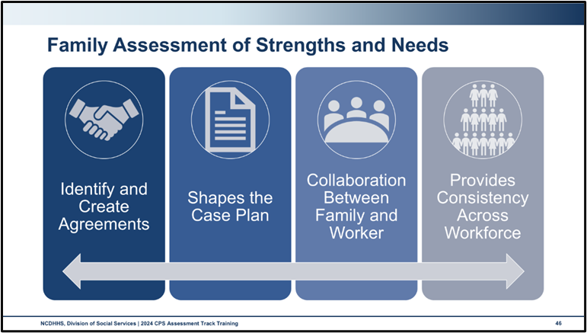
Use this space to record notes.

Worksheet: Family Assessment of Strengths and Needs
Using the table below, brainstorm behavioral indicators that would correspond with your assigned FSNA item.
- In the first column, transfer the underlined rating definitions for your assigned item.
- In the second column, identify at least two behavioral indicators that would warrant choosing that rating for your item.
Rating definitions | Behavioral Indicators
a. | 1.  2.
b. | 1.  2.
c. | 1.  2.
d. | 1.  2.

Social Worker Safety

Secondary Traumatic Stress and Vicarious Traumatization

Video: Impacts of Secondary Traumatic Stress on the Child Welfare Workforce
https://www.qic-wd.org/impact-secondary-traumatic-stress-child-welfare-workforce
Secondary Traumatic Stress, or STS, is emotional distress that results when an individual hears about the firsthand trauma experiences of another. It is indirect exposure to threatening events that can result in the presence of posttraumatic stress symptoms.
Compassion fatigue is the physical and emotional exhaustion experienced by those who care for others who are in distress. It is a less clinical and less stigmatizing term and is often used interchangeably with Secondary Traumatic Stress.
Vicarious trauma occurs after empathic engagement with a traumatized client and changes the inner experience of a practitioner. This term focuses less on trauma symptoms and more on cognitive changes that occur following cumulative exposure to another person’s trauma. The symptoms of vicarious trauma are disturbances in the cognitive frame of reference in the areas of trust, safety, control, esteem, and intimacy.
Source:
- Barbee, A., Purdy, L., and Cunningham, M. (2023, September). Secondary traumatic stress: definitions, measures, predictors and interventions. Quality Improvement Center for Workforce Development.
- Strand, V. C., and Sprang, G. (2018). Trauma Responsive Child Welfare Systems. Switzerland: Springer International Publishing.
- National Child Traumatic Stress Network. Secondary Traumatic Stress: A Fact Sheet for Child-Serving Professionals. Retrieved from https://www.nctsn.org/sites/default/files/resources/fact-sheet/secondary_traumatic_stress_child_serving_professionals.pdf

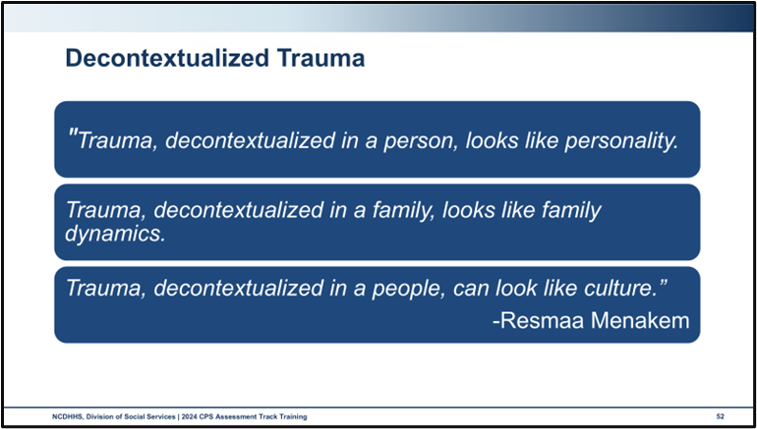
Use this space to record notes.

Worksheet: Socio-Ecological Model
With your group, brainstorm some of the factors that contribute to stress and trauma across the layers of the socio-ecological model.
Individual
Interpersonal/Relational
Organizational

Community
Policy/Institutional
Society

End-of-Day Values Reflection

Questions and Reflections
Use this space to record reflections and questions about what you have learned today.

Bibliography of References
Day Five
American Psychiatric Association, Dictionary of Psychology. (n.d.). Definition of decontextualization. https://dictionary.apa.org/decontextualization
Barbee, A., Purdy, L., & Cunningham, M. (2023, September). Secondary traumatic stress: definitions, measures, predictors and interventions. Quality Improvement Center for Workforce Development. https://digitalcommons.unl.edu/qicwdproducts/149/
CalSWEC Online, (2019, April 29) Child Welfare worker realistic job preview. [Video]. YouTube.com. https://www.youtube.com/watch?v=2aoOYAwgp2o&list=PLNYfSDZN2XUpWQ62KzijZDZ_g2VEjlSGD&index=1
Capacity Building Center for States. (n.d.). Defining quality contacts. [Brief]. Washington, DC: U.S. Department of Health and Human Services, Administration for Children and Families, Children’s Bureau. https://capacity.childwelfare.gov/states/resources/defining-quality-contacts#:~:text=Quality%20contacts%2C%20also%20referred%20to,assessment%20and%20case%20planning%20processes.
Capacity Building Center for States. (n.d.). Protective capacities and protective factors: Common ground for protecting children and strengthening families. [Infographic]. Washington, DC: U.S. Department of Health and Human Services, Administration for Children and Families, Children’s Bureau. https://capacity.childwelfare.gov/sites/default/files/media_pdf/protective-factors-capacities-cp-00052.pdf
Casey Family Programs, (2019, January 18) Jeremiah Donier: Birth dad winner. [Video]. YouTube.com. https://www.youtube.com/watch?v=yxBeN5-Rq_E&t=249s
Center for Leadership Education in Maternal & Child Public Health. (2024, July). Mental health and well-being ecological model. Minneapolis, MN: University of Minnesota School of Public Health. https://mch.umn.edu/resources/mhecomodel/
Center for the Study of Social Policy. (n.d.). Parental resilience: Protective and promotive factors. Washington, DC: Center for the Study of Social Policy. https://cssp.org/wp-content/uploads/2019/01/Research-Briefs-and-Action-Sheets-SF-CW.pdf
Child Welfare Information Gateway. (n.d.) Co-occurring factors. Washington, DC: U.S. Department of Health and Human Services, Administration for Children and Families, Children’s Bureau. https://www.childwelfare.gov/topics/casework-practice/co-occurring-factors/?top=293.
Child Welfare Information Gateway. (2014, July 23) Child and family services reviews quick reference items list. Washington, DC: U.S. Department of Health and Human Services, Administration for Children and Families, Children’s Bureau. https://www.acf.hhs.gov/sites/default/files/documents/cb/cfsr_quick_reference_list.pdf.
Child Welfare Information Gateway. (2020, October) How the Child Welfare system works. Washington, DC: U.S. Department of Health and Human Services, Administration for Children and Families, Children’s Bureau. https://www.childwelfare.gov/pubPDFs/cpswork.pdf
Child Welfare Information Gateway. (2023). Separating poverty from neglect in child welfare. Washington, DC: U.S. Department of Health and Human Services, Administration for Children and Families, Children's Bureau. https://www.childwelfare.gov/pubs/bulletins-povertyneglect
Fragoso, S. (2020, November 15). How Do We Heal? (with Resmaa Menakem). [Podcast]. Talkeasypod.com. https://talkeasypod.com/resmaa-menakem/
FRIENDS National Center. (2024). Protective factors. [Website]. Friendsnrc.org. https://friendsnrc.org/prevention/protective-factors/
Horn, W., & Sylvestor, T. (2002). Father Facts (4th ed.). Gaithersburg, MD: National Fatherhood Initiative.
North Carolina Department of Health and Human Services, Division of Social Services, Child Welfare Services. (2017). DSS-5231: North Carolina safety assessment. https://policies.ncdhhs.gov/wp-content/uploads/dss-5231-ia.pdf
North Carolina Department of Health and Human Services, Division of Social Services, Child Welfare Services. (2017). DSS-5231ins: North Carolina safety assessment. instructions. https://policies.ncdhhs.gov/wp-content/uploads/DSS-5231ins.pdf
North Carolina Department of Health and Human Services, Division of Social Services, Child Welfare Services. (2017). NC Domestic violence policy and best practice in Child Welfare. https://www.ncdhhs.gov/documents/files/dss/training/domestic-violence-workbook/download
North Carolina Department of Health and Human Services, Division of Social Services, Child Welfare Services. (2018). DSS-5229: North Carolina strengths & needs assessment. https://policies.ncdhhs.gov/wp-content/uploads/dss-5229-ia.pdf
North Carolina Department of Health and Human Services, Division of Social Services. (2019). Assessing safety and risk. Children’s services practice notes 24(2). https://practicenotes.org/v24n2.htm
North Carolina Department of Health and Human Services, Division of Social Services. (2020, May). CPS purpose & philosophy, Legal basis, administration: NC Child Welfare manual. https://policies.ncdhhs.gov/wp-content/uploads/purpose.pdf
North Carolina Department of Health and Human Services, Division of Social Services. (2021). North Carolina practice standards worker assessment. https://www.ncdhhs.gov/cw-worker-north-carolina-worker-assessment-all-practice-standards/open
North Carolina Department of Health and Human Services, Division of Social Services. (2021). Worker practice standards desk guide. https://www.ncdhhs.gov/cw-worker-north-carolina-worker-practice-standards-desk-guide/open
North Carolina Department of Health and Human Services, Division of Social Services. (2022). DSS-6191 – North Carolina division of social services plan of safe care. https://policies.ncdhhs.gov/wp-content/uploads/DSS-6191.pdf
North Carolina Department of Health and Human Services, Division of Social Services. (2024, April). Cross function topics: NC Child Welfare manual. https://policies.ncdhhs.gov/wp-content/uploads/In-Home_April-2024_2.pdf
North Carolina Department of Health and Human Services, Division of Social Services. (2024, August). CPS assessments policy, protocol, and guidance: NC Child Welfare manual. https://policies.ncdhhs.gov/wp-content/uploads/CPS-Assessments-Aug-2024.pdf
North Carolina Fatherhood Development Advisory Council. (2012). Best Practice Guide for Engaging Fathers and Non-Residential Parents. North Carolina Department of Health and Human Services, Division of Social Services. https://files.nc.gov/ncdhhs/documents/files/dss/other_resource_tools/Practice-Guide-for-Fatherhood-Engagement.pdf.
Patterson, K., Grenny, J., McMillan, R., & Switzler, A. (2002). Crucial Conversations. Maidenhead, England: McGraw-Hill Contemporary.
The Pennsylvania Child Welfare Resource Center. (n.d.). Engaging Clients from a Strength-Based, Solution-Focused Perspective, Handout #9, Page 1 of 4. Pittsburgh, PA: University of Pittsburgh, School of Social Work. https://www.pacwrc.pitt.edu/Curriculum/301EngggClntsFrmAnSBSFPrspctv/Hndts/HO_9_Solution_focused_skills_and_questions.pdf
Prevent Child Abuse North Carolina. (n.d.). Protective factors infographic. https://www.preventchildabusenc.org/wp-content/uploads/2019/06/PCANCProtectiveFactors.pdf?_gl=1*g0xgru*_ga*MTgxMTY1MzAwMC4xNzE0MjAxMTIy*_ga_Q9239P4QMY*MTcxNDIwMTEyMi4xLjEuMTcxNDIwMTEzMy4wLjAuMA.
Quality Improvement Center for Workforce Development. (n.d.). Impact of secondary traumatic stress on the Child Welfare workforce. Washington, DC: U.S. Department of Health and Human Services, Administration for Children and Families, Children's Bureau. https://www.qic-wd.org/impact-secondary-traumatic-stress-child-welfare-workforce.
Strand, V. C., and Sprang, G. (2018). Trauma responsive Child Welfare systems. Switzerland: Springer International Publishing.

Appendix: Handouts
Protective Factors Action Sheets 2
DSS-5230: Family Risk Assessment of Child Abuse/Neglect 12
Managing Crucial Conversations 23
Defining Quality Contacts 24

Protective Factors Action Sheets
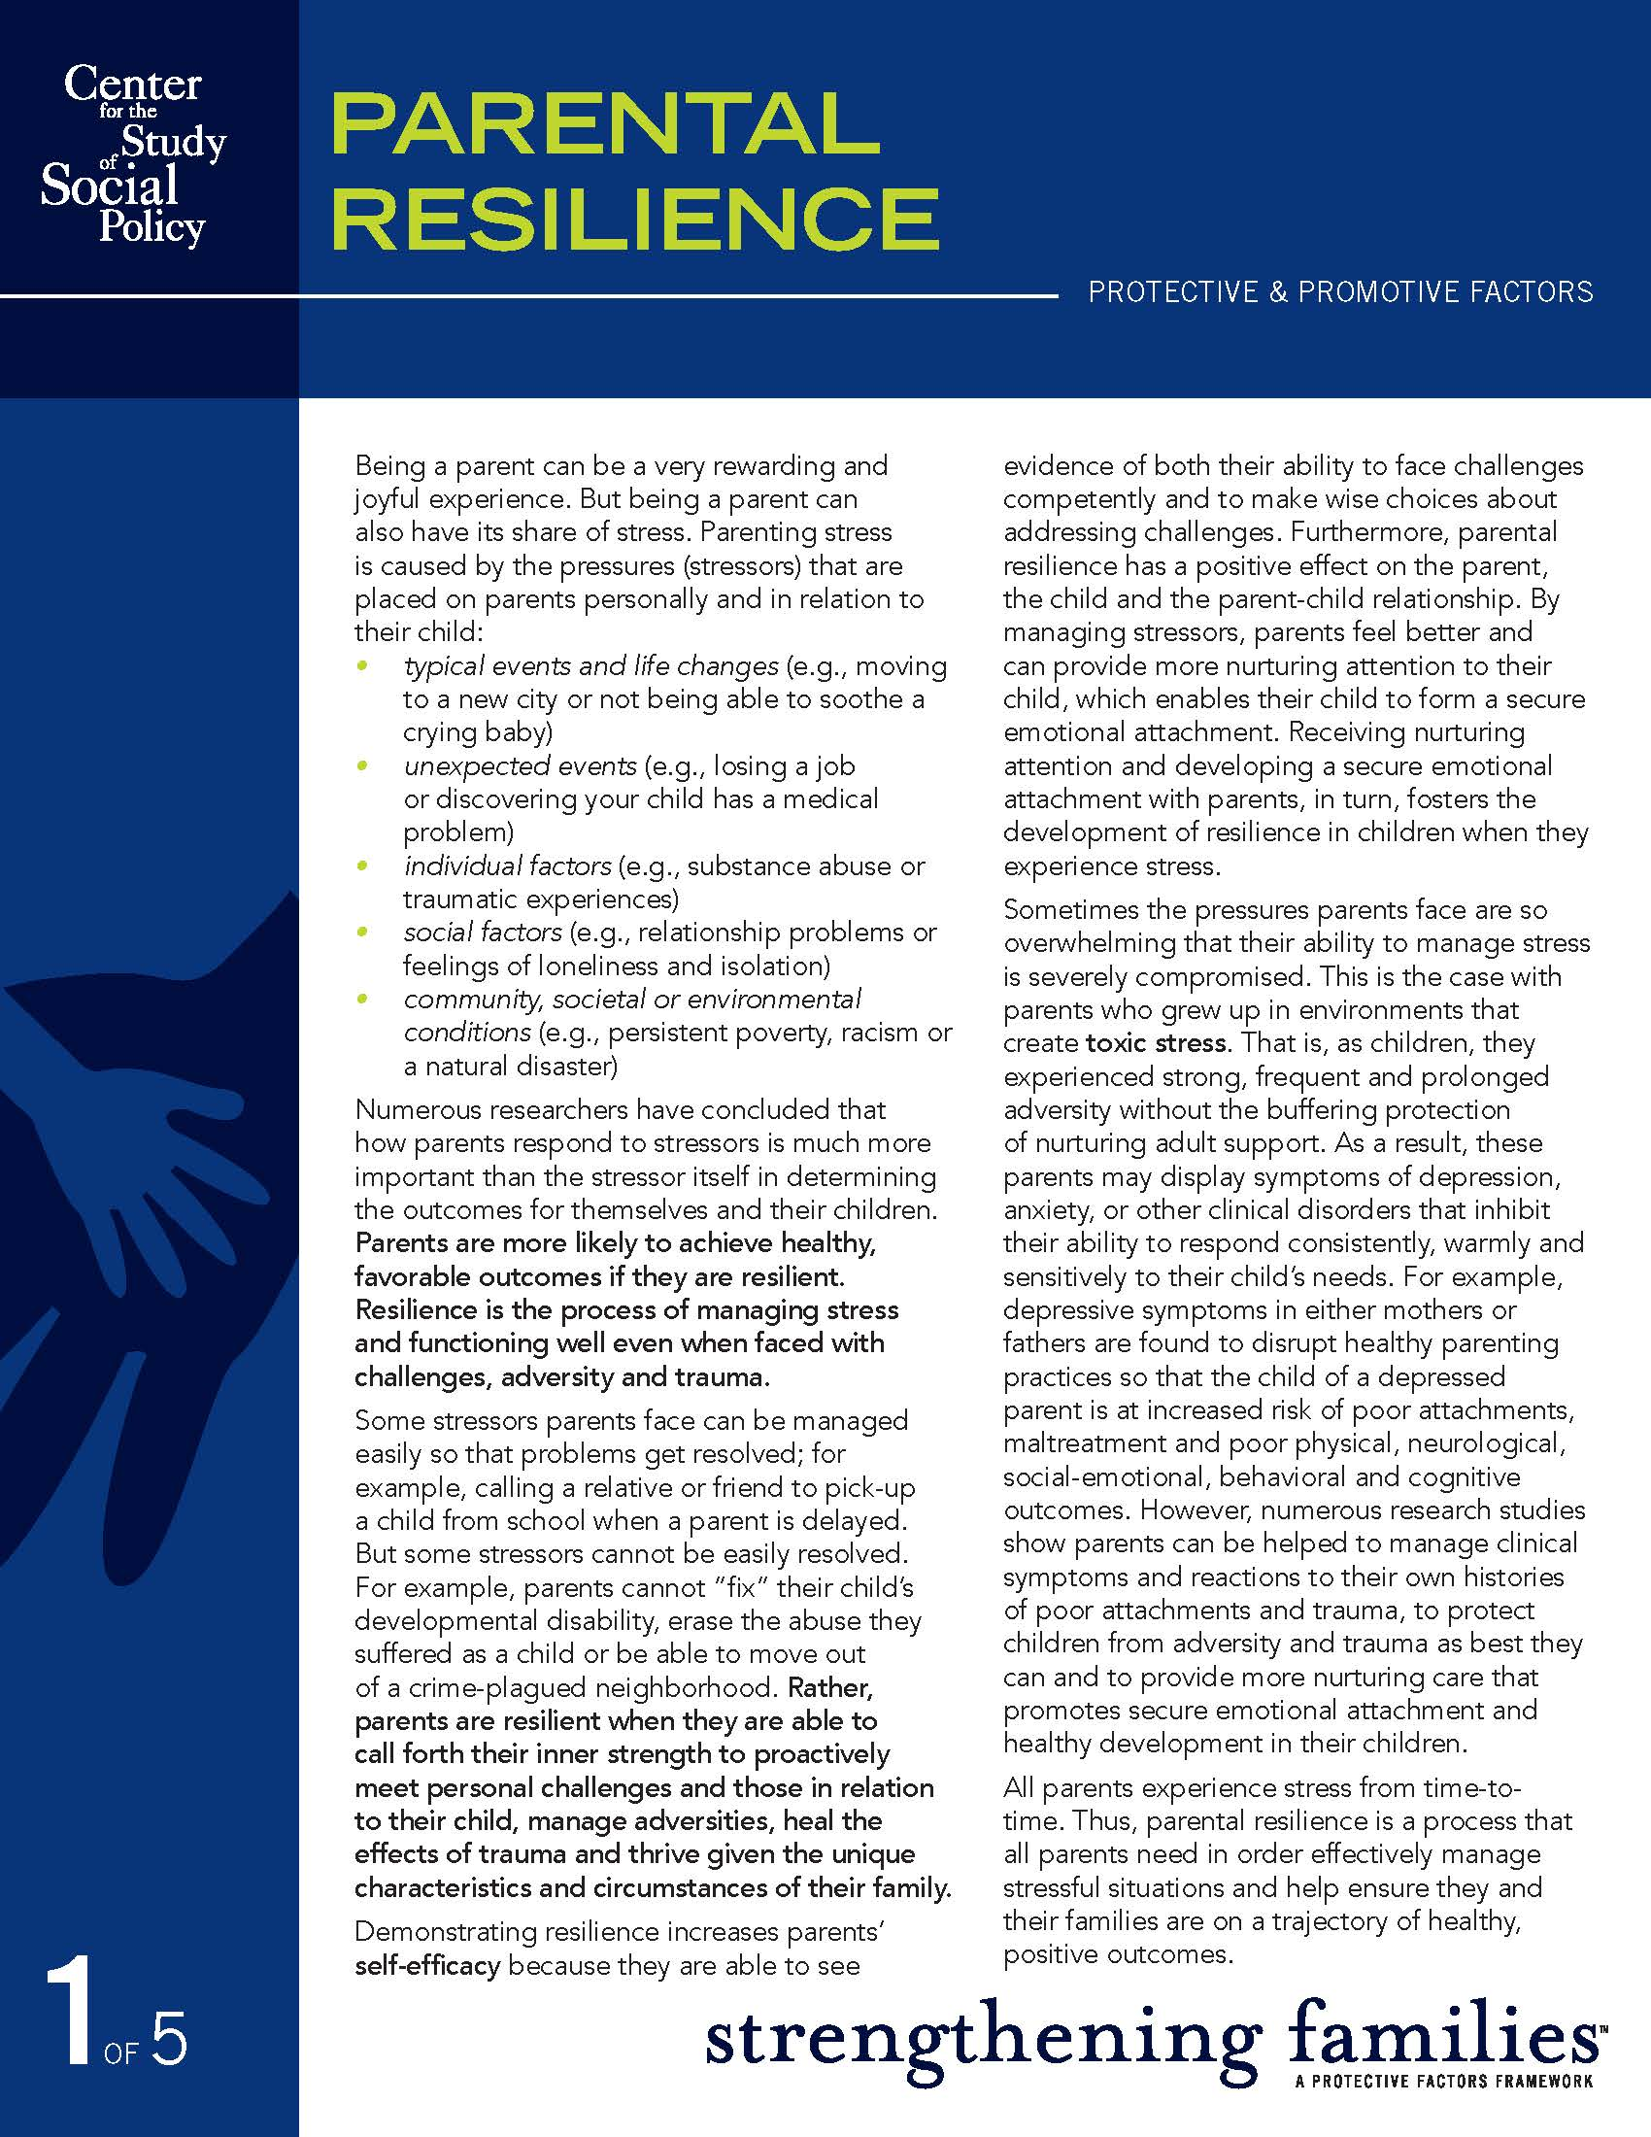

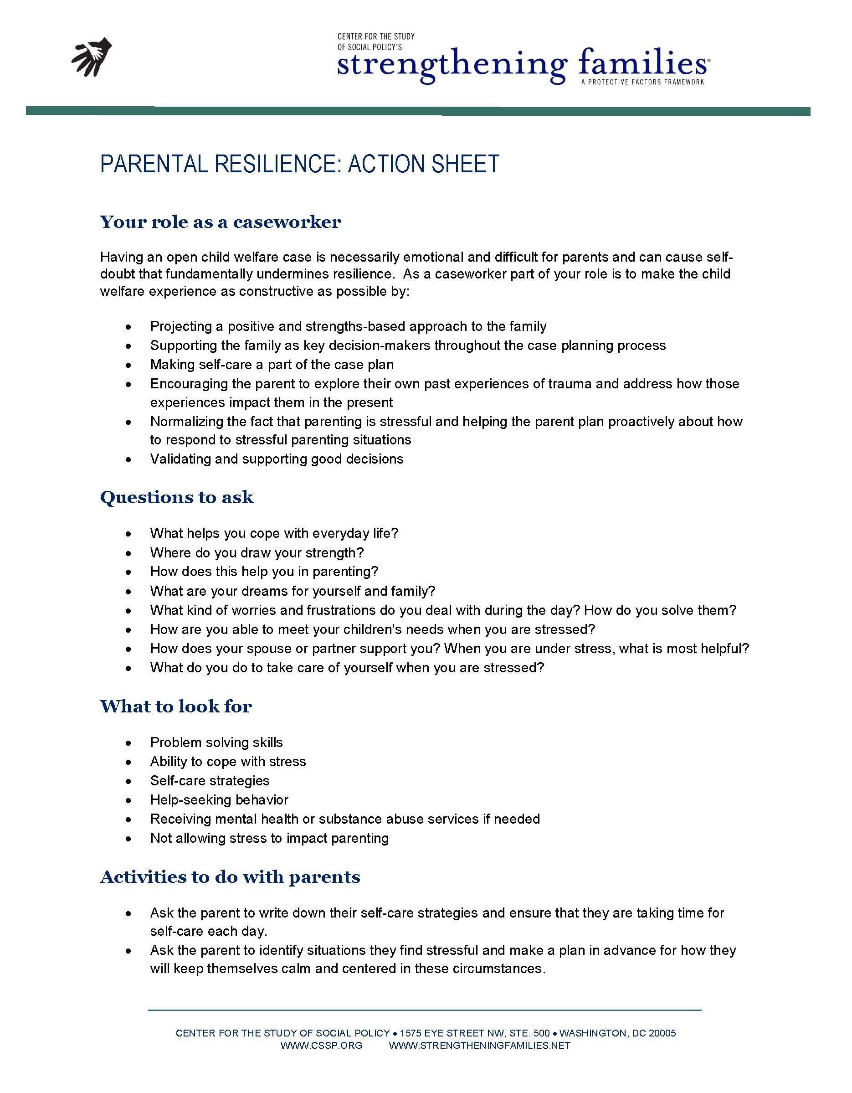

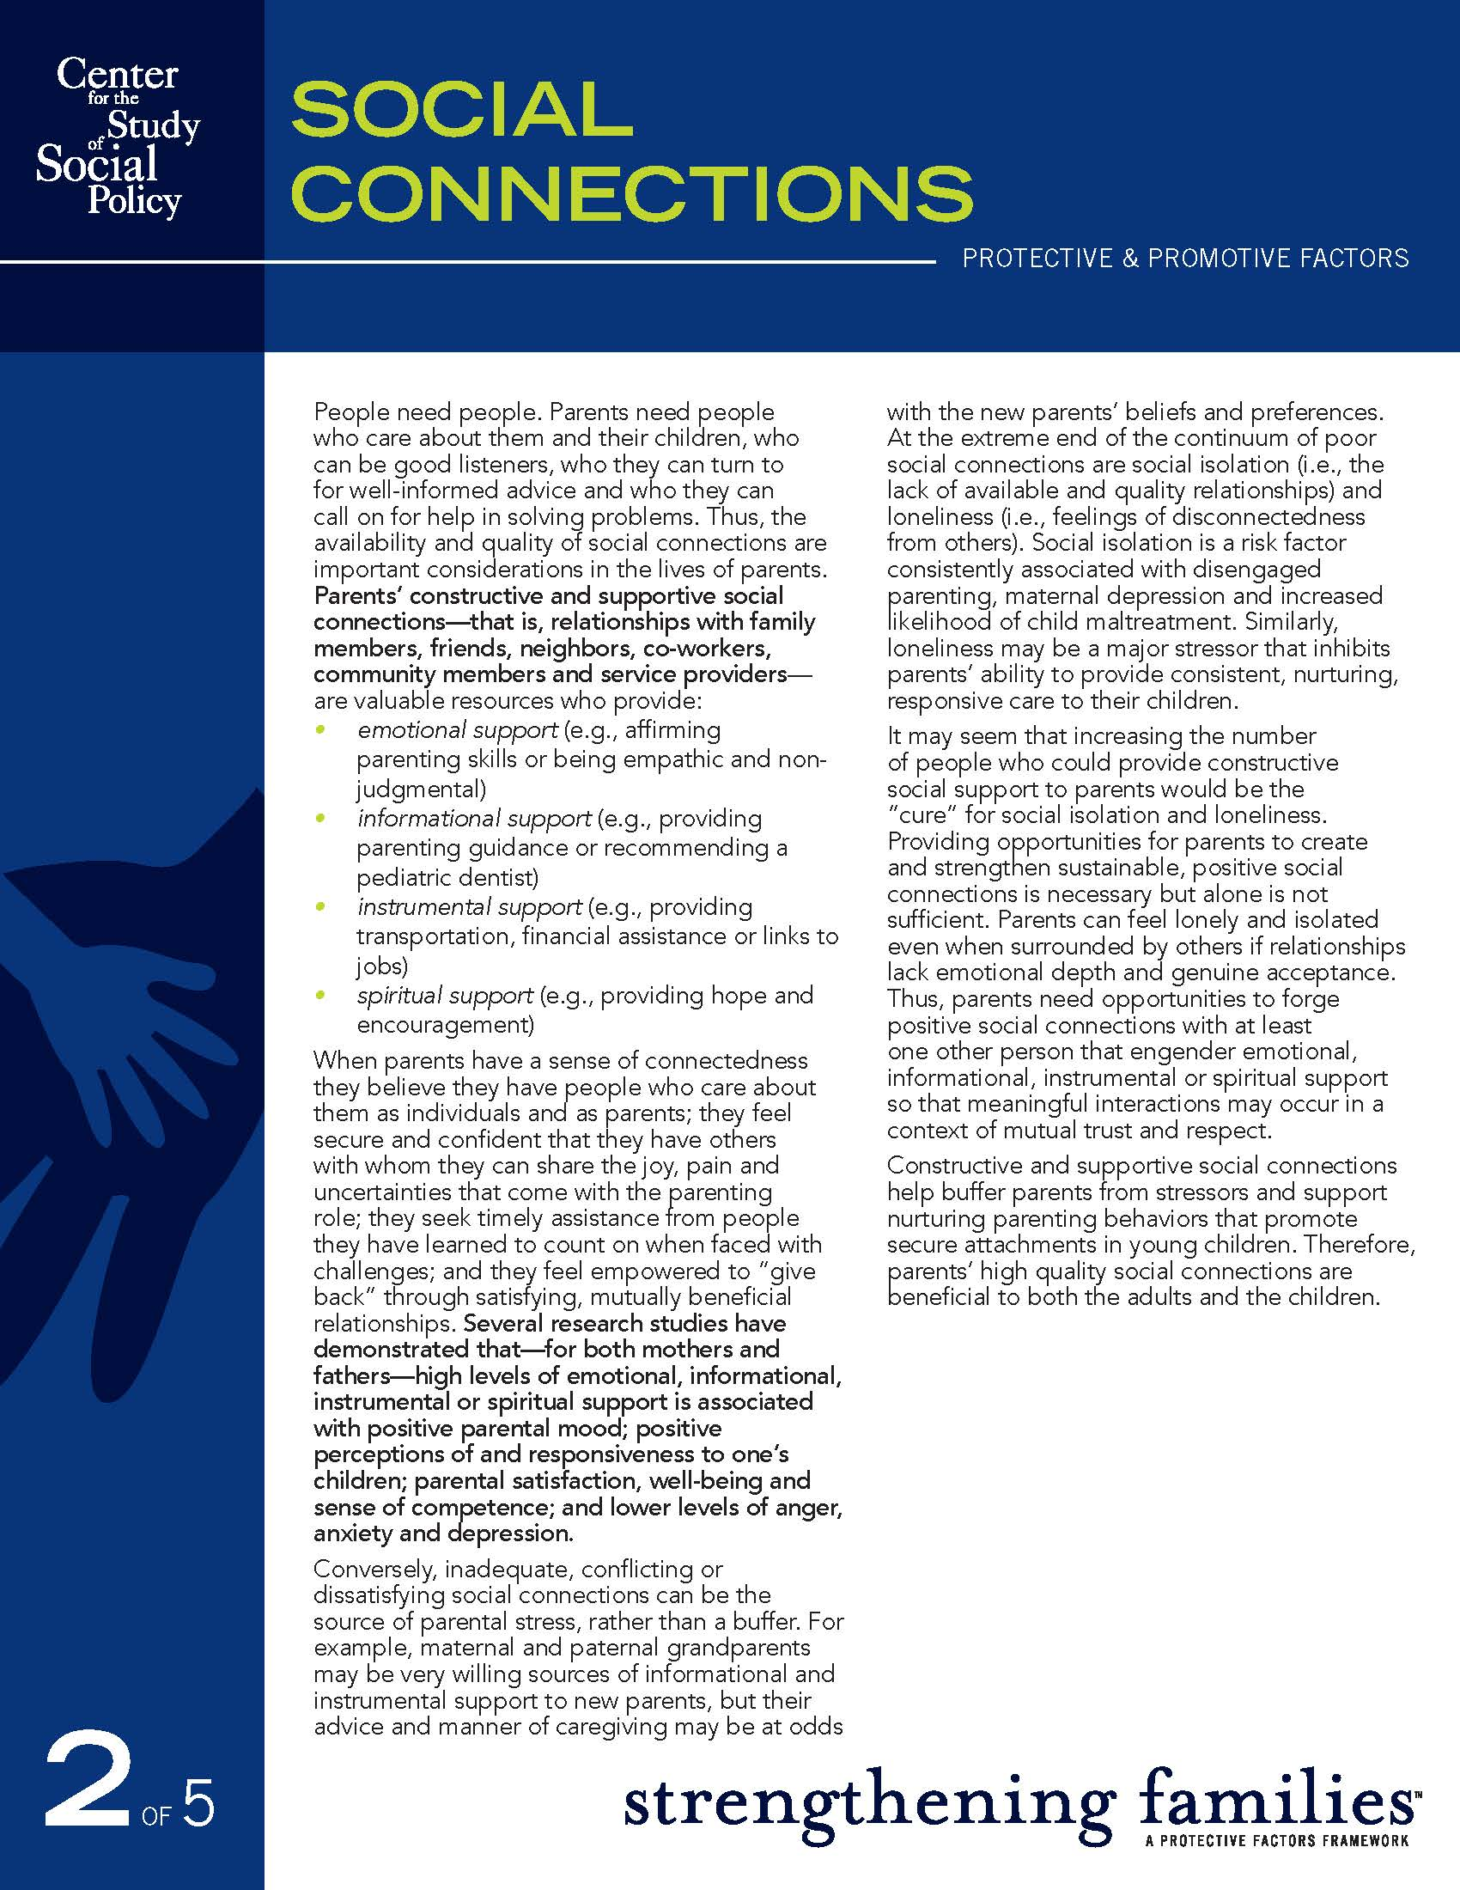

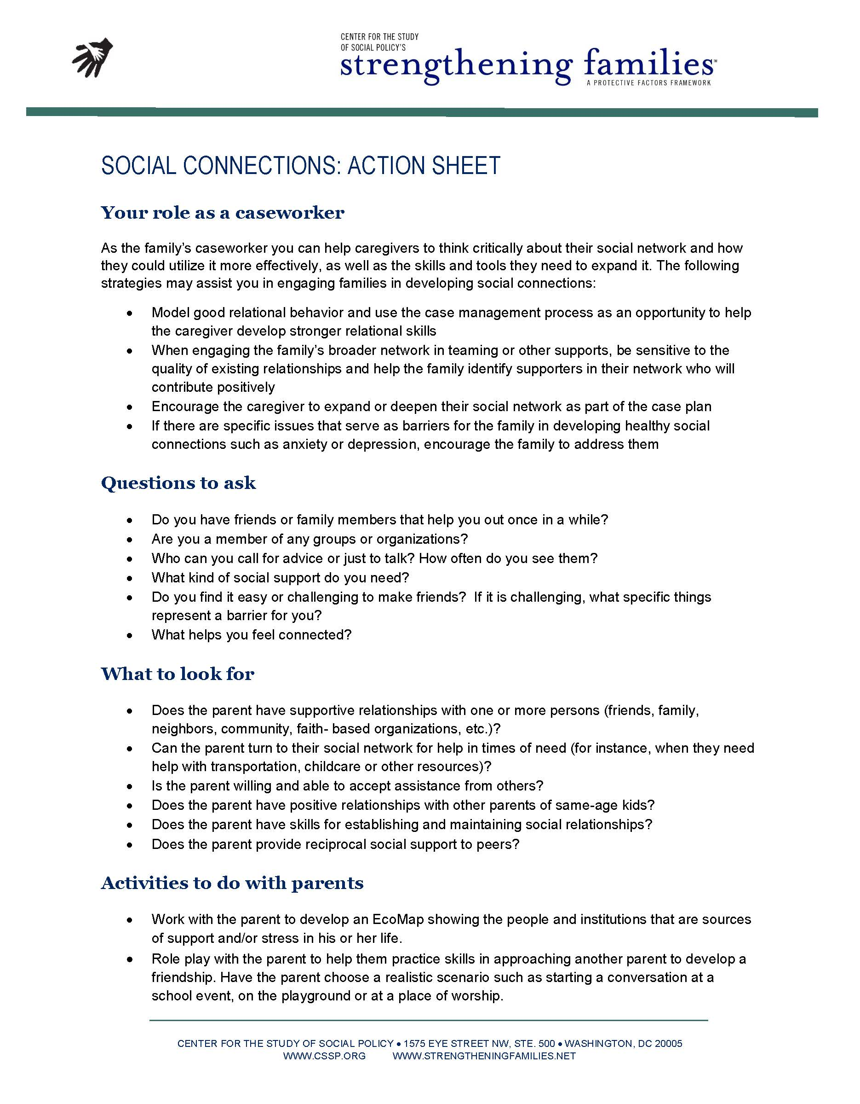

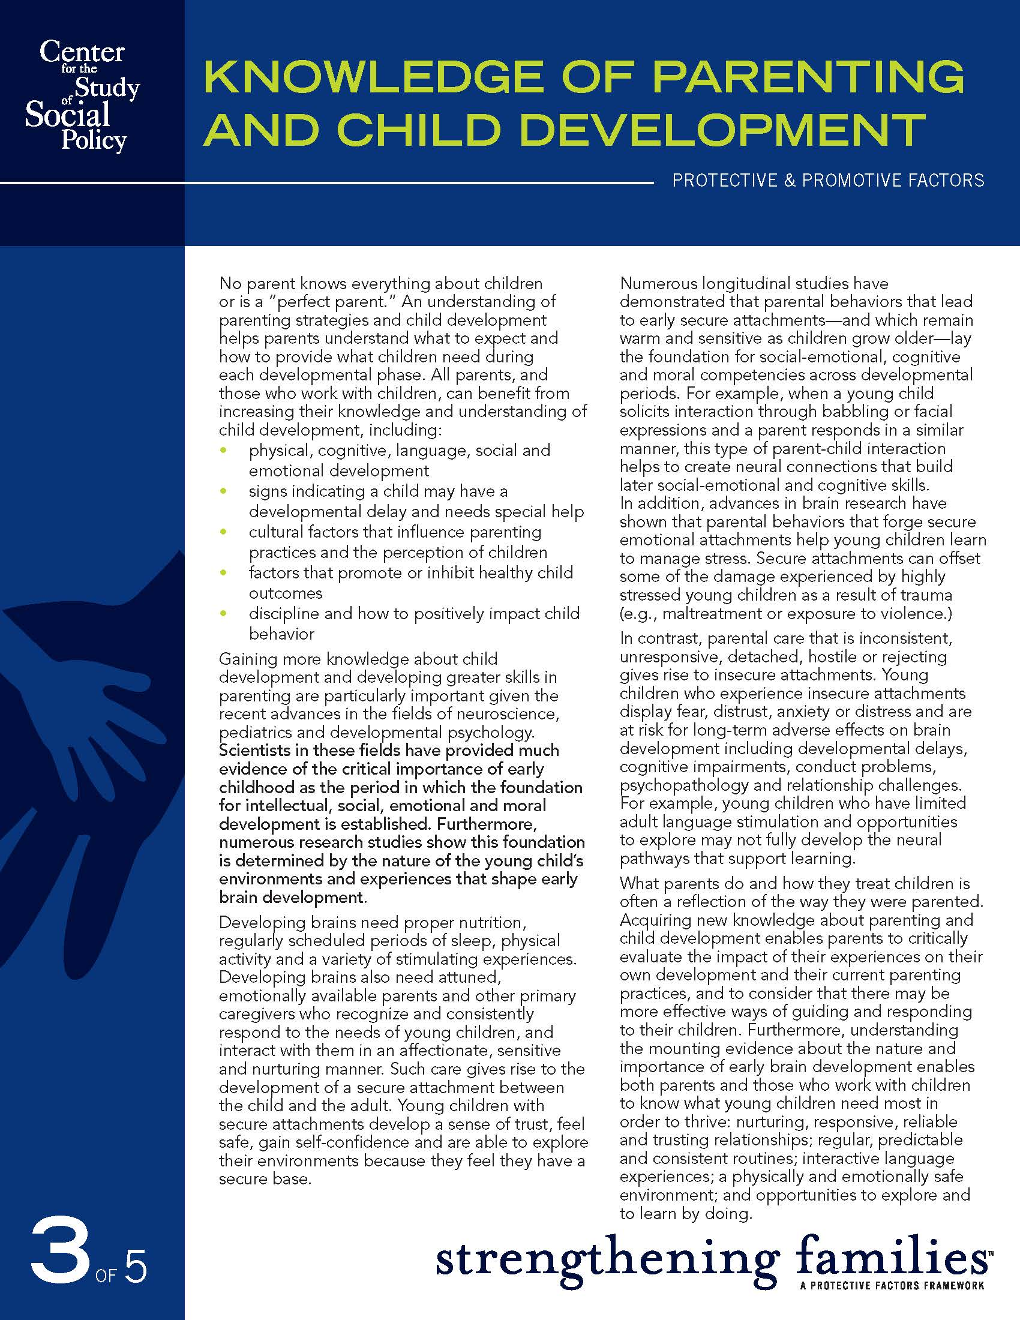

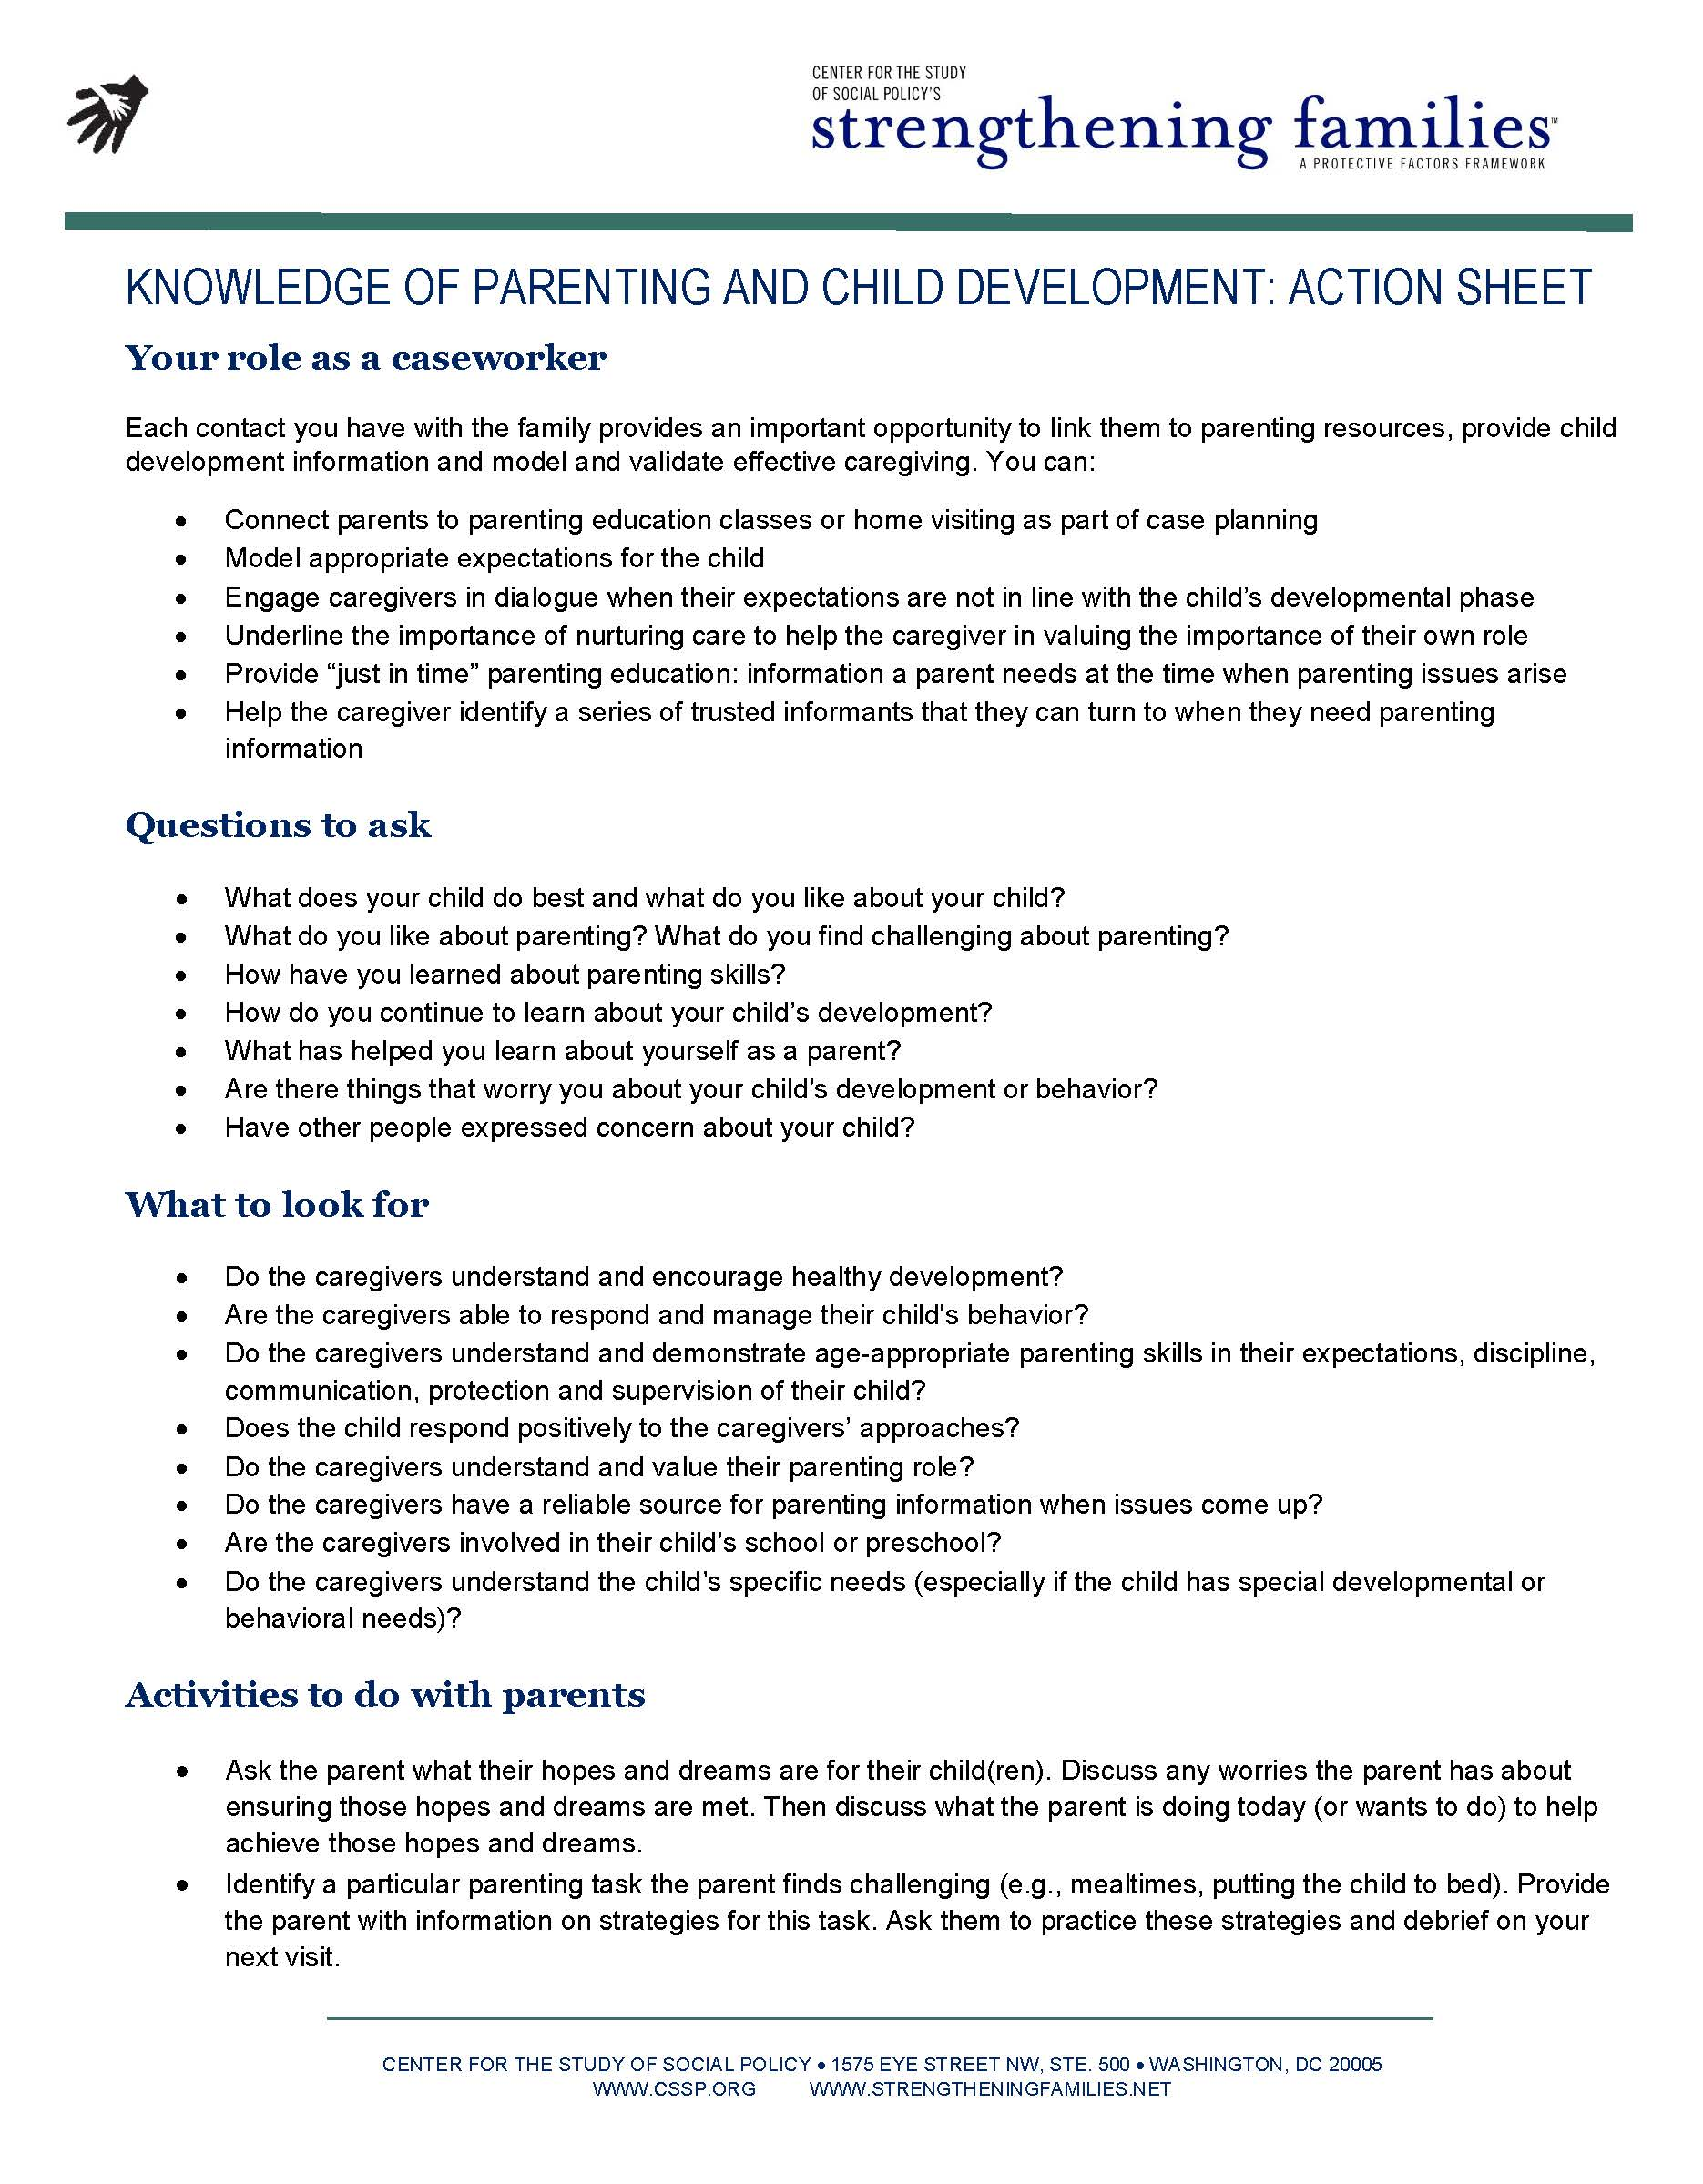

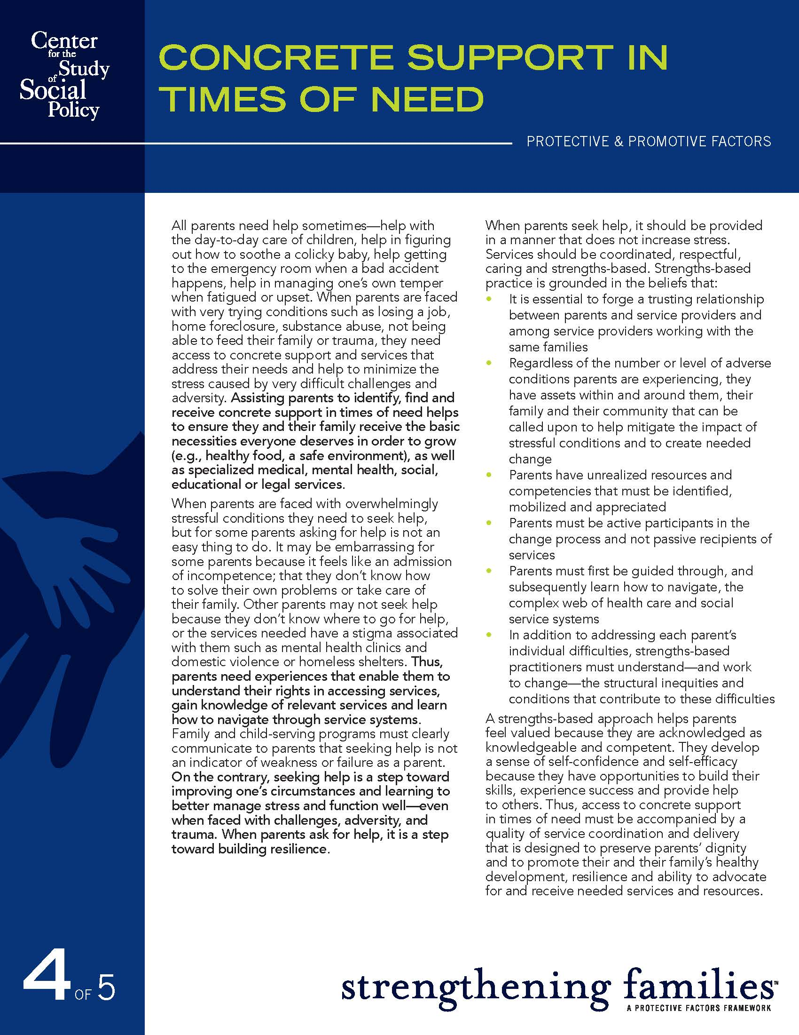

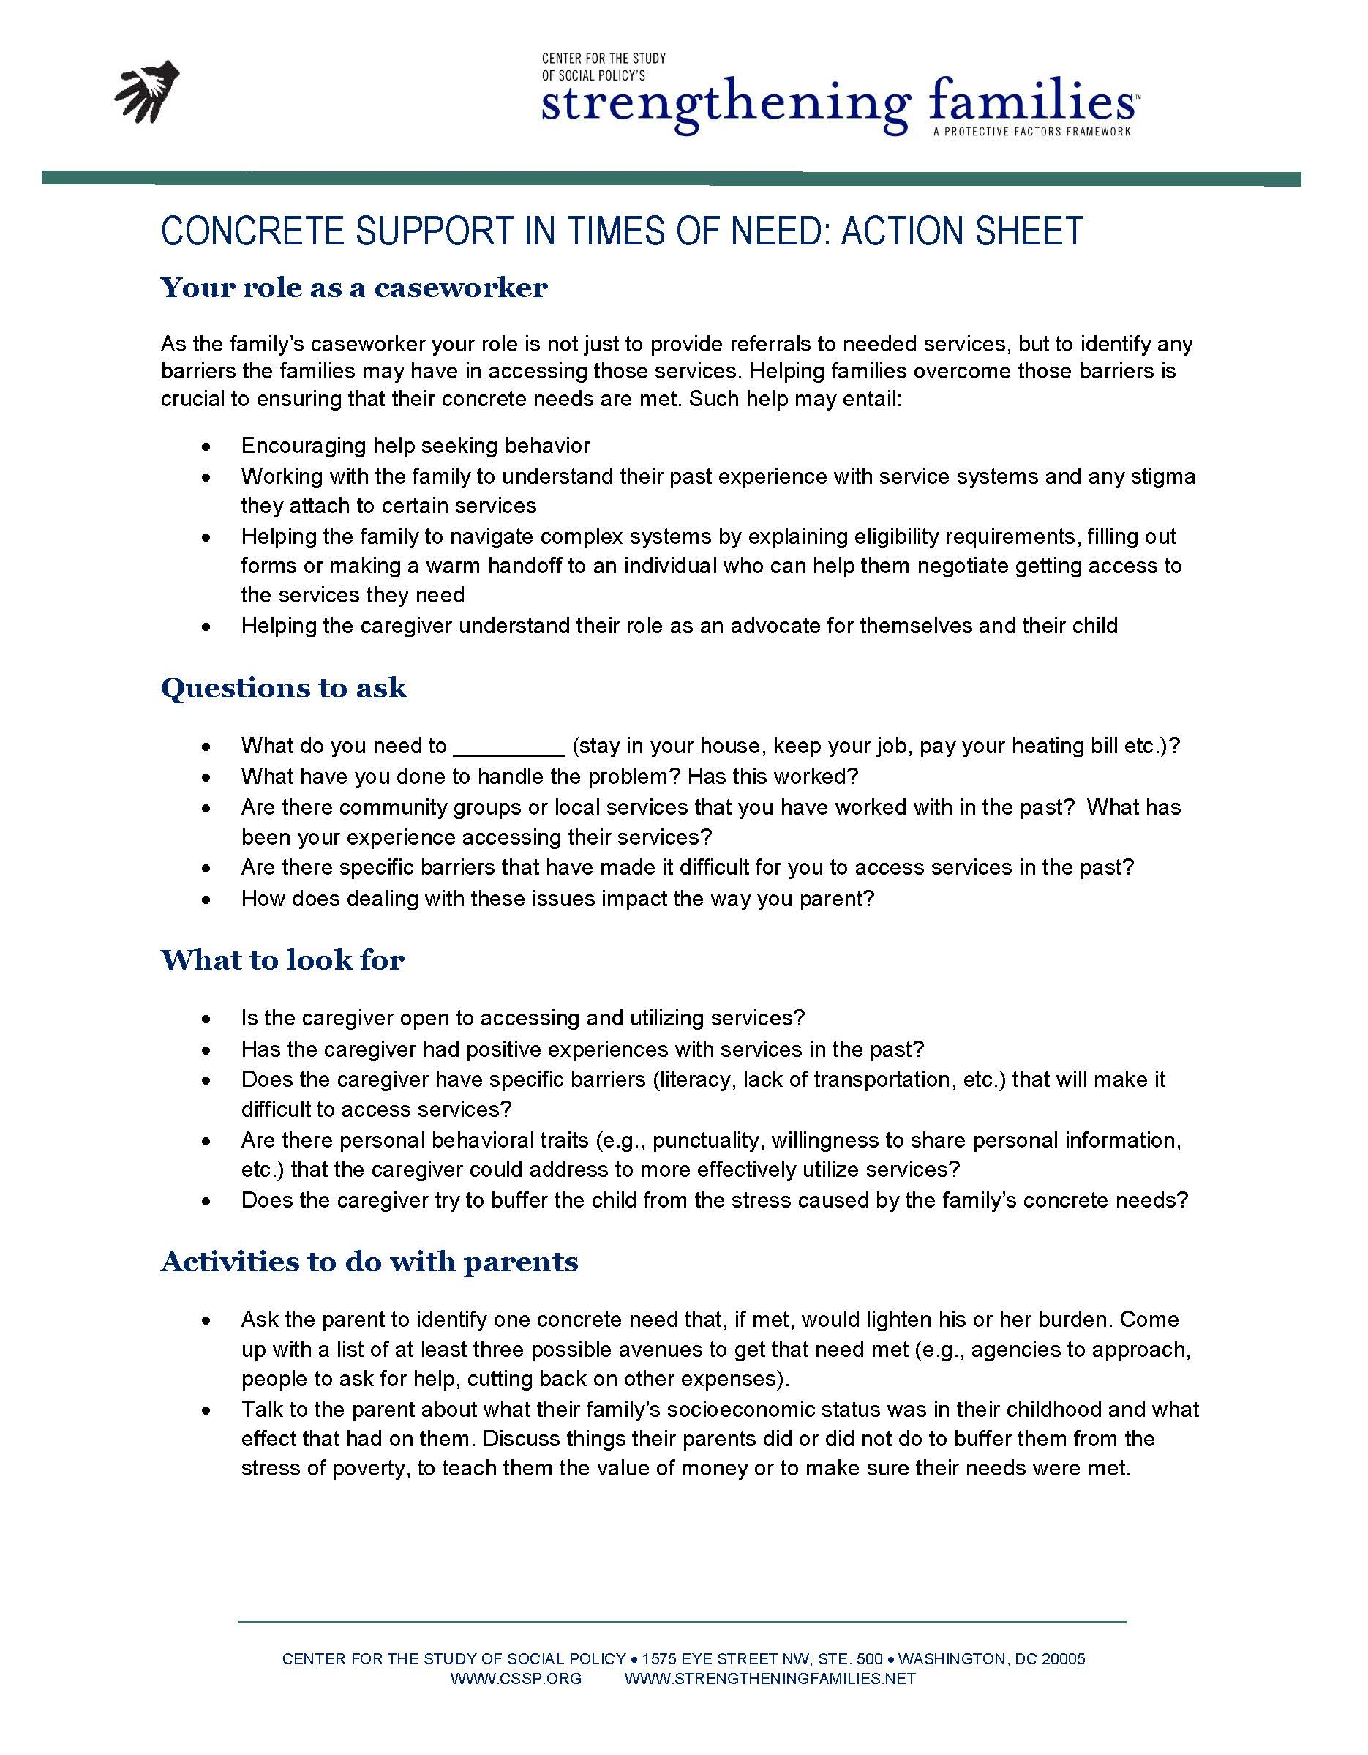

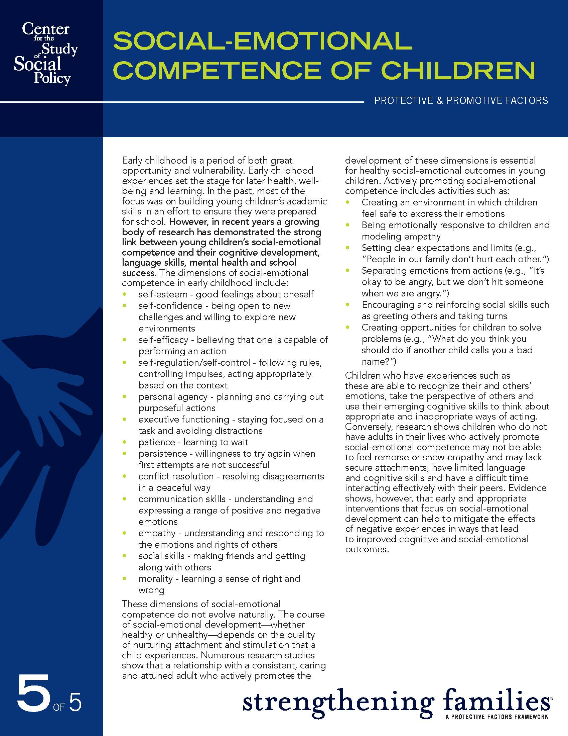

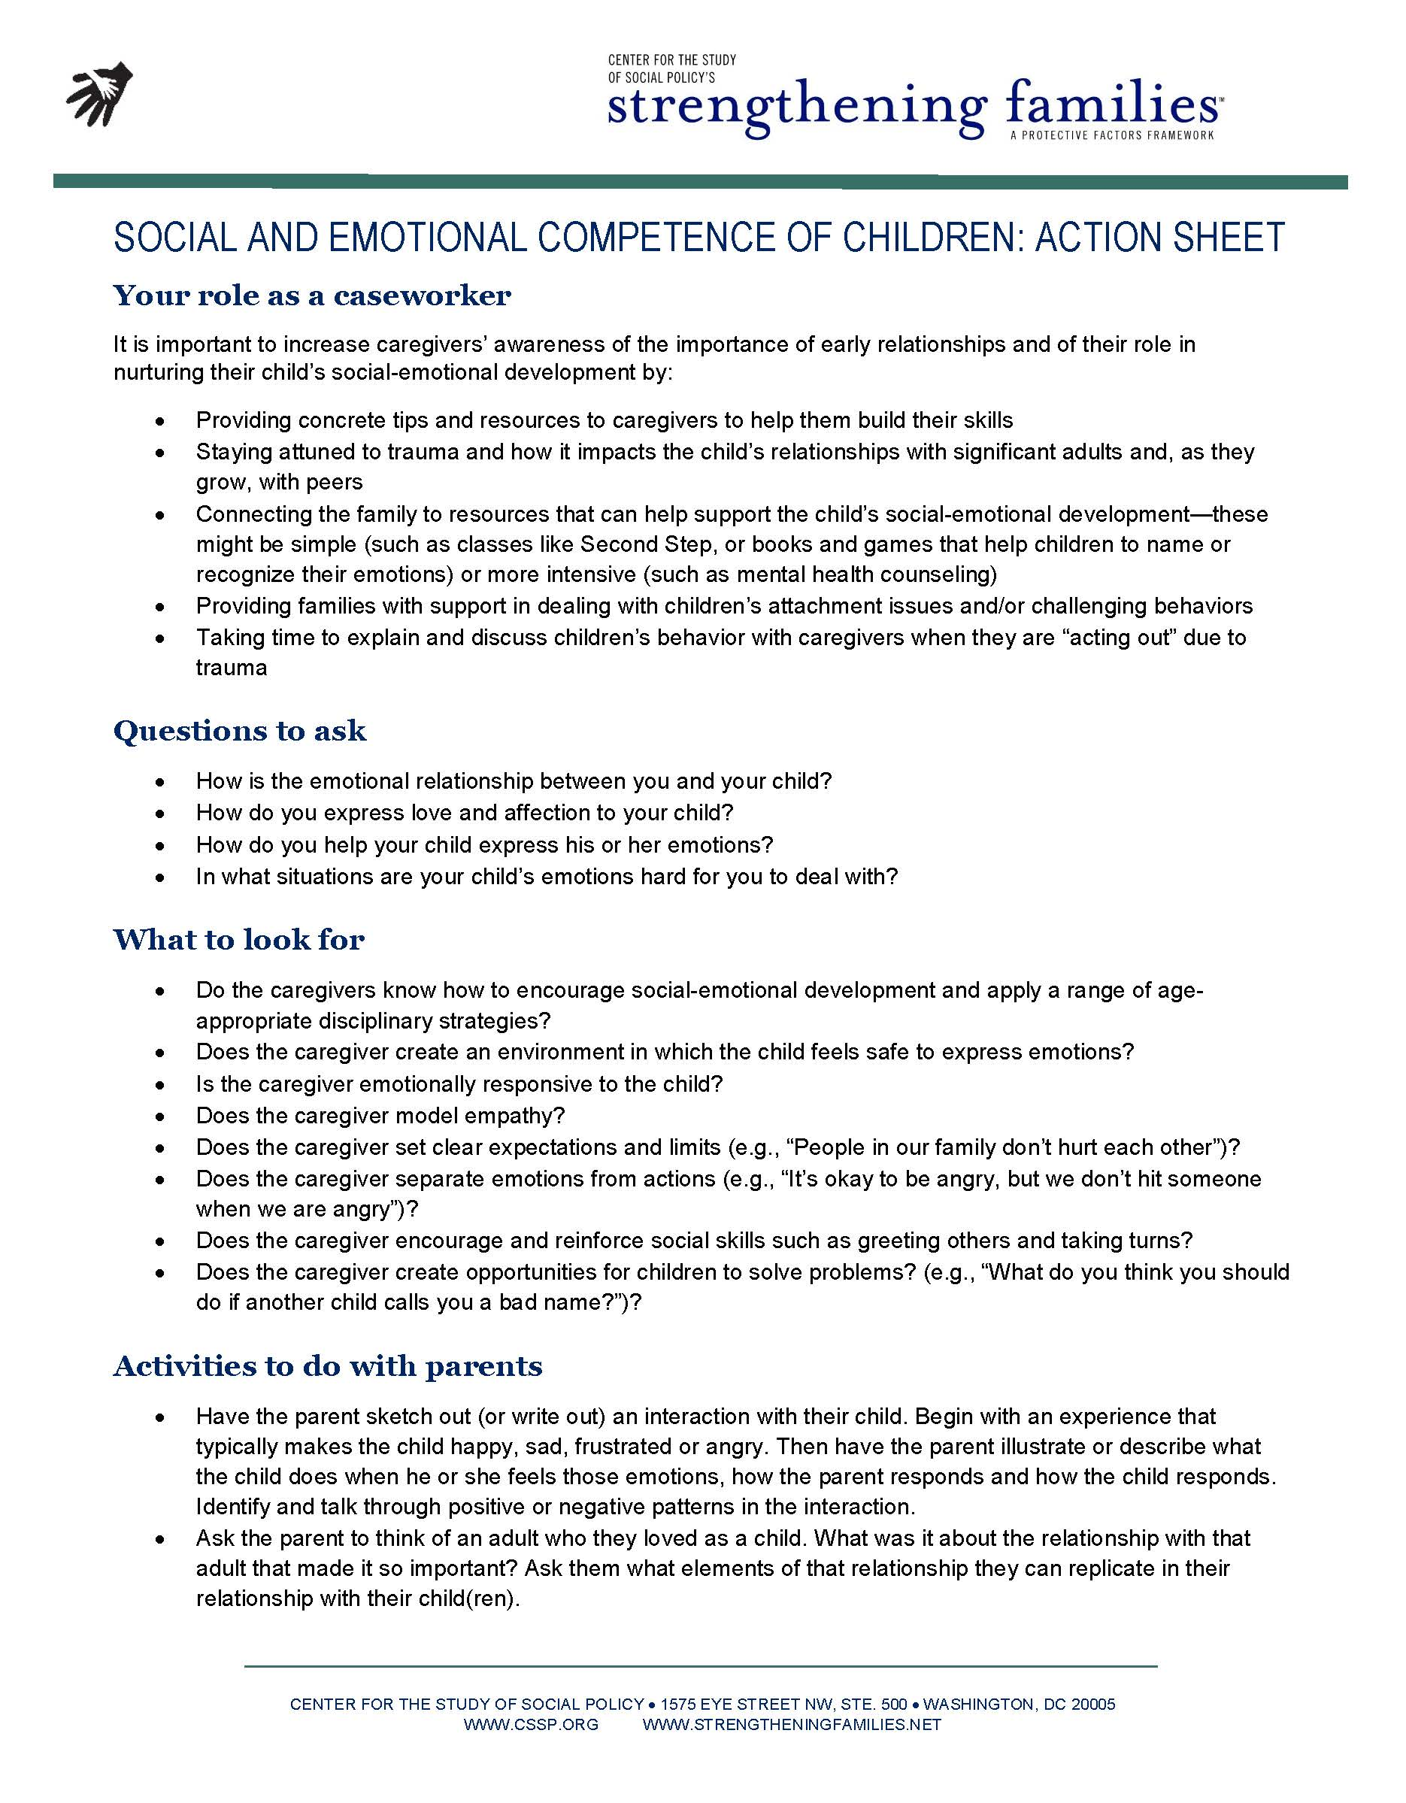

DSS-5230: Family Risk Assessment of Child Abuse/Neglect
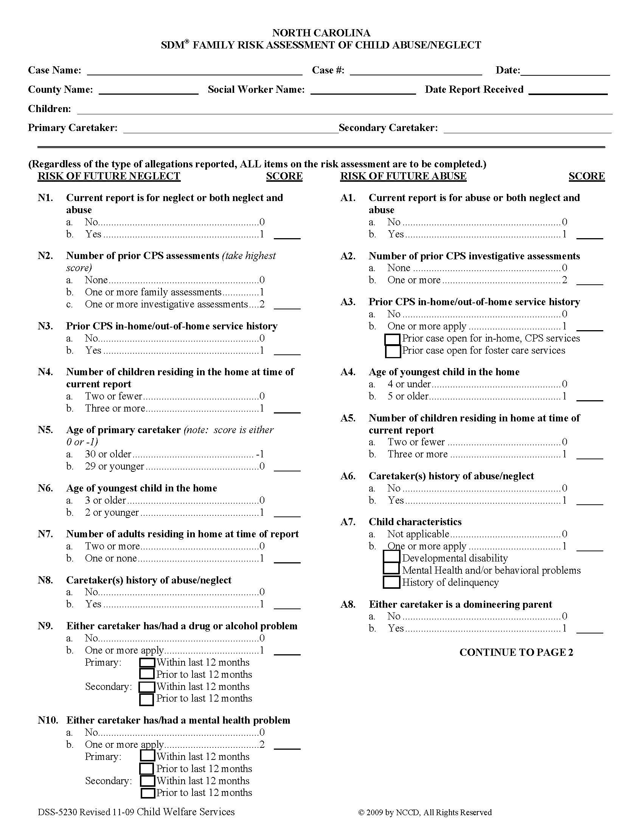
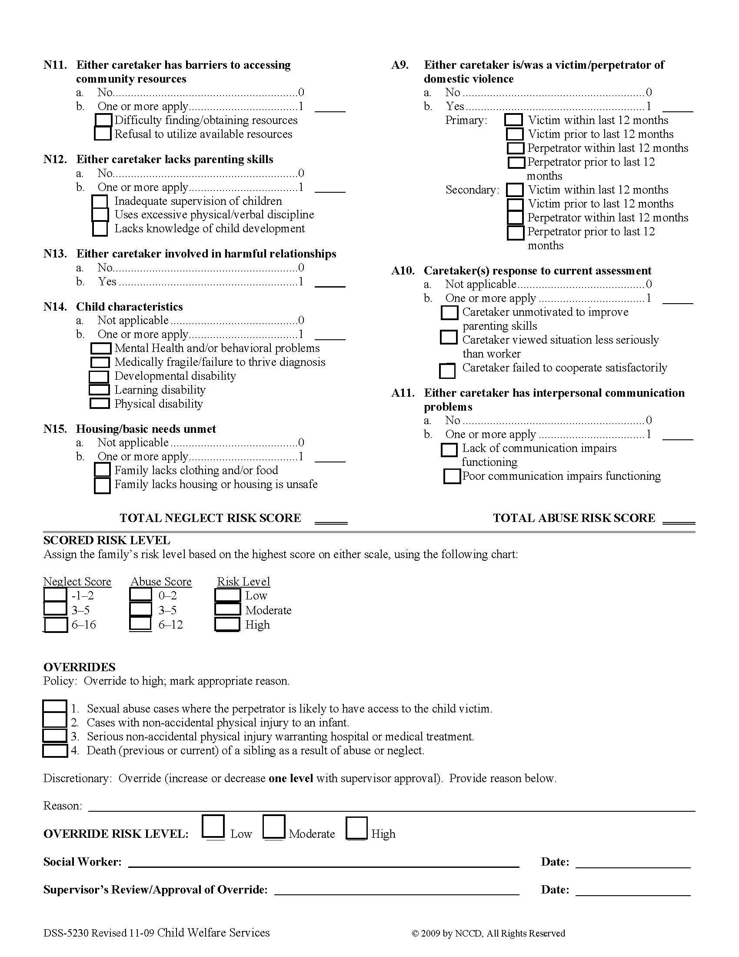
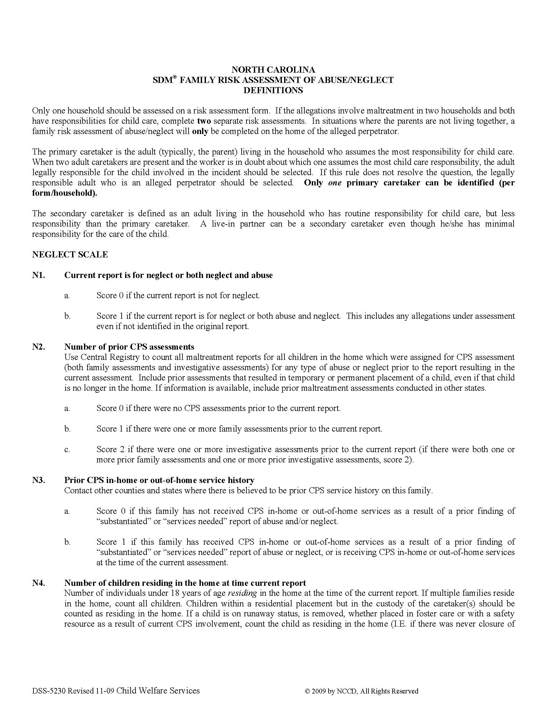
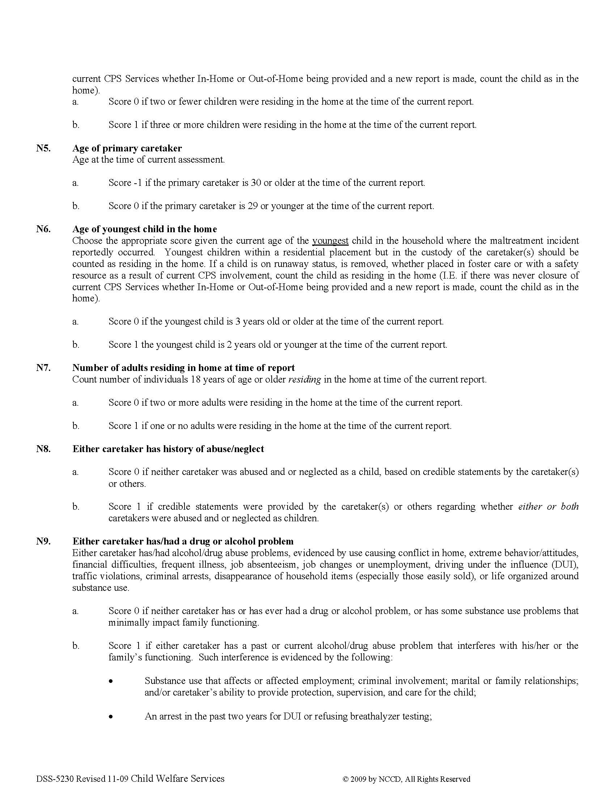
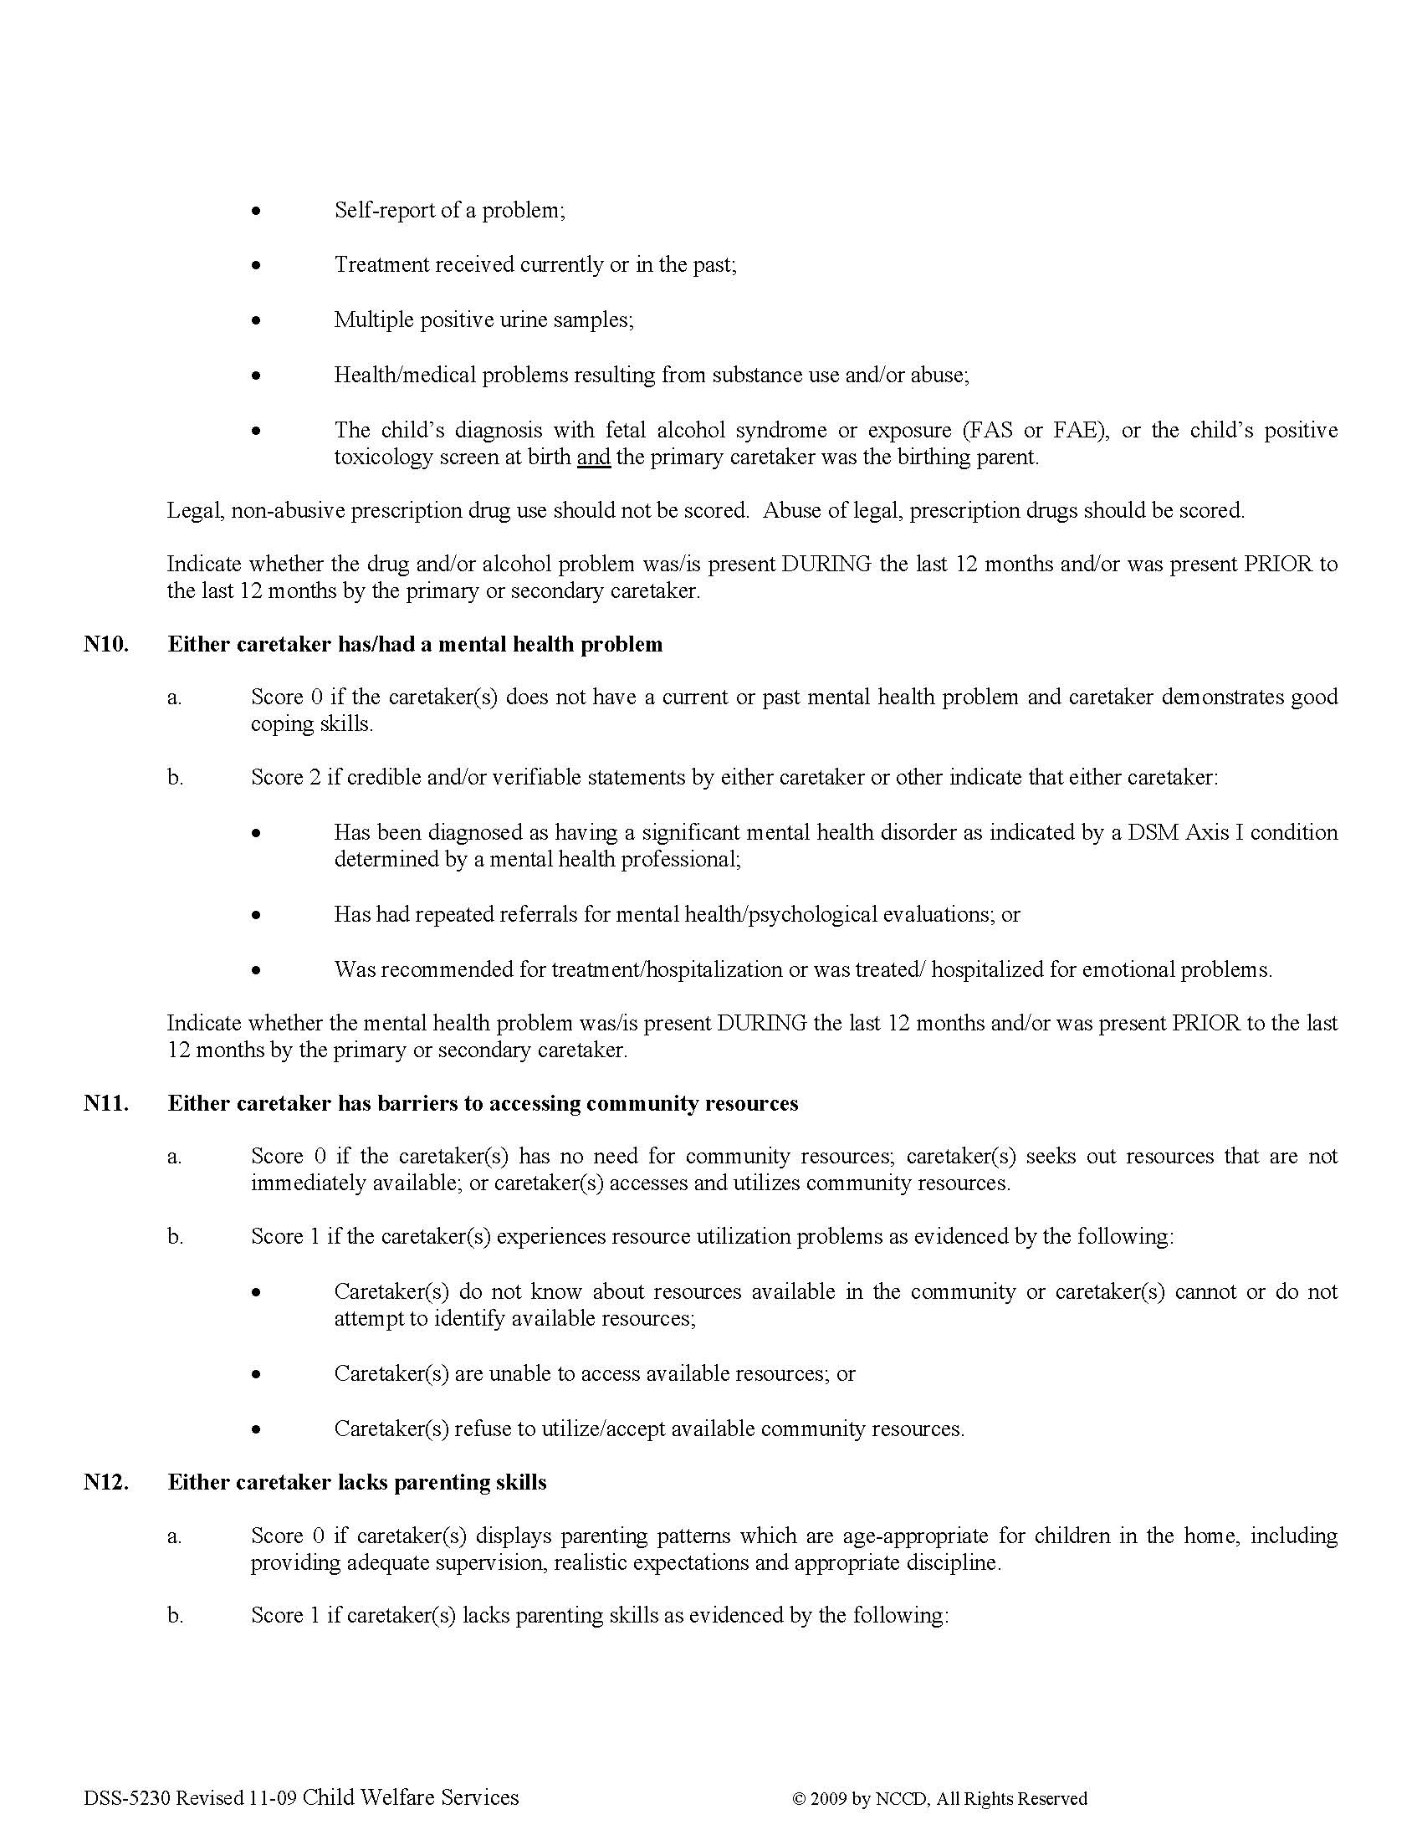
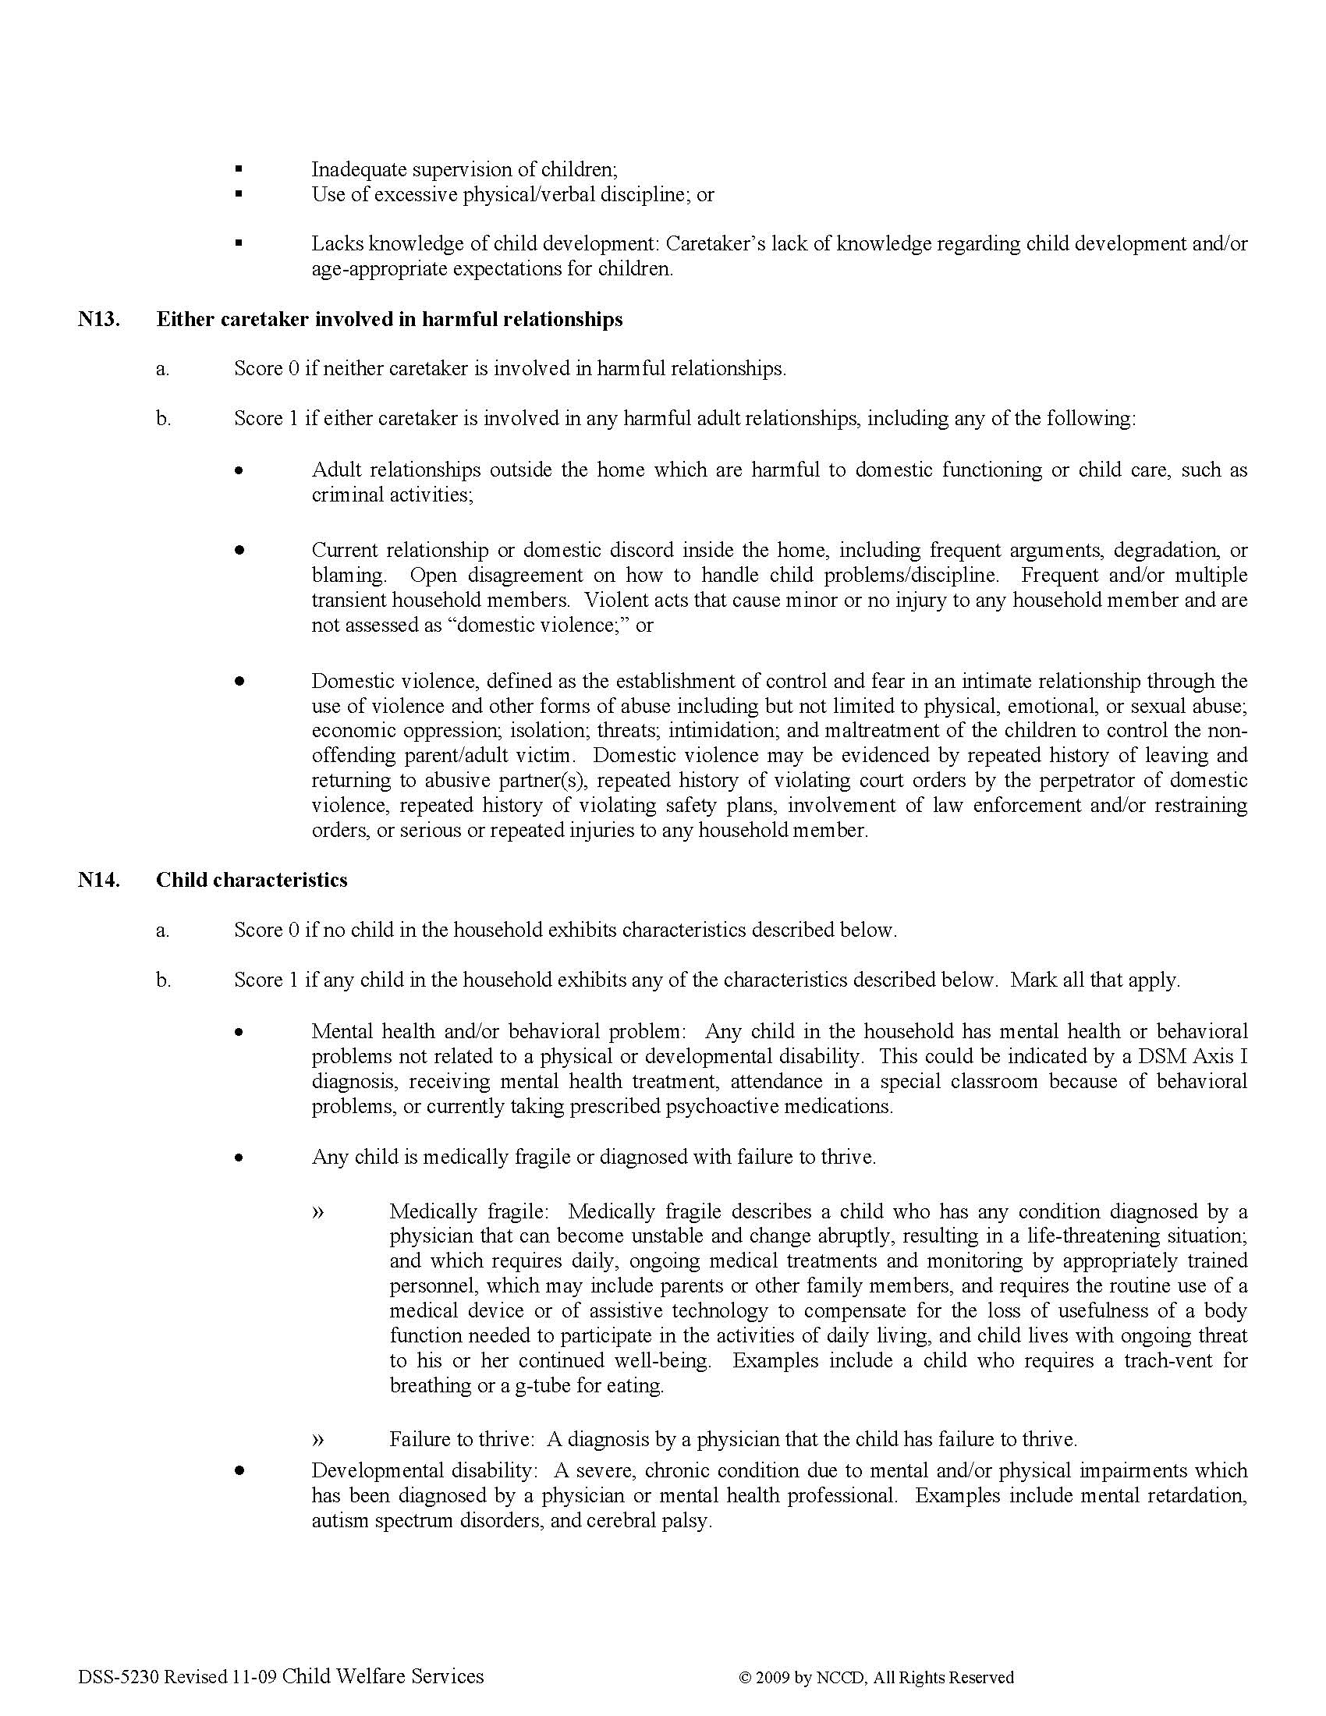
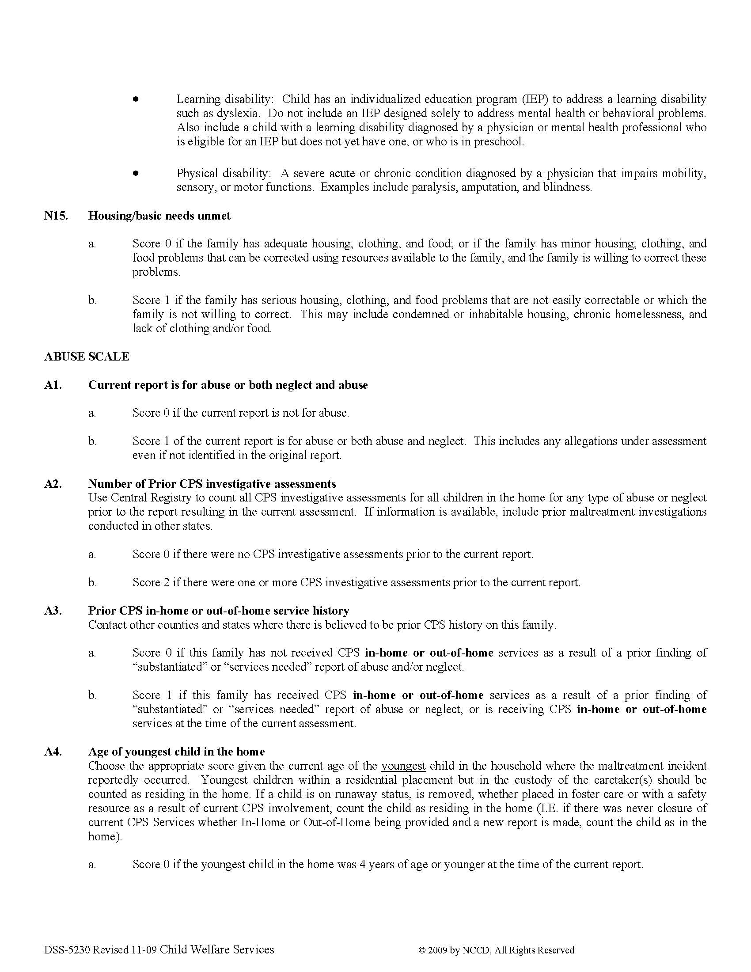
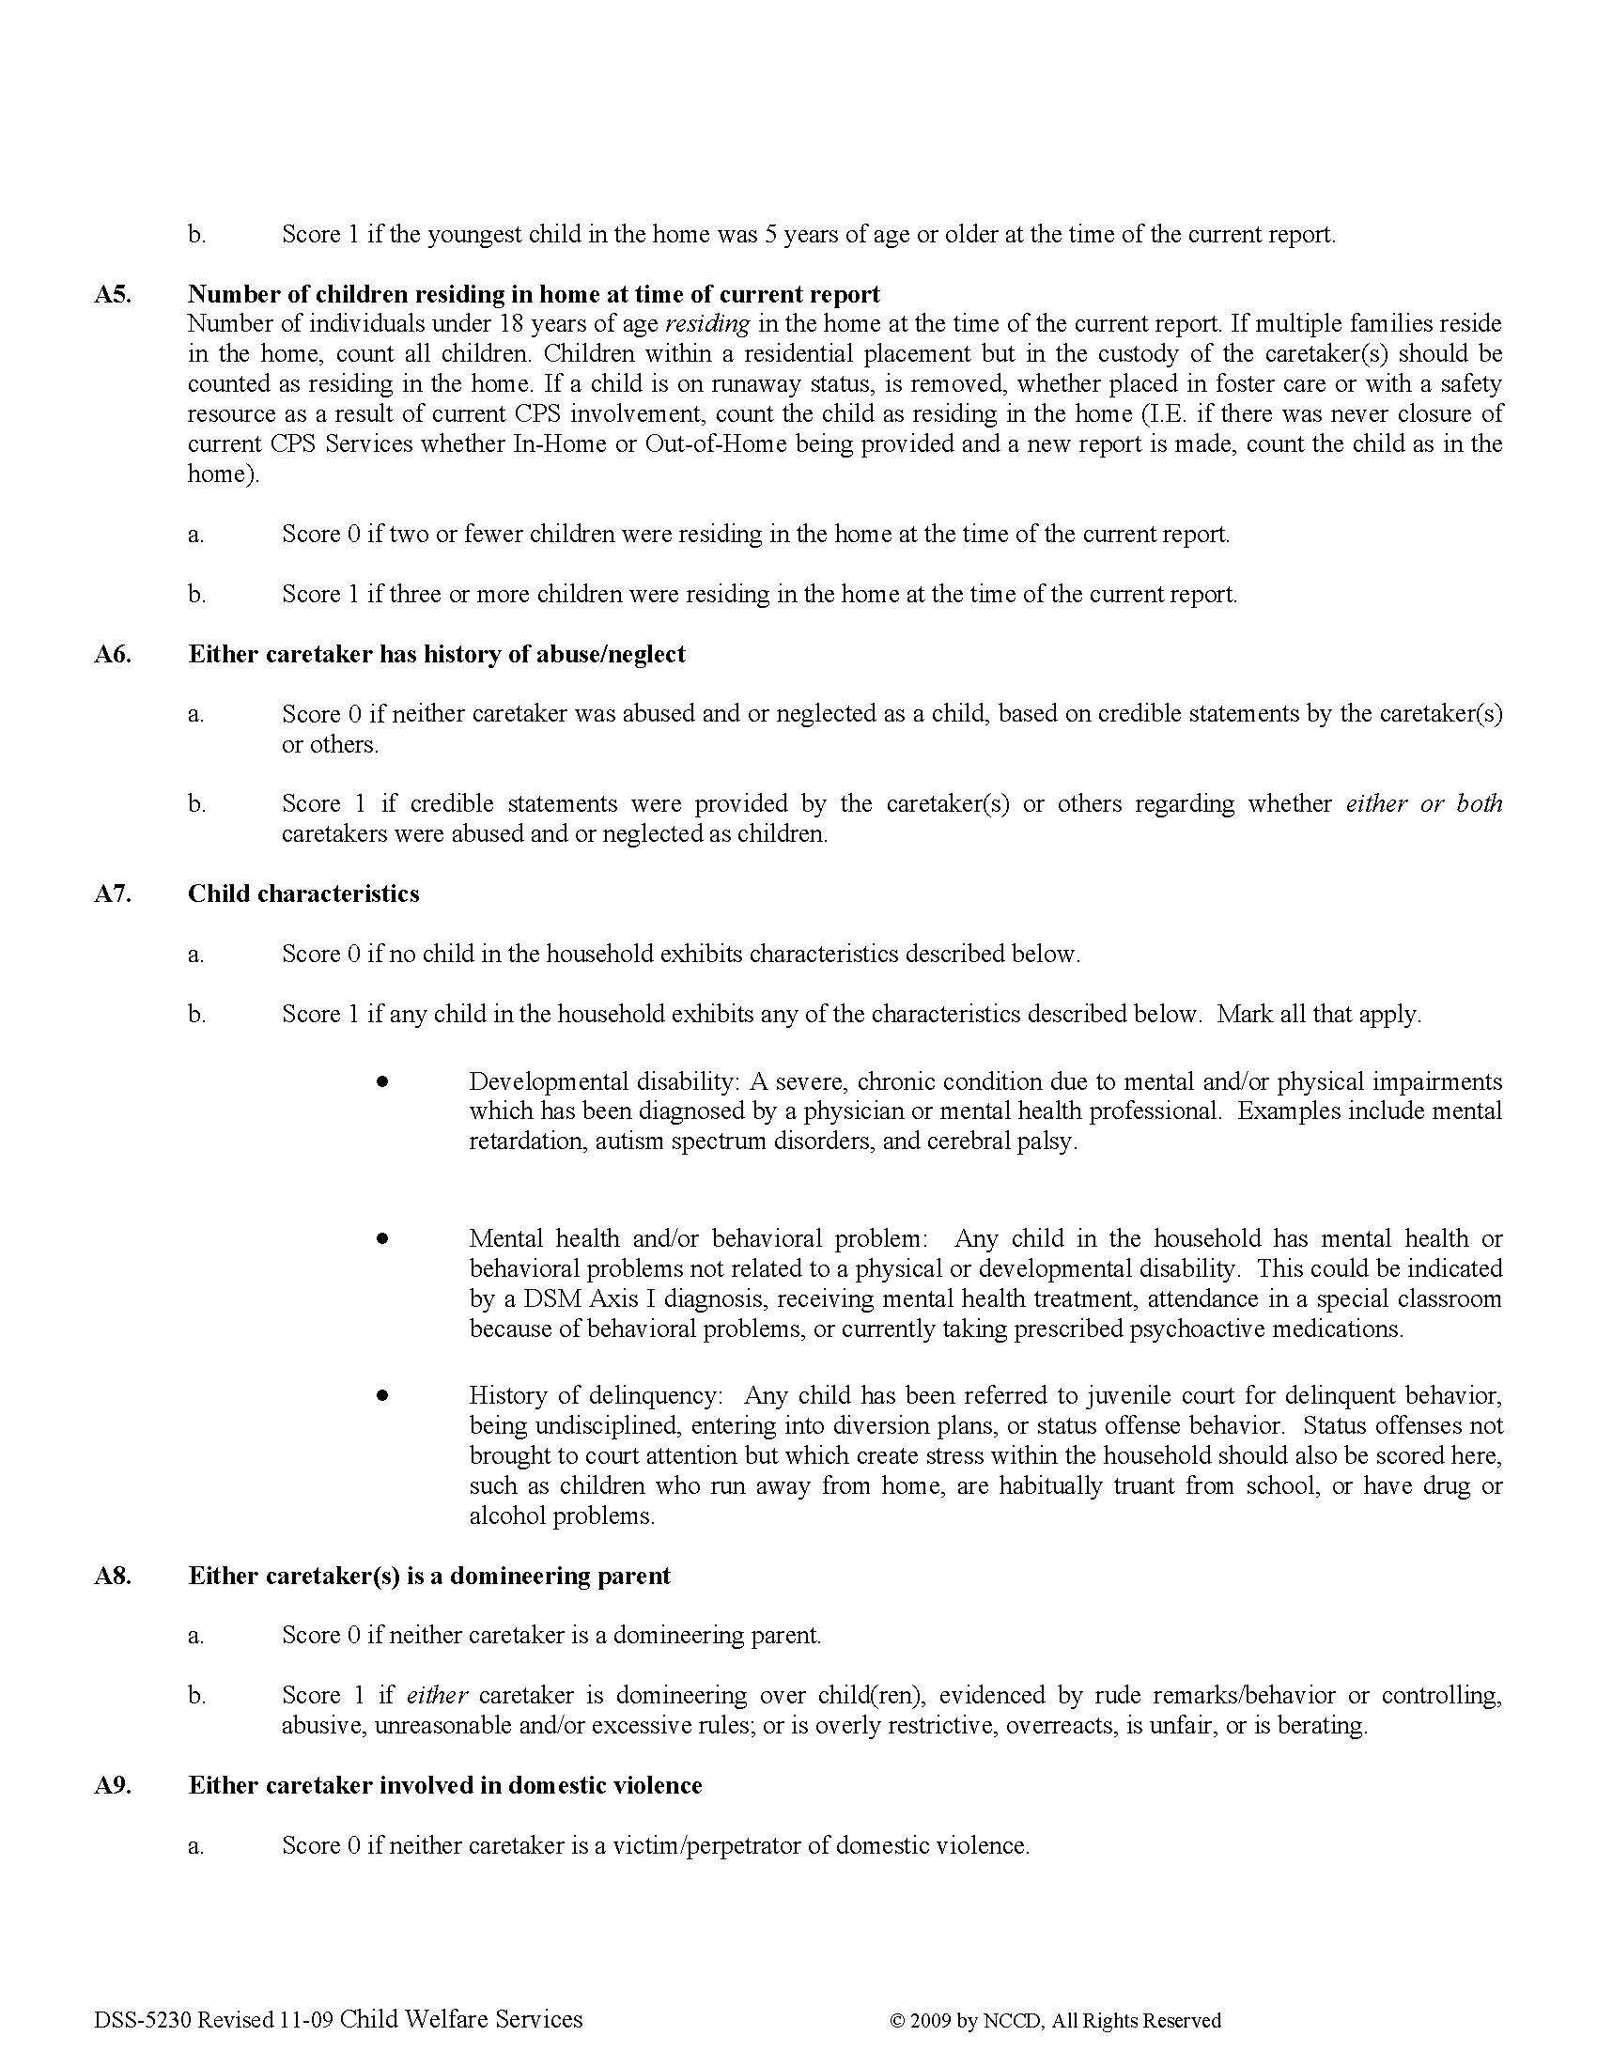
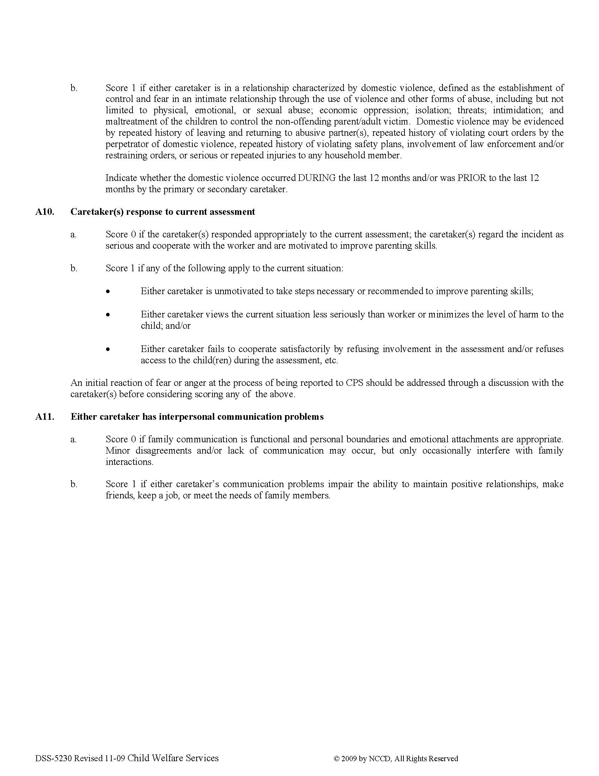
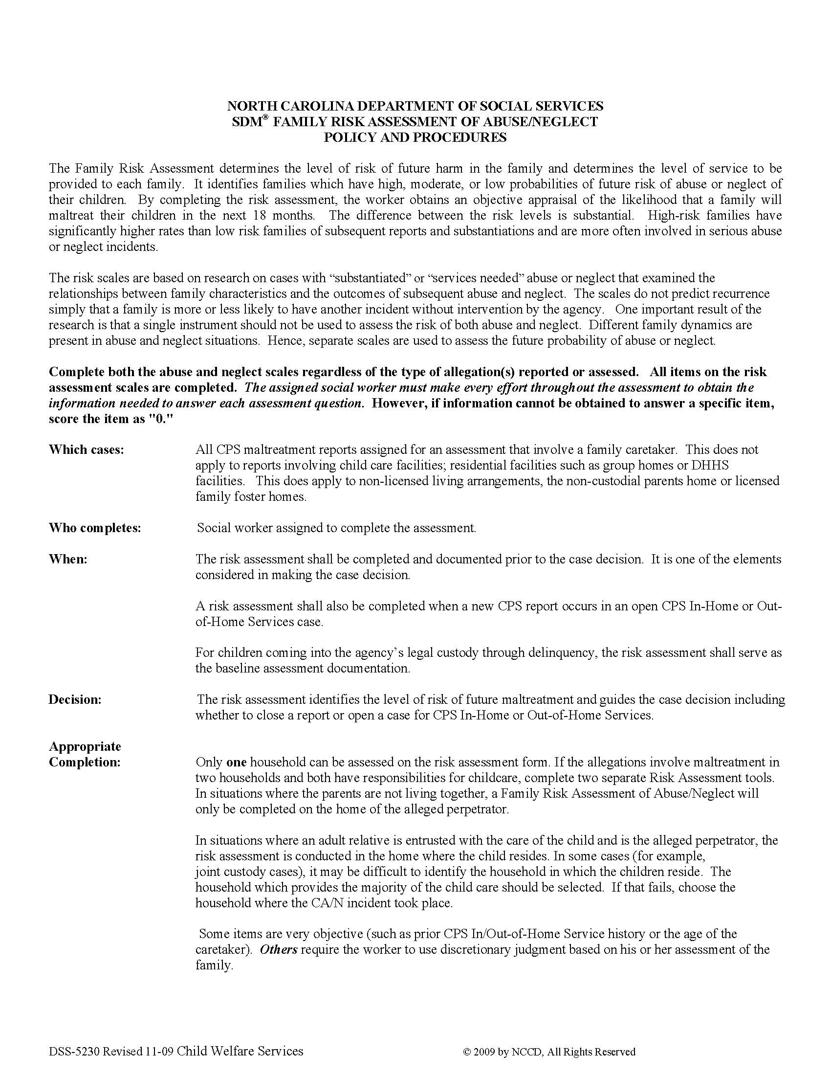
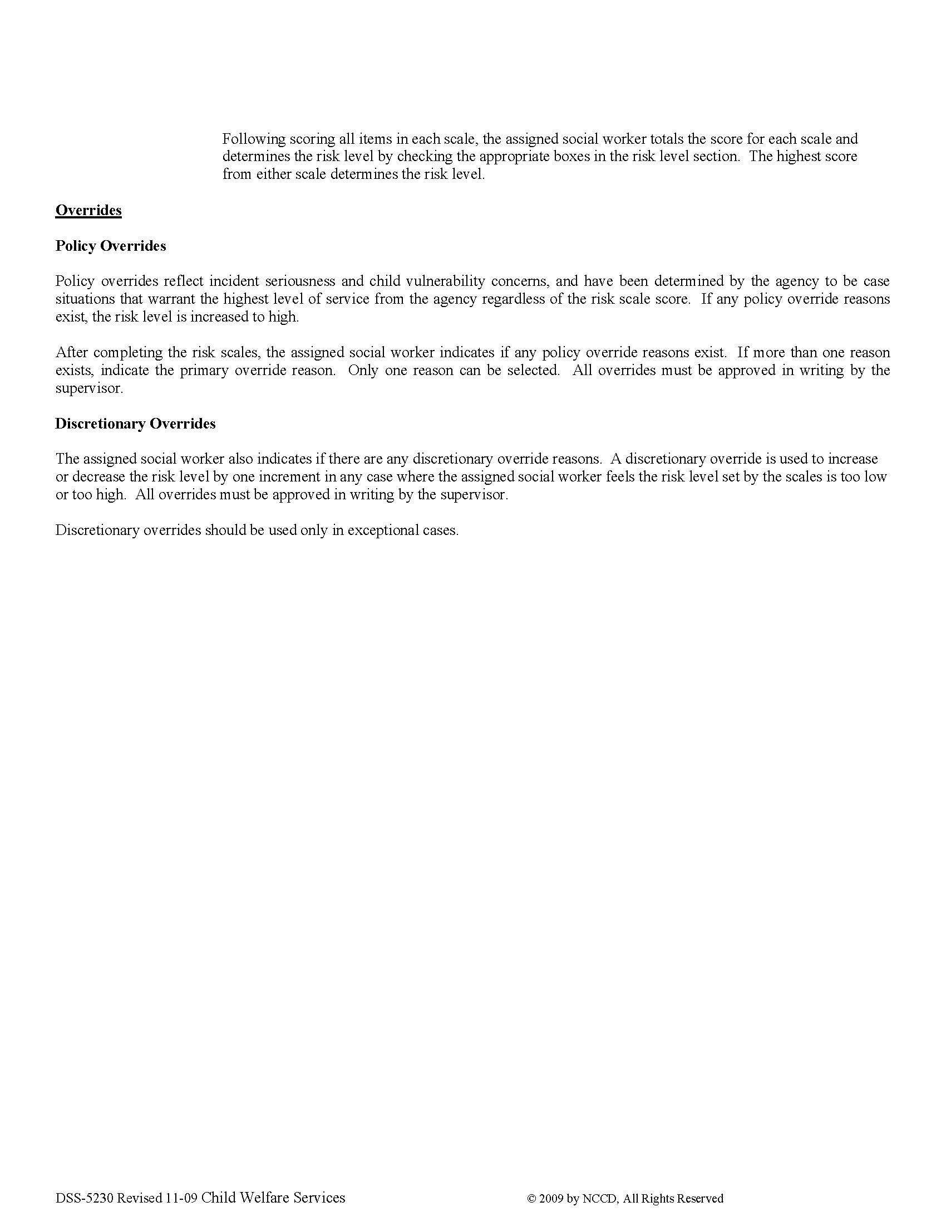

Managing Crucial Conversations
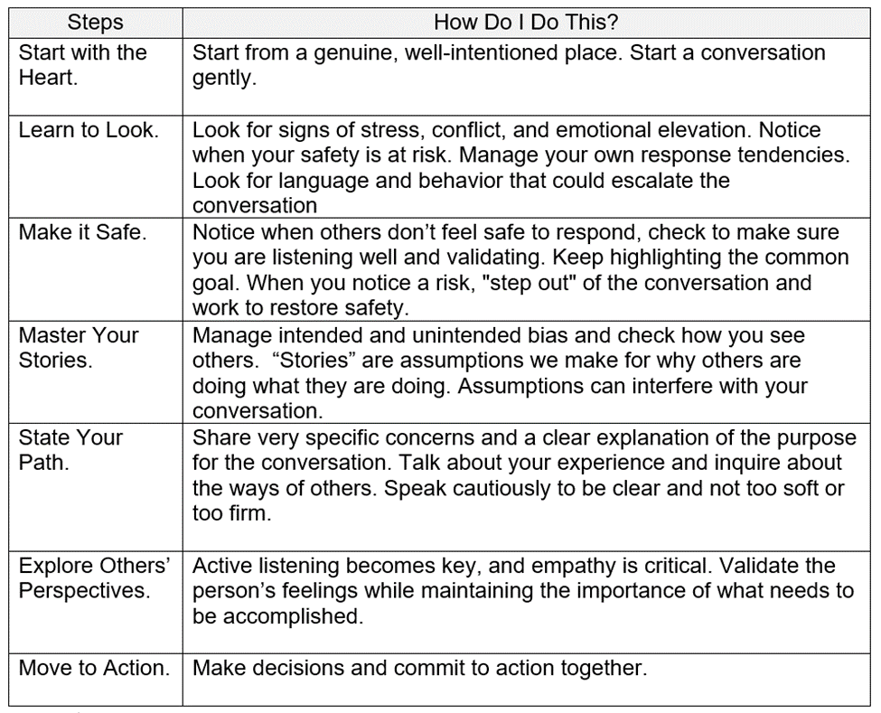

Defining Quality Contacts
