North Carolina Department of Health and Human Services

CPS Assessment in Child Welfare Track Training

Participant’s Workbook

Day Seven

October 2024



600 Airport Rd

Lakewood, NJ, 08701-5995

www.pubknow.com

info@pubknow.com

(800) 776-4229

This curriculum was developed by the North Carolina Department of Health and Human Services, Division of Social Services, and revised by Public Knowledge® in 2024.

Copyright © 2024 Public Knowledge®. All rights reserved. No part of this publication may be reproduced, distributed, or transmitted in any form without the written permission of the publisher.

**Table of Contents**

Instructions 4

Course Themes 4

Training Overview 5

Learning Objectives 7

Day Seven Agenda 9

Welcome 10

Well-Being as an Outcome 11

Well-Being Outcomes for Children and Families 11

Worksheet: Dimensions of Well-Being 12

Video: The Science of Resilience 14

Video: North Carolina Child Welfare Lived Experiences: The Youth Perspective 17

Activity: Well-Being and Voluntary Services Brainstorm 18

Reasonable Efforts and Removals 19

Parental Rights 19

Reasonable Efforts 22

Handout: Reasonable Efforts 23

Active Efforts 26

Skills Practice: Reasonable and Active Efforts 30

Filing a Juvenile Petition 33

Activity: The Court Process 35

Handout: The Court Process 37

Removal 43

Engaging Families in Placement Decisions 45

Activity: Preparing for Placement 47

Skills Practice: Collaborating with Parents During Removals 48

Worker Safety when Emergency Custody is Necessary 50

Video: Calming and De-Escalation Strategies 51

Skills Practice: Custody Conversation 52

Reasonable Efforts and Removals Learning Lab 53

Worksheet: Stations 1 - 4 53

End-of-Day Values Reflection 57

Questions and Reflections 57

Bibliography of References 58

Appendix: Handouts 1

Reasonable Efforts 2

The Court Process 3

# Instructions

This course was designed to guide child welfare professionals through the knowledge, skills, and behaviors needed to engage with families in need of child protection services. The workbook is structured to help you engage in the lesson through reflection and analysis throughout each week of training. Have this workbook readily available as you go through each session to create a long-lasting resource you can reference in the future.

If you are using this workbook electronically: Workbook pages have text boxes for you to add notes and reflections. Due to formatting, if you are typing in these boxes, blank lines will be “pushed” forward onto the next page. To correct this when you are done typing in the text box, you may use delete to remove extra lines.

# Course Themes

The central themes of the CPS Assessment Track Training are divided across several course topics.

* Purpose and Legal Basis for Child Protection Services in North Carolina
* Essential Function: Communicating
* Diversity, Equity, Inclusion, and Belonging
* Trauma-Informed Care
* Family-Centered Practice
* Essential Function: Engaging
* Safety Focused
* Essential Function: Assessing
* Interviewing Learning Lab
* The Role of Observation in Assessing for Safety
* Structured Decision-Making: Safety Assessment
* Assessment Learning Lab
* Safety Planning
* Safety Planning Learning Lab
* Trauma-Informed Practice
* Considerations for Cases Involving Special Circumstances
* Social Worker Safety
* Engaging the Family in Child Protection Services
* Risk Assessment
* Crucial Conversations
* Quality Contacts
* Assessing Family Strengths and Needs
* Secondary Traumatic Stress and Vicarious Traumatization
* Ongoing Assessment
* Family Engagement and Ongoing Assessment Learning Lab
* Documentation
* Well-Being as an Outcome
* Reasonable Efforts and Removals
* Reasonable Efforts and Removals Learning Lab
* Decision-Making
* Decision-Making and Case Closure Learning Lab

# Training Overview

Training begins at 9:00 a.m. and ends at 4:00 p.m. If a holiday falls on the Monday of training, the training will begin on Tuesday at 9:00 a.m. This schedule is subject to change if a holiday falls during the training week or other circumstances occur. The time for ending training on Fridays may vary and trainees need to be prepared to stay the entire day.

Attendance is mandatory. If there is an emergency, the trainee must contact the classroom trainer and their supervisor as soon as they realize they will not be able to attend training or if they will be late to training. If a trainee must miss training time in the classroom, it is the trainee’s responsibility to develop a plan to make up missed material.

**Pre-Work Online e-**Learning **Modules**

There is required pre-work for the CPS Assessment Track Training in the form of online e-Learning modules. Completion of the e-Learnings is required prior to attendance at the classroom-based training. The following are the online e-Learning modules:

1. North Carolina Worker Practice Standards
2. Safety Organized Practice
3. Understanding and Assessing Safety and Risk
4. Understanding and Screening for Trauma

**Transfer of Learning**

The CPS Assessment Track Training Transfer of Learning (ToL) tool is a comprehensive and collaborative activity for workers and supervisors to work together in identifying worker goals, knowledge gain, and priorities for further development throughout the training process. In four distinct steps, the worker and supervisor will highlight their goals and action plan related to participating in training, reflect on lessons and outstanding questions, and create an action plan to support worker growth. The tool should be started prior to beginning the CPS Assessment Track Training and re-visited on an ongoing basis to assess growth and re-prioritize actions for development.

* Part A: Training Preparation: Prior to completing any eLearning and in-person Track Training sessions, the worker and supervisor should meet to complete Part A: Training Preparation. In this step, the worker and supervisor will discuss their goals for participation in training and develop a plan to meet those goals through pre-work, other opportunities for learning, and support for addressing anticipated barriers.
* Part B: Worker Reflections During Training: The worker will document their thoughts, top takeaways, and outstanding questions regarding each section. This level of reflection serves two purposes. First, the practice of distilling down a full section of training into three takeaways and three remaining questions requires the worker to actively engage with the material, subsequently forming cognitive cues related to the information for future use in case practice. Second, prioritizing takeaways and questions by section allows workers to continually review information to determine if questions are answered in future sessions and supports the development of an action plan by requiring workers to highlight the questions they find most important.
* Part C: Planning for Post-Training Debrief with Supervisor: The worker considers the takeaways and questions they identified in each section and creates a framework to transfer those takeaways and questions into an action plan.
* Part D: Post-Training Debrief with Supervisor: Provides an opportunity for the supervisor and worker to determine a specific plan of action to answer outstanding questions and to further support worker training.

While this ToL is specific to the Track Training in North Carolina, workers and supervisors can review the takeaways and questions highlighted by the worker in each section of training on an ongoing basis, revising action steps when prior actions are completed, and celebrating worker growth and success along the way.

Training Evaluations

At the conclusion of each training, learners will complete a training evaluation tool to measure satisfaction with training content and methods. The training evaluation tool is required to complete the training course. Training evaluations will be evaluated and assessed to determine the need for revisions to the training curriculum.

**All** matters **as stated above are subject to change due to unforeseen circumstances and with approval.**

# Learning Objectives

**Day** Seven

|  |
| --- |
| Well-Being as an Outcome |
| * Learners will be able to identify ways to ensure children’s physical and emotional safety. |
| Reasonable Efforts and Removals |
| * Learners will be able to describe how to incorporate all safety and risk factors into the comprehensive family assessment. |
| * Learners will be able to develop strategies to adequately address safety and risk factors within ongoing case planning activities. |
| * Learners will be able to distinguish allowable actions from those that infringe on parental rights during a CPS Assessment. |
| * Learners will be able to describe diligent efforts at all stages of a CPS Assessment. |
| * Learners will be able to define Reasonable Efforts. |
| * Learners will be able to outline state and federal requirements regarding removal and placement decisions. |
| * Learners will explain the importance of collaborating with the child’s tribe when making placement decisions to meet ICWA placement preference standards. |
| * Learners will be able to explain how to follow requirements, including filing and engagement discussions when making removal and placement decisions. |
| * Learners will describe the importance of engaging families when placing children in out-of-home care. |
| * Learners will demonstrate how they will discuss removal and placement with children, families, and providers. |
| Reasonable Efforts and Removals Learning Lab |
| * Learners will be able to describe whether reasonable or active efforts are appropriate to prevent removals in different case circumstances. |
| * Learners will be able to document reasonable or active efforts made. |
| * Learners will understand how to apply and document active efforts to prevent the removal of Indian Children. |
| * Learners will be able to describe which efforts are appropriate to prevent removals in different case circumstances. |
| * Learners will be able to describe how to document reasonable efforts made. |
| * Learners will be able to describe skills to de-escalate, calm, and verbally intervene to diffuse tense and potentially violent outbursts. |
| * Learners will be able to demonstrate de-escalation skills and safety in response to violent outbursts. |
| * Learners will be able to explain the importance of collaboration and communication to their safety while executing emergency custody of a child or children. |

# Day Seven Agenda

|  |
| --- |
| CPS Assessment Track Training |
| Welcome | |
| Well-Being as an Outcome | |
| Well-Being Outcomes for Children and Families | |
| Reasonable Efforts and Removals | |
| Parental Rights | |
| Reasonable Efforts | |
| Active Efforts | |
| Skills Practice: Reasonable and Active Efforts | |
| Filing a Juvenile Petition | |
| Removal | |
| Engaging Families in Placement Decisions | |
| Worker Safety when Emergency Custody is Necessary | |
| Reasonable Efforts and Removals Learning Lab | |
| End-of-Day Values Reflection | |

# Welcome

Use this outlined space to record notes from the introduction activity.

|  |
| --- |
|  |

# Well-Being as an Outcome

## Well-Being Outcomes for Children and Families

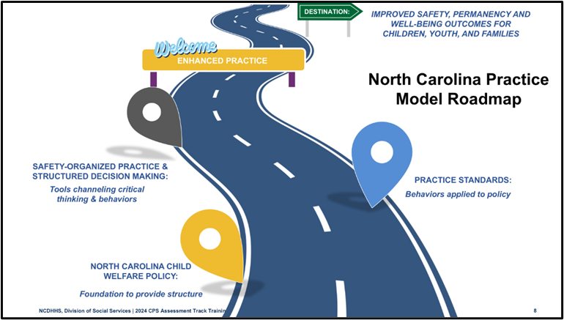

Use this space to record notes.

|  |
| --- |
|  |

### Worksheet: Dimensions of Well-Being

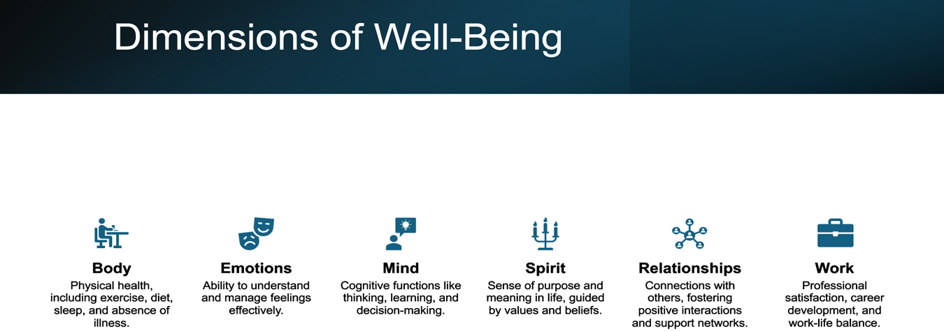

How does each dimension apply to our anchor family?

|  |  |  |
| --- | --- | --- |
| Body | Emotions | Mind |
|  |  |  |

|  |  |  |
| --- | --- | --- |
| Spirit | Relationships | Work |
|  |  |  |

### Video: The Science of Resilience

<https://www.youtube.com/watch?v=1r8hj72bfGo>

Use this space to record notes.

|  |
| --- |
|  |

How is resilience described?

|  |
| --- |
|  |

What individual elements impact resilience for an individual?

|  |
| --- |
|  |

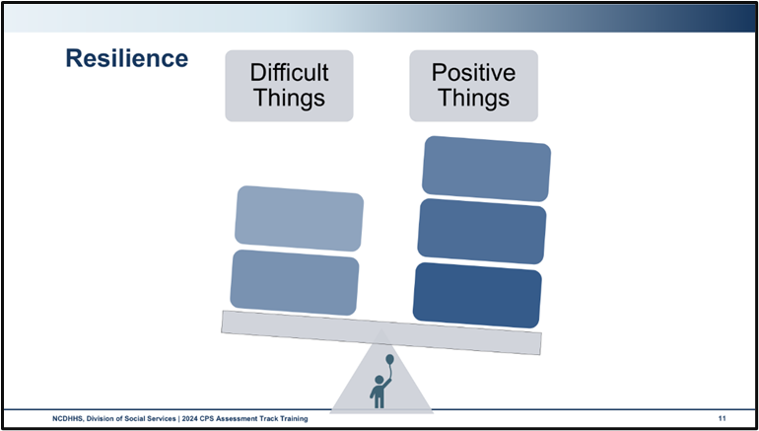

Use this space to record notes.

|  |
| --- |
|  |

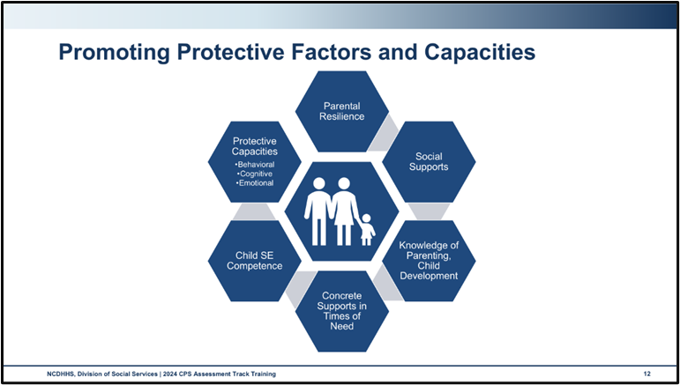

Use this space to record notes.

|  |
| --- |
|  |

### Video: North Carolina Child Welfare Lived Experiences: The Youth Perspective

[NCDHHS Lived Experience Video](https://www.dropbox.com/scl/fo/wu4s22b7ouc96gyvtmmik/h?e=1&preview=12_18_23_the_youth_perspective+(720p).mp4&rlkey=wrxfiviurth20lg80pv1d3b9l&dl=0)

You do not need to take any notes during this video, just absorb what the youth have to share with you. As you watch this video, listen to Ares and Mikaila describe their experiences in the child welfare system.

What are your feelings after that video?

|  |
| --- |
|  |

What are your thoughts after listening to these youth?

|  |
| --- |
|  |

What are some of the things you heard Ares and Mikaila share about the most important things for social workers to remember when working with youth?

|  |
| --- |
|  |

### Activity: Well-Being and Voluntary Services Brainstorm

For this activity, we encourage you to use the knowledge you have built throughout this training, your experience in the field, and Protective Factors: Action Sheets from the Center for the Study of Social Policy and the Protective Capacities Handout introduced in Day 5. As you complete this activity, please keep in mind that we are discussing the ***voluntary*** ways that families address well-being, and protective factors and capacities.

Work with your group to create a poster for your assigned topic following these prompts:

* How does this factor or capacity connect to child and parent well-being?
* What are ways to support the growth of this factor or capacity with voluntary informal resources?
* What are ways to support the growth of this factor or capacity with voluntary formal services?

Use this space for brainstorming ideas with your group.

|  |
| --- |
|  |

# Reasonable Efforts and Removals

## Parental Rights

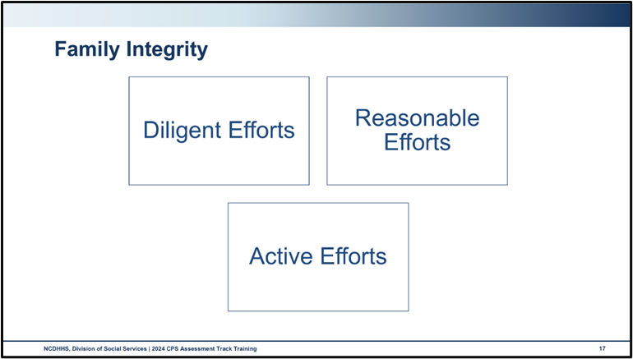

Diligent Efforts

Refers to the amount of effort put in by the social worker to find non-resident parents or caregivers who live outside the home and includes the efforts made by the social worker to locate relatives and kin to serve as collaterals and potentially to provide safety for the children, such as serving as a kinship placement. Diligent Efforts are measured by the actions you take to find and engage relatives or kin who support and/or provide safety for the child and the child’s parents and caregivers, from safety planning to out-of-home placement due to a removal.

Reasonable Efforts

Are defined as providing accessible, available, and culturally appropriate services that are designed to improve the capacity of families to provide safe and stable homes for their children. Reasonable Efforts describes how much effort CPS Assessment social workers put into centering the child and family’s strengths and needs as they assess for allegations, child safety, permanence, and well-being. The courts recognize that what you can do depends upon the problem and the resources within your specific community.

Active Efforts

Are affirmative, active, thorough, and timely efforts intended primarily to maintain or reunite an Indian child with their family.

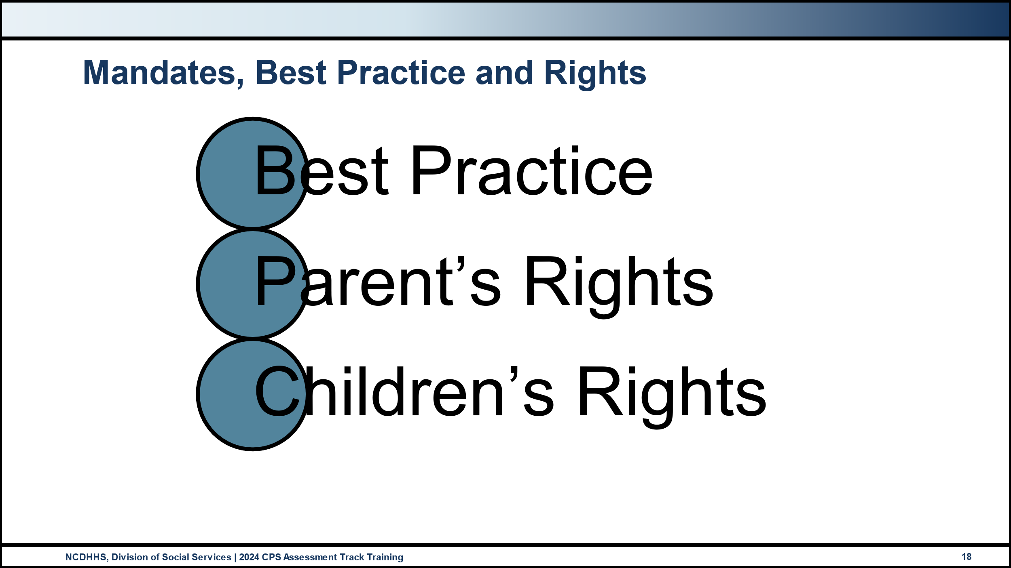

Policy and best practice indicate that parents/caregivers involved in cases of abuse, neglect, or dependency have the must:

* Be treated in a courteous and respectful manner.
* Know DSS’s legal authority and right to intervene in cases of child abuse, neglect, or dependency.
* Know the allegations of abuse, neglect, or dependency reported at the first contact with DSS.
* Know any possible action that DSS may take, including petitioning the court to remove the child in order to ensure safety and protection.
* Know DSS’s expectations of the parent/caregiver.
* Know what services they can expect from DSS and other community agencies.
* Have a family services case plan that is clearly stated, measurable, specific, that includes time-limited goals, and is mutually developed by the DSS and the parent/caretaker.

Parents/caregivers involved in cases of abuse, neglect, or dependency have the right to:

* Due process
* Reasonable efforts
* Diligent efforts
* Notification
* Entry
* Privacy/confidentiality
* If Native America, active efforts.

Children have a right to:

* Freedom from abuse, neglect, dependency, and exploitation.
* Minimally sufficient care and support.
* An environment that promotes physical and emotional well-being.
* A life-long family relationship with at least one adult that promotes a sense of mutual belonging and is legally secure.
* Representation before the juvenile court by a Guardian Ad Litem and/or attorney if custody has been removed from the parents.

Persons alleged to have caused or contributed to the abuse, neglect, or dependency of a child have a right:

* To be informed of the allegations of child abuse, neglect, or dependency at first contact with DSS.
* To receive services designed to correct the behavior that led to the abuse, neglect, or dependency.
* To retain legal counsel, if they so desire (the court appoints counsel to indigent parents).
* To be informed of the agency’s actions relating to them, including referral for criminal charges when indicated.

How can we respect parents’ autonomy while ensuring child safety and well-being?

|  |
| --- |
|  |

What role does permanence play in a child’s well-being?

|  |
| --- |
|  |

What impact does the systems of care approach have on children and families who are at risk for child abuse and neglect?

|  |
| --- |
|  |

## Reasonable Efforts

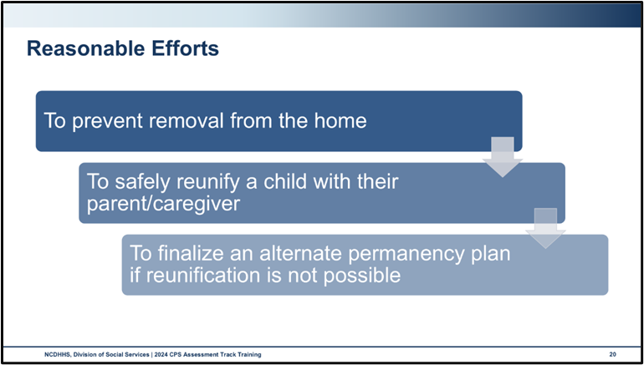

Use this space to record notes.

|  |
| --- |
|  |

### Handout: Reasonable Efforts

The following are the North Carolina citations related to reasonable efforts.

According to N.C.G.S. § 7B-101 (18), reasonable efforts are defined as the diligent use of preventive or reunification services by a department of social services when a juvenile's remaining at home or returning home is consistent with achieving a safe, permanent home for the juvenile within a reasonable period of time. If a court of competent jurisdiction determines that the juvenile is not to be returned home, then reasonable efforts mean the diligent and timely use of Permanency Planning Services by a department of social services to develop and implement a permanent plan for the juvenile.

Gen. Stat. § 7B-101 Reasonable efforts must be made to do the following:

* To prevent or eliminate the need for placement of the juvenile out of the home
* To develop and implement a permanent plan for the child when a court determines that the juvenile is not to be returned home

Gen Stat § 7B-507(a)(2)

An order placing or continuing the placement of a juvenile in the nonsecure custody of a county department of social services shall contain specific findings as to whether a county department of social services has made reasonable efforts to prevent the need for the placement of the juvenile. In determining whether efforts to prevent the placement of the juvenile were reasonable, the juvenile's health and safety shall be the paramount concern. The court may find that efforts to prevent the need for the juvenile's placement were precluded by an immediate threat of harm to the juvenile. A finding that reasonable efforts were not made by a county department of social services shall not preclude the entry of an order authorizing the juvenile's placement when the court finds that placement is necessary for the protection of the juvenile

Gen. Stat. § 7B-901 Unless the court concludes that there is compelling evidence warranting continued reunification efforts, the court shall direct that reasonable efforts for reunification shall not be required if the court makes written findings of fact pertaining to any of the following:

* A court determines or has determined that aggravated circumstances exist because the parent has committed, encouraged the commission of, or allowed the continuation of any of the following upon the juvenile: Sexual abuse; chronic physical or emotional abuse; torture; abandonment; chronic or toxic exposure to alcohol or controlled substances that causes impairment of or addiction in the juvenile; any other act, practice, or conduct that increased the enormity or added to the injurious consequences of the abuse or neglect
* A court terminates or has terminated involuntarily the parental rights of the parent to another child of the parent.
* A court determines or has determined that the parent has done any of the following: Committed murder or voluntary manslaughter of another child of the parent; aided, abetted, attempted, conspired, or solicited to commit murder or voluntary manslaughter of the child or another child of the parent; committed a felony assault resulting in serious bodily injury to the child or another child of the parent; committed sexual abuse against the child or another child of the parent; been required to register as a sex offender on any government-administered registry

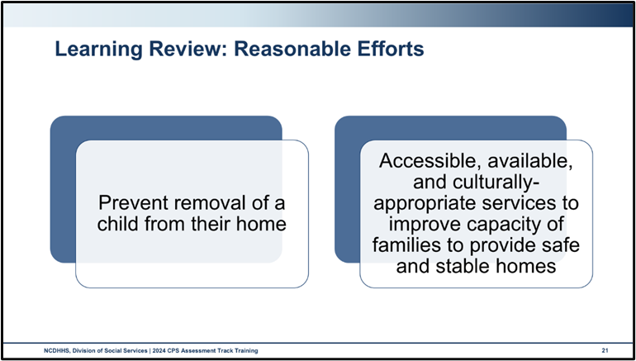

Use this space to record notes.

|  |
| --- |
|  |

## Active Efforts

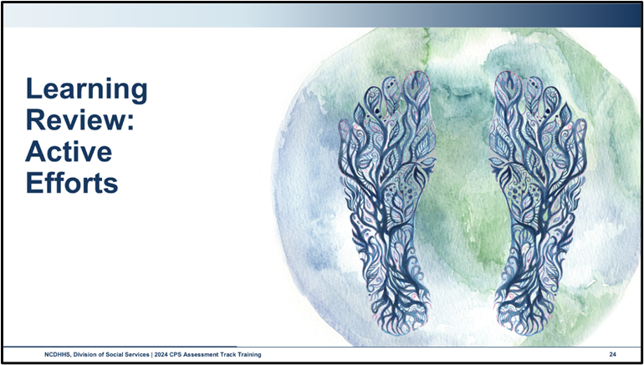

“Engaging in active efforts under the ICWA calls for employing all available and culturally appropriate family preservation services and strategies to meet families’ (and especially primary caregivers’) biopsychosocial needs (U.S. Dept. of the Interior, n.d.), including referrals to culturally knowledgeable service providers, elders, and traditional healing practices or ceremonies. Active efforts are demonstrated by casework practice that is committed to maintaining children’s cultural connections, preventing removals whenever child safety can be assured, and use of kinship or tribal placements when children cannot remain safely at home.” (CFSTC, 2023).

Use this space to record notes.

|  |
| --- |
|  |

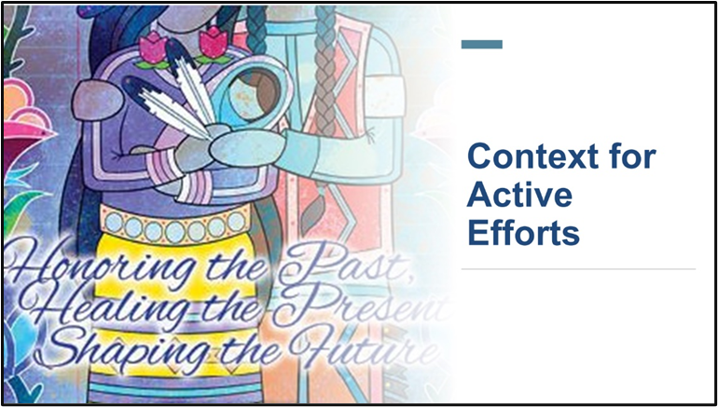

Use this space to record notes.

|  |
| --- |
|  |

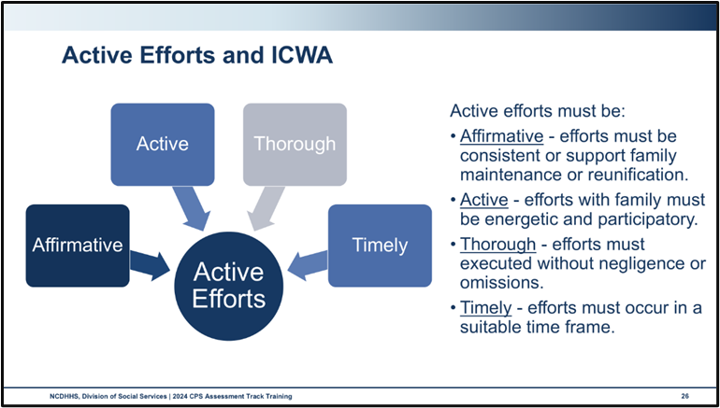

Active efforts are to be tailored to the facts and circumstances of the case and may include, for example:

1. Conducting a comprehensive assessment of the circumstances of the Indian child’s family, with a focus on safe reunification as the most desirable goal;
2. Identifying appropriate services and helping the parents to overcome barriers, including actively assisting the parents in obtaining such services;
3. Identifying, notifying, and inviting representatives of the Indian child’s tribe to participate in providing support and services to the Indian child’s family and in Family Team meetings, permanency planning, and resolution of placement issues;
4. Conducting or causing to be conducted a diligent search for the Indian child’s extended family members, and contacting and consulting with extended family members to provide family structure and support for the Indian child and the Indian child’s parents;
5. Offering and employing all available and culturally appropriate family preservation strategies and facilitating the use of remedial and rehabilitative services provided by the child’s tribe;
6. Taking steps to keep siblings together whenever possible;
7. Supporting regular visits with parents or Indian custodians in the most natural setting possible as well as trial home visits of the Indian child during any period of removal, consistent with the need to ensure the health, safety, and welfare of the child;
8. Identifying community resources including housing, financial, transportation, mental health, substance abuse, and peer support services and actively assisting the Indian child’s parents or, when appropriate, the child’s family, in utilizing and accessing those resources;
9. Monitoring progress and participation in services;
10. Considering alternative ways to address the needs of the Indian child’s parents and, where appropriate, the family, if the optimum services do not exist or are not available;
11. Providing post-reunification services and monitoring.

To explore this topic further on your own time, visit https://turtletalk.files.wordpress.com/2016/12/december2016guidelines.pdf for Guidelines for Implementing the Indian Child Welfare Act developed by the United States Department of the Interior, Bureau of Indian Affairs.

Use this space to record notes.

|  |
| --- |
|  |

### Skills Practice: Reasonable and Active Efforts

**Scenario 1:** You received a report regarding the Bravebird family alleging neglect of their seven-year-old child from a school counselor. The report stated that the parents’ alcohol use has led to the seven-year-old missing meals. The report alleges that she looks unkempt and has poor attendance. The family is Native American and is distrustful of Child Protective Services due to the long history of systemic racism and their tribe having to fight for their rights, land, and services. Their ancestors experienced boarding schools when they attempted to strip them of their culture. The family is deeply connected to their cultural traditions and community. The seven-year-olds only missed school when they were participating in important cultural ceremonies and learning traditional skills from elders. The parents are struggling with a substance use disorder and admit to drinking daily. The family also struggles with food insecurity, and their washing machine and dryer need repairs.

|  |  |  |  |
| --- | --- | --- | --- |
| **Areas where Support is Needed** | **Reasonable Efforts** | **Active Efforts** | **Potential Outcomes of Active Efforts** |
|  |  |  |  |
|  |  |  |  |
|  |  |  |  |
|  |  |  |  |

**Scenario 2:** A CPS Assessment report on the Littlefield family alleging that the three children are being raised by multiple people. There are allegations of abandonment for all three children and allegations of improper care of a medically fragile child. The medically fragile child has missed appointments, and the Doctor stated that the child’s medicine has not been filled in a month. Upon further investigation, it was found that the parents have not abandoned their children, but that family has a broader definition in their community. The family has a dedicated support system within their Native American tribe of multiple grandparents, aunties, uncles, cousins, etc. as they do not define these family members as only blood relatives. The family understands that the medically fragile child has additional needs they need help with, but they want to utilize both the Doctor and their traditional tribal healer. Their car broke down and they are having difficulty making appointments. The father has lost medical benefits as his work is seasonal. Work should pick up soon. The lack of benefits is a real concern for the medically fragile child’s care as their care can be costly.

|  |  |  |  |
| --- | --- | --- | --- |
| **Areas where Support is Needed** | **Reasonable Efforts** | **Active Efforts** | **Potential Outcomes of Active Efforts** |
|  |  |  |  |
|  |  |  |  |
|  |  |  |  |
|  |  |  |  |

**Scenario 3:** You received a report regarding the Locklear family alleging improper supervision and unsafe living conditions. Upon further investigation, you find that the single mother of two children is a veteran who is receiving mental health support for PTSD symptoms. Her husband died two years ago. She has been squatting in a condemned home with her two children ages 6 and 3 years. When she is not following her mental health treatment, she has wandered off leaving the 6-year-old to care for the three-year-old. She once was very connected to the Lumbee tribe but for the last few years, she has been reluctant to trust anyone.

|  |  |  |  |
| --- | --- | --- | --- |
| **Areas where Support is Needed** | **Reasonable Efforts** | **Active Efforts** | **Potential Outcomes of Active Efforts** |
|  |  |  |  |
|  |  |  |  |
|  |  |  |  |
|  |  |  |  |

## Filing a Juvenile Petition

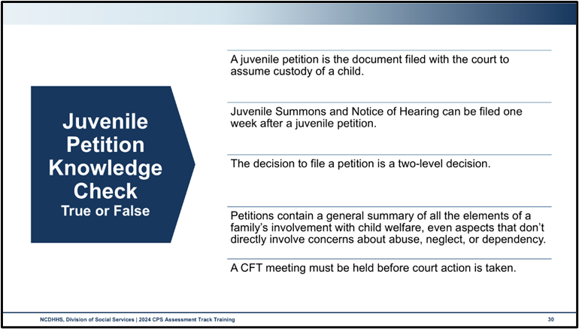

Per policy, a county child welfare services agency must file a petition requesting adjudication of abuse, neglect, and/or dependency:

* When safety-related circumstances necessitate the need for immediate removal.
* Due to the family’s unwillingness to accept critically needed services and those services are necessary to keep the family intact.
* When despite agency efforts to provide services, the family has made no progress toward providing adequate care for the child(ren) and those services are necessary to keep the family intact.

|  |  |
| --- | --- |
| Petitions are the documents filed with the court to assume custody of a child. [pause] False: Non-Secure Custody Orders are the documents filed with the court to assume custody of a child. Juvenile petitions can be filed with or without requesting non-secure custody, depending on the circumstances that exist in the family at the time. | True  False |
| Juvenile Summons and Notice of Hearing can be filed one week after a juvenile petition. [pause] False: Along with the juvenile petition, a Juvenile Summons and Notice of Hearing must also be filed. | True  False |
| The decision to file a petition is a two-level decision. [pause] True: A county child welfare supervisor (or another county manager position) must approve the decision to file a petition prior to filing a petition. County child welfare workers should consider staffing the case with the county child welfare services agency’s designated attorney prior to the decision to file a petition. | True  False |
| Petitions contain a general summary of all the elements of a family’s involvement with child welfare, even aspects that don’t directly involve abuse, neglect, or dependency. [pause] False: These petition statements should be broad enough to allow the introduction of all evidence that the agency considers important to the case. Statements should only include what the agency believes to be facts in the case, not observations or opinions held by others. County child welfare workers should be aware that while only those allegations that rise to the level of abuse, neglect, and/or dependency are to be included on the petition, some allegations might support more than one category. | True  False |
| A CFT meeting must be held before court action is taken. [pause] True: As stated previously, the act of filing a petition is a serious decision. Except for cases in which the immediate safety of the child(ren) would be compromised, a Child and Family Team (CFT) meeting shall be held before any court action is taken. If this is not possible due to an urgent need to remove the child(ren) in order to maintain safety, then the CFT meeting shall be held as soon after the removal as possible. This is an opportunity to bring the family, along with both formal and informal support, to the table to make a plan to keep the child(ren) safe, in his or her community, without court intervention. | True  False |

### Activity: The Court Process

With your group, generate ideas about how social workers can show up prepared to participate in court for your group’s assigned hearing type.

Non-secure custody hearing

|  |
| --- |
|  |

Adjudication

|  |
| --- |
|  |

Disposition

|  |
| --- |
|  |

Permanency planning review

|  |
| --- |
|  |

TPR petition

|  |
| --- |
|  |

TPR hearing

|  |
| --- |
|  |

### Handout: The Court Process

|  |  |  |
| --- | --- | --- |
| Proceeding | Timeframe | Overview |
| Petition | Initiates court process | Your agency must file a petition requesting adjudication of abuse, neglect, and/or dependency:  When safety-related circumstances necessitate the need for immediate removal.  Due to the family’s unwillingness to accept critically needed services and those services are necessary to keep the family intact.  When despite agency efforts to provide services, the family has made no progress towards providing adequate care for the child and those services are necessary to keep the family intact. |
| Adjudicatory hearing | no later than **60 days** from the filing of the petition unless continued for cause | At the adjudication hearing, the court decides whether CPS can prove the allegations in its petition. The child welfare agency’s attorney will present evidence through the testimony of the social worker, law enforcement officers, or other witnesses, including any experts. Documents such as medical records or photographs also may be entered into evidence. The attorneys for the parents and the child will have the right to question or cross-examine the witnesses and to present evidence. The parents may testify, as may other family members or neighbors who have knowledge of the facts alleged in the petition or of the care the parents provided their children. |
| Dispositional Hearing | **Immediately following adjudication**. If not, it shall be concluded within 30 days of the adjudication hearing | At the dispositional hearing, the judge decides what the best plan is for the child and what services will be ordered. For example, the court may enter an order that mandates counseling and rehabilitative services. The judge will also decide where the child will live, whether there are any relatives that can help take care of the child, and what type of visits the parent will have with their child. The judge may also order each parent to receive certain services, such as substance abuse treatment, parenting classes, or domestic violence counseling. Essentially, the dispositional hearing determines what will be required to resolve the problems that led to CPS intervention. |
| Initial Reviews | Within **90 days** of the dispositional hearing | The review hearing is an opportunity to evaluate the progress that has been made toward completing the case plan and any court orders and to revise the plan as needed. At each review hearing, the judge is given information about what each parent has been doing, how the child is doing, and whether there are any needs that haven’t been addressed. The court must decide if the plan that was made during disposition is working and if any changes are needed. Review hearings should guide the case to permanency for the child.  Review Hearings occur for cases where children remain in their homes and are not in DSS custody. |
| Ongoing reviews | At least every **6 months** after the initial review | Same as the initial hearing outlined above |
| Permanency Planning Review Hearings | Initial within 90 days of dispositional hearing and ongoing every 6 months thereafter | * Proceedings held for children in out-of-home placement. * Much like the Review Hearings outlined above. Additionally, permanent plans are set and reviewed through this process. * Permanency Planning Review Hearings cease after TPR if the court determines there is no longer a need for concurrent planning. |

While the court process follows a prescribed path, there is nuance as to the timeframes depending upon when a child enters custody.

It is possible that DSS initiates court proceedings during In-Home Services by filing a juvenile petition without filing for non-secure custody. When this occurs, the process is followed as outlined. It is possible that during the disposition or at a subsequent review hearing, the court may order that the child enter foster care. When this occurs, the case continues in the established court process and the review hearings become “Permanency Planning Review Hearings.”

If the child enters foster care by way of a non-secure custody order, a separate court process is enacted. This process can occur at either the CPS Assessment or In-Home Services stage of the child welfare process.

|  |  |  |
| --- | --- | --- |
| Proceeding | Timeframe | Overview |
| Non-Secure Custody Order | Initiates entry into foster care | Accompanies a petition alleging abuse/neglect/dependency and immediate safety needs of the children |
| Initial Hearing/Non-Secure Custody Hearing | Within **7 days** of non-secure.  May continue up to 10 business days with the consent of the parent and GAL if appointed | The main purpose of the initial hearing is to determine whether the child should be placed in substitute care or remain with or be returned to the parents pending further proceedings. The critical issue is whether measures can be put in place to ensure the child’s safety. |
| Second Hearing on Continued Non-Secure Custody | Within 7 business days of the initial non-secure hearing | Determine the need for continued non-secure custody.  Inquiry as to location of parents, engagement of relatives to provide placement, the safety of children who remain in removal parents’ home, MEPA and ICWA |
| Subsequent Non-Secure Custody Hearings | Occur at least every 30 calendar days after the second hearing until the dispositional hearing  Subsequent hearings can be waived only with the consent of the parents and GAL | Same as the second hearing outlined above |

Termination of Parental Rights

The Involuntary Termination of Parental Rights process follows a similar court process outlined above.

|  |  |  |
| --- | --- | --- |
| Proceeding | Timeframe | Overview |
| TPR Petition | Initiates TPR proceedings   * Within 60 days of the hearing setting adoption as the permanent plan * If the child has been in out-of-home placement for 12 of the most recent 22 months if no exception exists | Outlines reasonable efforts to reunify with parents, continuation of safety threats, and the ways in which TPR is in the best interest of the child. |
| TPR Hearing | No later than **90 days** from filing the petition or motion | A termination of parental rights (TPR) hearing is divided into two stages, adjudication and disposition. At adjudication, the party requesting TPR must prove to the judge by clear and convincing evidence that grounds exist for termination. If the judge decides that grounds do not exist, the judge will dismiss the case. If the judge decides that the grounds do exist, the judge moves to the disposition stage and must decide whether TPR is in the child’s best interest. |
| Post TPR Hearing | Within **6 months** after the TPR order has been entered and ongoing every 6 months thereafter | Ensure that every reasonable effort is being made to finalize the permanent plan for the child |

Foster Care 18-21 Program

When a young adult enters the Foster Care 18-21 program by signing a Voluntary Placement Agreement (DSS-597), court reviews continue. The initial court review hearing occurs within 90 days of signing the VPA and additional hearings occur at the discretion of the court although the young adult or DSS may request additional hearings at any time. No GAL is appointed for foster care in 18-21 cases.

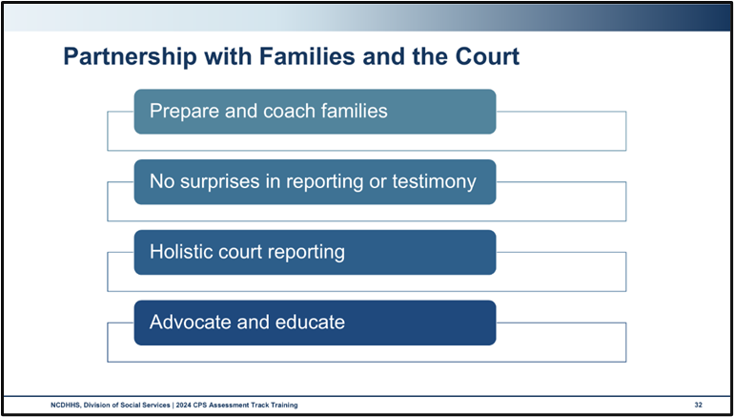

Prepare and coach families

|  |
| --- |
|  |

No surprises in reporting or testimony

|  |
| --- |
|  |

Holistic court reporting

|  |
| --- |
|  |

Advocate and educate

|  |
| --- |
|  |

## Removal

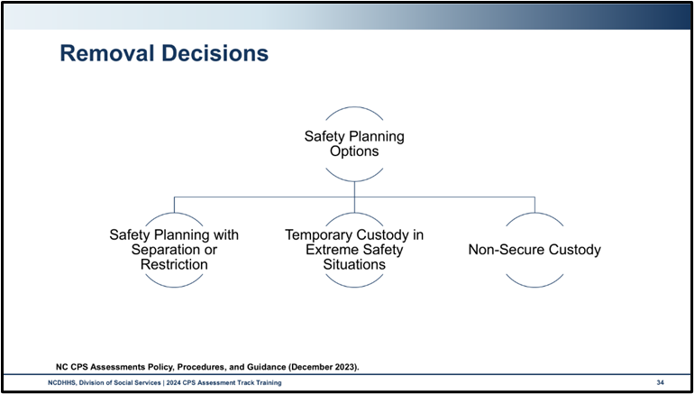

**Present safety threat** refers to an immediate, significant, and clearly observable family condition (severe harm or threat of severe harm) occurring to a child in the present. Present danger is easier to detect because it is transparent and is occurring now. If present danger is observed, the child is not safe.

**Impending safety threat** refers to threatening conditions that are not immediately obvious or currently active but are out of control and likely to cause serious harm to a child soon. Impending danger is covert. Impending danger is a threat that can be reasonably expected to result in serious harm if safety action is not taken and/or sustained. These threats may or may not be identified at the onset of involvement by a county child welfare services agency but are understood upon a more complete evaluation and understanding of the individual and family conditions and functioning.

To be classified as a safety threat, a situation, condition, or behavior must meet the “safety threshold.” The **safety threshold** is the point when a parent’s behaviors, attitudes, emotions, intent, or circumstances create conditions that fall beyond the mere risk of future maltreatment and have become an actual imminent threat to the child(ren)’s safety. These conditions could reasonably result in the serious and unacceptable pain and suffering of a vulnerable child. Safety threats are conditions that are specific, observable, out of control, and imminent, and the conditions can have a serious effect on the child.

Use this space to record notes.

|  |
| --- |
|  |

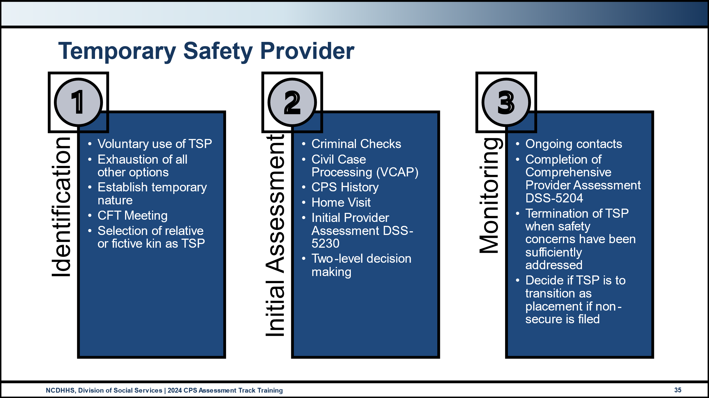

Use this space to record notes.

|  |
| --- |
|  |

## Engaging Families in Placement Decisions

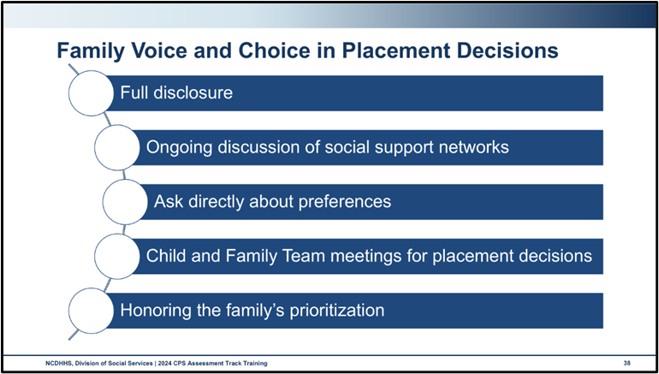

Use this space to record notes.

|  |
| --- |
|  |

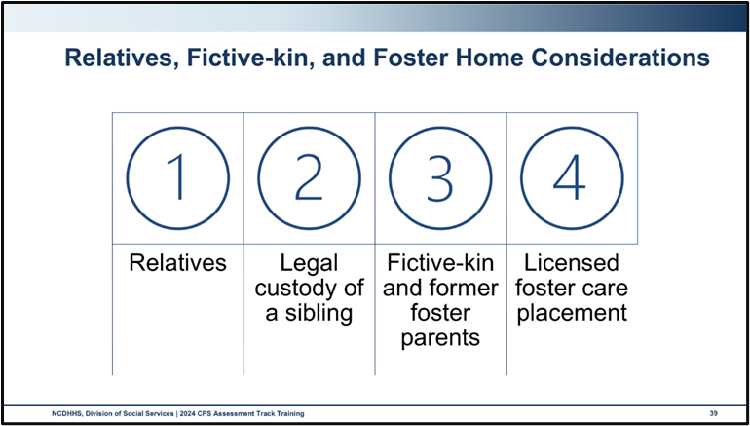

Use this space to record notes.

|  |
| --- |
|  |

### Activity: Preparing for Placement

Follow the trainer’s instructions to participate in this walking brainstorm activity where you will record your responses to what is involved in preparing the child, the placement provider, and the parents for placement.

Preparing the child/youth

|  |
| --- |
|  |

Preparing the placement provider

|  |
| --- |
|  |

Preparing parents

|  |
| --- |
|  |

### Skills Practice: Collaborating with Parents During Removals

Lewis Family Scenario

Five days after initiating the case, a New Report on Open Case (NROC) was received alleging that George whupped Raymond, causing injury. Interviews and observation revealed that George whupped Raymond after Raymond accidentally broke a glass. George caused bruising and swelling along Raymond’s spine, discomfort, and pain in movement, and later it was found by medical staff that Raymond had a broken rib.

Law Enforcement plans to arrest George for misdemeanor child abuse. William is out of state due to a critical family emergency and cannot return to care for the children. It is Saturday night, therefore George’s first appearance will not occur until Monday morning.

After staffing with your supervisor, it is determined that an alternative caregiver is required and that a juvenile petition will be filed.

Activity

* **Prepare to meet with Geroge and call the prison to speak with Monica.**
* **Craft several narrative statements and open-ended questions that could be used to partner with the parents during this removal process.**

|  |
| --- |
|  |

Group Debrief

* Gather into assigned small groups
* Share your statements and receive feedback
* Listen to group members' responses and give feedback

Feedback and notes

|  |
| --- |
|  |

## Worker Safety when Emergency Custody is Necessary

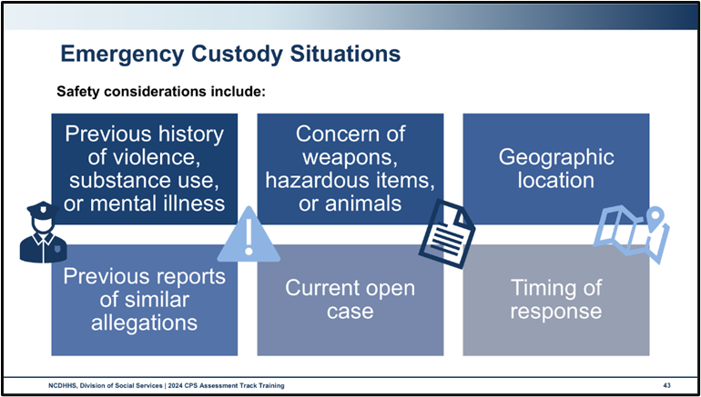

Use this space to record notes.

|  |
| --- |
|  |

### Video: Calming and De-Escalation Strategies

<https://www.youtube.com/watch?v=R2PSExM-NhU>

Calming and De-Escalation Strategies

Escalation

* We become escalated from a sense of threat or fear, real or perceived.
* Some brains are wired to expect harm or danger due to past experiences.
* When a person is stressed, angry, or scared, their survival brain becomes activated to keep them safe. This turns off the thinking part of the brain. People act on instincts, especially reading non-verbal cues from others and the environment.

De-Escalation

Use non-verbal cues to reduce the perception of threat.

* Do not block or corner people who are upset, angry, or escalated.
* Keep body posture open and relaxed, even when difficult.

*It takes the body 20-30 minutes to come back to baseline after a real or perceived threat.*

Three strategies for De-Escalation

Low and Slow: reference to body movements and voice and speech patterns.

* Speech: use a low tone and slow speed.
* Body: move slowly, sit down, or lower the body to a more equal stance to the escalated person.

Name it to Tame it: naming emotions, acknowledging feelings, validating the feeling, not the behavior.

Regulate over Educate: Focus on regulation for yourself and the escalated person.

* Give physical space and time.
* Avoid discussions of consequences or introspection about how actions are affecting others.
* Refrain from sharing essential information, as it cannot be processed or retained at this time.

### Skills Practice: Custody Conversation

The trainers will demonstrate a conversation between a parent and a social worker in the following scenario. Imagine yourself as the social worker.

As we discovered earlier today, George has caused harm to Raymond and will be arrested for misdemeanor child abuse. You have tried to contact Monica in jail and due to the after-hours timing, you were unable to make contact. All efforts to locate a TSP have been unsuccessful. You staff with your supervisor, and it is determined that DSS must assume emergency custody and then file a non-secure and juvenile petition, as law enforcement have indicated a need to bring George in the next thirty minutes.

You are speaking to George about the decision to file for non-secure custody. For the purposes of our role-play, we will imagine the conversation between George and the social worker without law enforcement involvement. You explain to George that the children will enter foster care.

At this point, the trainers will ask for volunteers to continue the conversation in the role of the social worker and practice one of the learned de-escalation techniques.

Use this space to record notes and observations.

|  |
| --- |
|  |

# Reasonable Efforts and Removals Learning Lab

### Worksheet: Stations 1 - 4

**Station 1: Reasonable Efforts**

Instructions: Using the Lewis scenario, document the reasonable efforts taken to prevent removal.

|  |  |
| --- | --- |
| **Scenario** | The Lewis Family |
| **Key Facts to consider from the scenario** |  |
| **Reasonable Efforts** |  |
| **Notes** |  |

**Station 2: Active Efforts**

Instructions: Using the Avilla Chavis scenario, imagine you learn that the family has Native American heritage. Document the active efforts taken that could be used to indicate prevention of removal, should new concerns arise in the future that warrant a discussion about family separation, restriction of contact, or removal.

|  |  |
| --- | --- |
| **Scenario** | Avila Chavis Family |
| **Key Facts to consider from the scenario** |  |
| **Active Efforts** |  |
| **Notes** |  |

**Station 3: Filing a Juvenile Petition**

Instructions: Filing a Juvenile Petition: Using the Lewis family scenario, write a list of what should be stated in a petition to the juvenile courts for an order of removal.

|  |  |
| --- | --- |
| **Scenario** | **Lewis Family** |
| **Key Factors to Consider from Scenario** |  |
| **What should be stated in a petition to the juvenile courts for an order of removal?** |  |
| **What documentation should you be prepared to provide?** |  |
| **Notes** |  |

**Station 4: Impact Trauma on Self-Care Discussion**

Instructions: Engage in a sharing session with others about their experiences of impact trauma, how they manage Secondary Traumatic Stress (STS) and Vicarious Trauma (VT), and strategies to combat compassion fatigue.

|  |
| --- |
| What is your experience with Impact Trauma? How does it impact your practice? |
|  |
| How do you manage STS and VT? |
|  |
| What strategies do you use to address compassion fatigue? |
|  |
| Notes |
|  |

# End-of-Day Values Reflection

### Questions and Reflections

Use this space to record questions and reflections about what you have learned today.

|  |
| --- |
|  |

# Bibliography of References

Day Seven

Andrews, Mark. (2002). Active versus reasonable efforts: the duties to reunify the family under the Indian Child Welfare Act and the Alaska Child in Need of Aid Statutes. *Alaska Law Review, 19*: 85. https://scholarship.law.duke.edu/alr/vol19/iss1/4/.

The Annie. E. Casey Foundation. (2014). *Team decision making: Engaging families in placement decisions.* Baltimore, MD: The Annie E. Casey Foundation. https://assets.aecf.org/m/resourcedoc/AECF-TeamDecisionMakingCaseStudy-2014.pdf

Bureau of Indian Affairs. (n.d.). *Active efforts, Final Rule: Indian child custody proceedings 25 CFR § 23.2 § 23.120.* U.S. Department of the Interior, Bureau of Indian Affairs. https://www.bia.gov/sites/default/files/dup/assets/bia/ois/ois/pdf/idc2-041405.pdf.

Bureau of Indian Affairs. (2016, December). *Guidelines for implementing the Indian Child Welfare Act*. Washington, DC: U.S. Department of the Interior, Office of the Assistant Secretary – Indian Affairs, Bureau of Indian Affairs. https://turtletalk.blog/wp-content/uploads/2016/12/december2016guidelines.pdf

Capacity Building Center for Tribes. (n.d.). *Active efforts: Indian Child Welfare Act*. Washington, DC: U.S. Department of Health and Human Services, Administration for Children and Families, Children’s Bureau. https://tribalinformationexchange.org/files/products/ActiveEffortsResourceList.pdf

Center on the Developing Child at Harvard University. (2015, April 22). *InBrief: The science of resilience*. [Video]. YouTube.com. Harvard University. https://www.youtube.com/watch?v=1r8hj72bfGo

Child and Family Services Training Center (CSFTC). (2023). *Active efforts federal regulations & guidelines, Indian Child Welfare Act, Regulations and guidelines*. GrandForks, ND: University of North Dakota. Retrieved from https://und.edu/cfstc/indian-child-welfare-act/regulations-and-guidelines/active-efforts.html#d56e88--1.

Child Welfare Information Gateway. (n.d.). *Indian Child Welfare Act.* Washington, DC: U.S. Department of Health and Human Services, Administration for Children and Families, Children’s Bureau. https://www.childwelfare.gov/topics/tribal-child-welfare/indian-child-welfare-act/?top=1390

Child Welfare Information Gateway. (2014, July 23) *Child and family services reviews quick reference items list*. Washington, DC: U.S. Department of Health and Human Services, Administration for Children and Families, Children’s Bureau. https://www.acf.hhs.gov/sites/default/files/documents/cb/cfsr_quick_reference_list.pdf

Child Welfare Information Gateway. (2020, October) *How the Child Welfare system works*. Washington, DC: U.S. Department of Health and Human Services, Administration for Children and Families, Children’s Bureau. https://www.childwelfare.gov/pubPDFs/cpswork.pdf

Child Welfare Information Gateway. (2020). *Reasonable efforts to preserve or reunify families and achieve permanency for children*. Washington, DC: U.S. Department of Health and Human Services, Administration for Children and Families, Children’s Bureau. https://www. childwelfare.gov/topics/systemwide/laws-policies/statutes/reunify/

Child Welfare Information Gateway. (2021, February). *Engaging Native families*. Washington, DC: U.S. Department of Health and Human Services, Administration for Children and Families, Children’s Bureau. https://www.childwelfare.gov/resources/engaging-native-families/

Crandall, Cassandra. (2019). *Moving forward from the scoop era: Providing active efforts under the Indian Child Welfare Act in Illinois*. *Northern Illinois University Law Review, 40*: 100. https://huskiecommons.lib.niu.edu/niulr/vol40/iss1/2/

Dartmouth Trauma Interventions Research Center. (2020, May 15). *Calming & de-escalation strategies.* [Video]. YouTube.com https://www.youtube.com/watch?v=R2PSExM-NhU

Francis, A.M., Hall, W.J., Ansong, D., Lanier, P., Albritton, T.J., & McMillan, A. (2022, March). Implementation and effectiveness of the Indian Child Welfare Act: A systematic review. *Children and youth services review, 146*: 106799. https://doi.org/10.1016/j.childyouth.2022.106799

Lidot, T., Orrantia, R. & Choca, M.J. (2012). Continuum of readiness for collaboration, ICWA compliance, and reducing disproportionality. *Child Welfare 91(3):* 65-88. PMID: 23444790.

Lucero, N.M., Bussey, M., & Carver-Roberts, T.(2021). Assessing Trauma in American Indian/Alaska Native Parents as an ICWA Active Effort.  *Child Welfare, 98*(5): 1-26. Washington, DC: U.S. Department of Health and Human Services, Administration for Children and Families, Children’s Bureau, National Child Welfare Workforce Institute. https://ncwwi.org/wp-content/uploads/2023/02/NCWWI-1-pager-Assessing-Trauma-in-American-IndianAlaska-Native-Parents-as-an-ICWA-Active-Effort-508.pdf

Mental Health First Aid USA. (2022, January 18). *How protective factors can promote resilience*. National Council for Mental Wellbeing, Missouri Department of Mental Health. <https://www.mentalhealthfirstaid.org/2022/01/how-protective-factors-can-promote-resilience/>.

National Indian Child Welfare Association. (n.d.). Setting the record straight: the Indian Child Welfare Act. [Fact Sheet]. www.nica.org. https://www.nicwa.org/wp-content/uploads/2018/10/Setting-the-Record-Straight-2018.pdf

North Carolina Court Improvement Program. (n.d.). *North Carolina juvenile court: a handbook for parents in abuse, neglect and dependency hearings.* University of North Carolina’s School of Government and the North Carolina Court Improvement Program. https://www.nccourts.gov/assets/documents/publications/English-Handbook-for-Parents-in-Abuse-Neglect-and-Dependency-Hearings.pdf?Patd3dXqiI9dO8lFtHHqZN.afF0FxFAN.

North Carolina Department of Health and Human Services, Division of Social Services, Child Welfare Services. (2017). *DSS-5231: North Carolina safety assessment.* https://policies.ncdhhs.gov/wp-content/uploads/dss-5231-ia.pdf

North Carolina Department of Health and Human Services, Division of Social Services, Child Welfare Services. (2017). *DSS-5231ins: North Carolina safety assessment.* instructions. https://policies.ncdhhs.gov/wp-content/uploads/DSS-5231ins.pdf

North Carolina Department of Health and Human Services, Division of Social Services, Child Welfare Services. (2017). N*C Domestic violence policy and best practice in Child Welfare*. https://www.ncdhhs.gov/documents/files/dss/training/domestic-violence-workbook/download

North Carolina Department of Health and Human Services, Division of Social Services, Child Welfare Services. (2018). *DSS-5229: North Carolina strengths & needs assessment.* https://policies.ncdhhs.gov/wp-content/uploads/dss-5229-ia.pdf

North Carolina Department of Health and Human Services, Division of Social Services. (2019). Assessing safety and risk. *Children’s services practice notes 24*(2). https://practicenotes.org/v24n2.htm

North Carolina Department of Health and Human Services, Division of Social Services. (2020, October). *Consent/authorization form for child medical & child/family evaluations.* https://policies.ncdhhs.gov/wp-content/uploads/dss-5143-ia.pdf

North Carolina Department of Health and Human Services, Division of Social Services. (2020, May). *CPS purpose & philosophy, Legal basis, administration: NC Child Welfare manual*. https://policies.ncdhhs.gov/wp-content/uploads/purpose.pdf

North Carolina Department of Health and Human Services, Division of Social Services. (2021). *North Carolina practice standards worker assessment*. https://www.ncdhhs.gov/cw-worker-north-carolina-worker-assessment-all-practice-standards/open

North Carolina Department of Health and Human Services, Division of Social Services. (2021). *Worker practice standards desk guide*. https://www.ncdhhs.gov/cw-worker-north-carolina-worker-practice-standards-desk-guide/open

North Carolina Department of Health and Human Services, Division of Social Services. (2021, December). *Child Welfare policy manual resources: Using safety circles to build safety networks with families*. https://policies-uat.ncdhhs.gov/wp-content/uploads/using-safety-circles-to-build-safety-networks-december-2021.pdf

North Carolina Department of Health and Human Services, Division of Social Services. (2022). *DSS-6191 – North Carolina division of social services plan of safe care*. https://policies.ncdhhs.gov/wp-content/uploads/DSS-6191.pdf

North Carolina Department of Health and Human Services, Division of Social Services. (2023, December 18). *The youth perspective.* [Video]. North Carolina Lived Experience Video Dropbox. https://www.dropbox.com/scl/fo/wu4s22b7ouc96gyvtmmik/h?e=2&preview=12_18_23_the_youth_perspective+(720p).mp4&rlkey=wrxfiviurth20lg80pv1d3b9l&dl=0

North Carolina Department of Health and Human Services, Division of Social Services. (2024, April). *Cross function topics: NC Child Welfare manual.* https://policies.ncdhhs.gov/wp-content/uploads/In-Home_April-2024_2.pdf

North Carolina Department of Health and Human Services, Division of Social Services. (April 2024). Reasonable and prudent parenting activities. *Permanency planning services policy, protocol, and guidance: NC child welfare manual*. <https://policies.ncdhhs.gov/wp-content/uploads/Permanency-Planning-April-2024.pdf>

North Carolina Department of Health and Human Services, Division of Social Services. (2024, August). *CPS assessments policy, protocol, and guidance: NC Child Welfare manual.* https://policies.ncdhhs.gov/wp-content/uploads/CPS-Assessments-Aug-2024.pdf

North Dakota ICWA Implementation Partnership. (2018). *Active Efforts.* [Infographic]. : University of North Dakota, Children & Family Services Training Center. Retrieved from https://und.edu/cfstc/indian-child-welfare-act/activeeffinfographic.pdf.

Northern California Training Academy. (n.d.).*Safety organized practice quick guide: Behaviorally-based case plans.* https://oercommons.s3.amazonaws.com/media/editor/92375/Behaviorally-Based_Case_Plans_-_SOP_Quick_Guide_2018-10-24.pdf.

Prevent Child Abuse North Carolina. (n.d.). *Protective factors infographic*. https://www.preventchildabusenc.org/wp-content/uploads/2019/06/PCANCProtectiveFactors.pdf?_gl=1*g0xgru*_ga*MTgxMTY1MzAwMC4xNzE0MjAxMTIy*_ga_Q9239P4QMY*MTcxNDIwMTEyMi4xLjEuMTcxNDIwMTEzMy4wLjAuMA.

Saakvitne, K.W. (1996). *Transforming the pain: a workbook on vicarious traumatization*. New York, NY: W.W. Norton & Company.

Scanlon, Megan. (2011). From theory to practice: Incorporating the active efforts requirement in Indian Child Welfare Act proceedings. *Arizona State Law Journal, 43*: 629. <https://narf.org/nill/bulletins/lawreviews/2011alr.html>.

Standing Strong for Native Families. (2007). *A practical guide to the Indian Child Welfare Act*. [Website]. Icwa.narf.org. Boulder, CO: National Indian Law Library, Native American Rights Fund. https://narf.org/nill/documents/icwa/index.html

Standing Strong for Native Families. (2024). *About the Indian Child Welfare Act (ICWA).* [Website]. Icwa.narf.org. Boulder, CO: National Indian Law Library, Native American Rights Fund. https://icwa.narf.org/about-icwa

Summers, Alicia. (2023). Exploring Indian Child Welfare Act implementation and case outcomes. *Juvenile and Family Court Journal 74*(1): 37-50. https://doi.org/10.1111/jfcj.12232

# Appendix: Handouts

Reasonable Efforts 2

The Court Process 3

## Reasonable Efforts

The following are the North Carolina citations related to reasonable efforts.

According to N.C.G.S. § 7B-101 (18), reasonable efforts are defined as the diligent use of preventive or reunification services by a department of social services when a juvenile's remaining at home or returning home is consistent with achieving a safe, permanent home for the juvenile within a reasonable period of time. If a court of competent jurisdiction determines that the juvenile is not to be returned home, then reasonable efforts mean the diligent and timely use of Permanency Planning Services by a department of social services to develop and implement a permanent plan for the juvenile.

Gen. Stat. § 7B-101 Reasonable efforts must be made to do the following:

* To prevent or eliminate the need for placement of the juvenile out of the home
* To develop and implement a permanent plan for the child when a court determines that the juvenile is not to be returned home

Gen Stat § 7B-507(a)(2)

An order placing or continuing the placement of a juvenile in the nonsecure custody of a county department of social services shall contain specific findings as to whether a county department of social services has made reasonable efforts to prevent the need for the placement of the juvenile. In determining whether efforts to prevent the placement of the juvenile were reasonable, the juvenile's health and safety shall be the paramount concern. The court may find that efforts to prevent the need for the juvenile's placement were precluded by an immediate threat of harm to the juvenile. A finding that reasonable efforts were not made by a county department of social services shall not preclude the entry of an order authorizing the juvenile's placement when the court finds that placement is necessary for the protection of the juvenile

Gen. Stat. § 7B-901 Unless the court concludes that there is compelling evidence warranting continued reunification efforts, the court shall direct that reasonable efforts for reunification shall not be required if the court makes written findings of fact pertaining to any of the following:

* A court determines or has determined that aggravated circumstances exist because the parent has committed, encouraged the commission of, or allowed the continuation of any of the following upon the juvenile: Sexual abuse; chronic physical or emotional abuse; torture; abandonment; chronic or toxic exposure to alcohol or controlled substances that causes impairment of or addiction in the juvenile; any other act, practice, or conduct that increased the enormity or added to the injurious consequences of the abuse or neglect
* A court terminates or has terminated involuntarily the parental rights of the parent to another child of the parent.
* A court determines or has determined that the parent has done any of the following: Committed murder or voluntary manslaughter of another child of the parent; aided, abetted, attempted, conspired, or solicited to commit murder or voluntary manslaughter of the child or another child of the parent; committed a felony assault resulting in serious bodily injury to the child or another child of the parent; committed sexual abuse against the child or another child of the parent; been required to register as a sex offender on any government-administered registry

## The Court Process

|  |  |  |
| --- | --- | --- |
| Proceeding | Timeframe | Overview |
| Petition | Initiates court process | Your agency must file a petition requesting adjudication of abuse, neglect, and/or dependency:  When safety-related circumstances necessitate the need for immediate removal.  Due to the family’s unwillingness to accept critically needed services and those services are necessary to keep the family intact.  When despite agency efforts to provide services, the family has made no progress towards providing adequate care for the child and those services are necessary to keep the family intact. |
| Adjudicatory hearing | no later than **60 days** from the filing of the petition unless continued for cause | At the adjudication hearing, the court decides whether CPS can prove the allegations in its petition. The child welfare agency’s attorney will present evidence through the testimony of the social worker, law enforcement officers, or other witnesses, including any experts. Documents such as medical records or photographs also may be entered into evidence. The attorneys for the parents and the child will have the right to question or cross-examine the witnesses and to present evidence. The parents may testify, as may other family members or neighbors who have knowledge of the facts alleged in the petition or of the care the parents provided their children. |
| Dispositional Hearing | **Immediately following adjudication**. If not, it shall be concluded within 30 days of the adjudication hearing | At the dispositional hearing, the judge decides what the best plan is for the child and what services will be ordered. For example, the court may enter an order that mandates counseling and rehabilitative services. The judge will also decide where the child will live, whether there are any relatives that can help take care of the child, and what type of visits the parent will have with their child. The judge may also order each parent to receive certain services, such as substance abuse treatment, parenting classes, or domestic violence counseling. Essentially, the dispositional hearing determines what will be required to resolve the problems that led to CPS intervention. |
| Initial Reviews | Within **90 days** of the dispositional hearing | The review hearing is an opportunity to evaluate the progress that has been made toward completing the case plan and any court orders and to revise the plan as needed. At each review hearing, the judge is given information about what each parent has been doing, how the child is doing, and whether there are any needs that haven’t been addressed. The court must decide if the plan that was made during disposition is working and if any changes are needed. Review hearings should guide the case to permanency for the child.  Review Hearings occur for cases where children remain in their homes and are not in DSS custody. |
| Ongoing reviews | At least every **6 months** after the initial review | Same as the initial hearing outlined above |
| Permanency Planning Review Hearings | Initial within 90 days of dispositional hearing and ongoing every 6 months thereafter | * Proceedings held for children in out-of-home placement. * Much like the Review Hearings outlined above. Additionally, permanent plans are set and reviewed through this process. * Permanency Planning Review Hearings cease after TPR if the court determines there is no longer a need for concurrent planning. |

While the court process follows a prescribed path, there is nuance as to the timeframes depending upon when a child enters custody.

It is possible that DSS initiates court proceedings during In-Home Services by filing a juvenile petition without filing for non-secure custody. When this occurs, the process is followed as outlined. It is possible that during the disposition or at a subsequent review hearing, the court may order that the child enter foster care. When this occurs, the case continues in the established court process and the review hearings become “Permanency Planning Review Hearings.”

If the child enters foster care by way of a non-secure custody order, a separate court process is enacted. This process can occur at either the CPS Assessment or In-Home Services stage of the child welfare process.

|  |  |  |
| --- | --- | --- |
| Proceeding | Timeframe | Overview |
| Non-Secure Custody Order | Initiates entry into foster care | Accompanies a petition alleging abuse/neglect/dependency and immediate safety needs of the children |
| Initial Hearing/Non-Secure Custody Hearing | Within **7 days** of non-secure.  May continue up to 10 business days with the consent of the parent and GAL if appointed | The main purpose of the initial hearing is to determine whether the child should be placed in substitute care or remain with or be returned to the parents pending further proceedings. The critical issue is whether measures can be put in place to ensure the child’s safety. |
| Second Hearing on Continued Non-Secure Custody | Within 7 business days of the initial non-secure hearing | Determine the need for continued non-secure custody.  Inquiry as to location of parents, engagement of relatives to provide placement, the safety of children who remain in removal parents’ home, MEPA and ICWA |
| Subsequent Non-Secure Custody Hearings | Occur at least every 30 calendar days after the second hearing until the dispositional hearing  Subsequent hearings can be waived only with the consent of the parents and GAL | Same as the second hearing outlined above |

Termination of Parental Rights

The Involuntary Termination of Parental Rights process follows a similar court process outlined above.

|  |  |  |
| --- | --- | --- |
| Proceeding | Timeframe | Overview |
| TPR Petition | Initiates TPR proceedings   * Within 60 days of the hearing setting adoption as the permanent plan * If the child has been in out-of-home placement for 12 of the most recent 22 months if no exception exists | Outlines reasonable efforts to reunify with parents, continuation of safety threats, and the ways in which TPR is in the best interest of the child. |
| TPR Hearing | No later than **90 days** from filing the petition or motion | A termination of parental rights (TPR) hearing is divided into two stages, adjudication and disposition. At adjudication, the party requesting TPR must prove to the judge by clear and convincing evidence that grounds exist for termination. If the judge decides that grounds do not exist, the judge will dismiss the case. If the judge decides that the grounds do exist, the judge moves to the disposition stage and must decide whether TPR is in the child’s best interest. |
| Post TPR Hearing | Within **6 months** after the TPR order has been entered and ongoing every 6 months thereafter | Ensure that every reasonable effort is being made to finalize the permanent plan for the child |

Foster Care 18-21 Program

When a young adult enters the Foster Care 18-21 program by signing a Voluntary Placement Agreement (DSS-597), court reviews continue. The initial court review hearing occurs within 90 days of signing the VPA and additional hearings occur at the discretion of the court although the young adult or DSS may request additional hearings at any time. No GAL is appointed for foster care in 18-21 cases.