NC DEPARTMENT OF HEALTH AND HUMAN SERVICES

Division of Employment and Independence for People with Disabilities

EMPLOYER SERVICES
We connect employers to job-ready candidates and a wide variety of no-cost services and resources.

RECRUITMENT

We assess your workforce needs and pre-screen our talent pool to identify candidates with required skills and experience for the job.

ONBOARDING

When our candidates become your new hires, ongoing support ensures that they continue to be a good fit.

RETENTION

We can help you retain high-value employees that acquire a disability and consult on accommodations and workplace modifications that help your workforce stay productive.

PIPELINE DEVELOPMENT
We can help you develop a pipeline of talent with the skills you need to grow your business through on-the-job training, internships and other work-based learning experiences.

INCLUSION TRAINING

Customized disability awareness and workplace inclusion training equips business leaders with the knowledge, skills and tools to create a workplace where all employees can thrive.

TECHNOLOGY SOLUTIONS

We offer expert assistance to help identify tools, devices and resources that improve productivity, retention and inclusion of all employees.

FINANCIAL INCENTIVES

We help you understand and access tax credits and other financial incentives available to businesses that hire our candidates.

WORKPLACE ACCESSIBILITY
We provide guidance regarding ADA and Section 503 compliance and can
advise on low-cost solutions to accommodate valued employees with
disabilities.

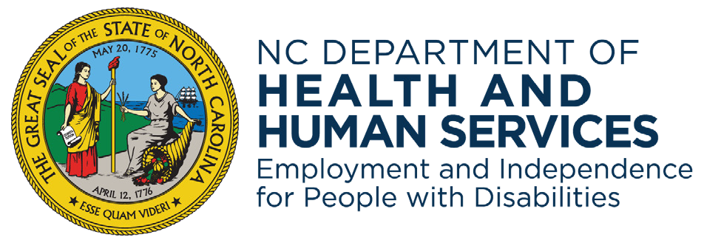
Learn more: www.ncdhhs.gov/eipd
NCDHHS is an equal opportunity employer and provider.

