Do you want to talk to another parent of a child who has hearing loss?
Get connected to the EHDI Parent Support Team!

What is the EHDI Parent Support Team?
The Early Hearing Detection and Intervention (EHDI) Parent Support Team is a diverse network of parents formed to provide parent-to-parent support for families that have a child who is deaf or hard of hearing. Each parent mentor has been trained to provide support for your family in an unbiased way as you and your child navigate the journey of hearing loss. The role of the parent mentor is to listen, help when asked, and connect you to various parent resources available in our state.
How can I get connected to the Parent Support Team?
- Email, call, or text the EHDI Parent Consultant:
  - Email: Jenna.Rankin@dhhs.nc.gov
  - Cell: 919-909-3501 (call or text)
What happens next?
- The EHDI Parent Consultant will speak with you via your preferred mode of communication.
- After learning what kind of support you need, the Parent Consultant will connect you with a parent support team member that is best suited to help you and your family.

Jenna Rankin is the Parent Consultant for North Carolina EHDI. She lives in Raleigh with her husband John and daughters Sadie and Colette. Her husband’s parents are both profoundly deaf as well as their younger daughter, Colette. Jenna and her family love spending time together playing games, watching movies, and having backyard campfires.

“I look forward to speaking with you and learning how EHDI can help support you and your family!”
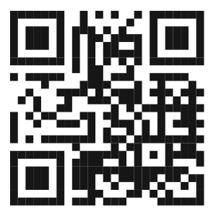
NC Department of Health and Human Services • Division of Public Health • WCH Section • C&Y Branch • EHDI Program • www.publichealth.nc.gov • NCDHHS is an equal opportunity employer. • 2/2021
North Carolina Early Hearing Detection and Intervention (EHDI) Program
Toll-free phone: 866-431-7434 • Email: ncnewbornhearing@dhhs.nc.gov

