LIVE HEALTHIER TO BE THERE
COVID-19/Flu Vaccine –
Post Caption/Description:
Get your updated COVID-19 and Flu Vaccines. Available at local pharmacies, doctors’ offices, and community health centers. Need help getting covered? Learn more at medicaid.ncdhhs.gov and covid19.ncdhhs.gov #NCMEDICAID
Social Post Graphic Options:
“Live healthier to be there for the holidays.”
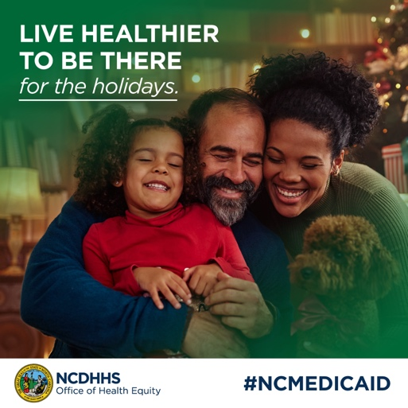 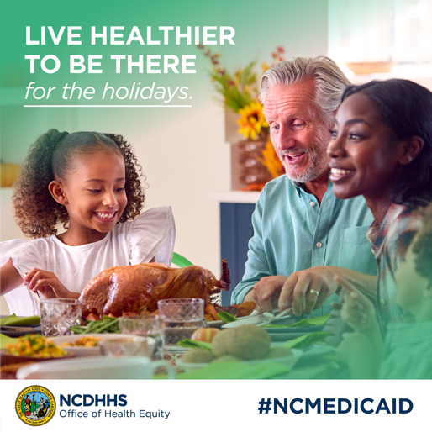 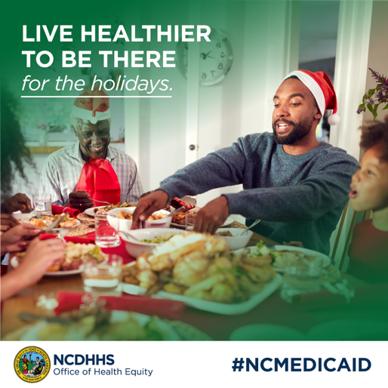
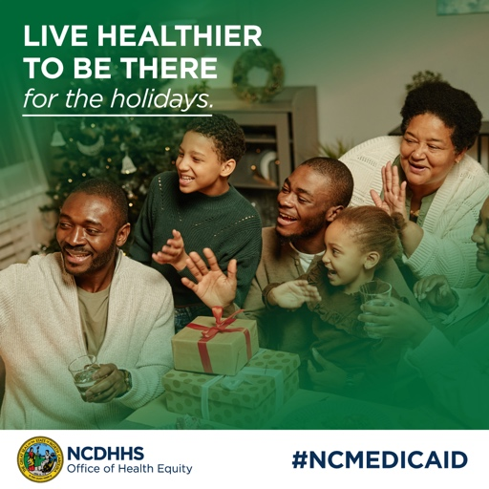 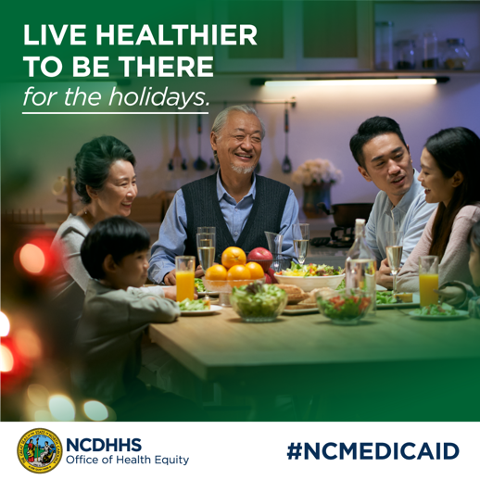

COVID-19/Flu Vaccine –
Post Caption/Description:
Fight off viruses and stay healthy this holiday by getting your flu and COVID-19 vaccines. Head to your nearest pharmacy, doctor’s office, or community health center to get vaccinated today! Need help getting covered? Learn more at medicaid.ncdhhs.gov and covid19.ncdhhs.gov #NCMEDICAID
Social Post Graphic Options:
“Live healthier to be there for the holidays.”
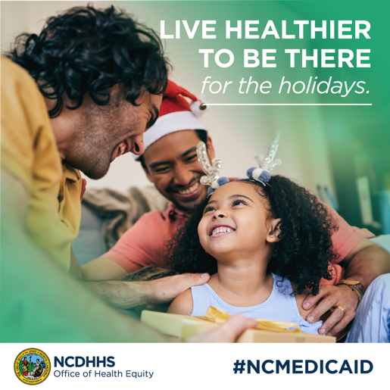 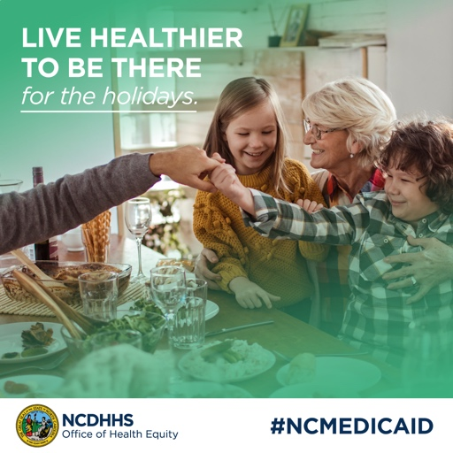 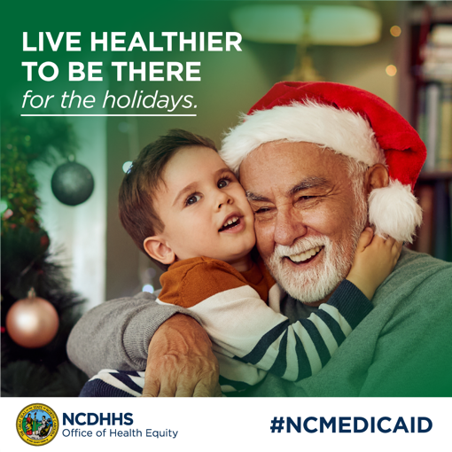

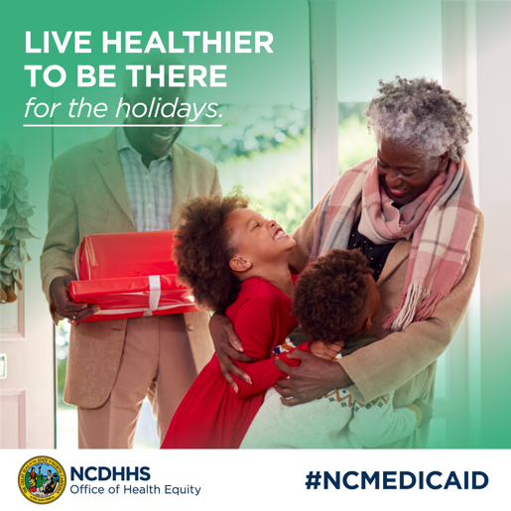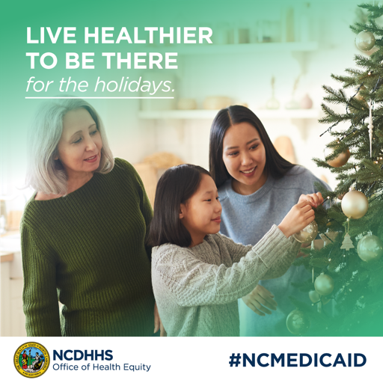

RSV Vaccine – End of December / January
Post Caption/Description 1:
Protect yourself and others from COVID-19, Flu, and RSV. Get vaccinated over the winter break. Available at local pharmacies, doctors’ offices, and community health centers. Need help getting covered? Learn more at medicaid.ncdhhs.gov and covid19.ncdhhs.gov #NCMEDICAID
Post Caption/Description 2:
Heading back to school? Keep the flu, COVID-19 and RSV at bay by getting vaccinated! Visit your local pharmacy, doctor’s office or community health center and protect yourself and those around you. Need help getting covered? Learn more at medicaid.ncdhhs.gov and covid19.ncdhhs.gov #NCMEDICAID
Social Post Graphic Options:
“Live healthier to be there and be my best in class.”
