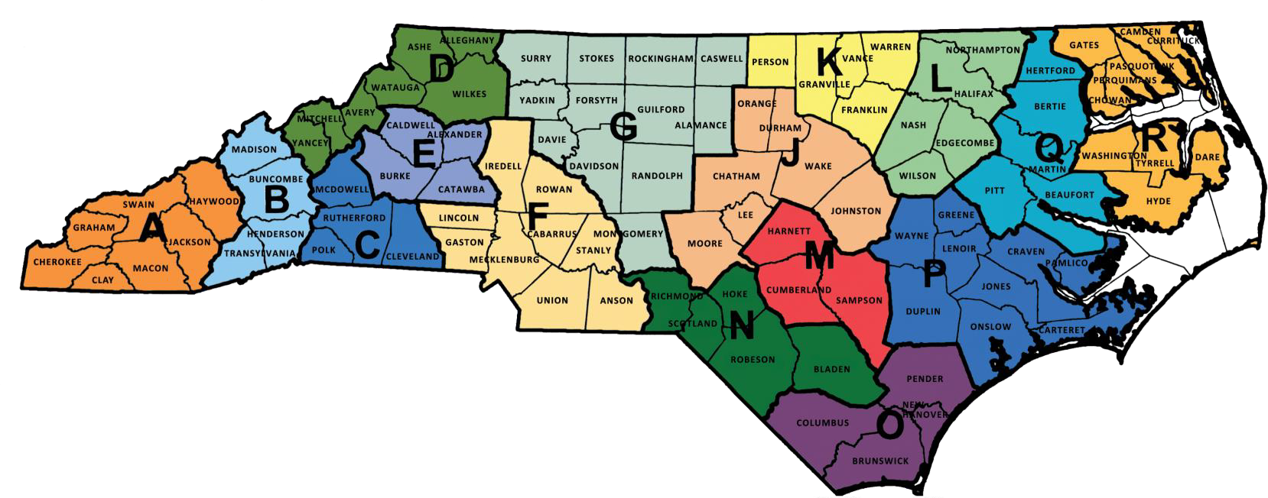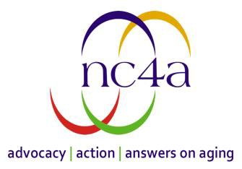

**North Carolina Area Agencies on Aging (AAA)**

|  |  |  |  |
| --- | --- | --- | --- |
|  | **Region A – Southwestern Commission Area Agency on Aging (AAA)**  Sarajane Melton at 828-586-1962 x220 or  [sarjane@regiona.org](mailto:sarjane@regiona.org) or contact your [senior center](https://www.ncdhhs.gov/fy24-25-senior-center-directory/download?attachment).  **Region B – Land of Sky AAA**  LeeAnne Tucker at 828-251-6622 x115 [leeanne@landofsky.org](mailto:leeanne@landofsky.org).  **Region C – Foothills AAA**  Laura Lynch at 828-351-2336 or [llynch@foothillsregion.org](mailto:llynch@foothillsregion.org). or contact your local [senior center](https://www.ncdhhs.gov/fy24-25-senior-center-directory/download?attachment).  **Region D – High Country AAA**  Contact your local [senior center](https://www.ncdhhs.gov/fy24-25-senior-center-directory/download?attachment).  **Region E – Western Piedmont AAA**  Contact your local [senior center](https://www.ncdhhs.gov/fy24-25-senior-center-directory/download?attachment).  **Region F – Centralina AAA** Austin Canton at 1-800-508-5777 or [aging@centralina.org](mailto:aging@centralina.org) **or** contact your local [senior center](https://www.ncdhhs.gov/fy24-25-senior-center-directory/download?attachment).  **Region G – Piedmont Triad AAA**  Contact your local [senior center](https://www.ncdhhs.gov/fy24-25-senior-center-directory/download?attachment).  **Region J – Central Pines AAA**  1-800-310-9777 **or** [aging@centralpinesnc.gov](mailto:aging@centralpinesnc.gov). |  | **Region K – Kerr-Tar Regional AAA**  Contact your local [senior center](https://www.ncdhhs.gov/fy24-25-senior-center-directory/download?attachment).  **Region L – Upper Coastal Plains AAA**  Demetria Ellis, 252-234-5955, [dellis@ucpcog.org](mailto:dellis@ucpcog.org) or Lynn Bullock, 252-234-5954, [lbullock@ucpcog.org](mailto:lbullock@ucpcog.org).  **Region M – Mid-Carolina AAA**  Tracy Honeycutt at 910-323-4191 x 27 [thoneycutt@mccog.org](mailto:thoneycutt@mccog.org).  **Region N – Lumber River AAA**  Twilla Allen at 910-775-9781 [tca@lrcog.org](mailto:tca@lrcog.org).  **Region O – Care Fear AAA** Contact your local [senior center](https://www.ncdhhs.gov/fy24-25-senior-center-directory/download?attachment).  **Region P – Eastern Carolina AAA**  Contact your local [senior center](https://www.ncdhhs.gov/fy24-25-senior-center-directory/download?attachment).  **Region Q – Mid-East Commission AAA**  Annette Eubanks at 252-974-1835 or  [aeubanks@mideastcom.org](mailto:aeubanks@mideastcom.org) **or** contact your local [senior center](https://www.ncdhhs.gov/fy24-25-senior-center-directory/download?attachment).  **Region R – Albemarle Commission AAA**  Laura Alvarico at 252-426-5753  [lalvarico@accog.com](mailto:lalvarico@accog.com) **or** contact your local [senior center](https://www.ncdhhs.gov/fy24-25-senior-center-directory/download?attachment). |

 NC Senior Tar Heel Athletic Card Distribution Sites