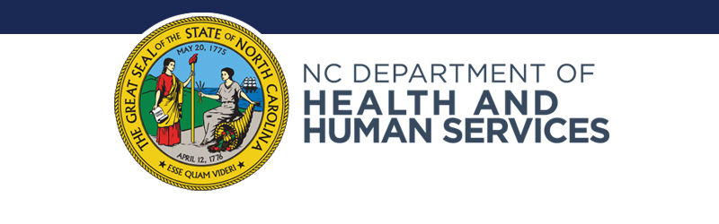

Medicaid Transformation Changes Service Delivery Model for NC Assistive Technology Program
Intended Release Date:
9/6/2019
Contact: news@dhhs.nc.gov
919-855-4840

RALEIGH — As the state transitions to NC Medicaid Managed Care, the NC Assistive Technology Program will realign its services with the national AT program model and will no longer accept Medicaid referrals for Alternative and Augmentative Communication (AAC) Assessments.

NCATP is one of 56 programs authorized under Section 4 of the Assistive Technology Act of 1998, administered by the Administration for Community Living, and intended to conduct activities that increase knowledge about, access to, and acquisition of assistive technology devices and services for individuals with disabilities and older Americans.

For several years, NCATP has provided below-cost AAC assessments for beneficiaries up to age 21 under an agreement with NC Medicaid. However, as the state moves to a managed care model, this fee-for-assessment arrangement is no longer viable as NCATP is not a medical provider.

Beginning September 1, NCATP will begin making referrals to Speech Language Pathologists (SLPs) and other medical providers around the state who can offer AT/AAC assessments under the managed care model.

NCATP will continue to provide device demonstrations, loans and reutilization, training, technical assistance, public awareness, and assistance with obtaining funding for AT. NCATP staff will work with LME/MCOs to develop additional capacity and resources for AT/AAC assessments and continue to offer technical assistance to SLPs and families. Additionally, NCATP will devote additional resources to its AT reuse program and enhancing services for older North Carolinians.

For more information, contact Tammy Koger at the NC Assistive Technology Program at 919-855-3500 or tammy.koger@dhhs.nc.gov.

###

To be completed by the Office of Communications:
Approved by subject matter expert(s): Choose an item.
Name(s): Click here to enter text.
Approved by Division Director(s): Choose an item.
Name(s): Click here to enter text.
Approved by Communications Director: Choose an item.
Name: Click here to enter text.
Approved by Secretary’s Office: Choose an item.
Name(s): Click here to enter text.
Approved by Governor’s Office (if necessary): Choose an item.
Name(s): Click here to enter text.
Embargo to LHDs (DPH only): Choose an item.

Suggested social media posts
Some press releases may only warrant one tweet/Facebook post with press release headline and link. Others call for a more prolonged messaging approach and could benefit from numerous social media posts throughout an extended time period. Some examples include awareness months and items DHHS is seeking public comment on. Please write suggested social media posts below.

Twitter
Please indicate whether it should go on @NCDHHS, @NCDPH or @SecMandyCohen or multiple accounts. Tweets can be 140 characters; Tweets with a link are 117 characters.

Facebook
Posts can be longer and should include photo. If no image is available, you can search for stock images on Thinkstock and send the link to suggested image to use.

