North Carolina
Department of Health & Human Services

Electronic Visit Verification Guidance

Released:
April 19, 2021

Revised:

June 23, 2021

Overview:

This Electronic Visit Verification Guidance Document (EVV Guidance Document) establishes minimum requirements and form and frequency of submission of EVV data by the LME-MCO to the Department. It also provides guidance related to the LME-MCOs support of the EVV process in terms of services effected by EVV. Information related to the Encounter Process and Prior Authorization transmission is subject to change and will be finalized in the applicable Encounter and Truven Manuals.

100 Electronic Visit Verification Overview

A | Use of the EVV | - Federally mandated for Personal Cares Service Programs (PCS) visit verification entry – Section 12006 of the 21st Century Cures Act  - EVV offers a measure of accountability to help ensure that individuals who are authorized to receive services in fact receive them.
B | EVV Data Elements | - Type of service performed  - Individual receiving the service  - Date of the service  - Location of service delivery  - Name of the Individual providing the service  - Time the service begins and ends
C | All Services Subject to EVV per the 21st Century Cures Act | - State Plan PCS (In Home Care Services Only) – 99509 HA and HB  - CAP/DA  - CAP/C  - Innovations Waiver  - (b)(3) Services  - Traumatic Brain Injury (TBI) Waiver
D | Innovations Waiver Services Subject to EVV | - Community Living and Support (In Home Services Only) - Group– T2013 TF HQ  - Community Living and Support (In Home Services Only) – Individual T2013 TF  - Supported Living – Periodic (In Home Services Only) – T2033 U1
E | TBI Waiver Services Subject to EVV | - Personal Care (In Home Services Only) – S5125  - In Home Intensive (In Home Services Only) – T1015  - Life Skills Training (In Home Services Only) – T2013
F | (b)(3) Services Subject to EVV | - Personal Care/ Individual Support (In Home Services Only) – T1019 U4  - Transitional Living Skills (In Home Services Only) – H2022 U4. Transitional Living Skills is not subject to EVV if it is billed on a case rate.  - In Home Skill Building (In Home Services Only) – T2013 U4  - Community Living and Support (In Home Services Only) - Group– T2013 TF HQ U4  - Community Living and Support (In Home Services Only) – T2013 TF U4  - Supported Living – Periodic (In Home Services Only) – T2033 U4
G | Service Providers Subject to EVV | All Providers providing the services subject to EVV will utilize an EVV system to collect and transmit EVV data to PIHP
H | Live-In Caregivers | Live-In Caregivers are not subject to Electronic Visit Verification. If a member has additional staff, that are not Live-In Caregivers, then those staff are subject to Electronic Visit Verification.  The following codes for Community Living and Supports will be used for the Live-in Caregiver providing Community Living and Supports: T2012 GC (Individual) and T2012 GC HQ (Group)*  *This system change is currently in process
I | Community Component of Community Living and Support and Life Skills Training (TBI Waiver) | Community Living and Support and Life Skills Training that does not start, occur or end in the beneficiary’s home are not subject to EVV.  The following code will be used for Community Living and Support and Life Skills Training that does not start, occur or end in the beneficiary’s home:  - T2012 - CLS or Life Skills that is Community only*  - T2012 HQ – CLS OR Life Skills that is Group - Community only*  *This system change is currently in process
J | GDIT Enhancements to address duplicate encounter edits | 5.4.3.7.1 Edit/Audit Bypasses  Audits will be bypassed for claims that have the same date of service, by same billing provider, procedure and modifier for EVV encounter claims. The EVV start and end times are not included in the duplicate checking process. The following duplicate audits will be bypassed for encounter claims when C-LI-EVV-IND = 'Y'. The audit expression will be updated for each audit on table R_RULE_EXP_TB to bypass the audits.
J.1 | Audit 13460 | POSSIBLE DUPLICATE SAME PROVIDER, SAME PROCEDURE CODE, OVERLAPPING DATES OF SERVICE
J.2 | Audit 13510 | POSSIBLE DUPLICATE SAME PROVIDER, OVERLAPPING DATES OF SERVICE
J.3 | Audit 34420 | EXACT DUPLICATE-SAME DATE OF SERVICE/PROCEDURE/MODIFIER/SAME AMOUNT
J.4 | Audit 34460 | SEVERE DUPLICATE-SAME RENDERING PROV/PCODE/INTERNAL MODIFIER/DOS/MODIFIER
J.5 | Audit 34490 | EXACT DUPLICATE-SAME PCODE/INTERNAL MODIFIER/DOS/MODIFIER/BILL AMOUNT/REND PROVIDER/TCN
J.6 | Audit 34550 | SEVERE DUPLICATE-SAME PCODE/INTERNAL MODIFIER/MODIFIER/DOS/TCN

Electronic Visit Verification Data Flow:

Table 1: LME-MCOs – EVV Conceptual Architecture Diagram (Managed Care Encounters)

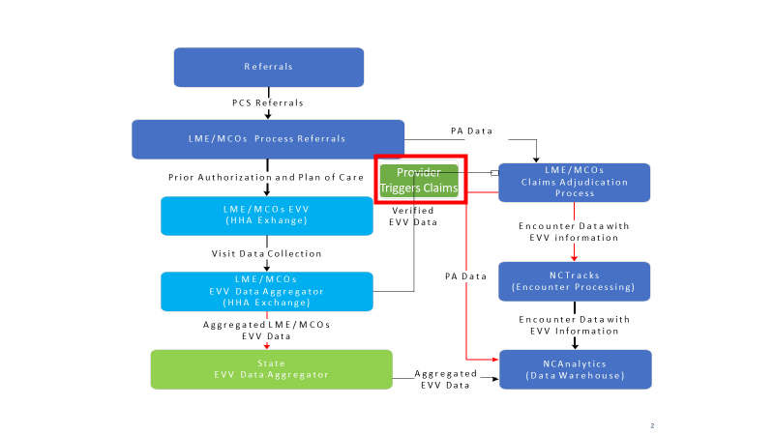

Table 2: LME-MCOs – EVV Conceptual Architecture Diagram (Managed Care Encounters) Alternate Version

A | Prior Approval Request | - LME-MCO provider submits the service request to the LME-MCO.
B | LME-MCO Data to LME/MCO EVV Vendor | - The LME-MCO processes the PA request and sends the Care Plan and authorization data to the MCO EVV Vendor.
C | Data from LME-MCO EVV Vendor to LME-MCO | - Aggregated EVV data is sent to the LME-MCO for Claims Adjudication purposes.
D | Provider Billing | - Provider submits billing to the LME-MCO EVV Vendor  - LME-MCO adjudicates the claim based on the Aggregated EVV Data and PA on file.
E | Data from LME-MCO EVV Vendor to State Solutions (Sandata) | - LME-MCO Aggregated EVV data to Sandata EVV Data Aggregator.  - Information about the LME-MCO Aggregated EVV data to the Sandata EVV Aggregator is included in the Alt EVV layout that is referenced in section 110 LME-MCO EVV Vendor to Sandata (State Solution).
F | Data from State Solution (Sandata) to NC Analytics | - LME-MCO Aggregated EVV data will be sent to NC Analytics for OBC and KPI reports.  - This integration is part of the Sandata vendor onboarding. Sandata will send all Aggregated data to NC Analytics.
G | LME-MCO Data to NC TRACKS | - LME-MCO will send post adjudicated claims as encounters to NC TRACKs along with the EVV information used during the adjudication.

110 LME-MCO EVV Vendor to Sandata (State Solution)

A | Transmission Method | - Sandata supports an SOA architecture. Sandata will provide an API for 3rd party vendors or agency’s internal IT organizations to utilize.  - The transmitted EVV information will be identical to the EVV data provided by provider through Fee for Service.  - Sandata will provide sample JSON or XML format information (Java equivalent to XML), as well as the WADL (JSON equivalent of the WSDL) to those parties developing the interface.  - Please see appendix A for the draft sample JSON and XML format information (In Progress).
B | Requirement Specification for Receipt of Alternative EVV Systems Data (altEVV) | Please see Appendix B

115 LME-MCO Encounter Data to NC Tracks

 | Data Submission Manual | - GDIT has compiling, updating, and distributing the Encounter Manual for encounter data processing.  - The updated Encounter Manual will replace this section.  - Information in this section is subject to change.
 | Draft 837 P Companion Guide | - Below is the Draft 837P Companion Guide that includes EVV information.  - The companion manual can also be found at https://www.nctracks.nc.gov/content/public/providers/provider-trading-partners.html
 | Encounter Sample File | - Please See Appendix C
A | Encounter Details | - The LME/MCO must submit the information for each EVV visit on a separate claim line.
B | Span of Dates | - The claim line cannot have a span of dates. The header level can have a span, but each claim line must have a single date  Example:  Header date – 20201101-20201105  Line 1 – 20201101-20201101  Line 2 – 20201102-20201102  Line 3 – 20201103-20201103  Line 4 – 20201104-20201104  Line 5 – 20201105-20201105
C | X12 837P, loop 2400 SV101-7 | - The LME/MCOs must submit the start time, end time, last name of the attendant and first name of the attendant in the X12 837P, loop 2400 SV101-7
D | SV101-7 | - The start and end times and the attendants’ last and first name must be submitted in the SV101-7 in the following format: ‘HHMM-HHMM,VISITKEY,LAST,FIRST’.  (ex: 0815-0905, 1234567899,SMITH,MARY).  - The start and end times are separated by a dash  - The fields should be delimited by a comma. (Please check with the LME/MCOs to see if the comma will be an issue)  - HHMM-must submit the attendant start time and the attendant end time in the 24-hr military time format  - The start time must not be greater than the end time  - The time should never span over a day (ex: 2330-0015 should be separated into 2 separate claim lines)  - Visit Key – must contain 10-character key  - The last name of the attendant is limited to 15 characters  - The first name of the attendant is limited to 10 characters

E | Location of Service | - The LME/MCOs must report the location of service in X12 837P, loop 2420G, Ambulance Pick-up Location (street address, city, state, zip).
F | EVV Edits | - There will be 7 new edits created for LME/MCO EVV encounter claim a the line level  5 existence edits: each of the following fields must be present. If the field is not present, the edit will set. Also, submitting the SV101-7 field incorrectly could cause an edit to set (ex: leaving out the comma delimiter)  1. Start time  2. End time  3. Last name  4. First Name  5. Pickup address (this edit includes address, city, state, zip)
G | Validation Edits | 6. Relationship Edit for start and end time - the start time must not be greater than the end time (ex: 0930-0900 would set the edit)  7. Edit for not allowing Date Span at line - span dates can be at the header, but each line should have a single date

120 Prior Auth Data Flow

A | Prior Auth Data to NC Analytics | - The LME-MCO will provide the Prior Authorization information to NC Analytics in the format below.  - The updated Encounter Manual will replace this section.  Information in this section is subject to change.
B | Prior Authorization Format
C | Data Transfer Options and Requirements
D | IBM Tag File Example
E | Who does the PA DATA get provided too? | The LME-MCO only required to send the PA Data to NC Analytics for the purpose of EVV.
F | How often is PA DATA provided to NC Analytics? | It is expected that the LME/MCO provides this information to NC Analytics on a weekly basis.
G | Date and Time that PA DATA is submitted to NC Analytics | Every Monday  After Hours
H | NPI on the Header Record | The LME/MCO NPI or Atypical Provider is required to include on the header record.

Table 3: Prior Authorization Data Layout to NC Analytics – See File in 120 B

Appendix A: Sample JSON and XML format –

https://files.nc.gov/ncdma/documents/Providers/Programs_Services/EVV/NC-DHB-altEVV-Addendum-v1.2--002-.pdf

Appendix B: Sandata Alternative EVV Process

Appendix C: Encounter Sample File

