Ikigo citaho abana batoyi hamwe n’impinja muri Leta ya Carolina y’uburaruko

Uburenganzira bw’Umwana n’ubw’Umuryango

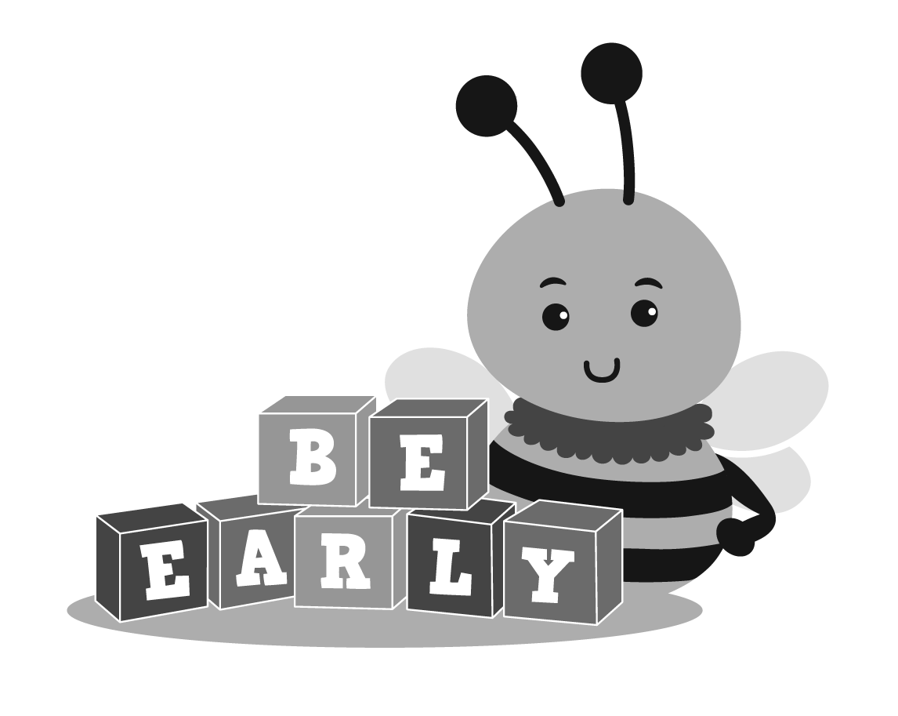

Urwego rujejwe gutabara vyihuse
Igisata c’imibereho myiza y’abana n’imiryango
N.C. Ubushikiranganji bw’amagara y’abantu n’ibikorwa vyubahiriza kiremwa muntu
(919) 707-5520
Ndamukiza 2013 | Kigarama 2020 | Rusama 2022

Urashobora kuronka ibindi bitabu uciye www.ncdhhs.gov/itp-beearly

Ikigo citaho abana batoyi hamwe n’impinja muri Leta ya Carolina y’uburaruko
Aho ushobora kuronka amakuru

Ibiro vy’ikigo kijejwe gukurikirana ingene abana bakura(CDSA) binyegere biri:

Aho biherereye:

Terefone:
Fagisi:
Umuhuzabikorwa wanje ajejwe ibikorwa vyo ku rwego rwa mbere (EISC) ni:
________________________________________________________________
Terefone yiwe:
Ahandi ushobora kuronka amakuru
Ikibanza:

Email:
Terefone ngendanwa:
Ico ubivugako:

Ikigo citaho abana batoyi hamwe n’impinja muri Leta ya Carolina y’uburaruko
Uburenganzira bw’abana n’ubw’imiryango
Igitabu c’ikigo citaho abana batoyi hamwe n’impinja muri Leta ya Carolina y’uburaruko kivuga ku burenganzira bw’umwana n’ubw’umuryango kirasigura neza uburenganzira umuryango wawe ufise, nk’uko biri mw’itegeko ry’igihugu rizwi nk’itegeko rigenga inyigisho z’abantu bagendana ubumuga (IDEA). Mu gace karyo C riraregurira ibikorwa vy’ubutabazi bwihuta ku bana batoyi hamwe n’impinja bakwije ibisabwa (bafise imyaka guhera bakivuka gushika kuri itatu). Muri Leta ya Carolina y’uburaruko, ukwo ako gace C k’itegeko rigenga inyigisho z’abana bagendana ubumuga IDEA kameze kazwi nk’Integuro yo kwhutira gutabara canke umugambi witaho abana batoyi hamwe n’impinja (ITP).
Ikigo kiza imbere mu mugambi wa Leta ya Carolina y’uburaruko witaho abana batoyi hamwe n’impinja (ITP) ni urwego rujejwe ibikorwa vy’ubutabazi bwihuta. Urwo rwego rukaba rubarizwa mu gisata ca Leta ya Carolina y’uburaruko citaho imibereho myiza y’abana n’imiryango. Ku rwego rwo hasi, urwego rw’ubutabazi bwihuta biciye mu gisata kijejwe gukurikirana abana uko bagenda barakura (CDSAs) kiratanga intumbero, kirgakurikirana, kandi kigasuzuma imigambi n’ibikorwa vyo kwitaho abana n’impinja. Hari ibigo 16 bijejwe gukurikirana abana uko bagenda barakura CDSAs mu gihugu cose bitanga amahirwe ku bantu yo gukorerwa canke gukirikiranwa n’ikigo citaho abana batoyi n’impinja. Ivyo bigo CDSAs vyose bikaba bikorera mu bice bishika 100 muri Leta ya Carolina y’uburaruko yose mu karere kamwe canke twinshi dutaandukanye.
Iki gitabu ni urwandiko rujanye n’uburenganzira bwawe rwemewe n’amategeko y’igihugu. Harimwa amajambo atari menshi ahobora kuba ari mashasha kuri wewe. Nico gituma, amajambo amwe yatangiwe insiguro mu ntango y’iki gitabu ayandi ari mu gice c’insiguro y’amajambo agoye mu mpera zaco. Amajambo yatangiwe insiguro mu gice c’amajambo agoye canke nk’uko ari muri iki gitabu yanditse mu buryo ahita aboneka.
Umuhuzabikorwa ajejwe ibikorwa vy’ubutabazi bwihuta (EISC) akoranye n’umuryango wawe murashobora gusaba ko habaho abandi bantu ndetse n’ibikoresho kugira mutahure uburenganzira bwanyu kurusha.

IBIRIMWO
INTANGAMARARA 1
URWANDIKO RWO KUMENYESHA IMBERE Y’IGIHE 2
URUHUSHA RW’ABAVYEYI 3
GUSUZUMA INYANDIKO 4
IBANGA RY’AMAKURU 6
GUTATURA AMATATI 7
Umwumvikano 7
Kwumvirizwa mu rubanza 8
Kwitwarira Leta 9
UWUSUBIRA MU GISHINGO C’UMUVYEYI 11
INSIGURO Y’AMAJAMBO 12

INTANGAMARARA
Umugambi wa Leta ya Carolina y’uburaruko witaho abana batoyi hamwe n’impinja (N.C. ITP) washizwe ho kugira werekane uruhara rw’umuryango kandi hagakenerwa uruhusha ruvuye nyene muri wo kuri buri ntambwe yose y’ingene ibikorwa vy’ubutabazi bwihuta bigenda uhereye kw’irungikwa ry’umwana kuzobandanya gushika aho ingingo y’uko umwana wawe akwije ibisabwa. Aho rero hagaca hagarwako integuro hamwe n’ukuronsa umwana wawe n’umuryango ivyo bakeneye.
Umugambi wa Leta ya Carolina y’uburaruko witaho abana batoyi hamwe n’impinja N.C. ITP ni kimwe mu bigize ibikorwa vy’ubutabazi bwihuta vyashizweho na Leta bivugwa mu gace C k’itegeko ry’igihugu rigenga inyigisho z’abantu bagendana ubumuga (IDEA). Amabwirizwa y’igihugu agenga ibikorwa vy’ubutabazi bwihuta (bwasiguwe mw’itegeko ry’igihugu rigenga ayandi mabwirizwa y’igihugu nimero 34 CFR agace ka 303) ariryo Umugambi wa Leta ya Carolina y’uburaruko witaho abana batoyi hamwe n’impinja N.C. ITP wisunga.
Mu mugambi wa Leta ya Carolina y’uburaruko witaho abana batoyi hamwe n’impinja N.C. ITP harimwo intambuko zikingira amategeko yubahiriza uburenganzira bw’abana bamaze kurungikwa/canke bamaze gushirwa ku rutonde rw’abakurikiranwa n’umugambi ITP, hamwe n’ubw’abavyeyi babo. Abavyeyi bategerezwa kubanza kumenyeshwa ibijanye n’ubu burenganzira bw’ingene bakingirwa nk’uko bitomorwa n’itegeko rigenga amabwirizwa nimero 34 CFR 303.400-438, harimwo n’uburyo amatati atorerwa inyishu nyene aho mu gice 34 CFR 303.430-438. Aho rero bagaca baba mu bagira uruhara rudasanzwe kandi bakaba mu bafata mu minwe ubuyobozi bw’ibikorwa biba vyagenewe gukorerwa umwana n’umuryango. Iki gitabu kivuga ku burenganzira bw’umuvyeyi ni urwandiko ruzwi n’amategeko rw’ingene abana n’imiryango baheza bagakingirwa nk’uko amabwirizwa ari mu gace C k’itegeko ry’igihugu kabitegekanya.
Wewe hamwe n’umuryango wawe kuba mu bagize Umugambi wa Leta ya Carolina y’uburaruko witaho abana batoyi hamwe n’impinja N.C. ITP ubikora ku gushaka ata gahato. Muri uwo mugambi, ufise uburenganzira bukurikira:
- Umwana wawe araronka akaryo ko kugirirwa umwihwezo bafatiye ku bintu bitandukanye kugira barabe ko akwije ibisabwa mu gihe atoba yaramaze gutorwako indwara yerekana ko ashobora kurwara mu buryo butankanye canke aka yaramaze kuba umukehabwenge bisunze inyandiko zerekana ingene umwana wawe yagiye aravurwa canke izindi nyandiko. Hanyuma basanze umwana wawe akwije ibisabwa, isuzuma ryiwe hamwe n’ishirwaho ry’ikirangamisi cibikorwa bishirirwaho umuryango (IFSP) bica bikorwa mu kiringo c’imisi mirongo ine n’itanu(45) uhereye ku musi umwana arungikwa mu mugambi.
- Igihe umwana wawe akwijije ibisabwa kugira yakirwe mu mugambi wa Leta ya Carolina y’uburaruko witaho abana batoyi hamwe n’impinja N.C. ITP, uburenganzira bwo gukorerwa ibikorwa bibereye hamwe n’ibikorwa vy’ubufsha bwihuta ku mwanya wo bironswa umwana wawe n’umuryango nk’uko biri mu kirangamisi IFSP, mu kiringo c’imisi 30 navyo nyene bitegerezwa kwongerwako kuri ico kirangamisi IFSP nyene.
- Uburenganzira bwo kugirirwa umwihwezo, amasuzumwa, gushirirwaho ikirangamisi c’ibikorwa IFSP, gukurikiranirwa ibikorwa, hamwe no gukingirwa ata kiguzi c’amafaranga imiryango irinze kuriha.
- Uburenganzira bwo kwemera canke kwanka ko ukorerwa imyihwezo yo kuraba ko umwana akwije ibisabwa canke atabikwije, amasuzumwa, canke ko hari igikorwa na kimwe bogukorera.
- Uburenganzira bwo kuronka ubutumire bwanditse bwo kwitaba no kugira uruhara mu Manama yose ajanye n’ikirangamisi c’ibikorwa vy’umuryango IFSP.
- Uburenganzira bwo kumenyeshwa mbere y’igihe biciye mu nyandiko, imisi cumi (10) imbere y’uko haba impinduka ku vyasabwe canke ku bitashoboye kwakirwa mu gihe c’itororokanya, c’umwihwezo, canke ikibanza (aho umwana asanzwe aronkera ubufasha) vy’umwana wawe, canke mu busfasha buhabwa umwana wawe canke umuryango.
- Uburenganzira burekurira umwana wawe gufashirizwa aho asanzwe aba we nyene kandi amenyereye biboneka ko ari ahantu hashobora gufasha umwana wawe kuronka ivyo akeneye kugira akure neza.
- Uburenganzira bwo kubikirwa amakuru yamaze gutangwa mw’ibanga.
- Uburenganzira bwo kuronswa urwandiko rwa mbere ruriko ibikorwa vy’ubufasha bwihuta waronkejwe ku buntu.
- Uburenganzira bwo gusubiramwo ndetse bibaye ngombwa, gukosora inyandiko zerekeye ibikorwa vy’ubutabazi bwihuta.
- Uburenganzira bwo kuronswa ata mafaranga arinze gutangwa ikopi y’umwihwezo wose wakozwe hariko haronderwa kumenyekana ko umwana akwije ibisabwa,gutororakanya, isuzumwa ry’umwana, isuzumwa ry’umuryango, hamwe n’ikirangamisi c’ibikorwa vyashiriweho umuryango IFSP hakiri kare bishoboka uko inama yose ku kirangamisi IFSP iba ikoranye.
- Uburenganzira bwo kwitura ubutungane mu gutorera umuti amatati ajanye n’ikibazo cose c’umwirondoro, umwihwezo, kuba mu bakwije ibisabwa, aho umwana aronkera ubufasha canke ibitangwa muri ubwo bufasha bwihuta ku mwana wawe.
- Kuronswa amahirwe y’uko haba kwumvikanishwa ku gushaka kugira ingorane izo ari zo zose ziba zihari zitorerwe umuti hisunzwe amateka n’amategeko bigenga ikigo itaho abana n’impinja.
- Uburenganzira bwo kwitwarira Leta mu gihe ikigo ca Leta caba ikiri ku rwego rw’igihugu canke ikiri aho uherereye, canke umukozi wa Leta yahonyanze ibisanzwe biri mu vyo amategeko akurekurira.
- Uburenganzira bwo kudatinda mu gukemura ibibazo bigatorerwa inyishu ku gihe gitegekanijwe.
Iruhande y’ubu burenganzira bwavuzwe muri rusangi, urafise uburenganzira bwo kumenyeshwa ibijanye n’uburyo bwihariye bwo kugukingira nk’uko bitomorwa n’ Umugambi wa Leta ya Carolina y’uburaruko witaho abana batoyi hamwe n’impinja N.C. ITP (Agace C k’itegeko rigenga inyigisho z’abagendana ubumuga IDEA, agace kandi E), uza gusanga mu bice bikurikira v’iki gitabu.

URWANDIKO RWO KUMENYESHA IMBERE Y’IGIHE
Urwandiko rwo kumenyesha rutegerezwa kuba rwatanzwe imisi cumi (10) imbere y’uko Umugambi wa Leta ya Carolina y’uburaruko witaho abana batoyi hamwe n’impinja , biciye murwego rwo gutabara vyihuta ruri mu gisata kijejwe gukurikirana ingene abana bakura (CDSA), rutangura ibikorwa bimwe bimwe. Uvyipfuje urashobora kubinyarutsa imbere y’uko imisi 10 ihera. Ibi bikorwa ni ugusaba canke guhakana gutangura canke guhindura itororokanywa, umwihwezo, canke aho umwana wawe aronkera ubufasha, canke ibikorwa urwego rujejwe ubutabazi bwihuta rwategekanirije umwana wawe n’umuryango wawe.
Urwo rwandiko rutegerzwa kukumenyesha ibi bikurikira:
- Ibikorwa vyasabwe gukorwa canke vyahakanywe.
- Imvo ituma igikorwa gisabwa canke gihakanwa.
- Intabuko zose zihari kugira zikingire igikorwa mu mugambi wa Leta ya Carolina y’uburaruko witaho abana batoyi hamwe n’impinja N.C. ITP.
- Intambuko z’ukwitura ubutungane mu mugambi wa Leta ya Carolina y’uburaruko witaho abana batoyi hamwe n’impinja N.C. ITP, harimwo gusigura neza ingene ibirego bitangwa n’ikiringo cavyo gitegekanijwe. (Raba ikigabane Gutatura amatati kiri muri iki gitabu.)

Urwo rwandiko rutegerezwa kwandikwa mu rurimi abantu bose batahura kandi rukaba mu rurimi rw’amavuko canke mu rurimi usanzwe ukoresha atari uko mu bisanzwe ibindi ntivyemewe.
Mu gihe ururimi rwawe rw’amavuko canke ubundi buryo bwo kuvugana atari ururimi rwanditse, igisata kijejwe gukurikirana ingene abana bakura CDSA gitegerezwa gukora ibishoboka kugira:
- Urwandiko ruhindurwe mu buryo bwo kuvuga hakoreshejwe amajwi canke ubundi buryo bukubangukira mu rurimi rw’amavuko canke ubundi buryo bushobora gutuma kwumvikana vyoroha.
- Utahure ibiri mu rwandiko.
- Habe icemezo canditse cemeza ko ibisabwa muri iki kigabane vyose vyatorewe umuti.
Mu gihe naho ufise ubumuga bwo kutumva canke wumva bigoranye, ubumuga bwo kutabona, canke udashobora gusoma ivyanditse, uburyo usanzwe ukoresha mu kuvugana no kwumvikana n’abantu nib wo buheza bugahabwa agaciro (nko kuvuga ukoresha ibimenyetso, inyandiko z’abafise ubumuga bwo kutabona canke hagakoreshwa kuvuga usohora amajambo mu majwi).

URUHUSHA RW’ABAVYEYI
Uruhusha bisigura ko:
- Wamenyeshejwe uranasigurirwa mu buryo bwose ibijanye n’ibikorwa vyasabiwe uruhusha. Uraheza ukabimenyeshwa mu rurimi rwawe rw’amavuko canke mu buryo usanzwe ukoresha mu kuvugana no kwumvikana n’abandi, atari uko ibindi ntivyemewe.
- Ko utahura kandi wemera mu nyandiko gukorerwa ibikorwa warondererwako uruhusha, kandi urwo ruhusha ruratomora ibikorwa n’urutonde rw’inzandiko (mu gihe zihari) zizotangwa hamwe n’abazozihabwa.
- Ko utahura ko watanze uruhusha ku gushaka ata gahato, bikuvuyeko, kandi ko ushobora kuruhagarika biciye mu nyandiko umwanya uwo ari wo wose uvyipfuje.
Iyo uhagaritse uruhusha, iryo hagarikwa riraba ibindi ibikorwa vyose kiretse ivyatanguye imbere y’uko urwo uruhusha ruhagarikwa.
Uruhusha rwanditse utanga rutegerezwa gusabwa:
- Imbere y’uko haba umwihwezo n’isuzumwa ku mwana wawe.
- Imbere y’uko ibikorwa vy’ubutabazi bwihuta bitangura.
- Imbere y’uko ibigo vyo kuvuzanya canke vy’ubwishingizi vyaba ivya Leta canke ivyigenga birengana ikiringo co kuriha.
- Imbere y’uko haba gushirwa hanze amakuru y’umuntu uwo ari we wese kiretse mu gihe amategeko abirekura.
Mu gihe udatanze uruhusha nta gikorwa gishobora gukorwa.
Agace C (34 CFR 303.414) ko mu mabwirizwa y’igihugu hamwe n’itegeko rigenga uburenganzira bwo kurererwa mu muryango hamwe n’ubuzima bwite bw’umuntu, canke FERPA (34 CFR 99.31) ritegekanya ko uruhusha ruva ku bavyeyi rutegerezwa kuba rwabonetse imbere y’uko haba gushira hanze amakuru yose ajanye n’umwirondoro:
- Mu kuyaha umuntu wese atari mu bakozi mwahanye amasezerano canke umutangabufasha ariko akusanya amakuru canke ngo ayakoreshe ahawe uburenganzira n’agace C k’itegeko. Atari uko, birabujijwe n’itegeko rigenga uburenganzira bwo kurererwa mu muryango hamwe n’ubuzima bwite bw’umuntu FERPA (34 CFR 99.31).
- Akoreshwa kubw’intumbero yindi iyo ariyo yose itari mu gace C k’itegeko.
Mu makuru ajanye n’umwirondoro harimwo:
- Amazina y’umwana canke amazina yabandi bagize umuryango.
- Aho umwana wawe aba canke umuryango wawe uba.
- Ikiranga umuntu, aho ni nk’inimero iranga umwana wawe canke inimero yawe y’akazi.
- Urutonde rw’ibuntu bishobora kumuranga we nyene ubwiwe canke ivyo vyose vyotuma umwirondoro w’umwana wawe umenyekana bitagoranye.
Amakuru y’umwana wawe ari mu nyandiko z’urwego rw’ubutabazi bwihuta kirazira ko ahabwa ayandi mashirahamwe atanzwe n’uwufitaniye amasezerano n’urwo rwego canke umukozi w’urwo rwego nyene hatabanje kuboneka uruhusha ruvuye iwawe kiretse iyo umukozi w’urwego rw’ubutabazi bwihuta abiherewe uburenganzira n’itegeko rigenga uburenganzira bwo kurererwa mu muryango hamwe n’ubuzima bwite bw’umuntu FERPA.
Hisunzwe itegeko rigenga uburenganzira bwo kurererwa mu muryango hamwe n’ubuzima bwite bw’umuntu FERPA hamwe n’itegeko rigenga inyigisho z’abagendana ubumuga IDEA mu gace karyo C, ikigo citaho abana batoyi hamwe n’impinja N.C. ITP kirarekuriwe kandi kirasabwa gutanga amazina n’italiki y’amavuko vy’umwana wawe, hamwe n’amakuru y’ingene mwoshobora gutorwa (harimwo amazina yawe n’aho uba, hamwe n’inimero za terefone) hatarinze gukenerwa uruhusha rwawe ku kigo ca Leta kijejwe indero c’aho umwana asanzwe aba. Aya makuru araheza agakenerwa kugira hamenyekane abana bose bashobora kuba bakeneye ubufasha nk’uko biri mu gace B k’itegeko rigenga inyigisho z’abagendana ubumuga IDEA.
Mu gihe udatanze uruhusha kugira hakorwe umwihwezo, isuzumwa, canke habe ubutabazi bwihuta, ikigo citaho abana batoyi hamwe n’impinja N.C. ITP kiraheza kigakora utwigoro dushoboka bimenyekane y’uko:
- Uzi neza ubwoko bw’umwihwezo, isuzumwa, canke igikorwa coba kigezweko.
- Utahura ko umwana wawe adashobora kugirirwa umwihwezo, adashobora gusuzumwa canke ngo hagire igikorwa akorerwa kiretse habonetse uruhusha.
Vyongeye, nk’umuvyeyi w’umwana yarungitswe canke yashizwe ku rutonde rw’abarabwa n’ ikigo citaho abana batoyi hamwe n’impinja N.C. ITP, urashobora kwemera canke ukanka igikorwa ico ari co cose kiri mu butabazi bwihuta vyateguwe gukorerwa umwana wawe canke uwundi muntu wo mu muryango udahutaje ibindi bikorwa. Urashobora kandi kwisubirako ugahakana gukorerwa igikorwa wari wemeye mbere, udahungabanije ibindi bikorwa vy’ubutabazi bwihuta.

GUSUZUMA INYANDIKO
Twisunze ibijanye n’amategeko y’ukuzigama amakuru mw’ibanga yavuzwe mu bigabane biza gukurikira, urafise akaryo ko kugenda ugasuzuma kandi ugahindura inyandiko zose ziri mu rwego rw’ubutabazi bwihuta zivuga ku mwana wawe n’umuryango zagiye zegeranywa, zabitswe, canke zagiye zikoreshwa n’ikigo. Izo nyandiko zishobora kuba zijanye gucishwa mu vyuma vyo kwa muganga, imyihwezo, amasuzumwa, kwemeza ko umwana akwije ibisabwa, ugukura no gushira mu ngiro ikirangamisi c’umuryango IFSPs, ibitangwa n’urwego rwo gutabara vyihuta, hamwe n’ibirego vy’umuntu ku bijanye n’ibikorwa vyakorewe umwana wawe. Muri ibi harimwo ico cose kiri mu nyandiko zakorwe n’urwego rw’ubutabazi bwihuta ku mwana wawe.
Uburenganzira bwo gusoma inyandiko – Kugira ushobore gusuzuma inyandiko zakozwe ku mwana wawe, urabisaba, igisata kijejwe gukurikirana ingene abana bakura CDSA gitegerezwa gukorera ku gisabo cawe atagutevya bibayemwo kandi mu kiringo kitarenza imisi cumi (10) uhereye umusi ubisaba. Igisata kijejwe
gukurikirana ingene abana bakura CDSA kiraheza kikabikorerako imbere y’uko inama ku kirangamisi cashiriweho umuryango IFSP iyo ari yo yose iba canke ukwumvirizwa ukwo ari kwo kwwose kujanye no gushira ahabona, isuzumwa, aho umwana aronkera ubufasha canke ivyo aronka bibereye bivuye mu rwego rw’ubufasha bwihuta.
Uburenganzira bwo gusesangura no guhindura inzandiko ziri mu rwego w’ubutabazi bwihuta vyerekeye:
- Uburenganzira bwo guhabwa inyishu ivuye mu gisata kijejwe gukurikirana ingene abana bakura CDSA ku bibazo bibereye kugira haboneke insiguro hamwe n’ivyo inyandiko z’urwego rw’ubutabazi zerekana.
- Uburenganzira bwo gusaba ko igisata CDSA gitanga amakopi y’inyandiko ziri mu rwego rw’ubutabazi bwihuta harimwo amakuru mwen’ayo. Mu gihe bidakunze ko zitangwa ntibiba bigishobotse ko bwa burenganzira bwo gusesangura no guhindura ibiri mu nzandiko ziri mu rwego rw’ubutabazi bwubahirirzwa.
- Uburenganzira bwo kugira uwuguserukira mu gusesangura no guhindura ibiri mu nzandiko zanditswe n’urwego rw’ubutabazi.
Igisata kijejwe gukurikirana ingene abana bakura CDSA kiremanga ko ufise ububasha bwo gusesangura no guhindura ibiri mu nzandiko zafashwe n’urwego rw’ubutabazi zerekeye umwana wawe kiretse iyo vyamenyeshejwe mu nyandiko ko ata bubasha ubifitiye hisunzwe itegeko ry’igihugu canke rya sentare rigenga mwen’ivyo bijanye n’inzandiko nk’uburezi bw’umwana, gutana hamwe no kwahukana.
Uruhusha rwo gusoma inyandiko zibitswe – Ibiro vyose vya CDSA bitegerezwa kubika impusha zose zatanzwe ku muntu uwo ari we wese yahawe uruhusha rwo kuraba inzandiko ziri mu rwego rw’ubutabazi (kiretse uruhusha rw’abavyeyi hamwe n’abakozi barusanganywe ba CDSA), harimwo amazina y’uwo muntu, italiki urwo ruhusha rwatangiweko, hamwe n’intumbero yatumye uwo muntu ahabwa uruhusha rwo gukoresha inzandiko ziri mu rwego rw’ubutabazi.
Iyo usanze urwandiko ruri mu rwego rw’ubutabazi bwihuta ruriko amakuru canke imyirondoro y’abana barenga umwe, ufise uburenganzira bwo gusuzuma no guhindura amakuru arabana n’umwana wawe gusa, canke kumenyeshwa amakuru yihariye ku mwana wawe.
Igisata kijejwe gukurikirana ingene abana bakura CDSA kirashobora kukuronsa urutonde rw’inyandiko zegeranirijwe mu biro vy’urwego rujejwe ubutabazi bwihuta, ubwoko bw’inyandiko hamwe n’ibibanza zegeranirijwemwo zikongera zikabikwa canke zakoreshejwe n’ikigo.
Kurihisha inzandiko – Igisata kijejwe gukurikirana ingene abana bakura CDSA kirashobora kurihisha amafaranga inzandiko ziri mu rwego rw’ubutabazi bwihuta mu gihe bidashobora kukubera intambamyi ngo bihungabanye uburenganzira bwawe bwo gusuzuma no guhindura ibiri muri izo nyandiko muri urwo rwego. Igisata kijejwe gukurikirana ingene abana bakura CDSA gitegerezwa gutanga inyandiko ata kiguzi kirinze gusabwa urwandiko rw’umwihwezo wose ubaye, isuzuma ryose ribaye ku mwana, isuzuma ry’umuryango hamwe n’iry’ikirangamisi cashiriweho umuryango IFSP igihe cose inama ku kirangamisi IFSP iheze. Igisata kijejwe gukurikirana ingene abana bakura CDSA kirashobora kutakurihisha mu gihe amafaranga mu gihe uriko urarondera amakuru canke kurondera ayazimiye.
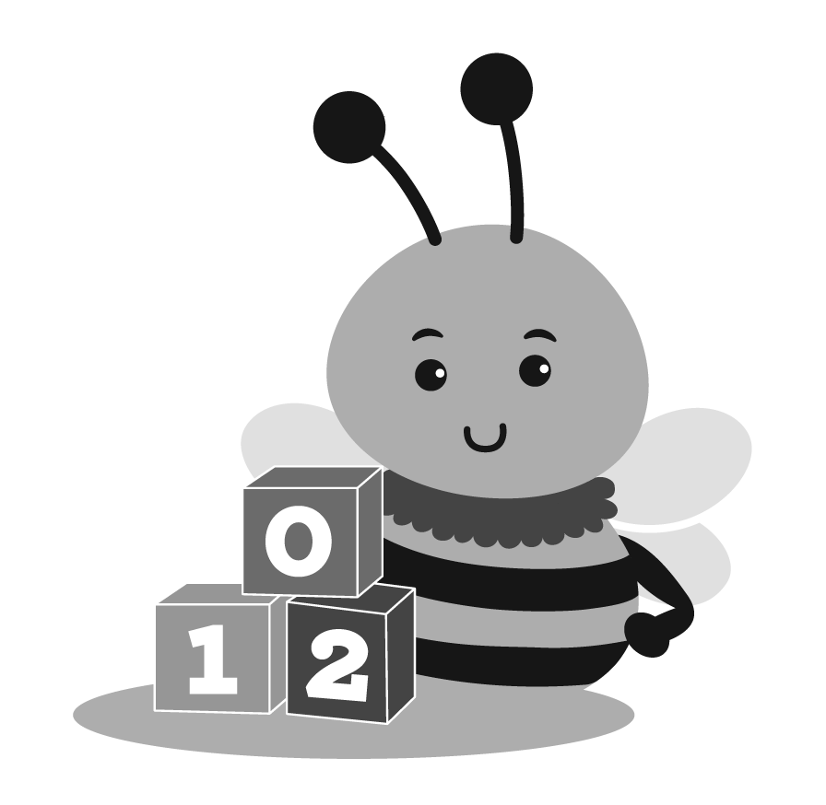
uguhindurwa kw’inyandiko – Mu gihe uzi neza ko amakuru ari mu nyandiko zegeranirijwe akongera akabikwa mu rwego rw’ubutabazi bwihuta, canke ziriko zirakoreshwa n’ikigo citaho abana batoyi hamwe n’impinja ataho ahuriye n’ukuri, ayovya, canke ahonyanga uburenganzira bwo kutinjirirwa mu buzima canke ubundi burenganzira bwawe canke bw’umwana wawe, urashobora gusaba Igisata kijejwe gukurikirana ingene abana bakura CDSA canke ikindi kigo coba gifise izonyandiko kigahindura amakuru ari muri zo.

Igisata CDSA gitegerezwa gusuzuma nimba cohindura amakuru ajanye n'ivyo usavye mu gihe gikwiye, inyuma y'aho uronse ico ikibazo kimeze nk’ico.
Iyo ico gisata CDSA canse guhindura amakuru nk'uko mwabisavye, CDSA gitegerezwa kukumenyesha ko canse kandi kikakugira inama kikwereka ko ufise uburenganzira bwawe bwo kumwumvirizwa.
Urwego rwo Gutabara hakiri kare ruratanga akaryo ko kumvirizaa ibibazo bijanye n’inyandiko ziri muri urwo rwego kugira ngo hihwezwe niba hari koko ibitari vyo, biyovya, canke ibindi bijanye n’ihonyangwa ry’uburenganzira bwo kugumirizwa ibanga canke ubundi burenganzira bw’umwana.
Iburanisha ryakozwe kuri ivyo bibazo ritegerezwa gukorwa hakurikijwe inzira zitegekaanywa n’amategeko agenga uburenganzira bw’umuryango n’uburenganzira bwite (FERPA) dusanga kuri 34 CFR 99.22. Urashobora kandi gusanga ubu buryo buvugwa mu kinyamakuru c’ikigo citaho abana batoyi muri Carolina y'uburaruko kivuga ku buryo bwo gukingira umwana no Gutatura Amatati.
Iyo urwo rubanza ruvuye mu kwiyemeza ko amakuru atari yo, ahenda canke arenze ku burenganzira bwiwe canke ubundi burenganzira bw'umwana, CDSA izoca ihindura ayo makuru hisunzwe kandi izoca ikumenyesha mu nyandiko.
Mu gihe urwo rubanza rwavuye ku ciyumviro c'uko ayo makuru atari ay'ukuri, ahenda canke arenze ku burenganzira bw'umwana canke ubundi burenganzira bw'umwana, urafise uburenganzira bwo gushira itangazo mu ntango y'ukuja kwa umwana wawe ku nyandiko zijanye n'ayo makuru kandi agasigura imvo iyo ari yo yose yo kutumvikana n'urwego rujejwe kwitaba amakoraniro.

Insiguro zose zashizwe mu nyandiko z’umwana ziri mu rwego rwo gutabara vyihuta muri kano gace bitegerezwa kubikwa na CDSA nk’ibiri mu vyo urwego rwo gutabara vyihuta birabana n’umwana mugihe cose inyandiko yo gutabara hakiri kare canke igice carwanijwe (ico gice c’inyandiko mutumvikanako ) ikomezwa na CDSA. Iyo inyandiko z'umwana ziri rwego rwo gutabara vyihuta canke igice kiburanwa zashizwe ahabona na CDSA ku muburanyi uwo ari we wese, insiguro zitegerezwa no kumenyeshwa uwo muburanyi.

IBANGA RY’AMAKURU
Uburyo bw'ibanga buvugwa muri iki gice bujanye n'amakuru atazwi yerekeye umwana wawe n'umuryango wawe aho:
- Ibiri mu rwego rwo gutabara vyihuta vyanditswe kandi vyakusanirijwe hamwe, vyakoreshejwe, canke vyagumijwe n’ikigo citaho abana batoyi, canke ikigo ico ari co cose kibifisemwo uruhara, hamwe
- Ikurikizwa kuva mugihe umwana wawe arungitswe rwego rwo gutabara vyihuta gushika aho amakuru atagisabwa kubikwa n’ikigo.
Ibisabwa ku bijanye n’ibanga
Ikigo citaho abana batoyi hamwe n’impinja muri Carolina y’uburaruko gitegerezwa kukumenyesha mugihe umwana wawe yarungitswe kuri CDSA kugirango ikumenyeshe mu buryo buhagije ibisabwa mu mabanga harimo:
- Insobanuro y'umwana canke abana amakuru atazwi ku giti ciwe, ubwoko bw'amakuru aronderwa, uburyo porogarama itegekanya gukoresha mu kwegeranya amakuru (harimwo n'amasoko y'amakuru yunganira), hamwe n'ikoreshwa mu gutanga amakuru.
- Incamake ya politiki n'inzira ibigo vyitabiriye bitegerezwa gukurikiza bijanye no kubika, kumenyesha abandi bantu, kubika no gusambura amakuru yihariye.
- Insiguro z'uburenganzira bwose bw'abavyeyi n'abana ku bijanye n'ayo makuru, harimwo agateka k'abana hisunzwe itegeko rigenga indero n'amabanga y'umuryango (FERPA) hamwe n'amategeko ashira mu ngiro mu 34 CFR Igice ca 99A, insiguro y'aho iryo tangazo ritangwa mu ndimi kavukire z'imigwi itandukanye y'abanyagihugu.
Ibanga ry’amakuru y’umutekano
Uburyo bukurikira burahari kugirango hamenyekane ibanga ry’inyandiko:
- Buri kigo gikoresha uruhara/abatanga intererano kikingira ibanga ry'amakuru amenyekana mu gukusanya, kubungabunga, gukoresha, kubika, gushikiriza amakuru, hamwe n'ibibanza vyo gusambura.
- N’imiburiburi umuyobozi umwe muri buri kigo ashinzwe kugenzura ibanga ry’amakuru yose yamenyekanye.
- Abantu bose bakusanya canke bakoresheje amakuru ashobora kumenyekana bararonka inyigisho canke inyigisho zijanye n'amategeko, uburyo n'imikorere nk'uko biri mu gace karyo C na FERPA.
- Buri kigo cyitabiriye gikomeza, kugira ngo kigenzurwe mu ruhame, urutonde rw'amazina n'imyanya y'abo bakozi bo mu kigo bafise amakuru adasanzwe.
Amashirahamwe y'abagiraneza/abatanga imfashanyo ategerezwa kumenyesha abavyeyi igihe we nyene amakuru y'ido n'ido. Mu gihe umuvyeyi amenyeshejwe ko ayo makuru atakiri akenewe, amakuru ategerezwa gusamburwa mu gihe umuvyeyi abisabwe. Ariko rero, integuro y'izina ry'umwana, itariki yavukiyeko, amakuru yerekeye abavyeyi (harimwo aderesi na nomero za telefone), amazina y'umuhuza w'umurimo (s) hamwe n'uwutanga serivisi hakiri kare (harimwo umwaka n'imyaka, hamwe na porogarama iyo ari yo yose yinjiye iyo ava) irashobora kubungabungwa ata mwanya ufise.

GUTATURA AMATATI
Mu gihe utemeranya n’ikigo / umutanga bufasha mu kumenya, gusuzuma, gushira umwana wawe, canke gutanga ubufasha bukwiye bwo gutabara umwana wawe canke umuryango wawe, urashobora gusaba ko bagukemurira ibibazo vyawe.
Ikigo citaho abana batoyi n’impinja muri Carolina y’uburaruko gikemura ibibazo mu gihe gikwiye bitarinze guca muri sentare, nko kuvugana n’umuhuzabikorwa wo rwego rwihutira gutabara canke uwundi mubonano ku kigo CDSA caho. ITC ya N.C itanga kandi inzira eshatu zemewe: abunzi, iburanisha ryategekanijwe, hamwe nuburyo bwo kurega kwa leta.
Izi nzira zose ziraboneka nta kiguzi gishizwe ku miryango.

Umwumvikano
Ikigo citaho abana batoyi n’impinja muri Carolina y’uburaruko kiragira uruhara kugira habe umwumvikano kugira ngo hakemurwe ivyo mutumvikanako. Ubwunzi bushobora kubaho mbere canke nyuma yo gutanga ikirego gikwiye canke ikirego ca leta. Muvyeyi, urashobora gusaba abahuza mu kwuzuza no kohereza ubutumwa bwa N.C. ITP Ababyeyi basaba urupapuro rwabunzi kuri
Umwumvikano utanga amahirwe yo gukemura ivyo mutumvikanako mu buryo butavuguruzanya.
Ni kugushaka kandi bitegerezwa kumvikana ku buntu nimpande zompi.
Early Intervention Section, Part C Director
Division of Child and Family Well-Being
1916 Mail Service Center
Raleigh, NC 27699-1916

Gahunda yo Guhuza Impinja-Abana bato bareba neza ko abunzi ari:
- Ubushake ku mpande zose.
- Ntabwo ikoreshwa mu guhakana canke gutinza uburenganzira bwawe bwo kumva inzira ikwiye, canke guhakana ubundi burenganzira ufise mu gice C ca IDEA.
- Iyobowe numuhuza wujuje ibyangombwa kandi utabogamye wahuguwe muburyo bwiza bwo kunga.
Ikigo citaho abana batoyi n’impinja muri Carolina y’uburaruko gikora urutonde rwabantu bafise ubuhanga bwo guhuza kandi bafise bize ivy’amategeko n'amabwiriza ajanye no gutanga serivisi zo gutabara hakiri kare. Abahuza bategerezwa gutoranywa ku bushake, kuzunguruka canke ubundi buryo budahengamye.
Umuhuza ntagira aho ahengamiye – Umukozi w'umuhuza ashobora kuba adashobora kuba umukozi w'urwego rushinzwe gukurikirana abakozi ba Leta, canke umukozi w'urwego rw'umukoresha ashinzwe gukurikirana ibikorwa vy'ubuvuzi bwa kare canke mu bindi bikorwa vy'umwana; Nta nyungu z'umuntu ku giti ciwe canke ku nyungu z'umuntu ku giti ciwe zidahuza n'ivyo umuntu afise. Umuntu akwije ibisabwa nk'umuhuza si umukozi canke umutanga serivisi hakiri kare kubera gusa ahembwa n'ishirahamwe canke uwutanga ico ajejwe kugira ngo abe umuhuza.
N.C. ITP ishinzwe ikiguzi cyibikorwa byabunzi, harimo amafaranga yinama.
Buri cyiciro mu nzira y’abunzi kigomba gutegurwa mu gihe gikwiye kandi kigomba kubera ahantu korohereza ababuranyi mu mpaka.
Niba amakimbirane akemuwe binyuze mu nzira y'abunzi, ababuranyi bagomba gushyira umukono ku masezerano yemewe n'amategeko asobanura imyanzuro akavuga ko:
- Ibiganiro vyose vyabaye mu gihe c’abahuza bizokomeza kuba ibanga kandi ntibishobora gukoreshwa nk’ibimenyetso mu manza zose zizokurikira canke mu manza zaciwe na sentare iyo ari yo yose canke leta y’igihugu ruhabwa ubufasha hakurikijwe igice C.
• Amasezerano y’abahuza yanditse, yashizweho umukono hakurikijwe iki gika ashirwa mu bikorwa muri sentare iyo ari yo yose ifise ububasha canke mu sentare y’intara yo muri Amerika.
Mu gihe uhisemwo kudakoresha inzira y'abahuza, N.C. ITP izotanga amahirwe yo guhura, mu gihe n’ahantu wipfuza, hamwe n’ishaka ridashishikajwe, gusobanura inyungu no gushishikariza gukoresha abahuza. Umwumvikano ntukubuza gusaba kudahengama mu kuburanisha canke kwitwarira leta igihe ico arico cose. Urashobora icarimwe gutanga icifuzo co kunga no kuburanisha mu buryo budahengamye canke ikirego ca leta.

Kwumvirizwa mu rubanza
Urashobora gusaba uburyo bukwiye bwo kumva wuzuza no kohereza ubutumwa bwa N.C. ITP Abavyeyi Gusaba Ifishi Yategekanijwe Kuri:
Early Intervention Section, Part C Director
Division of Child and Family Well-Being
1916 Mail Service Center
Raleigh, NC 27699-1916

Iyo ikirego gikwiye cakiriwe, hashirwaho ushinzwe kuburanisha vyategekanijwe kugirango ashire mu ngiro inzira yo gukemura ibibazo. Umukozi ashinzwe kuburanisha ategerezwa:
- Kugira ubumenyi ku bitegekanijwe mu gice C n'ibikenewe, na serivisi zo gutabara hakiri kare kuboneka, impinja n’abana bato bafite ubumuga n'imiryango yabo kandi bagakora imirimo ikurikira:
    - Umva gutanga ibitekerezo byerekeranye n'ikibazo, usuzume amakuru yose ajyanye nibibazo kandi ushake gukemura ikibazo mugihe gikwiye.
    - Tanga inyandiko y'iburanisha ku giciro cya leta, harimo icyemezo cyanditse.
- Abashinzwe kumva neza inzira bagomba "kutabogama." Kutabogama bivuze ko umuntu washyizweho kugirango abe umuyobozi ushinzwe iburanisha:
    - ntabwo ari umukozi wo mu gice cyambere cyo gutabara, CDSA, cyangwa utanga serivise yo gutabara hakiri kare agira uruhare mugutanga serivisi zo gutabara hakiri kare cyangwa kurera umwana, kandi
    - ntabwo afite inyungu z'umuntu ku giti cye cyangwa iz'umwuga zanyuranya n’ubushake bwe mu gushyira mu bikorwa iburanisha ryateganijwe.
Umuntu akwije ibisabwa n'amategeko y'urwego rw'igihugu canke rw'abikorera utwabo ( Early Intervention Section canke CDSA), uwutanga serivisi z'ubuvuzi hakiri kare canke uwutanga serivisi zo kubaza hakiri kare kubera ko uwo muntu ahembwa n'ikigo canke porogarama kugira ngo ashire mu ngiro ibitegekanijwe n'amategeko.
Umubyeyi wese wagize uruhare mu iburanisha ryateganijwe afite uburenganzira bwo:
• Baherekejwe kandi bagirwe inama nabunganizi mu by'amategeko ndetse n'abantu bafite ubumenyi bwihariye cyangwa amahugurwa bijyanye na serivisi zo gutabara hakiri kare ku bana bato bato bato bafite ubumuga.
• Tanga ibimenyetso kandi uhangane, ubaza ibibazo, kandi uhatira kwitabira abatangabuhamya.
• Kubuza gutanga ibimenyetso byose mu iburanisha bitamenyeshejwe umubyeyi byibura iminsi itanu mbere y’iburanisha.
• Shaka inyandiko-mvugo ya elegitoronike yanditswe mu rubanza nta kiguzi kubabyeyi.
• Akira kopi yanditse yerekana ibyavuye mu byemezo no gufata ibyemezo nta kiguzi kubabyeyi.
Iburanisha ryateganijwe ryakozwe rigomba gukorwa mugihe nahantu byoroheye ababyeyi.
ITC ya N.C igomba kwemeza ko, bitarenze iminsi mirongo itatu (30) nyuma yo kwakira ikirego cyababyeyi gikwiye, iburanisha ryateganijwe rirangiye, kandi icyemezo cyanditse cyohererezwa buri muburanyi. Umukozi ushinzwe kumva ashobora gutanga igihe cyihariye kirenze iminsi 30 abisabwe nababyeyi cyangwa abatanga serivisi
Umuburanyi uwo ari we wese wababajwe n’imyanzuro n’icyemezo cyatanzwe hashingiwe ku iburanisha ryateganijwe cyangwa ikirego cya Leta afite uburenganzira bwo kurega mu rukiko rw’ikirenga cyangwa rw’igihugu.
Mugihe cyibikorwa byose birimo ikirego gikwiye, keretse keretse Igice cyo Gutabara hakiri kare hamwe nababyeyi b’impinja cyangwa umwana muto w’abana bafite ubumuga ukundi babyumvikanyeho, umwana agomba gukomeza guhabwa serivisi zibishinzwe hakiri kare mugihe cyagenwe muri IFSP aricyo byemeranijwe n'ababyeyi. Niba ikirego gikwiye gikubiyemo gusaba serivisi zambere mu gice ca C, umwana agomba kwakira izo serivisi zitavugwaho rumwe.

Kwitwarira Leta
Gahunda ya N.C. Uruhinja-Uruhinja rufite politiki nuburyo bwo gukemura ibibazo byatanzwe n’umuntu ku giti cye cyangwa umuryango (harimo no mu kindi gihugu) bivuga ko ikigo cya leta, ikigo cy’ibanze, cyangwa abimenyereza umwuga ku giti cyabo cyarenze ku ruhinja cyangwa leta. -Ibisabwa na Porogaramu ya Toddler. Ikirego kigomba kuba cyanditse, kigashyirwaho umukono, kandi kigizwe n’inyandiko y’ihohoterwa rivugwa hamwe n’ikirego gishingiyeho.
Ibibazo bigomba koherezwa kuri N.C. ITP kuri aderesi ikurikira:
Early Intervention Section, Part C Director
Division of Child and Family Well-Being
1916 Mail Service Center
Raleigh, NC 27699-1916

Ihohoterwa rivugwa rigomba kuba ryabaye mu gihe kitarenze umwaka umwe mbere y’itariki ikirego cakiriwe n’ishami ryita ku ntangiriro hakiri kare ishami ry’imibereho myiza y’abana n’umuryango. Umuburanyi utanga ikirego agomba kohereza kopi yikirego mubigo bya leta cyangwa abatanga serivise yo gutabara hakiri kare bakorera umwana icyarimwe umuburanyi atanga ikirego mugice cyambere cyo gutabara.
Ikirego kigomba gukemurwa mugihe cyiminsi mirongo itandatu (60) uhereye igihe wakiriye ikirego canditse cyashyizweho umukono nigice cyambere cyo gutabara igice cyigabana ryimibereho myiza yumuryango. Kwiyongera bigomba kwemererwa niba hari ibihe bidasanzwe bihari nushinzwe kumva. Kwagura ntibishobora kuba kuborohereza ubuyobozi. Mu minsi 60 uhereye igihe wakiriye ikirego, Igice cyo Gutabara hakiri kare:
- Kora iperereza ryigenga kurubuga, niba igice cyambere cyo gutabara cyemeje ko hakenewe iperereza.
- Guha urega amahirwe yo gutanga amakuru yinyongera, haba mu magambo cyangwa mu nyandiko, kubyerekeye ibirego arega.
- Guha CDSA cyangwa izindi nzego zishinzwe gutabara hakiri kare / abatanga amahirwe yo gusubiza ikibazo, harimo kubushake bwigice cyambere cyo gutabara, icyifuzo cyo gukemura ikibazo n'amahirwe impande zose zo kwishora mubunzi.
- Ongera usuzume amakuru yose afatika kandi ufate icyemezo cigenga cyo kumenya niba CDSA, ikigo cya leta, cyangwa abatanga ubufasha hakiri kare barenze kubisabwa mugice C.
- Tanga icemezo cyanditse ku muntu utanga ikirego gikemura buri kirego kiri mu kirego kandi gikubiyemo ibyavuye mu myanzuro n'imyanzuro kimwe n'impamvu zatumye icyemezo cya nyuma c'ikigo gikuru.
- Shyiramo uburyo bwo gushyira mubikorwa neza icyemezo cya nyuma c’igice ca mbere cyo gutabara, harimo ibikorwa byubufasha bwa tekiniki, imishyikirano, nibikorwa byo gukosora kugirango bigerweho niba bikenewe.
Niba icyemezo cya nyuma cyerekana ko serivisi zikwiye zitatanzwe / zidatangwa, Igice cyambere cyo gutabara kigomba gukemura:
• Kunanirwa gutanga serivisi ziboneye, harimo n'ibikorwa byo gukosora bikwiye kugira ngo bikemure ibibazo by’umuryango n’umuryango bafite ibibazo (nka serivisi z’indishyi cyangwa amafaranga y’amafaranga), na
• Gutanga serivisi nziza mugihe kizaza kubana bato nabana bato bafite ubumuga bemerewe na Gahunda yimpinja nimiryango yabo.
Igice cyo Gutangira hakiri kare cyemerera kongererwa igihe gusa iyo:
• Ibihe bidasanzwe bibaho kubijyanye nikirego runaka.
• Umubyeyi (cyangwa umuntu ku giti cye cyangwa umuryango, niba umuhuza aboneka kumuntu cyangwa umuryango muburyo bwa leta) hamwe na ITP, ikigo cya leta cyangwa abatanga ubufasha bwambere babigizemo uruhare bemera kwishora mubunzi.
Niba ikirego cyanditse cyakiriwe nacyo kikaba kiburanishwa mu gihe gikwiye cyangwa kirimo ibibazo byinshi umwe cyangwa benshi bagize uruhare muri urwo rubanza, Gahunda y’abana bato igomba gutandukanya igice icyo ari co cose c’ikirego gikemurwa mu gihe gikwiye. inzira yo kumva kugeza iburanisha rirangiye. Icyakora, ikibazo icyo ari cyo cyose mu kirego kitari mu iburanisha ryateganijwe kigomba gukemurwa hakoreshejwe igihe ntarengwa n'inzira zasobanuwe muri iki gice.
Niba ikibazo cyatanzwe mu kirego cyatanzwe mbere cyaciwe mu gihe gikwiye kireba ababuranyi:
• Icyemezo gikwiye cyo kumva iburanisha ni itegeko kuri icyo kibazo.
• Gahunda y'abana bato igomba kumenyesha urega kuri iyo ngaruka.
Ikirego kivuga ko ikigo cya leta cya N.C. ITP canke serivisi zitanga serivisi hakiri kare zidashyira mu bikorwa icyemezo gikwiye co kumva bigomba gukemurwa n’ishami ryita ku ntangiriro.

UWUSUBIRA MU GISHINGO C’UMUVYEYI
Gahunda ya NC Infant-Toddler ishyiraho umubyeyi usimbuye niba:
• Nta mubyeyi ushobora kumenyekana.
• Imbaraga zifatika zo gushakisha umubyeyi ntizishobora.
• Umwana ni umurinzi wa leta nkuko bigenwa n'amategeko ya Carolina y'Amajyaruguru
Umubyeyi usimbuye ni umuntu washyizweho kugira ngo akore mu nshingano z’ababyeyi no kurengera uburenganzira bw’umwana witabira Gahunda y’abana bato. Igenwa ry'umuntu nk'uwo rigomba gukurikiza inzira zihariye, zirimo uburyo bwo kumenya ibyo umwana akeneye ku babyeyi basimbuye kimwe n'intambwe zo guha umwana umubyara umwana. ITP izakora ibishoboka byose kugirango umubyeyi usimbuye ahabwe iminsi mirongo itatu (30) uhereye igihe bikenewe.
Umubyeyi usimbuye:
• Nta nyungu zidasanzwe zinyuranya ninyungu zumwana.
• Afite ubumenyi nubuhanga butuma uhagararirwa bihagije.
• Ntabwo ari umukozi wa CDSAs ya gahunda ya N.C. Uruhinja-Uruhinja, cyangwa ikigo icyo aricyo cyose, cyangwa umuntu cyangwa umukozi wumuntu utanga serivisi zo gutabara hakiri kare umwana, cyangwa kubandi bagize umuryango wumwana.
Umubyeyi usimbuye ashobora guhagararira umwana mubibazo byose bijyanye:
• Gusuzuma no gusuzuma umwana.
• Gutezimbere no gushyira mubikorwa IFSPs yumwana, harimo gusuzuma, gusuzuma no gusuzuma buri gihe.
• Gukomeza gutanga serivisi zo gutabara hakiri kare.
• Ubundi burenganzira ubwo ari bwo bwose bwashyizweho n’amategeko ya federasiyo cyangwa politiki ya ITC.

INSIGURO Y’AMAJAMBO
Isuzuma
Isuzumabumenyi risobanura inzira zihoraho zikoreshwa n'abakozi babishoboye kugirango bamenye imbaraga zidasanzwe z'umwana n'ibyo akeneye hamwe na serivisi zo gutabara hakiri kare kugira ngo zuzuze ibyo bikenewe mu gihe cyose umwana yujuje ibisabwa mu gice C ca IDEA kandi harimo no gusuzuma umwana no gusuzuma umuryango wumwana. Isuzuma ryambere ryerekeza ku isuzuma ryumwana hamwe nisuzuma ryumuryango ryakozwe mbere yinama yambere yumwana IFSP.
Ibikorwa bibereye mu butabazi bwihuta
Serivisi zikwiye zo gutabara hakiri kare zigenwa binyuze muri IFSP. IFSP igomba kuba ikubiyemo itangazo rya serivisi zihariye zo gutabara hakiri kare zikenewe kugira ngo umwana n'umuryango badasanzwe bakeneye kugira ngo bagere ku bisubizo byagaragaye muri IFSP. Amabwiriza ya leta asobanura serivisi zitabara hakiri kare nka serivisi “zagenewe guhuza ibikenewe mu iterambere rya buri mwana wemerewe muri iki gice [Igice C ca IDEA] hamwe n’umuryango ukeneye mu bijyanye no kuzamura iterambere ry’umwana.”
Gusenya Amakuru Yumuntu Kumenyekana
Kurimbura kumubiri kwandikirwa hakiri kare cyangwa kuvanaho ibiranga umuntu ku makuru kugirango bitakigaragara
Gushira hanze amakuru
Kwemerera kugera cyangwa kurekura, kwimura cyangwa ubundi buryo bwitumanaho rya N.C. ITP, cyangwa amakuru yamenyekanye kugiti cye akubiye muri izo nyandiko, muburanyi bose. Kumenyekanisha bishobora kubaho muburyo bwinshi, harimo umunwa, inyandiko cyangwa uburyo bwa elegitoronike.
Early Intervention Records
Inyandiko zo gutabara hakiri kare zisobanura inyandiko zose zerekeye umwana usabwa gukusanywa, kubungabungwa, cyangwa gukoreshwa mugice C ca IDEA namabwiriza mugice C ca IDEA. Ijambo inyandiko zo gutabara hakiri kare zirimo ubwoko bwinyandiko zivugwa mubisobanuro bya '' inyandiko zuburezi '' muri 34 CFR Igice cya 99 (amabwiriza ashyira mu bikorwa itegeko ryerekeye uburenganzira bw’umuryango n’uburenganzira bw’ibanga ryo mu 1974, 20 USC 1232g (FERPA).
Serivisi yo Gutanga hakiri kare
Ikigo ca Leta cyangwa icyigenga cyangwa umunyamwuga wakira amafaranga ya leta kugirango utange serivisi zo gutabara hakiri kare umwana wemerewe numuryango wumwana.
Umwihwezo
Inzira zikoreshwa nabakozi babishoboye kugirango bamenye umwana 'intangiriro kandi ikomeza kwemererwa muri gahunda yimpinja. Isuzuma ryambere ryerekeza ku isuzuma ryumwana kugirango hamenyekane uburenganzira bwe bwambere.
Isuzumabumenyi ry’umuryango
Isuzuma ryakozwe n'abakozi babishoboye hagamijwe kumenya umutungo wumuryango, ibyihutirwa, nibibazo hamwe ninkunga na serivisi zikenewe kugirango umuryango wongere ubushobozi bwo gukemura ibibazo byiterambere byumwana.
Ikirangamisi c’ibikorwa vyashiriweho umuryango (IFSP)
Gahunda yanditse yo gutanga ubufasha hakiri kare inkunga na serivisi kubana bujuje ibisabwa nimiryango yabo:
• yatejwe imbere nitsinda rya IFSP, ririmo umuryango,
• ishingiye ku isuzuma ryinshi no gusuzuma umwana hamwe nisuzuma ryerekanwe mumuryango,
• ikubiyemo ibisubizo bikora, ingamba, nibikorwa, na
• ikubiyemo serivisi zikenewe mu kuzamura iterambere ryumwana nubushobozi bwumuryango kugirango uhuze ibyo umwana akeneye.

Umwumvikano
Inzira ifasha ababyeyi b'abana biyandikishije, Gahunda ya N.C. Impinja-Abana bato, hamwe n'abashinzwe gutanga hakiri kare gukemura amakimbirane mu buryo butemewe, butavuguruzanya. Ubwunzi ni ubushake kandi impande zombi zigomba kwemera kubigiramo uruhare. Impande zombi zigira uruhare mu gushyira hamwe kandi zigomba kwemeza amasezerano. Ubwunzi ntibushobora gukoreshwa mu guhakana cyangwa gutinza uburenganzira bwababyeyi bwo kuburanisha mu buryo butabogamye cyangwa kurega leta.
Umurwi w’ivyigwa vy’ubumenyi butandukanye
Uruhare rwimyuga ibiri cyangwa myinshi itandukanye kubijyanye na:
Isuzuma ry'umwana n'isuzuma ry'umwana n'umuryango; na
Ikipe ya IFSP, igomba kuba irimo uruhare rwababyeyi nabantu babiri cyangwa benshi baturutse mubyiciro bitandukanye byumwuga. Umwe muri abo bantu agomba kuba umuhuzabikorwa wa serivisi.
Ururimi kavukire
Iyo ikoreshwa hifashishijwe abantu batazi icyongereza gike, ururimi kavukire bisobanura ururimi cyangwa uburyo bwitumanaho busanzwe bukoreshwa nababyeyi b'umwana.
Iyo ukora isuzuma nisuzuma, ururimi kavukire rusobanura kandi ururimi rusanzwe rukoreshwa numwana niba urwo rurimi rubereye umwana.
Mu kibano
Igenamiterere risanzwe cyangwa risanzwe kumyaka imwe cyangwa umwana muto udafite ubumuga. Ibidukikije birashobora gushiramo urugo rwumwana cyangwa imiterere yabaturage.
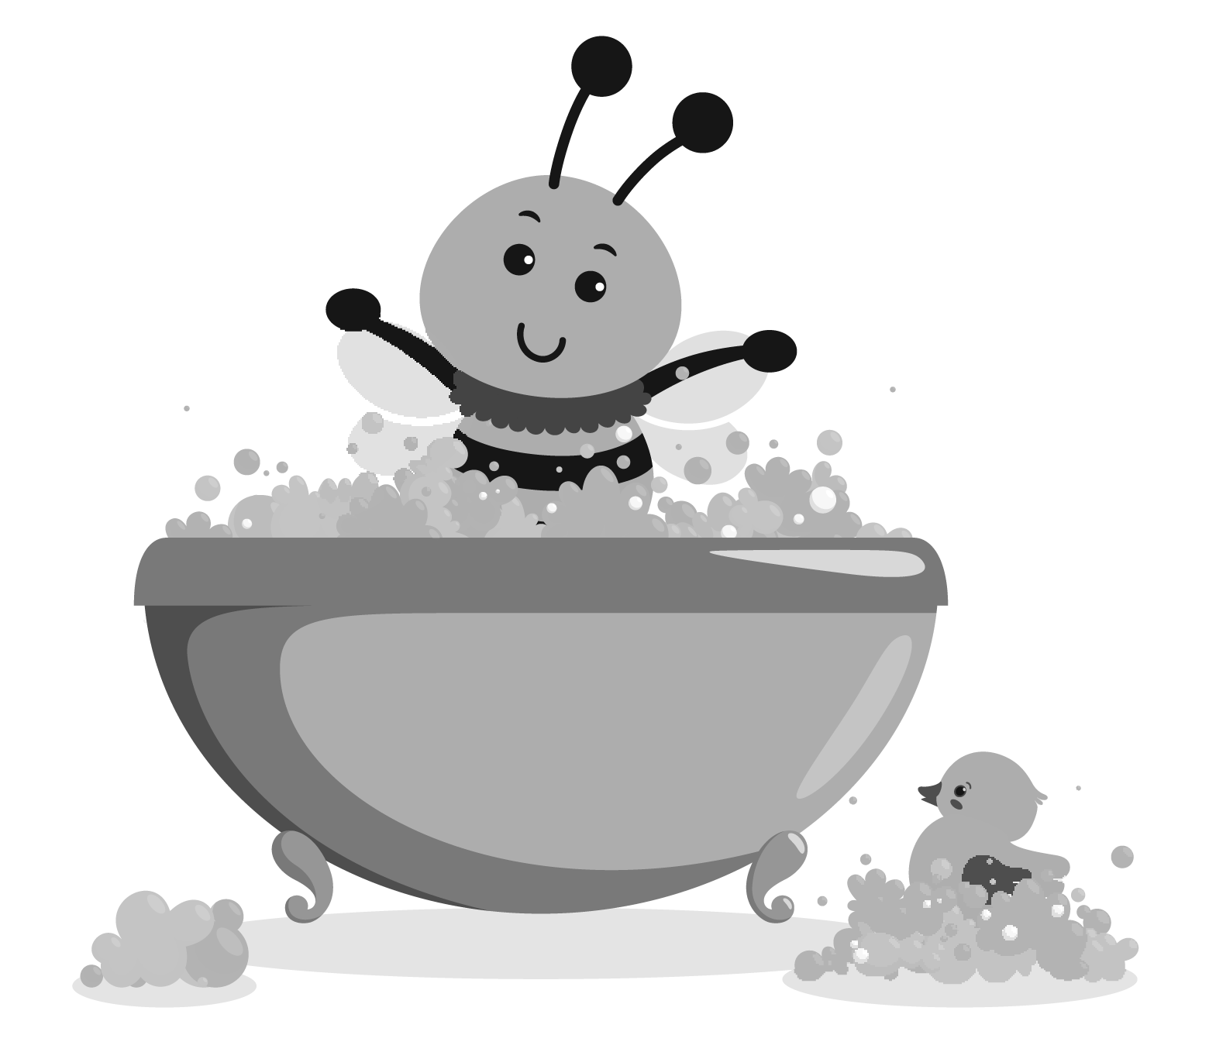
Umuvyeyi
Umubyeyi ubyara cyangwa urera umwana.
Umubyeyi urera, keretse amategeko ya leta, amabwiriza, cyangwa inshingano zamasezerano yagiranye na leta cyangwa ikigo cyibanze bibuza umubyeyi urera gukora nkumubyeyi.
Umurinzi muri rusange yemerewe gukora nk'umubyeyi w'umwana, cyangwa yemerewe gufata ibyemezo hakiri kare, uburezi, ubuzima cyangwa ibyemezo by'iterambere ku mwana (ariko ntabwo ari leta niba umwana ari umurinzi wa leta).
Umuntu ku giti cye ukora mu mwanya wumubyeyi ubyara cyangwa urera (harimo nyirakuru, nyirarume, umubyara, cyangwa undi muvandimwe) babana.
Umuntu ku giti cye ushinzwe ubuzima bwemewe n'amategeko.
Uwuja mu gishingo c’umuvyeyi.

Ikigo cararitswe
Ikigo citabira bisobanura umuntu uwo ari we wese, ikigo, ikigo, cyangwa ikigo gikusanya, kibungabunga, cyangwa gikoresha amakuru yamenyekanye kugiti cye kugirango ashyire mubikorwa ibisabwa mu gice C cya IDEA kuri N.C. ITP n'amabwiriza yo mu gice C ca IDEA yerekeye umwana runaka. Ikigo cyitabiriye amahugurwa kirimo igice cyambere co gutabara, CDSAs, abatanga interineti hakiri kare, numuntu ku giti cye cyangwa ikigo gitanga serivisi iyo ari yo yose C (harimo guhuza serivisi, gusuzuma no gusuzuma, hamwe nizindi serivisi C). Ikigo cyitabira ntabwo gikubiyemo amasoko y'ibanze yoherejwe (nk'ibigo bya Leta nka gahunda ya Medicaid cyangwa Porogaramu y'Ubwishingizi bw'Ubuzima bw'abana [CHIP]) cyangwa ibigo byigenga (nk'amasosiyete y'ubwishingizi yigenga) bikora gusa nk'inkomoko y'inkunga ya serivisi igice cya C.
Mu makuru ajanye n’umwirondoro harimwo::
- Amazina y’umwana canke amazina yabandi bagize umuryango.
- Aho umwana wawe aba canke umuryango wawe uba.
- Ikiranga umuntu, aho ni nk’inimero iranga umwana wawe canke inimero yawe y’akazi.
- • Ibindi biranga indirect, nk'itariki umwana wawe yavukiyeho, aho yavukiye, cyangwa izina ry'umukobwa wa nyina.
- Ibindi biranga indirect, nk'itariki umwana wawe yavukiyeho, aho yavukiye, cyangwa izina ry'umukobwa wa nyina.
- Urutonde rw’ibuntu bishobora kumuranga we nyene ubwiwe canke ivyo vyose vyotuma umwirondoro w’umwana wawe umenyekana bitagoranye
- • Amakuru yasabwe numuntu gahunda yo gutabara hakiri kare yemera ko azi umwirondoro wumwana wawe.
- Amakuru yasabwe numuntu gahunda yo gutabara hakiri kare yemera ko azi umwirondoro wumwana wawe.
Umwana yiharijwe na Leta
Umwana ni Ward ya Leta mugihe ishami ryintara ishinzwe imibereho myiza yahawe uburenganzira bwo kurera umwana kandi afite inshingano nububasha bwo gufata ibyemezo bijyanye numwana, kabone niyo umubyeyi usanzwe cyangwa umurera azwi, arahari, kandi abishaka mu guhagararira umwana.

Ikigo citaho abana batoyi hamwe n’impinja muri Leta ya Carolina y’uburaruko
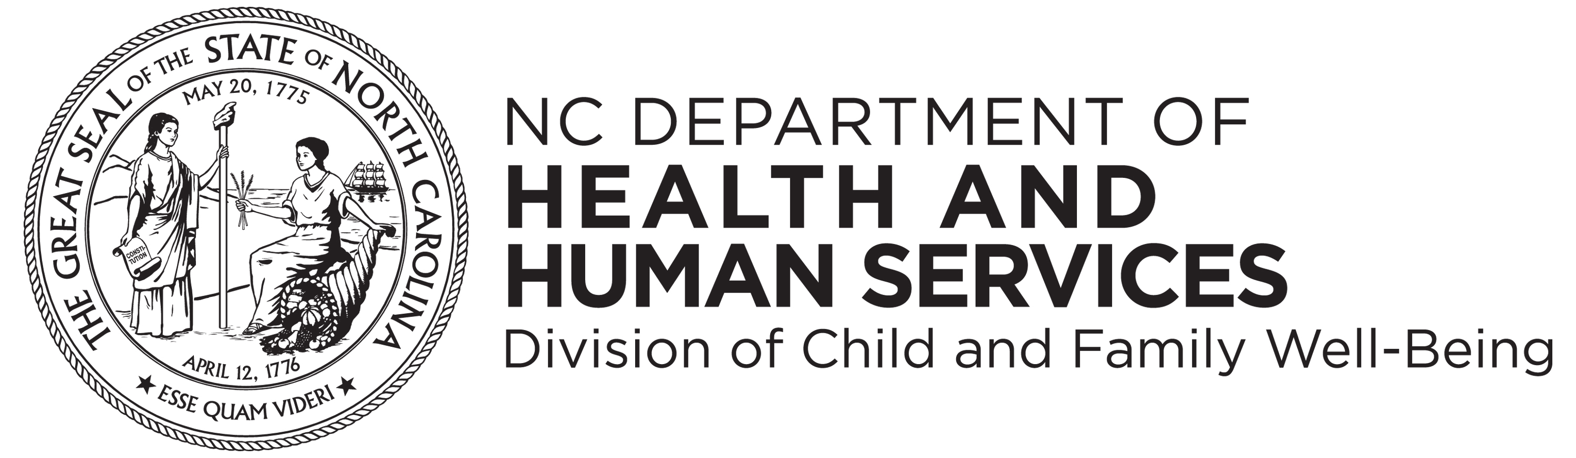

Leta ya Carolina y’Uburaruko
Ubushikiranganji bw’amagara y’abantu n’ibikorwa vyubahiriza kiremwa muntu
Igisata kijejwe Imibereho Myiza y’Abana n’Imiryango
Urwego rujejwe gutabara mu buryo bwihuse
www.ncdhhs.gov
www.ncdhhs.gov/division-child-and-family-well-being
www.ncdhhs.gov/itp-beearly

Kurwiza aka gatabu birarekuwe
Ndamukiza 2013 | Rusama 2022

Ubushikiranganji bw’amagara y’abantu n’ibikorwa vyubahiriza kiremwa muntu ntibushigikira ivangura rishingiye ku rukoba, ibara, igihugu umuntu avamwo, igitsina, idini, imyaka canke ubumuga umuntu agendana mu gutanga akazi canke mu gukemura ibibazo vy’umuntu.

