**NC Office of Rural Health Operations Team**

**SFY 2024 Q1 Quarterly Newsletter**

This newsletter serves a repository of information relevant to North Carolina State-Designated Rural Health Centers (SDRHCs) and CMS Rural Health Clinics (RHCs). Please share any content suggestions or feedback with Justin Kearley at [justin.kearley@dhhs.nc.gov](mailto:justin.kearley@dhhs.nc.gov)

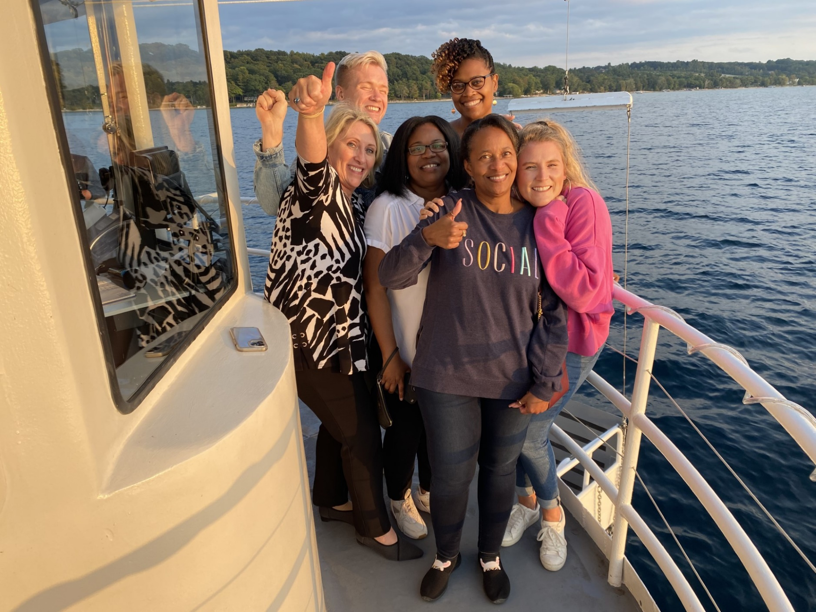

Greetings from the NC Office of Rural Health Operations Team! This past quarter was a busy one. The above picture was taken at the National Organization of State Offices of Rural Health (NOSORH) Annual Meeting in Traverse City, Michigan joined by our Director Maggie Sauer and Lisa McKeithan, Placement Services Manager.

As always, our team is happy to share news this quarter highlighting folks from across the state who are going the extra mile to care for our rural communities.

Contents

Grantee Highlights 2

Cabarrus Rowan Community Health Centers Mobile Clinic Provides Much Needed Services to Farmworker Community 2

Recent Events 3

NOSORH Annual Meeting 3

NC Office of Rural Health Regional Meetings 4

Operations Team Member Selected for Appalachian Regional Commission (ARC) Leadership Institute 5

In the News 5

UNC Eschelman School of Pharmacy Receives Funding to Support Two Rural Pharmacy Hubs in Eastern NC 5

Training and Continuing Education 6

LilyPad Webinars for CMS Rural Health Clinics 6

Emergency Preparedness for Rural Health Clinics 7

Funding Opportunities 7

Rural Health Centers Capital Funding Closes December 30 7

Upcoming Events 8

From Silos to Synergy 8

NC Office of Rural Health Celebrates 50 Years on National Rural Health Day 9

Contact Information 10

# Grantee Highlights

## Cabarrus Rowan Community Health Centers Mobile Clinic Provides Much Needed Services to Farmworker Community

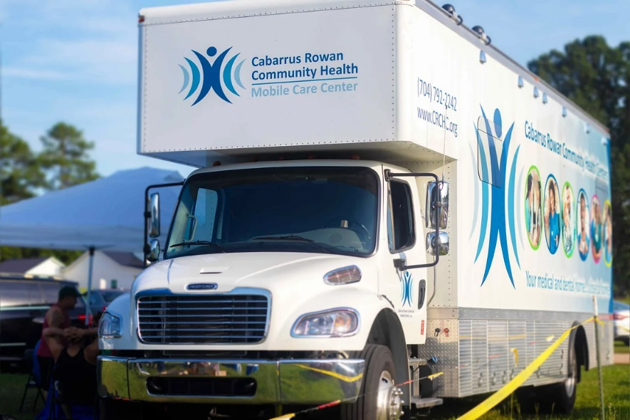

Cabarrus Rowan Community Health Centers (CRCHC) Mobile Clinic provides much needed services to farmworkers in their service area. In August, the mobile clinic visited Patterson Farms, where roughly 200 seasonal migrant farmworkers received primary care services from the organization. Since CRCHC partnered with Patterson Farms in 2019, the clinic has seen more than 500 farmworkers in total. “It’s been an awesome experience,” said Christina Echevarria, CRCHC’s mobile unit/special populations manager, who oversees the operation. “It’s a very rewarding thing to do.” Most staff working at the mobile clinic are bilingual, making service delivery to the farmworkers easier.

Raul Sanchez, one of the farmworkers, had the following to say about the clinic’s services and their bilingual service providers: “That is very helpful because I can talk in my own language, and I can express what my symptoms are”.

For many migrant workers employed by the farm, CRCHC’s mobile clinic is more than just a nice convenience; it’s an absolute lifeline. “I would say the biggest benefit is that they would go without healthcare otherwise,” said CRCHC’s Director of Administration Brittany Payne. “A lot of people who access our services would have to go to the emergency room or would just go without care and struggle.”

You can read more about the work of CRCHC’s mobile clinic at the link here: <https://independenttribune.com/news/local/crchc-provides-key-lifeline-for-migrant-workers-through-its-mobile-clinic/article_f28bc65a-3aae-11ee-a055-77566995a25e.html?utm_source=independenttribune.com&utm_campaign=%2Fnewsletter-templates%2Feedition&utm_medium=PostUp&lctg=7452930&tn_email_eh1=d5ff9a47448b3de6a3d2f8de0729766d9530a580>

# Recent Events

## NOSORH Annual Meeting

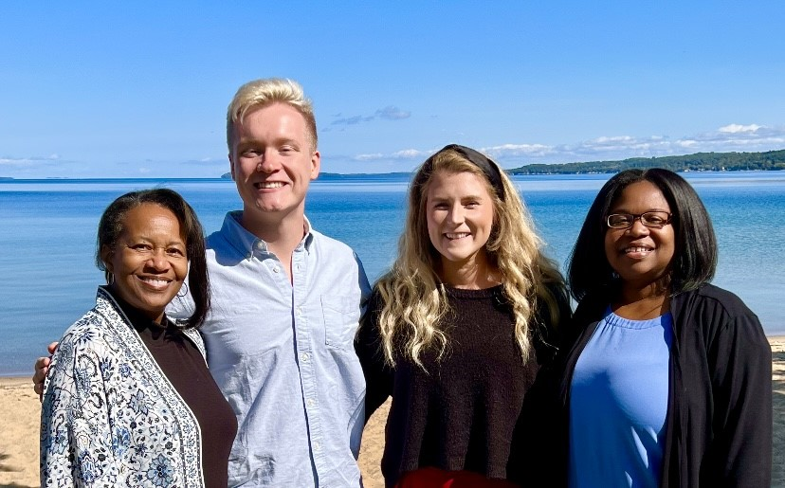

The Operations Team attended the NOSORH Annual Meeting in Traverse City, Michigan from September 18 - 21.

During that time, NC Office of Rural Health staff met with colleagues from across the nation to discuss how to better support rural health. Topics discussed included health equity, maternal health, behavioral health, innovative approaches to health in rural areas, and more.

Staff also dedicated time to work on the State Office of Rural Health grant in concert with Offices across the nation. During this time, Offices discussed best practices and methods to conduct SORH grant activities such as disseminating rural health information, collaboration with rural health partners, and provision of technical assistance. The SORH grant is spearheaded by the Operations team.

The National Organization of State Offices of Rural Health (NOSORH) was established in 1995 to assist State Offices of Rural Health (SORH) in their efforts to improve access to, and the quality of, health care for nearly 61 million rural Americans.

NOSORH enhances the capacity of SORH to do this by supporting the development of state and community rural health leaders; creating and facilitating state, regional and national partnerships that foster information sharing and spur rural health-related programs/activities; and enhancing access to quality healthcare services in rural communities. https://nosorh.org/

## NC Office of Rural Health Regional Meetings



The Office successfully conducted six regional meetings across the state in the first quarter of the fiscal year. Service Area Teams (SATs) facilitated by the Operations team led the effort to conduct meetings throughout August and September in each of the six Medicaid regions across NC.

Topics covered included Medicaid Expansion, community engagement and empowerment, electronic health record support, behavioral health integration, and grant writing. Additionally, each meeting had an interactive icebreaker and networking session. The goal of the meetings was to provide high quality and personalized technical assistance to communities and to support and strengthen connections to improve the state’s health care safety net.

* Region 1: August 11, 2023 in Waynesville, NC
* Region 2: September 14, 2023 in Dobson, NC
* Region 3: August 15, 2023 in Charlotte, NC
* Region 4: August 21, 2023 in Raleigh, NC
* Region 5: September 7, 2023 in Pinehurst, NC
* Region 6: September 28, 2023 in Greenville, NC

Surveys were used to measure the effectiveness of the meetings and continuous quality improvement practices were put into place to address any areas of concern. In total, the regional meetings had an impact of 280 individuals, 62 organizations, and 37 counties.

Thank you to all our grantees and partners who had a hand in the meetings, without your assistance none of this would have been possible.

## Operations Team Member Selected for Appalachian Regional Commission (ARC) Leadership Institute

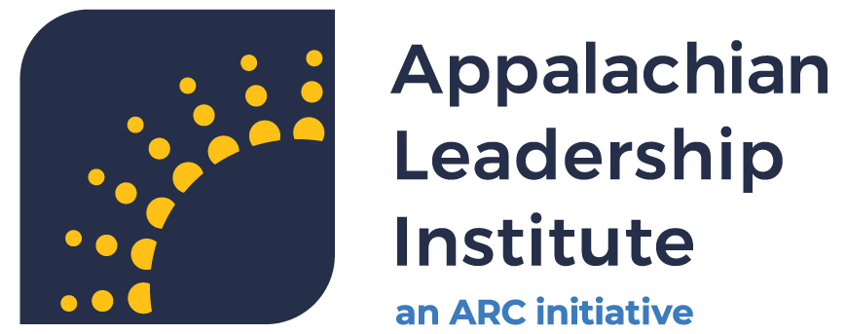

The Appalachian Regional Commission (ARC) has announced the Fellows selected for the 2023-2024 Class of the Appalachian Leadership Institute, a free leadership and economic development training opportunity.

Over the next nine months, Justin Kearley will participate in sessions focused on skill-building with regional experts, peer-to-peer learning, and case study analysis. Justin is an Appalachian native and is excited to participate in the program.

Once completed, he will join a robust alumni network, allowing him to continue connecting with, and learning from, other leaders across Appalachia.

Learn more about the program at <https://www.arc.gov/leadership/>.

# In the News

## UNC Eschelman School of Pharmacy Receives Funding to Support Two Rural Pharmacy Hubs in Eastern NC

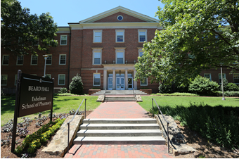

The UNC Eshelman School of Pharmacy was recently awarded $815,000 over three years from The Duke Endowment to launch rural pharmacy hubs as part of the School’s Rural Pharmacy Health Initiative. This grant, led by principal investigator Betsy Sleath, Ph.D., enables the School to extend its reach into underserved communities across North Carolina to improve access to care in these areas while creating new, sustainable models for rural health care.

The Duke Endowment grant will support two pharmacy hubs that will launch over the next three years across Eastern North Carolina. The hubs will create the infrastructure needed to build and deliver innovative models of practice to provide high-quality care for underserved patients. Ultimately, it’s a collective approach to improving health in small communities.

These hubs will help address rural health care provider shortages by having pharmacists work on interprofessional teams to optimize medication use. Community pharmacists are well-positioned to fill the health care workforce gap as accessible and trusted health care providers.

“We are super excited about this new opportunity to train community pharmacists with our outstanding partners in Eastern North Carolina and to build these rural pharmacy hubs so that pharmacists can work on health care teams and help patients better understand how to use their medications for chronic conditions like diabetes and high blood pressure and to prevent hospitalizations and improve patient outcomes,” said Sleath, Ph.D., Regional Associate Dean Eastern North Carolina and George H. Cocolas Distinguished Professor in the Division of Pharmaceutical Outcomes and Policy.

The Duke Endowment funded two hubs—New Bern and Rocky Mount. These rural hubs will provide unique educational opportunities to develop the pharmacist workforce Eastern North Carolina needs while at the same time serving as an important patient resource.

# Training and Continuing Education

## LilyPad Webinars for CMS Rural Health Clinics

All times 1:00 PM Eastern

December 11, 2023 Behavioral Health Program Development [Register](https://us02web.zoom.us/meeting/register/tZMpcu2uqz4pH9dQGe--2L7Tqe0vLw99slEv#/registration)

Access to high-quality behavioral healthcare is perhaps the most important and strategically relevant issue facing rural communities, providers, payers, and policy makers. Join us for a comprehensive survey of rural-specific service line opportunities, provider types, regulatory requirements, reimbursement best practices and creative options to increase access to behavioral health services – and how to ensure those services are financially viable to your organizations.

March 11, 2024 Value Based Payments for RHCs [Register](https://us02web.zoom.us/meeting/register/tZEkcOCspzwoHNCKQ6pmTRsgd4zhjTz3GGAW#/registration)

We are in the midst of a healthcare reimbursement sea change based on the concept of value, and one that can benefit rural health clinics and small rural hospitals. Effective primary care practices and networks have the unique ability to reduce the overall cost of care in rural communities through better patient engagement, education, prevention, clinic operations and a culture of improvement. The economic value of these cost savings should accrue at least in part to the providers and not exclusively to public and private payers. This presentation offers examples and action steps to design, implement and market rural primary care oriented VBP programs.

June 10, 2024 RHC Revenue Cycle Best Practices [Register](https://us02web.zoom.us/meeting/register/tZEkd-mvrTwjEt1Sl4jh47It1sWsq1ZdSGo4#/registration)

Too often rural health clinics maintain revenue cycle infrastructure that fails to address and fully leverage its unique documentation, coding, and billing processes. As a result, the revenue cycle remains one of the best opportunities for clinics (and in many cases, hospitals) to improve operational efficiencies due to its complexity and core function. This presentation walks participants through the full revenue cycle value chain specific to RHCs while identifying common pitfalls that impact revenue.

## Emergency Preparedness for Rural Health Clinics

Join the National Association of Rural Health Clinics (NARHC) for their free, upcoming technical assistance webinar, RHC Emergency Preparedness 101!

This webinar will provide an overview of the RHC Emergency Preparedness requirements found in RHC regulation and interpretive guidance, review the important components of your EP manual, learn sample exercises, and more!

There will also be a Q&A session during the webinar.

Date: Tuesday, November 7th, 2023, 3 PM Eastern

Speaker: Scott Robbins, Pediatric Clinic Practice Manager / Women & Children’s Services Clinic Practice Manager, Southeast Health

Moderators:

· Nathan Baugh, NARHC Executive Director

· Sarah Hohman, NARHC Director of Government Affairs

To register, go to <https://us06web.zoom.us/webinar/register/1416969401170/WN_TlADBRcGTj-n7QaUTnvadg>

# Funding Opportunities

## Rural Health Centers Capital Funding Closes December 30

**Description**

The purpose of grants awarded under this program is to support State Designated Rural Health Centers (SDRHC). ORH assists underserved communities and populations with developing innovative strategies for improving access, quality, and cost-effectiveness of health care. The ability of a healthcare facility to meet the needs of a rural patient population is directly related to the efficiency, size, and quality of the facility and its equipment. Capital Grant funding allows for investment in healthcare infrastructure, including the construction, renovation, and expansion of rural healthcare facilities. Capital investments can also be made through the purchase and installation of major equipment and technology. Capital Grant funding does not support staff salaries and requests should not duplicate Community Health, Farmworker Health, or SDRHC grant funded operating projects.

**Application and Submission Instructions**

Please read the following grant instructions and requirements carefully. Applications that do not adhere to all instructions and requirements will not be considered.

Grant applications must be received via electronic survey by 5:00 p.m. December 29, 2023. Applications are accepted on a rolling basis starting August 28, 2023, until available funds are fully obligated, or up to December 29, 2023, whichever comes first. Organizations are encouraged to apply at least two months prior to their project to allow for application review and grant processing. Applicants will be notified of awards within 20 business days of submitting their application.

Applicants must submit their application electronically through an online REDCap survey. There is a two-step process to receive a personalized link to the application. The link below will request information about your organization and a contact person. The contact person will then be sent a personalized link to apply to the Rural Health Centers Support Grants RFA. Use this document as guidance for the electronic version of the application. All necessary attachments are noted within the requirements section of the document.

Click link to access electronic version of application: <https://ncorh.ncdhhs.gov/redcap/surveys/?s=CTR77JEAE8ENTKRL>

# Upcoming Events

## From Silos to Synergy

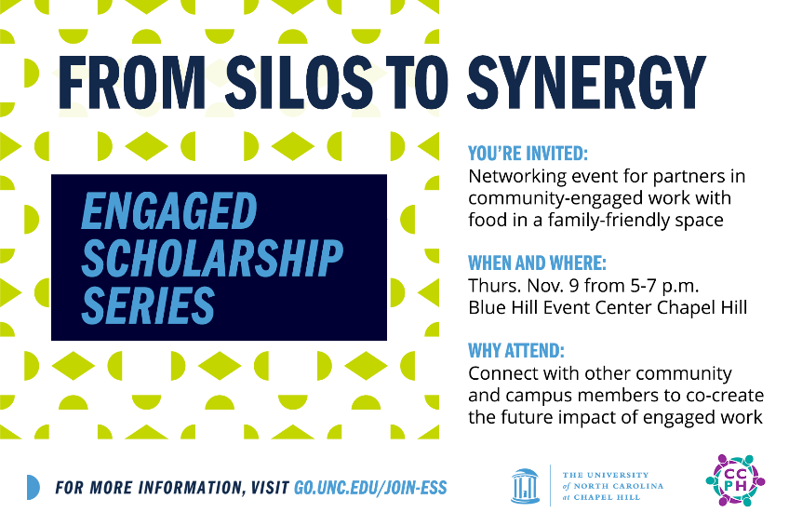

**Help Shape the Future of Community-Campus Partnerships!**

The UNC Engaged Scholarship Series (ESS) aims to bring together community and campus partners to share experiences and strengthen relationships. ESS is open to all community members and Carolina faculty, staff, and students who already are or would like to be involved in community-engaged work.

**You’re Invited to a Networking Event on Nov. 9, 2023!**

Connect with other community and campus members in-person at the first event in the UNC Engaged Scholarship Series (ESS). Attendees will help shape the future of the series and increase the impact of community-engaged work.

* **Date and Time:**Thurs., Nov. 9, 2023, from 5-7 p.m.
* **Location:** Blue Hill Event Center at 200 South Elliott Road, Chapel Hill, NC 27514
* **Family Friendly Event:** If it helps to bring your kids along given the time of this gathering, they are welcome! Although we won't have childcare, we'll have space in the room for crafts and activities so please let us know the number of guests in your RSVP below.
* **Food and Refreshments Provided:** Please include any dietary restrictions and any other necessary accommodations for you and your guests in your RSVP below.
* **For Community Partners:** You will receive an automatic confirmation email after you RSVP and a separate email from [eghall@email.unc.edu](mailto:eghall@email.unc.edu) with details regarding optional support for your time participating in this event.
* **Questions?** Contact Gail Currin Fallon at [eghall@email.unc.edu](mailto:eghall@email.unc.edu) or 919-607-4829.

**For more information and to RSVP by Nov. 2, visit:**[**go.unc.edu/join-ess**](https://go.unc.edu/join-ess)

## NC Office of Rural Health Celebrates 50 Years on National Rural Health Day

The North Carolina Department of Health and Human Services’ Office of Rural Health is proud to celebrate our 50th Anniversary this year on National Rural Health Day. On this special occasion, we take the opportunity to recognize the selfless, community-minded spirit of health professionals and volunteers in North Carolina communities.

National Rural Health Day falls on the third Thursday in November each year and recognizes the efforts of those serving the health needs of 4.6 million people who live in one of the state’s 70 rural counties across North Carolina.

NC Office of Rural Health 50th Anniversary Celebration: Honoring the Past, Celebrating the Present, Embracing the Future

Thursday, Nov. 16, 2023

[Register Here](https://events.gcc.teams.microsoft.com/event/c3c42c32-3298-492d-9822-5aa7b41b7811@7a7681dc-b9d0-449a-85c3-ecc26cd7ed19)

As part of National Rural Health Day, our office plans to host a hybrid event beginning at 10:00 AM. The event is an opportunity to “Celebrate the Power of Rural” by honoring the selfless, community-minded spirit that prevails in rural America. NRHD showcases the efforts of rural health care providers, The State Office of Rural Health, and other rural stakeholders to address the unique health care challenges rural citizens face today and in the future.

Events include a special presentation of the National Rural Health Day Gubernatorial Proclamation, recognition of North Carolina’s Community Star, and a celebration of local leaders across the state. The event is sponsored by the NC Office of Rural Health, NC Rural Health Association, NC Rural Center, and Hometown Strong.

# Contact Information

[Rural Health Operations Website](https://www.ncdhhs.gov/divisions/office-rural-health/office-rural-health-programs/rural-health-centers)

For technical assistance or general inquiries, please contact your regional contract monitor.

Program Manager – Dorothea Brock

Email: Dorothea.brock@dhhs.nc.gov

Regions 1 & 2 – Justin Kearley

Email: Justin.kearley@dhhs.nc.gov

Regions 3 & 5 – Beth Blaise

Email: [Beth.blaise@dhhs.nc.gov](mailto:Beth.blaise@dhhs.nc.gov)

Regions 4 & 6 – Kimberly R. McNeil

Email: Kimberly.r.mnceil@dhhs.nc.gov