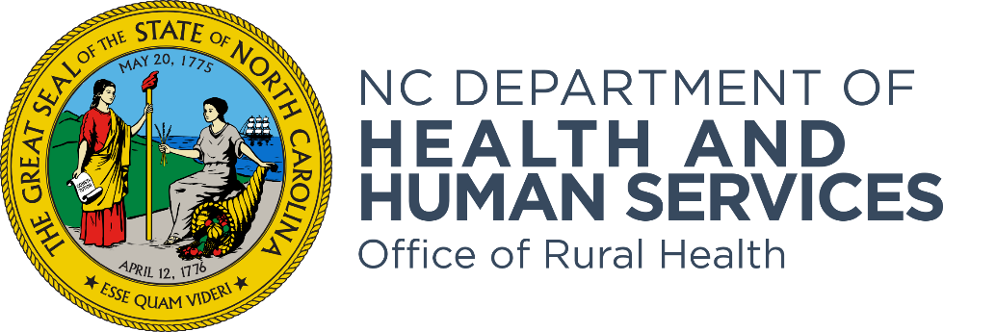

Community Health Grant SFY2025 Technical Assistance Webinar
Frequently Asked Questions Document

The purpose of the Office of Rural Health’s Community Health Primary Care Access Program is to provide primary medical care services to underserved residents in North Carolina by awarding Community Health Grants (CHG) to health entities throughout the state.

- What does NCORH count as under-insured? Medicaid? Medicare? Private insurance with large deductibles?
Is there an official ORH/DHHS definition of underinsured?
- Patients at or below 200% of the Federal Poverty Level lacking adequate access to health insurance coverage.
Generally, it refers to individuals whose health insurance coverage is inadequate due to limited medical services and/or prescription drug coverage, high deductibles, lifetime coverage limits, and high out-of-pocket expenses.
There is no definition in PPMD (recommendation added to Things to Consider)
- Can CHG funds support both clinical and community-based behavioral health work? Clinical services include primary care, psychiatry, counseling, and MAT services. Community-based services include services such as post-overdose response, syringe services, HIV/Hep C rapid testing, one-on-one & group peer support, inpatient substance use/mental health treatment navigation, etc.
I believe CHG funds can support both the clinical and community-based services as outlined above.
As for what counts as an encounter if this potential project was a Track A type project, the guidance for encounter types states: You can count group visits. You can count care coordination visits, do not report encounters that are screenings, tests, or vaccines as visits.
If these are activities are something CHG can support, can funds be used for things like Community Health Worker salary/fringe, travel for community-based work, and the purchase of harm reduction supplies (e.g. naloxone, syringe services supplies, fentanyl/xylazine test strips, etc.)?
Yes.

- If a hospital foundation within a multi-foundation healthcare system (each market foundation in a different part of the state has a unique EIN) received an initial 3-year award for FY 2023, does that mean that no other hospital foundation within that healthcare system can apply until 2025 for FY 2026?
Qualified organizations can submit one application per competitive grant cycle.
- If we operate a free clinic, should we take into consideration that we could lose patients due to Medicaid expansion? We only see uninsured patients.
Yes, and this should be noted in the Community Need section of the Project Narrative.

- Does ORH have a preference for Track A or Track B budgets, or are they equally acceptable?

Either Track is acceptable. However, if choosing Track A, ensure that you have the patient volume to spend down the entire award amount by the end of the grant cycle.

- Do you have to be a member of HIE HealthConnex to apply?

An agency does not have to be a member to apply; however, a condition of receiving funding is to connect or have a plan to connect NC HealthConnex to meet the state’s mandate.

