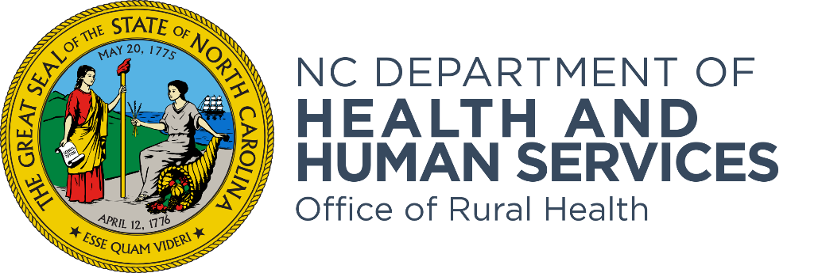

NC Office of Rural Health Medication Assistance Program (MAP)
SFY 2024 & 2025 Technical Assistance Webinar
Frequently Asked Questions (FAQ)
Document

These grant funds, supported through the North Carolina General Assembly, are for helping uninsured, low-income North Carolinians gain access to free and low-cost medications. Safety net organizations who care for underserved and medically indigent patients including community health centers, free and charitable clinics, rural health centers, and health departments offering medication assistance to the uninsured in their community are eligible to apply for this funding.

- What is the SFY 24 & 25 MAP RFA? The State Fiscal Year 24 & 25 Medication Assistance Program Request for Application (SFY 24 & 25 MAP RFA) is the Office of Rural Health (ORH) announcement of the availability of grant funding to identify and fund community organizations in North Carolina that will help uninsured, low-income citizens of all ages gain access to free and low-cost medications.

- Who is eligible to apply for the SF 24 & 25 MAP RFA? Eligible applicants are safety net organizations who care for underserved and medically indigent patients that provide or will provide medication assistance programs for uninsured and low-income patients. (i.e., Eligible applicants include federally qualified health care centers and look-alikes, free and charitable clinics, health departments, hospital owned primary care clinics, rural health centers, school based and school linked health centers, area health education centers, and other nonprofit community organizations that include pharmacies).

- I missed the comment about not including vaccine clinic data. What was that in reference to? The comment about not including vaccine clinic data is in reference to performance measure requirements of data collection. During data collection, you are asked to provide the number of unduplicated patients served. Do not include patients from when you are hosting a vaccination clinic (i.e., if you're having a Flu Clinic Day, then do not count the attendees from the Flu Clinic). The performance measure is asking for the number of unduplicated patients served. Patients are individuals who have at least one visit during the reporting period.

- As a current grantee, we are implementing the program in 5 counties (at the request of ORH) under one grant currently. How can we continue to offer this program in 5 counties under the new guidelines of $28,850 - $3,000 = 25,850? It appears we will need to find other organizations to apply for the funds, correct? Yes, that is correct. ORH has undertaken efforts to ensure that these state appropriations are being used equitably and that is the reason for the maximum award amount per grant. Grantees would have $25,850 in funding to support grant approved expenditures after including the TPC fee. ORH encourages grantees to explore other funding opportunities to help support service delivery.

- Is it $28,850 per year for 2 years? Or $28,850 total? And is the $3k for TPC part of the $28,850?? The award amount will be $28,850 per grant year. (i.e., $28,850 awarded in SFY 24 and another $28,850 to be awarded in SFY 25). Yes, the $3,000 fee for TPC is included in the award amount. The $3,000 fee is a reimbursable line-item expense that comes from the total budget. Thus, a grantee will have $25,850 to utilize for service delivery.

- Will there be another funding application next year as well or will it now be on a 2-year cycle versus the prior every year application? The application for the second fiscal year of funding, SFY25, will be a closed continuation application.

- What is the difference in the money amount? What was the amount before? The maximum amount that will be awarded to each eligible organization is $28,850. The difference is that there was no specific maximum award amount before. The award amount previously varied among awarded organizations.

- Does the TPC fee come from out of the total amount of funding we can apply to receive? Yes, the TPC fee will be deducted from the maximum award amount, as a required budget line item.

- Will the $3,000 TPC fee that is pre-populated in the MAP budget cover just one year or both years? Or will the budget line be $6,000? The TPC Licensing Fee of $3,000 will be paid one time during each of the two-year funding cycle. This means that you will have a budget line item for $3,000 during the first year, SFY 24, and during the second year, SFY 25.

- Is the amount awarded for pharmacy services for the entire organization or for MAP only? The amount awarded under the MAP SFY 24 & 25 RFA Grant is for pharmacy assistance. Under this RFA application, the information that is shared with us is to be directly related to the Medication Assistance Program.

- I have been approached by NC MedAssist to partner with them. Would a partnership with them hinder our contract with ORH's Medication Assistance Program? A partnership with MedAssist would not hinder a contract with ORH. However, you want to be careful about any appearance of double dipping. In that circumstance, ORH expects that you would track your time to ensure ORH is only reimbursing time dedicated to our program and the use of TPC.

- We serve multiple counties, but our grant writer, who attended the TA webinar, said we can only apply for ONE grant for our organization and for a max amount of $28,500. Does this mean we cannot apply for each county and can only apply as one organization to serve all of those counties with $28,500? If so, we will not be able to serve all of the counties we currently serve and will force us to discontinue MAP services in several rural counties. Are there service providers willing to step in and do this program in far western counties? I am very concerned about patients getting lost in this process if there are not enough service providers for ORH to contract with to provide the MAP services. You are correct, the newest MAP RFA will limit you to a single application. ORH understands your funding concerns. One option, and certainly not the only option to consider, is to partner with other organizations to continue offering services. This relationship might be with a local pharmacy or other safety net organizations. ORH cannot say what organizations might be interested in applying in your area. ORH wishes there were adequate funds to provide MAP grants to everyone. Our intent with the changes this year is to provide equity across the state in a way our current distribution does not.

- How many applications are you expecting? The predicted number of applications for the MAP SFY 24 & 25 RFA is unknown. It is possible that ORH will receive an upward of 60 plus applications.

- Can we obtain a copy of how to apply? For more information on how to apply for the SFY 24 & 25 MAP RFA and other Office of Rural Health grant opportunities go to:
https://www.ncdhhs.gov/about/grant-opportunities/rural-health-grant-opportunities/sfy-2024-2025-medication-assistance-program-rfa

- How many applications will be awarded? The Office of Rural Health anticipates that 59 grants will be awarded to the top 59 highest scoring applications.

- I am in the process of completing the MAP RFP for this upcoming year and it is asking for a Grant Narrative. Is this a specific document? The Grant Narrative is a word template document to be completed by applicants. The Grant Narrative is the compilation of the questions and your proposed responses to all the scored sections detailing your use of the grant funds. The grant narrative template document can be found on the MAP RFA website. The survey gives instructions for completing the Grant Narrative. It can be found here: https://www.ncdhhs.gov/sfy24-map-rfa-grant-narrativedocx/open

- Is this grant different from previous grants? The MAP SFY 24 & 25 RFA grant is similar to past grants. The difference is the amount awarded per agency has a maximum award amount of $28,850.

- The MAP RFA asks if our agency has a 340-B program. We do have 340-B medications for Family Planning, STD and TB clinics, but we do not purchase other drugs under 340-B. Should I say no since our meds are specific to those programs or should I say yes and report numbers from those programs that were served? You should answer yes and report the numbers for the programs served.

- We have a question about the RFA. It's asking for a complete copy of the grant narrative. Is there a template or where can I find this document to fill out? The narrative document is located on the RFA website. The link to the Grant Narrative document can be found here: SFY24 MAP RFA Grant Narrative.docx (scroll to the bottom of the page.

- What is TPC? The Pharmacy Connection (TPC) is a web-based software program created by the Virginia Health Care Foundation that helps provide prescription medications to chronically ill, uninsured individuals throughout all 50 states.

- We are also a current grantee and provide these services in 11 counties. If we are not chosen to receive grant funds through this program, does our access to TPC end? Do we have to pay for TPC user only access?
If not awarded a grant, ORH will no longer reimburse the cost of being a TPC user through the Medication Assistance Program. However, there is an opportunity to be a TPC user only for non-grantees. Since there are fees associated with being a TPC user only, please contact Lisa Hueston to discuss TPC user only status.

Contact information: Lisa Hueston, Program Manager,
The Pharmacy Connection
Virginia Health Care Foundation
707 East Main Street, Suite 1350
Richmond, VA 23219
Phone: (804) 828-5803
Fax: (804) 828-4370
Email: lisa@vhcf.org
tpc@vhcf.org

- If our system currently uses TPC, but is not selected for a grant, will we be able to contract directly with the Virginia Health Foundation leadership? Yes, you can have TPC user only access without being a current MAP grantee. For any questions regarding TPC user only access, you can reach out directly to Lisa Hueston.

Contact information: Lisa Hueston, Program Manager,
The Pharmacy Connection
Virginia Health Care Foundation
707 East Main Street, Suite 1350
Richmond, VA 23219
Phone: (804) 828-5803
Fax: (804) 828-4370
Email: lisa@vhcf.org
tpc@vhcf.org

