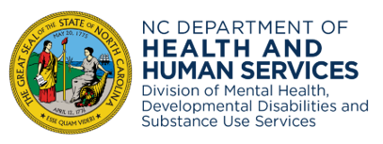

|  |  |
| --- | --- |
| **The State Consumer and Family**  **Advisory & State to Local Collaboration**  **2024-2025 Meeting Schedule** | |
| **State CFAC Meeting**  **Hybrid Meeting**  *Every 2nd Wednesday, from 9:00-3:00 p.m.*  ***Join link:* Please see the monthly agenda for the correct link.**  **Register prior to the meeting to receive login details and dial-in information.** | |
| **\*Location:** 2104 Umstead Drive, Raleigh, NC 27699, Ashby Building, CR 115 | |
| **2024 Schedule**  July10, 2024  August 14, 2024-Retreat  September 12,2024-Thursday  October 09, 2024  November 13, 2024  December 4, 2024 | **2025**  January 08,2025  February 12, 2025  March 12,2025  April 09, 2025  May 14,2025  June 11, 2025 |
| **State to Local Collaboration**  **Virtual Meeting**  *Every 4th Wednesday, from 6:00 – 7:30 p.m.*  *Join Link:*  [**https://www.zoomgov.com/meeting/register/vJItcO-przMiGlBgjTpXMqNMtrPbDPI0Iw0**](https://www.zoomgov.com/meeting/register/vJItcO-przMiGlBgjTpXMqNMtrPbDPI0Iw0) | |
| **2024 Schedule**  July 24, 2024  August 28, 2024  September 25, 2024  October 23, 2024  November No Cal  December 18, 2024 | **2025 Schedule**  January 22, 2025  February 26, 2025  March 26, 2025  April 23, 2025  May 28, 2025  June 25, 2025 |
| ***\*Location subject to change.***  **Red indicates change in meeting** | |

